
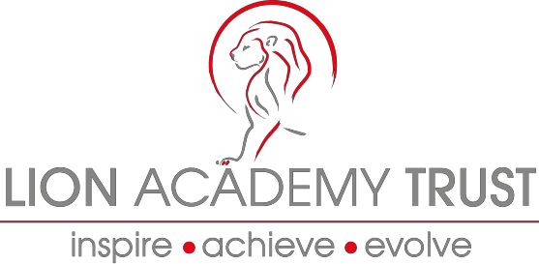

Lion Academy Trust
Information and Application Pack for the position of:
Deputy Head Teacher – Leadership Scale L13-L17
Location: Wellingborough, Northamptonshire
(Not Suitable for NQT’s)


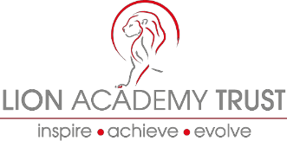







Dear Candidate

Thank you for the interest you have shown in the post of Deputy Head Teacher.

The Lion Academy Trust is looking to recruit an outstanding, enthusiastic, innovative and committed Deputy Head Teacher to support the Trust’s continual improvement and growth extension to Northamptonshire. This will be alongside other Deputy Head Teachers, Heads of School and the wider Trust Executive team. If you are excited by innovation and challenge, are energised by opportunities to lead, develop and share your practice, whilst learning with your colleagues and from the children you work with, then we look forward to hearing from you.

The Lion Academy Trust is made up of several schools in Waltham Forest and Essex and continues to expand with a new reach that includes supporting several schools in Northamptonshire. Our schools serve rich multi-cultural communities and challenging neighbourhoods and we are proud that all our schools are on a journey to being truly outstanding.

The following pages provide further information about the Lion Academy Trust. A detailed job description and person specification are enclosed which explain the attributes you will need to succeed in this role.

We are seeking a Deputy Head Teacher to commence as soon as possible or in the next relevant term. For informal discussions, to arrange a visit to one of our schools, or if you have any questions please contact our Regional Director, Debbie Morrison on debbie@lionacademytrust.net in the first instance.
I trust the information provided is helpful.

Yours sincerely
Justin James
Chief Executive Officer


The Lion Academy Trust is a non-profit making educational charity with over twenty years of experience in running schools in and around London and is growing to meet the demand of schools in need of support nationally, through our two new hubs.

The Lion Academy Trust is a sponsor of schools in need of a structural and educational change to how they operate for the benefit of their pupils and local communities. Prospective candidates need to share our no excuses values and have an inherent belief that all children, irrespective of context or background have the right to an outstanding education and can succeed.

If you are looking to become a Head in an organisation that has a proven track record of promoting staff with the right skills, attitude and disposition into senior leadership posts, we offer amazing opportunities for mentorship, leadership development and training to further your career in a supportive and secure environment.

Successful candidates will be expected to work across the range of our current and newly opening schools as part of their development and training - exposing aspirational and driven Deputy Head Teachers to the widest range of settings, challenges and opportunities to develop your practice.

The successful candidate will also work closely with the Trust Executives and the trust board to move our schools forward, ensuring that our pupils have the best possible education and school experience.

We support a range of school improvement services including brokering support from our Specialist Leaders of Education to assist other schools.

We run a series of internal networks including NQTs, subject leaders, EYFS leaders, SEN and Inclusion leaders. Alongside our internal programmes we also facilitate and host licensed national programmes such as National Professional Qualification for Senior Leaders, Middle Leaders and Head Teachers.

Lion Academy Trust have high expectations, ambitious and hardworking staff and above all happy and enthusiastic children with a thirst for learning.

We are seeking committed, positive and ambitious candidates who are:

- Innovative, creative and strategic thinkers;
- Resilient and confident leaders with a passion for working at all tiers of a school and organisation;
- Able to lead, motivate, challenge and inspire whole school communities;
- Able to demonstrate an ability to teach and model the highest possible standards of learning and teaching;
- Dynamic and enthusiastic with the vision and energy to help lead schools to excellence;
- Friendly and approachable with excellent communication skills and a passion for teaching; and
- Experienced in school improvement with a proven track record of success and strong leadership in developing teaching and learning.

We can offer you:
- Rapid and structured career progression - our growth and your growth are linked;
- Competitive salaries and performance related incentives;
- Vibrant schools situated in a culturally diverse area across the country with exposure to a wide range of settings and rewards;
- Lively, friendly and aspirational children who are determined to make the most of their schooling
- Innovative CPD which is of the highest quality.
- A supportive and forward thinking Trust Board and Senior Executive; and
- An employer who is constantly seeking to moderate and reduce the workload on all staff through innovation and use of related technologies.

The Lion Academy Trust

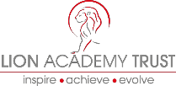

Our Schools

We believe that all children and students have a right to have an excellent education in order to give them the best life chances irrespective of race, colour, creed or circumstance. We have high aspirations for our children, staff and communities. At the heart of our schools, are dedicated staff teams who are committed to being part of schools that enable all staff and students to make outstanding progress.

We believe that obstacles and barriers, both real and perceived, can be overcome by clear, strategic and targeted support that creates culture change based on sharing good and outstanding practice, collegiality, and a relentless pursuit of excellence. This underpins our high expectations and actions and drives all the staff to provide opportunities for our children in order for them to reach the highest possible levels of attainment and achieve exceptionally well in all walks of life.

We believe that outstanding teaching and learning must be central to every decision made and every development introduced.

We are inclusive, caring schools where every child matters to us. We recognise that all children have talents and abilities to celebrate and part of our role is to help children to discover these. We challenge and develop our children to become curious, autonomous learners who are inspired and stimulated through a rich and varied curriculum that is appropriate to individual needs. We develop children’s learning skills and by setting high expectations and exacting standards, we prepare our children to flourish, have high self-esteem and self-belief.

We believe that teacher learning and continued professional development is central to our success. Teachers will be given opportunities and challenged to continuously improve their practice.

Teachers will be supported to:
- Adapt to changing demographics and environments
- Facilitate and lead outstanding learning opportunities and experiences for children
- Become outstanding teachers and learning must be central to every decision made and every development introduced.

As a Trust, we are committed to ensuring that we train, develop and recruit outstanding professionals so that we provide only the best for all our pupils. Through our links with quality tertiary providers we have access to the most up to date research and training that is at the forefront of educational development and transformation. Through effective use of this professional and leadership development we are able to provide learning journeys for aspiring professionals, at all levels, to develop into outstanding practitioners and leaders within our schools.

We continually develop and provide high quality education to our local communities and are becoming a group of strong self-sustainable and self-sufficient schools working and contributing within the Lion Academy Trust.

The Lion Academy Trust believes that access to outstanding education is a right for all our children and young people.
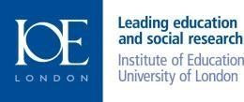
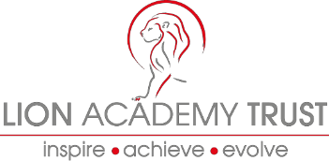



We aim to work closely with our parents, other schools and organisations, building partnerships which benefit not only our children but others in the wider community, on a local, national and global level.

How to apply
To apply please forward:

- A completed Application Form
- Application monitoring form

Candidates who are invited to interview will have a further opportunity to explore the content and context of these responses.

Please send your completed application by email to: recruitment@lionacademytrust.net

Recruitment process
The recruitment process:

We will treat all enquiries, formal and informal in confidence. Potential applicants are welcome to visit the Schools within the Trust.
The closing date for applications is 22nd January 2018 at 12 noon.
A selection of candidates will be invited for interview on 31st January 2018.

Candidates will have the opportunity to spend time with key people involved in our schools.

Alternatively, you can find out more information and download an application pack from
the Lion Academy Trust Website www.lionacademytrust.net

