08 December 2017

Dear Candidate

RE: Permanent, full-time Second in Science
Required for September 2018

Thank you for your recent enquiry in respect of the above vacancy.

Enclosed/attached is an application form and recruitment pack setting out the duties and responsibilities of the post, which I hope you will find helpful. Please note to be considered for this post you must fully complete the application form and Recruitment and Monitoring form and return them to me by noon, Monday 8th January 2018.

In addition write a letter in support of your application which includes a brief description of your educational philosophy and your approach to teaching Chemistry within a 13-18 High School. Your letter should be no more than two sides of A4.

If you require any further clarification or information relating to this post please do not hesitate to contact my P.A., Mrs M Barnes on 01785 337429.

Yours sincerely
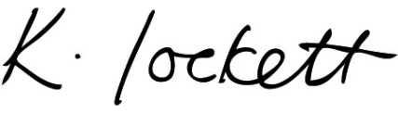

Ms K Lockett
Headteacher

