Deputy Principal / Head of Education
Outcomes and Effective Learning
Recruitment Information Pack
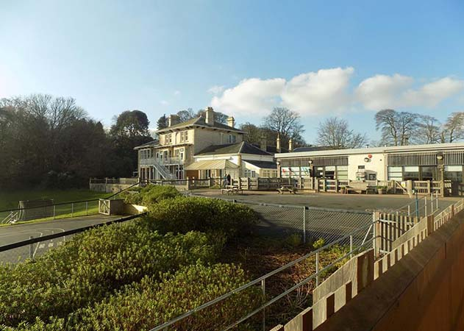
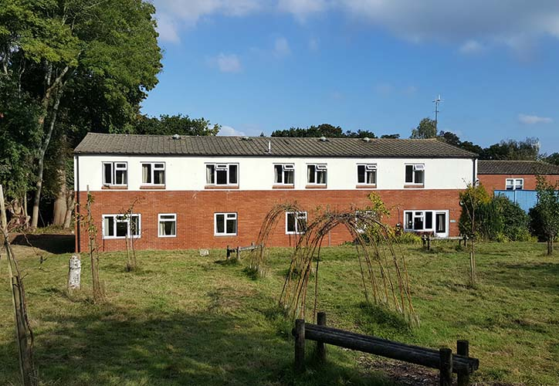

Dawlish Federation of Special Schools

Required for April 2017

Vacancy number: K03376

Required for April 2018

Key Dates

Deputy Principal / Head of Education
Outcomes and Effective Learning
Required from April 2018

Applications close at:
Noon Friday 19th January 2018

Interviews will take place on:
Wednesday 31st January 2018
Thursday 1st February 2018

Visits by prospective candidates are encouraged and very welcome
Visits will take place on:
- Friday 12th January 2018
- Monday 15th January 2018
Please telephone Jayne Davis on 01626 862939 ext. 225 to arrange
email: jdavis@dawlish-ratcliffe.devon.sch.uk

Salary range: L17 – L21
The salary offered within this range will be subject to experience

Location Map and Contact details

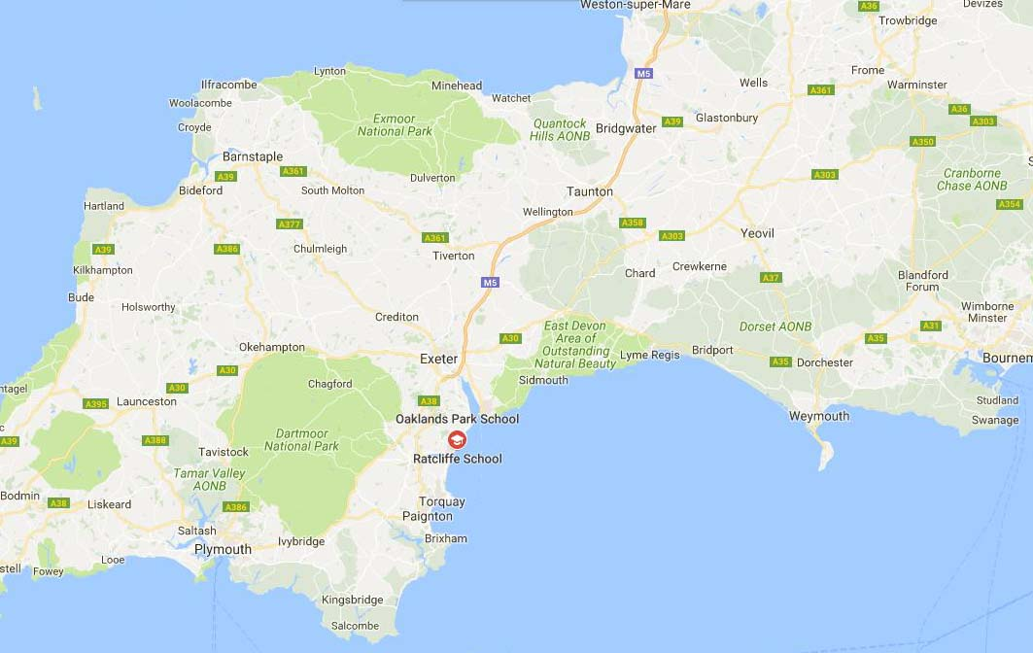

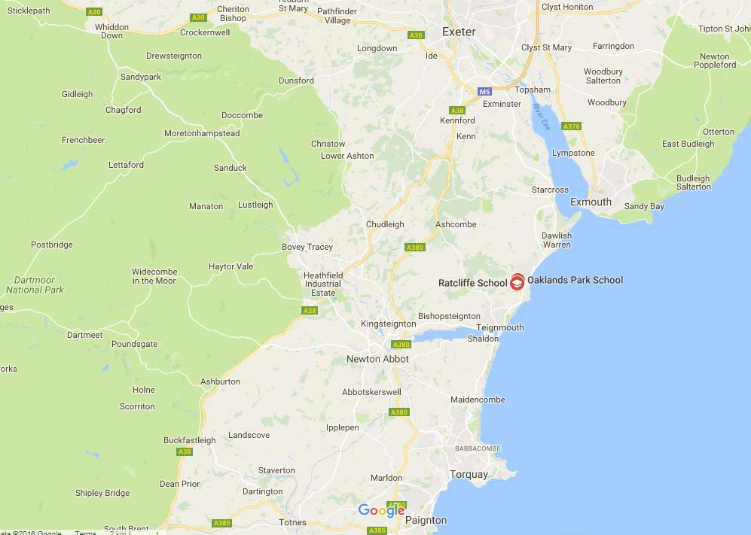



Contact Details:

Dawlish Federation of Special Schools

Ratcliffe School
John Nash Drive
Dawlish
Devon
EX7 9RZ

Tel: 01626 862939

Letter from the Chair of Governors

December 2017

Dear Applicant,

On behalf of the Governors I would like to thank you for your interest in this post. I hope you will find the information pack helpful and proceed with an application.

This is an exciting time for both schools, Oakland’s Park and Ratcliffe, as they merge together to form on new school. It is an opportunity to build together a centre of excellence for 3-19 year old children and young people supporting them and their families.

Our new Deputy Principal/Head of Education, Outcomes and Effective Learning post will be an instrumental part of this new provision bringing strategic vision, commitment and innovative practice to the new school achieving the very best outcome for our pupils.

Within the school community, you will find support from a dedicated Executive Principal, talented staff, enthusiastic pupils and a committed Governing Body well supported by the SENtient Trust and the Local Authority.

As you will have noticed the closing date for this post is midday on Friday 19th January 2018. Shortlisting will take place shortly afterwards with interviews scheduled for Wednesday 31st January and Thursday 1st February 2018.

As part of the application process you are warmly invited to visit the School. Visits will take place on 12th and 15th January 2018. Please telephone Jayne Davis on 01626-862939 ext. 225 to arrange.

I hope that all find all the information you require is within the application pack, however should you need any additional information, please feel free to contact me with any queries.

Yours faithfully,

Keith Hodgins
Chair of Governors
khodgins@oaklandspark.devon.sch.uk

Local Area – Dawlish

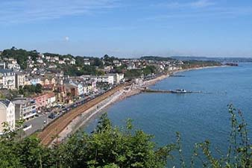
Dawlish is located at the outlet of a small river, Dawlish Water (also called The Brook), between Permian red sandstone cliffs, and is fronted by a sandy beach with the South Devon Railway sea wall and the Riviera Line railway above. Behind this is a central public park, The Lawn, through which Dawlish Water flows. Immediately to the south-west of Dawlish is a headland, Lea Mount, with Boat Cove at its foot and Coryton Cove, the furthest part of the beach accessible by the seawall path, behind it.


To the north-east, via the beach or seawall, the coast can be followed some 2 km to Langstone Rock and the resort of Dawlish Warren. The renowned sand spit at Dawlish Warren is the location of both the golf course and the nature reserve. Dawlish Warren is internationally recognised as an important ecological site. Dawlish is also known for its black swans, which live with other exotic waterfowl in a small urban sanctuary on Dawlish Water.

Local Area – Teignmouth


The town is located on the north bank of the mouth of the estuary of the River Teign, at the junction of the coast road, the road to Newton Abbot, and the road which climbs up the A380 onto Haldon. Teignmouth is linked to Shaldon, the village on the opposite bank, by a passenger ferry at the river mouth and by a road bridge further upstream. The red sandstone headland on the Shaldon side called "The Ness" is the most recognizable symbol of the town from the seaward side. Shaldon is an unspoilt village with a thriving community.


Along with its promenade and Pier, the sea beach wraps around the spit at the head of the river Teign providing a river beach, commonly known as the Back Beach on the estuary side which overlooks the harbour and has views up the estuary to Dartmoor. An 18-mile long way marked route known as the Templer Way has been created between Haytor on Dartmoor and Shaldon.

Local Area – Newton Abbot

A distinctly Victorian railway town, Newton Abbot is located in the heart of South Devon, giving you great access to Dartmoor National Park and the South Devon coast – an Area of Outstanding Natural Beauty. The town holds food and drink festivals, has a popular racecourse and holds Town and Product Markets twice weekly, it also has an indoor pannier market.


Newton Abbot is surrounded by some great parks and outdoor spaces. In the middle of town you’ll find
Victoria Gardens set alongside the river Lemon, and Decoy Country Park, Courtenay Park and Bakers Park can all be found within walking distance of the centre. The Town Quay and wonderful new bridge, form part of a cycle route, and provide a great chance to explore the surrounding area. Within a short drive you’ll find Stover Country Park, and Haldon Forest with spectacular views and woodland exploration with a difference.

About our School


Ratcliffe and Oakland’s Park Schools are situated geographically next door to each other and currently form the Dawlish Federation of Special Schools. They are both Devon foundation schools within the SENtient Trust, a co-operative trust with 10 other special schools across Devon.

The two schools will merge in September 2018 to form one residential special school with a roll of 190. Our new school will provide an all through provision for children and young people aged 3-19 years with a continuum of needs including autistic spectrum conditions, communication and interaction difficulties, learning difficulties and social development needs. All pupils are placed by the Local Authority and have Statement of Educational Need or Education, Health and Care Plans

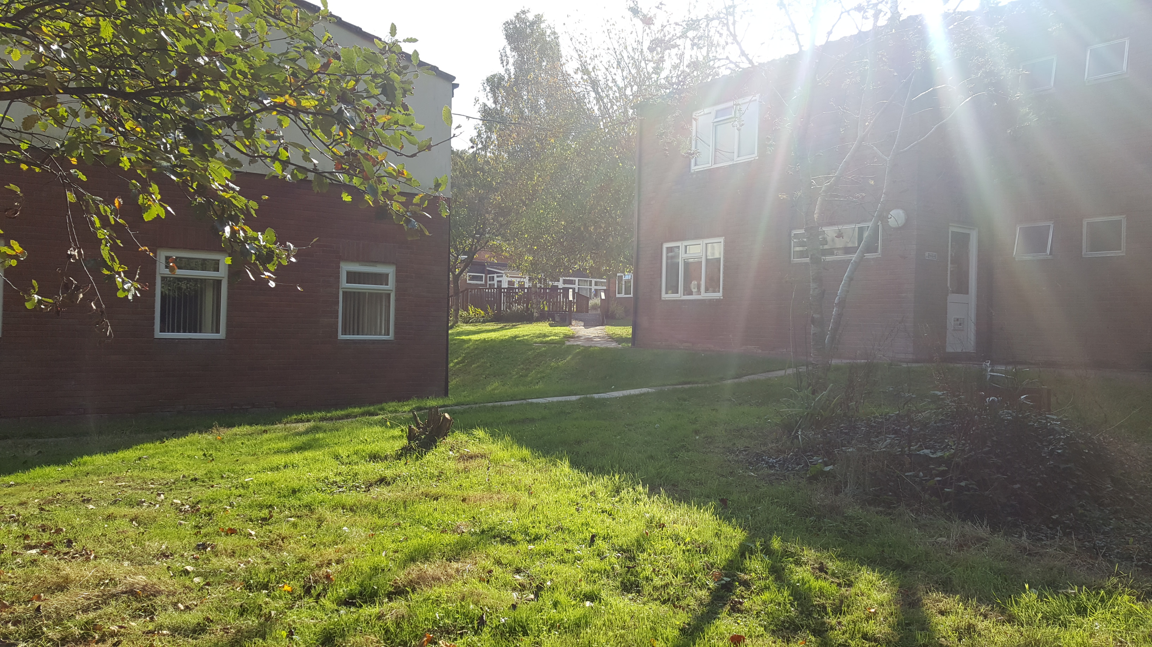
The majority of pupils attend as day pupils however a proportion benefit from weekly residential placements. The whole school provision aims to support their life and social skills development, prepare them for adult life and support them to achieve their full potential.

The new school will enable us to utilise the fabulous grounds that we have across the federation not just recreationally but educationally with dedicated leads for Forest School, Rural Skills and Outdoor Education. This will further build on our commitment to promote the holistic development of our pupils fostering resilient, confident, independent and creative learners.

This appointment will provide the successful applicant the opportunity to work with other highly motivated senior leaders to shape and develop the new residential special school provision. There is the opportunity to maximise the impact of the combined skills, knowledge and expertise of the staff team and the combined resources, building and environment that exists within the current two schools and to sculpt a centre of excellence.

This is an exciting opportunity to work with the Governors, Executive Principal and staff to create a united, single, forward thinking and outward looking residential school that provides the highest quality of education and care to our pupils.

School Aims and Values

We continue to ensure our pupils are at the centre of everything we do and our school mission is
“Everyday we live and learn together”.

The school aims to provide an environment that:
- Keeps pupils happy, safe, cared for and included
- Promotes positive mental health and well-being
- Prepares all pupils for adulthood enabling them to access and make a valuable contribution to the wider community
- Supports children and young people to express themselves and know their views are listened to.
Within school we respect each other showing trust, kindness and courage.
We continue to build on the curriculum provision to ensure all individual needs are met and there is access to appropriate subjects or programmes.
For our school, the holistic development of all pupils is of paramount importance.
We celebrate all achievements – from gaining small steps of independence, to high level national accreditation.

Ofsted Reports
 | Oaklands Park School  https://reports.ofsted.gov.uk/inspection-reports/find-inspection-report/provider/ELS/113642  Ratcliffe School  https://reports.ofsted.gov.uk/inspection-reports/find-inspection-report/provider/CARE/SC003895

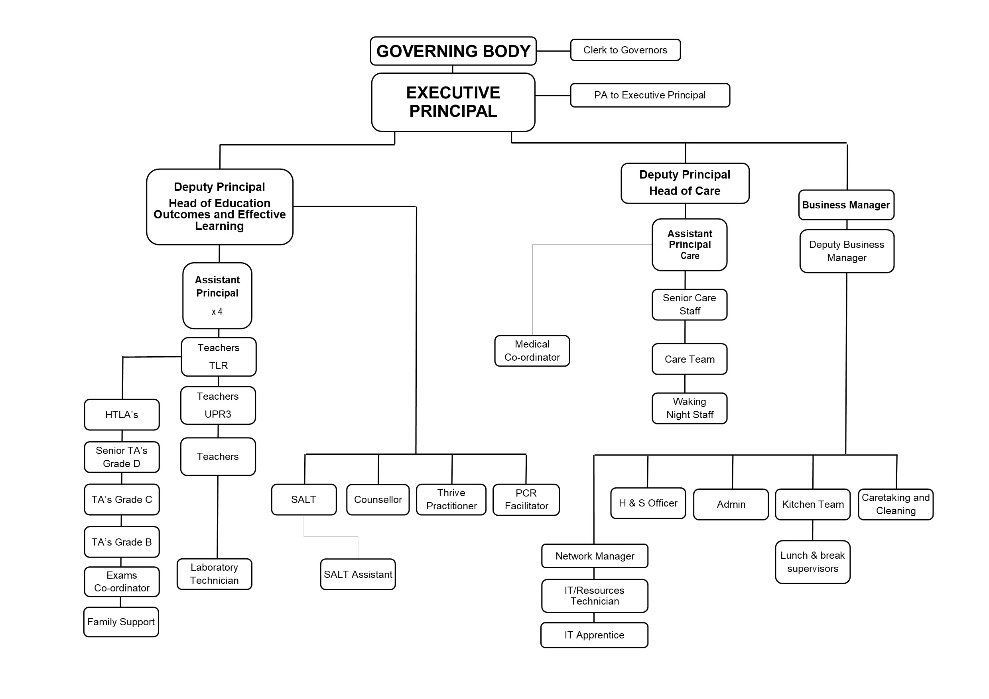
Staff Structure Chart

Governors

Mark Rose - Executive Principal | Keith Hodgins (Chair of Governors)
Vicky Eul-Barker | Richard Ensor
Matt Williams | Helen Stone
Terry Lowther | Stephanie Smith
Pat Henchie | Mary May
Sarah Mascall | Reg Lake

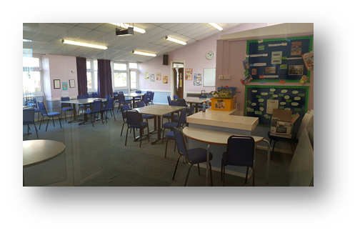

Job Title | Deputy Principal  (Head of Education Outcomes and Effective Learning)
Location | School
Reporting to | Executive Principal
Effective date of JD
Salary range | L17 - L21

School Purpose
The purpose of the School is to meet the holistic communication and interaction, social, emotional and educational needs of young people who have statements / EHCP’s

Job Purpose including main duties and responsibilities:
In addition to the Conditions of Employment for Deputy Head teachers to:
- provide the leadership and management which enables the School to give every pupil high quality education and care which promotes the highest possible standards of achievement progress and personal development.
- secure the long-term success of the School
- undertake, to the extent required by the Executive Principal or Governing Body, the professional duties of the Executive Principal in the event of his absence

Under the direction and support of the Executive Principal, to be responsible for:
- Playing a significant role alongside the Executive Principal and Senior Leadership Team in the planning of the future strategic direction of the whole school.
- Taking a lead role in incorporating and unifying all agreed whole school strategies, developments, systems, protocols, policies and procedures to ensure efficient and effective working practises.
- Working as a cohesive member of the school staff team, including becoming a pro-active, solution focussed,
- Positive thinking member of the School’s Senior Leadership Team.
- Inspirational leadership and proactive positive management; encourage, motivate, support and value all staff promoting high quality team working, co-operation, trust and professionalism.
- Supporting the strategic transformation of the school in its entirety (all school facilities / sites)
- Overseeing the day-to-day organisation, management and conduct of this educational provision in accordance with school Policy and procedures, the current School Teachers’ Pay and Conditions Document and any applicable associated guidance and/or legislation.

Key Accountabilities (in partnership with the Executive Principal:
- Creating the Future of the School
- Working under the direction of the Executive Principal to ensure the long term success of the school
- Contribute to, and communicate, the schools vision which expresses core values and purpose
- Implement the vision through agreed objectives and operational plans and notably the whole School Development Plan priorities
- Through collaboration, innovation and research develop school practice and procedures
- Motivate others to create a shared learning culture and positive climate
- Effectively collaborate with a range of professional partner schools and agencies to realise the schools vision
- Assist the Executive Principal with recruitment as required

- Leading Teaching and Learning in the School to:
- Ensure a continuous and consistent School-wide focus on pupils’ achievement progress and development
- Ensure creative, responsive and effective approaches to learning and teaching that meet the needs of all pupils
- Ensure that high expectations and aspirational targets are maintained for the whole school community
- Oversee the monitoring, evaluation and review of pupils’ achievement progress and development to ensure on-going school improvement and appropriate reporting to stakeholders
- Tackle under-performance at all levels of pupils and staff
- Ensure the efficient and effective utilisation of all available resources

- Working with the Executive Principal to Develop Self and Others:
- Maintaining effective strategies and procedures for, staff induction, professional development and performance review.
- Promote and maintain a culture of high expectations for self and others
- Lead on developing a culture of self-evaluation that promotes professional and personal development
- Ensure the deployment of all staff is efficient and effective with maximum impact for teams, individuals and pupils, including teacher cover on a daily basis
- Regularly review own practice, set personal targets and take responsibility for own professional development
- Act as a lead coach / mentor where need dictates
- Responsible for work placement and NQT programs

- Managing the Organisation
- Ensure the smooth day-to-day running of the School and report directly to the Executive Principal
- Responsible for the consideration of consultations for pupils placement and response / negotiation with the LA
- Report to Governors when required
- In consultation with the Executive Head, recruit and retain staff. Oversee the effective deployment of staff within the school to maximise impact.
- Inputting to key strategic whole school documents, including: formal school self-evaluation, school development plan, policies & procedures and statutory web site published data.
- To provide information to the Executive Principal, both written and verbally on the progress made towards achieving the aims and objectives set for the School and progress towards meeting specific targets set
- Line manage the Assistant Principals and oversee the implementation of the performance management/appraisal policy
- Ensure that any allegations, conduct, capability issues about any member of the school community is reported immediately to the Executive Principal for a decision on how to proceed
- To secure the acquisition of additional funding to support the school
- Producing and implementing the schools timetables
- Leading on high profile, consistent, high quality behaviour management. Setting and operating firm but fair consistent boundaries with all students (& staff) at all times. Leading / managing the staff team to do the same.
- Support school improvement ensuring all Ofsted outcomes have been met and reaching good or better standards
- Promote staff and student pride and ‘ownership’ of the whole school, including all physical resources (grounds, buildings, equipment, furniture, vehicles etc.)

- Securing Accountability
- Contribute to, and articulate the School ethos, which enables everyone to work collaboratively
- Ensure individual staff accountabilities are clearly defined, understood and agreed within the School
- Ensure every individual child has access to high quality teaching and learning and development opportunities
- Secure evidence from self-evaluation opportunities to inform school improvement
- Monitor, evaluate and provide timely evidential reports to the Executive Principal on the schools work as requested
- Represent and deputies for the Executive Principal as required to include Governors meetings and Strategic meetings within the wider School community
- Tackle under-performance at all levels

- Strengthening Community
- Promote positive strategies for challenging all discrimination
- Ensure and promote a range of community-based learning experiences
- Collaborate with other agencies to ensure pupil and community needs are met
- Ensure all complaints are appropriately investigated, managed and reported to the Executive Principal
- Engage in effective school to school support and challenge to improve the quality of educational provision across the SENtient trust and wider school community
- Lead on the promotion and maintenance of positive high quality relationships with all stakeholders and communities at all times.

The post holder will be expected to:
- hold a full driving license and be prepared to drive school vehicles and use own car on school business if required
- work flexible hours by prior agreement if / as required.
- undertake any other reasonable duties as directed by the Executive Principal.

The Deputy Principal/ Head of Education Outcomes and Effective Learning is not delegated to carry out the following actions and must refer any potential issues to the Executive Principal for discussion, action or delegated authority to carry these out each time.

- To suspend a member of staff
- To exclude a pupil, either fixed term or permanently
- To undertake threshold assessment
- To set school budgets
- To vire money between allocated budgets
- To appoint staff
- To agree and sign salary amendments for staff
- To sign or amend contracts or offer posts within the school
- To approve overtime

Person specification:

Attribute | Essential | Desirable | Method of Assessment
Education & Qualifications | QTS | Further leadership qualification i.e. leading from the middle, NPQH | - Application
Education & Qualifications | Willingness to undertake further leadership CPD |  | - Application
Leadership | Leadership and management skills to improve the School’s level of attainment and success | Experience of challenging and managing under performance in school staff | - Application  - References  - Interview  - Observation
Leadership | Outstanding classroom practitioner who can lead by example | Experience of Acting Headship | - Application  - References  - Interview  - Observation
Leadership | Ability to motivate pupils and staff | Experience of Acting Headship | - Application  - References  - Interview  - Observation
Leadership | Ability to motivate pupils and staff | NCTL designation SLE, LLE | - Application  - References  - Interview  - Observation
Leadership | Demonstrated ability to lead, coordinate and delegate | NCTL designation SLE, LLE | - Application  - References  - Interview  - Observation
Leadership | Ability to manage change and work under pressure of changing circumstances |  | - Application  - References  - Interview  - Observation
Leadership | Leading change, creativity and innovation |  | - Application  - References  - Interview  - Observation
Leadership | Experience of managing personnel |  | - Application  - References  - Interview  - Observation
Leadership | Experience of whole school leadership with positive outcomes |  | - Application  - References  - Interview  - Observation
Experience | Experience of whole school senior leadership with positive outcomes | Experience of leading within an SEN provision  Experience of leading from  Early Years too Post 16  Experience of leading Literacy or Numeracy  Experience of positive behaviour management and impact | - Application  - Interview  - References
Experience | Experience of leading the management of challenging / disaffected behaviour |  | - Application  - Interview  - References
Practical Skills | Excellent organisational skills |  | - Application  - Interview  - References
Practical Skills | Excellent time management skills |  | - Application  - Interview  - References
Practical Skills | Ability to distribute leadership and delegate effectively |  | - Application  - Interview  - References
Practical Skills | Excellent abilities to work collaboratively with other school leaders |  | - Application  - Interview  - References
Communication | Ability to liaise effectively with parents and local community | Experience of working in a range of SEN school settings | - Application  - References  - Interview
Communication | Excellent written, verbal, presentation and listening skills | Experience of working in a range of SEN school settings | - Application  - References  - Interview
Communication | Ability to communicate effectively under pressure | Experience of working in a range of SEN school settings | - Application  - References  - Interview
Communication | Ability to build and maintain positive relationships with all stakeholders | Experience of working in a range of SEN school settings | - Application  - References  - Interview
Personal Qualities | Integrity |  | - References  - Interview  - Observation
Personal Qualities | Fairness |  | - References  - Interview  - Observation
Personal Qualities | Optimistic, constructive and solution focused |  | - References  - Interview  - Observation
Personal Qualities | Ability to motivate others |  | - References  - Interview  - Observation
Personal Qualities | Ability to mediate |  | - References  - Interview  - Observation
Personal Qualities | Ability to inspire confidence in the parent community |  | - References  - Interview  - Observation
Personal Qualities | Excellent communicator and motivator of people |  | - References  - Interview  - Observation
Strategic Thinking | Knowing how to use school evaluation and performance data to support, monitor and challenge school improvement | Evidence of ways to build, communicate and implement a shared vision | - Application  - Interview  - References
Strategic Thinking | Ability to contribute to, and maintain a clear vision for the School and to lead others to plan and deliver it |  | - Application  - Interview  - References
Technology / IT Skills | An understanding of technologies and their impact on learning | Experience of leading technological development | - Application  - Interview
Equal Opportunities | Excellent understanding of safeguarding roles and procedures | Experience of managing legal issues relating to managing a school, including equal opportunities, race relations, disability, human rights and employment legislation  Experience of being a senior designated officer for safeguarding with level 3 training | - Application  - Interview  - References
Equal Opportunities | Experience in effective management of children with significant inclusion needs |  | - Application  - Interview  - References
Equal Opportunities | Experience in effective management of children with significant inclusion needs  Excellent understanding of children exhibiting behavioural difficulty and how to support them to achieve |  | - Application  - Interview  - References
Equal Opportunities | Understanding of equality issues, their impact and how to manage discrimination effectively |  | - Application  - Interview  - References

Person specification:

Attribute | Essential | Desirable | Method of Assessment
Education & Qualifications | QTS | Further leadership qualification i.e. leading from the middle, NPQH | - Application
Education & Qualifications | Willingness to undertake further leadership CPD |  | - Application
Leadership | Leadership and management skills to improve the School’s level of attainment and success | Experience of challenging and managing under performance in school staff | - Application  - References  - Interview  - Observation
Leadership | Outstanding classroom practitioner who can lead by example | Experience of Acting Headship | - Application  - References  - Interview  - Observation
Leadership | Ability to motivate pupils and staff | Experience of Acting Headship | - Application  - References  - Interview  - Observation
Leadership | Ability to motivate pupils and staff | NCTL designation SLE, LLE | - Application  - References  - Interview  - Observation
Leadership | Demonstrated ability to lead, coordinate and delegate | NCTL designation SLE, LLE | - Application  - References  - Interview  - Observation
Leadership | Ability to manage change and work under pressure of changing circumstances |  | - Application  - References  - Interview  - Observation
Leadership | Leading change, creativity and innovation |  | - Application  - References  - Interview  - Observation
Leadership | Experience of managing personnel |  | - Application  - References  - Interview  - Observation
Leadership | Experience of whole school leadership with positive outcomes |  | - Application  - References  - Interview  - Observation
Experience | Experience of whole school senior leadership with positive outcomes | Experience of leading within an SEN provision  Experience of leading from  Early Years too Post 16  Experience of leading Literacy or Numeracy  Experience of positive behaviour management and impact | - Application  - Interview  - References
Experience | Experience of leading the management of challenging / disaffected behaviour |  | - Application  - Interview  - References
Practical Skills | Excellent organisational skills |  | - Application  - Interview  - References
Practical Skills | Excellent time management skills |  | - Application  - Interview  - References
Practical Skills | Ability to distribute leadership and delegate effectively |  | - Application  - Interview  - References
Practical Skills | Excellent abilities to work collaboratively with other school leaders |  | - Application  - Interview  - References
Communication | Ability to liaise effectively with parents and local community | Experience of working in a range of SEN school settings | - Application  - References  - Interview
Communication | Excellent written, verbal, presentation and listening skills | Experience of working in a range of SEN school settings | - Application  - References  - Interview
Communication | Ability to communicate effectively under pressure | Experience of working in a range of SEN school settings | - Application  - References  - Interview
Communication | Ability to build and maintain positive relationships with all stakeholders | Experience of working in a range of SEN school settings | - Application  - References  - Interview
Personal Qualities | Integrity |  | - References  - Interview  - Observation
Personal Qualities | Fairness |  | - References  - Interview  - Observation
Personal Qualities | Optimistic, constructive and solution focused |  | - References  - Interview  - Observation
Personal Qualities | Ability to motivate others |  | - References  - Interview  - Observation
Personal Qualities | Ability to mediate |  | - References  - Interview  - Observation
Personal Qualities | Ability to inspire confidence in the parent community |  | - References  - Interview  - Observation
Personal Qualities | Excellent communicator and motivator of people |  | - References  - Interview  - Observation
Strategic Thinking | Knowing how to use school evaluation and performance data to support, monitor and challenge school improvement | Evidence of ways to build, communicate and implement a shared vision | - Application  - Interview  - References
Strategic Thinking | Ability to contribute to, and maintain a clear vision for the School and to lead others to plan and deliver it |  | - Application  - Interview  - References
Technology / IT Skills | An understanding of technologies and their impact on learning | Experience of leading technological development | - Application  - Interview
Equal Opportunities | Excellent understanding of safeguarding roles and procedures | Experience of managing legal issues relating to managing a school, including equal opportunities, race relations, disability, human rights and employment legislation  Experience of being a senior designated officer for safeguarding with level 3 training | - Application  - Interview  - References
Equal Opportunities | Experience in effective management of children with significant inclusion needs |  | - Application  - Interview  - References
Equal Opportunities | Experience in effective management of children with significant inclusion needs  Excellent understanding of children exhibiting behavioural difficulty and how to support them to achieve |  | - Application  - Interview  - References
Equal Opportunities | Understanding of equality issues, their impact and how to manage discrimination effectively |  | - Application  - Interview  - References

How to Apply

Your application form must be completed in full.

An incomplete application form may be returned for completion before it can be considered. You must give details of all employment, training and unemployment since leaving secondary education to the present day. Any additional information which you wish to bring to the notice of the School Governors should be included in your supporting statement.

References must cover the previous five years of employment. If there has been a gap in employment, then a personal reference covering this period from someone who can comment on your ability to do the job is acceptable.

As well as postal addresses for your referees please provide correct email addresses for us to contact them.

Please inform your referees when you apply that they may be contacted. References are normally requested immediately following short listing by email and sometimes with only a few days’ notice.

If you have any queries regarding completion of the application form, please contact the Jayne Davis.

You may submit your application, diversity form and any declaration forms either by email, by post or in person.

Application sent by email

Your application should be sent to jdavis@dawlish-ratcliffe.devon.sch.uk

Application by post

Ratcliffe School
John Nash Drive
Dawlish
Devon
EX7 9RZ

Postal applications should arrive at least one working day before the closing date, please ring 01626 862939 to check it has arrived safely. You can also deliver your application in person to reception at the above address during normal office hours (8.30am – 4.00 pm, Monday – Friday).

All applications will be acknowledged by email.

All applicants will be notified of the outcome of their application.

Further Guidance for Applicants

Short listing and interview procedure

Applicants selected for interview will be contacted as soon as possible after the shortlisting meeting. If their application has been sent by email, applicants will be required to sign their application on arrival at interview.

Only applicants meeting the essential criteria of the person specification will be short listed.

1. References must be received before the interview. As well as being asked about your suitability for the post, relating to the person specification, the reference pro-forma will ask:

• for comment on your performance history and conduct, including performance management issues, disciplinary investigations and any proven disciplinary offences, whether time expired or not;
• for any specific concerns that the referees might have or be aware of in regard to your suitability to work with children.

2. Any discrepancies or anomalies in the information provided or issues arising from references will be taken up with candidates at interview.

3. There will be a panel of interviewers consisting of School Governors supported by a School Improvement Lead Adviser and the Executive Principal.

4. Candidates will be questioned about safeguarding children.

Interview Expenses

Applicants invited to interview will be provided with a form on which to reclaim essential travelling and subsistence expenses in accordance with the County scale. Expenses will not be allowed to any candidate withdrawing, or refusing the post for reasons considered to be inadequate, and they will not be paid to the successful candidate until after the appointment has been taken up. There is no scheme in operation for the reimbursement of legal, removal or any other expenses connected with the change of home by the successful candidate.

Safeguarding Children

This post is one the Authority has deemed to involve substantial access to children and the governors will require a satisfactory enhanced DBS disclosure for the successful candidate before the appointment is confirmed. Applicants are advised that they should disclose at the time of application, on the declaration form enclosed with the application form, the details of any convictions, cautions, bind‐overs, outstanding cases, disqualification from working with children or inclusion on the DCSF list 99 and any allegations concerning behaviour towards children, whether or not the allegations were investigated, Any declarations will be treated in confidence and only seen by the Chair of Governors and the School Improvement Lead Adviser who, if necessary, will seek advice from HR support.

Terms and Conditions

The following terms and conditions apply to this appointment:
• The receipt of at least two satisfactory references
• Verification of identity
• Verification of qualifications
• Verification of professional status
• A satisfactory enhanced DBS disclosure
• Verification of medical fitness

