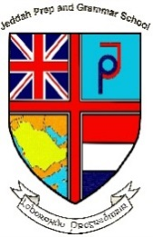
Jeddah Prep and Grammar School
The International British / Dutch School
Member of
BSME
SAIKAC
COBIS
CIE

Exciting International Teaching Vacancies
Apply Now

We invite applications from excellent Teachers for both our Prep and Grammar School here in Jeddah, KSA.
Applicants must hold an appropriate degree, teaching qualification and be a British passport holder. Experienced and NQT’s may apply.
The school is a long established British school serving the British expatriate community, Saudi Arabian families and other nationalities, practising the New National Curriculum, IGCSE, AS and A levels.
We offer a highly competitive tax free salary & benefits
- Bupa Gold Medical Insurance
- End of Service Benefits
- Fully furnished accommodation
- Paid utilities, freight allowance
- Annual flight allowance
- Free child places for 2 children
- Excellent career opportunities
To apply send your CV, photo must be included and a letter of application to: hr@jpgs.org
Closing date: 6th January 2018
Face to Face Interviews will be held in Manchester on 12th 13th & 14th January 2018
Skype interviews can be arranged.

School E-mail: hr@jpgs.org
School Website: www.jpgs.org

