
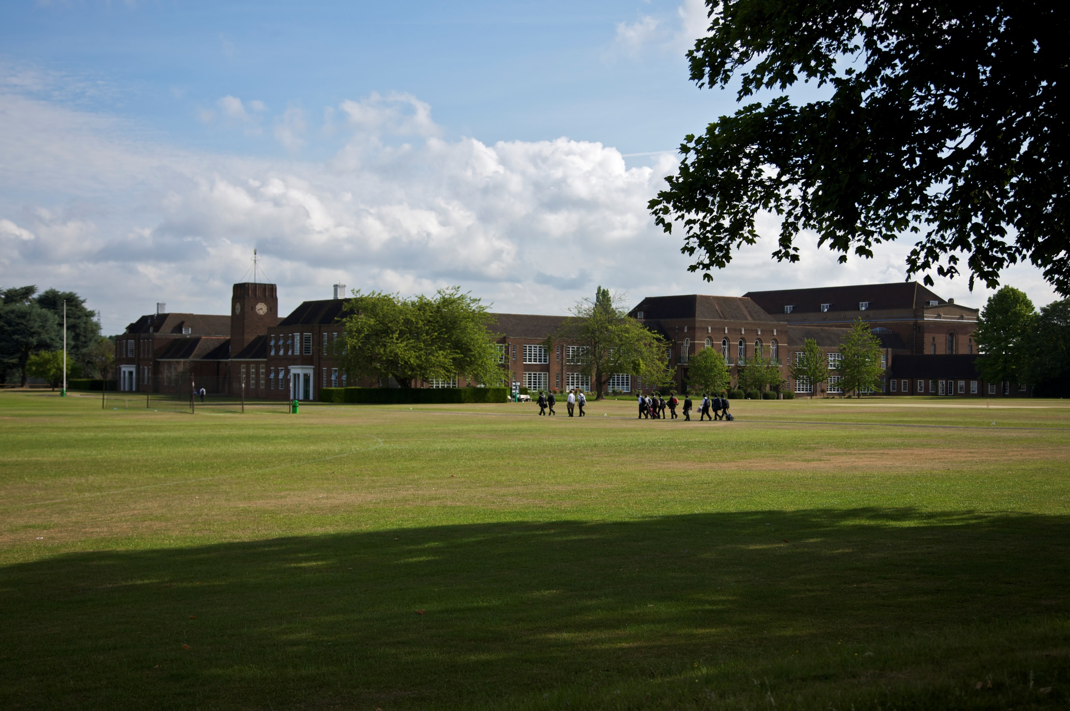
Excellence, integrity, and distinction since 1561
Teacher of Design & Technology
For boys 3-18
Information for candidates
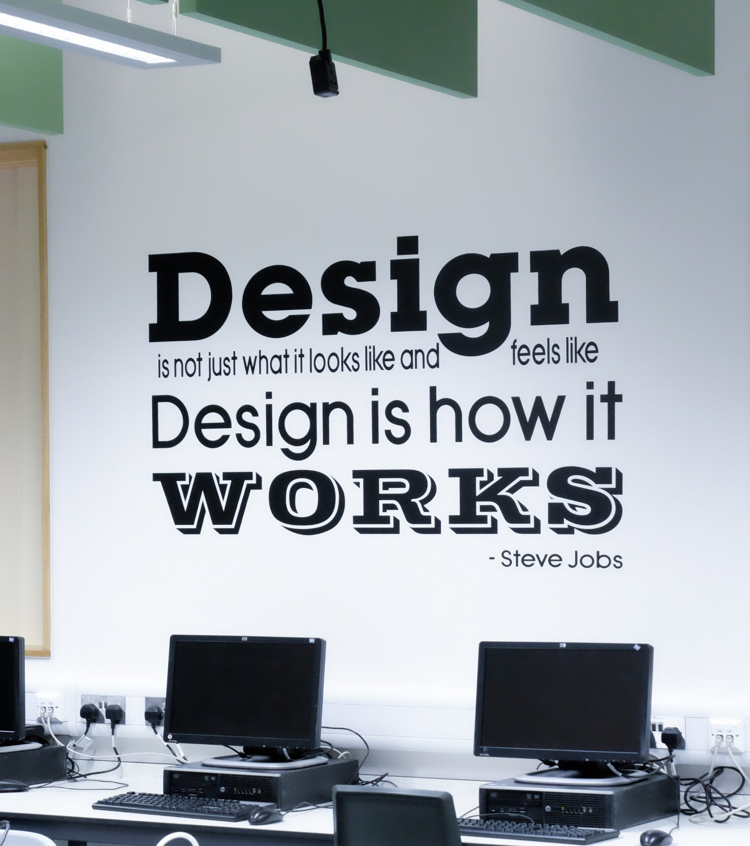

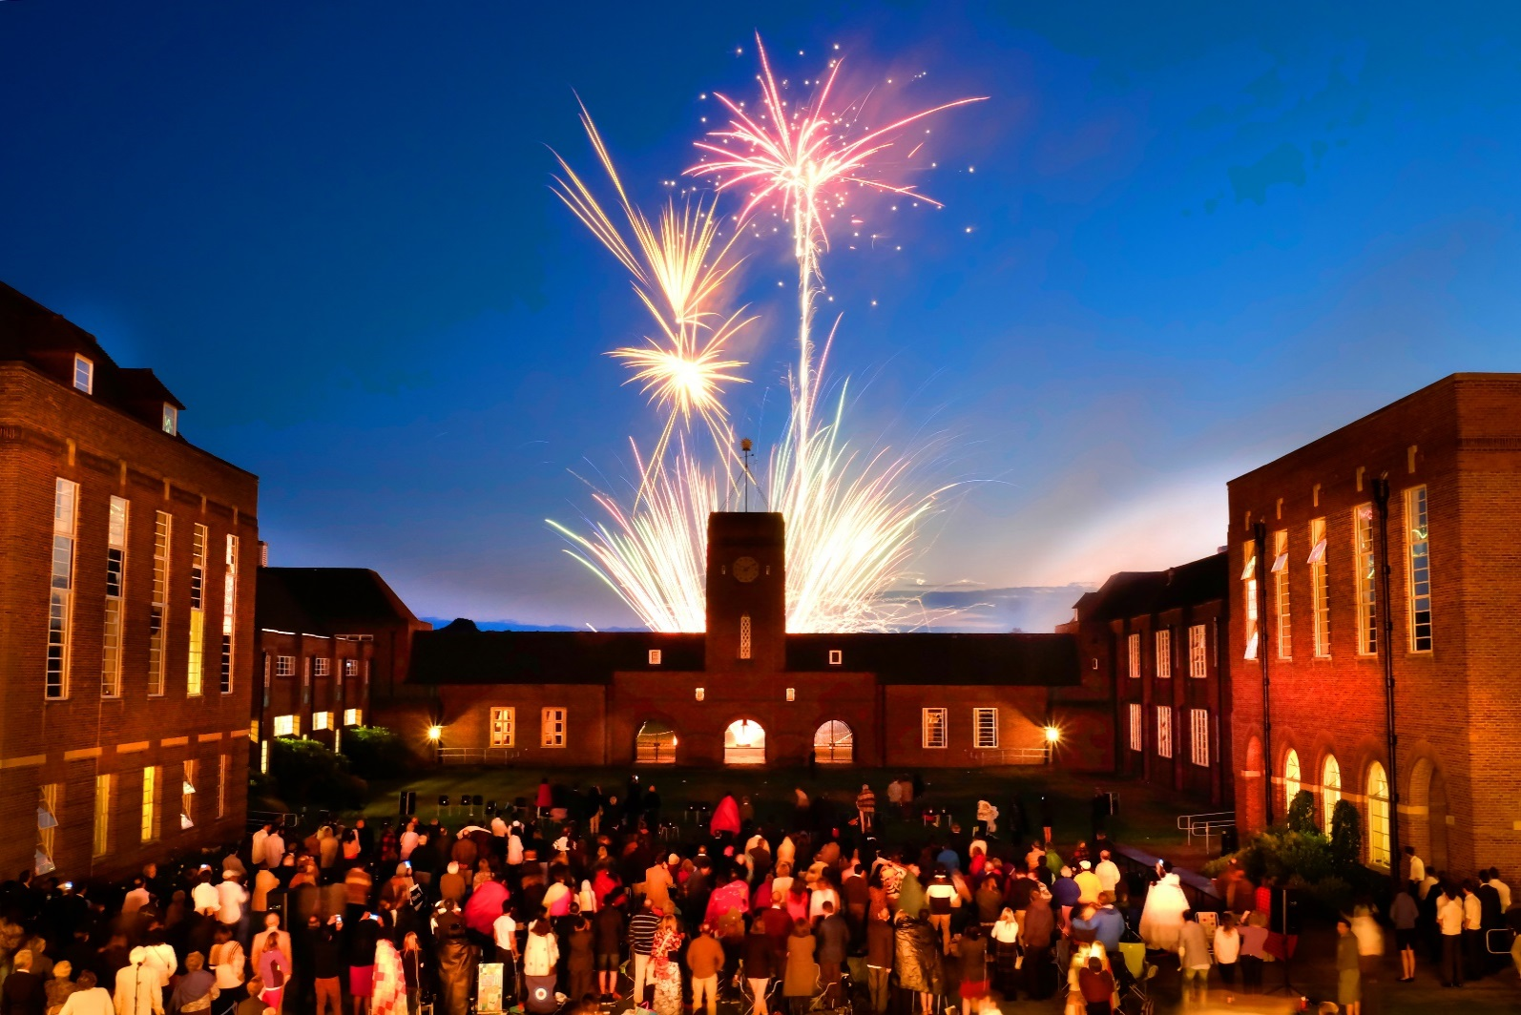
The School
Contents
03 The School
05 The Person
06 The Department
08 The Position
11 The Benefits
13 The Process

Merchant Taylors’ School has been one of the top ten boys’ schools in the UK since its foundation by the Merchant Taylors’ Company, one of the twelve Great Livery Companies of the City of London, in Suffolk Lane in 1561. One of the nine original ‘Clarendon schools’, its alumni have achieved distinction throughout history. However, the school wears its heritage lightly, its strong sense of tradition very much at the service of the future. Through the Merchant Taylors’ Educational Trust, it retains close links with other Merchant Taylors’ schools, and with the Merchant Taylors’ Company itself.

Relocated from the City to Sandy Lodge, Northwood in 1933, the school occupies a superb setting: 286 acres of lakes, playing fields, and woodland, all within easy reach of central London, Middlesex, Buckinghamshire, and Hertfordshire.

There are four distinct boys’ day schools on campus. The Nursery, the Pre-Prep & the Prep cater for 340 boys from 3 to 13 years of age, while the Senior School has some 890 pupils from 11 – 18, with over 300 in the Sixth Form (The Prep School shares some of its facilities with the Senior School, but is a separate school in its own right).

Competition for places is fierce, and entry is by competitive examination at 11+, 13+, and 16+.

Public examination results are outstanding, the majority of students proceeding either to Oxbridge or other leading universities and medical schools in the UK or abroad.

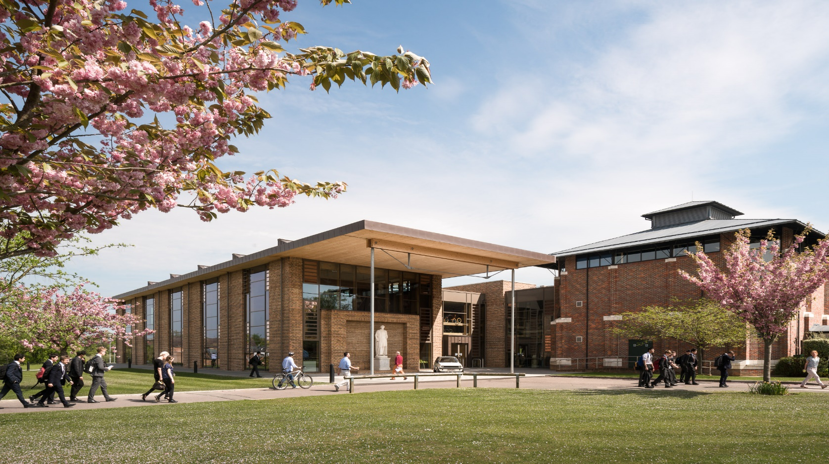

We pride ourselves on our outstanding pastoral care as well as our excellent academic results, and aspiration in all areas goes well beyond the norm, making Taylors’ a particularly exciting and rewarding place to teach.

Merchant Taylors’ is an exciting, rewarding environment in which to teach and work. For those with talent, ambition, and commitment, Merchant Taylors’ provides the means for the development of a successful career in a place with a real sense of community.

The Design Centre

The 2014 Inspection Report accorded the school the highest accolade of “exceptional”, finding that pupil achievement and learning are exceptional, and the teaching, curricular and co-curricular provision are all excellent:

“Pupils are receptive, alert, highly articulate and well-motivated… friendly, happy and self-reflective… highly articulate… logical and independent thinkers… and show high levels of creativity”.
The Design Center

Probably the best way to get a taste of life at Taylors’ is to read our weekly magazine Scissorum, which is available on the school’s website www.mtsn.org.uk/scissorum

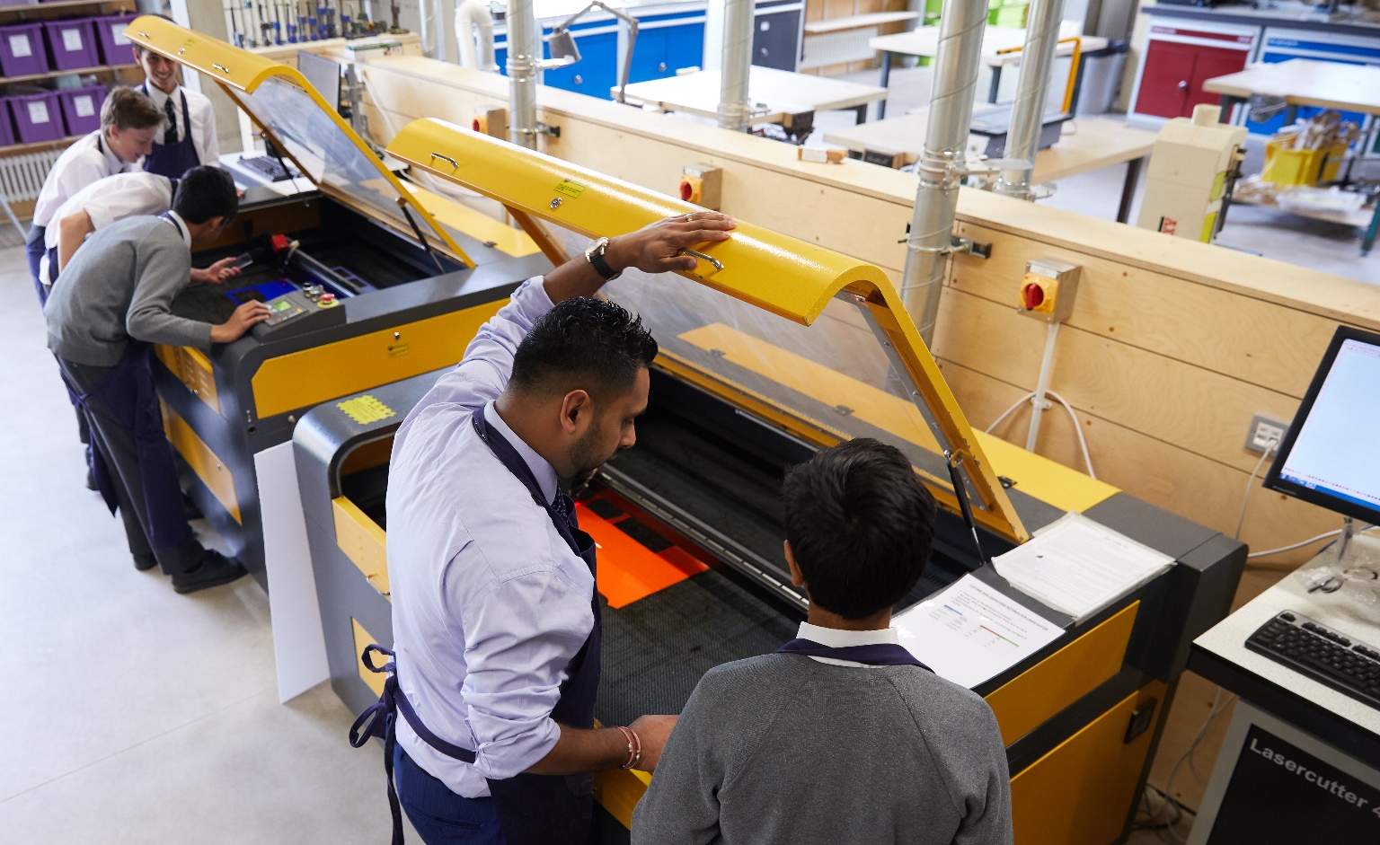
The Person
CAM workshop

In addition to having excellent subject knowledge, the successful applicant should be dynamic, enthusiastic and passionate about Design and Technology. We are looking for either an established teacher seeking a move to a centre of excellence or an NQT with a relevant design or engineering degree. Experience of traditional workshop skills and CAD/CAM are essential while knowledge of other areas within the subject, such as electronics, graphics etc. would be very beneficial.

You will teach KS3, KS4 and A level. The successful candidate should have the ability to inspire students and at the same time be approachable, compassionate, and caring. Good communication and the ability to work within a team will be essential. The department prides itself on engendering innovative design thinking and quality outcomes, and also providing a range of extra-curricular activities within the department. Motorsports, 4x4 in schools and Rampaging Chariots are just some of our activities. The successful candidate would be expected to contribute in their own way to the extra-curricular programme. We wish to find someone who is willing to show a high level of commitment, has a desire to share ideas and make a contribution towards the ongoing vision of the department.

Besides this, the school embraces the most diverse range of teaching styles and personalities, deeply believing that boys benefit from exposure to such diversity.

There is a strong Common Room culture of 'going the extra mile' to stretch and support, in and beyond the classroom, so that every boy realises his potential.
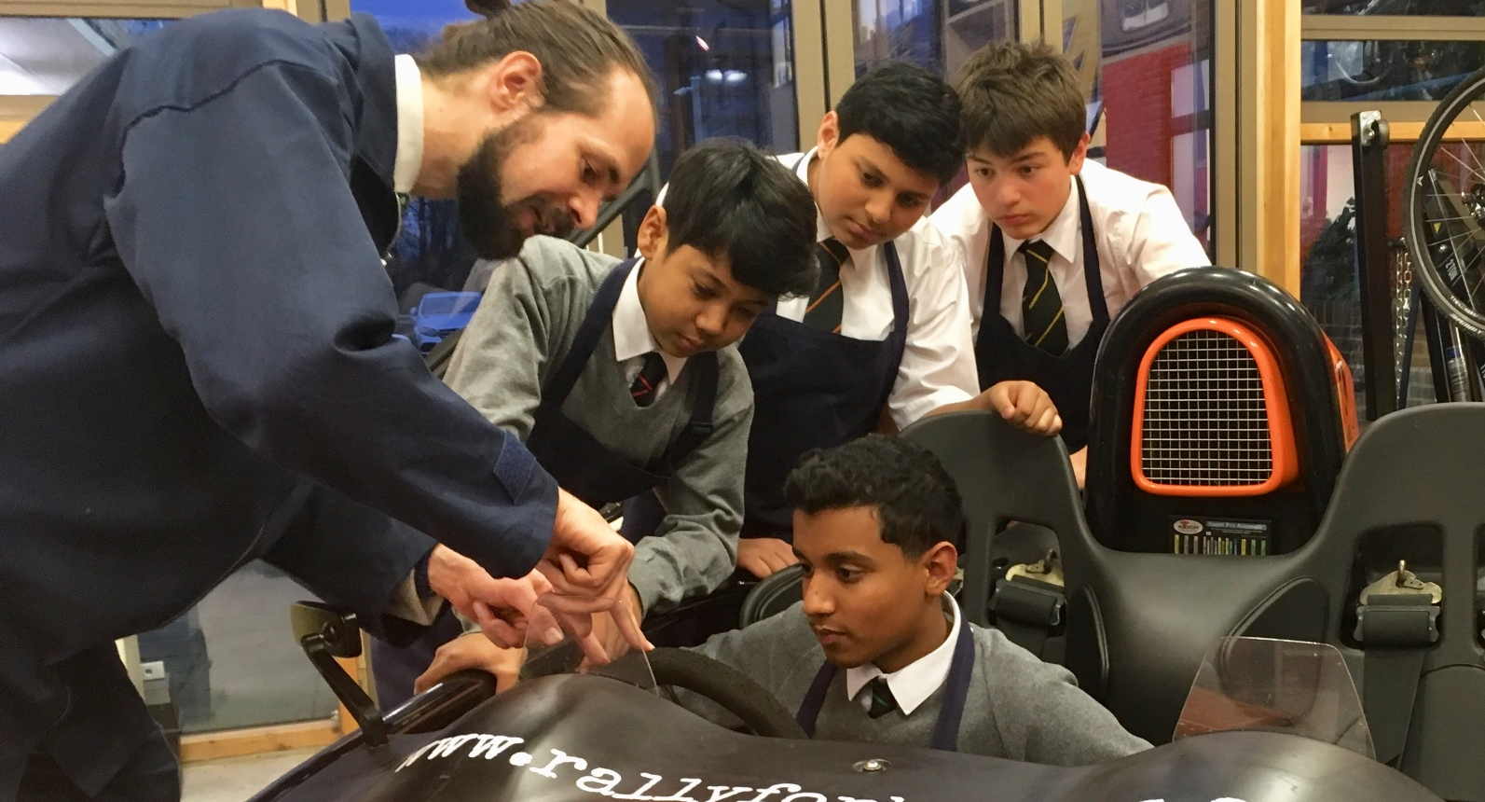

Enthusiasm and ability are as important for this post as experience.

The school is proud of its reputation as a caring and friendly community with a high achieving culture across a broad range of
Dudley Cox CAD/CAM Hub
Extension class with Arial Atom
curricular and co-curricular activities. You will engage fully in the life of the school, forge happy, productive working relationships across our friendly and welcoming Common Room and be sensitive as to where support is needed.

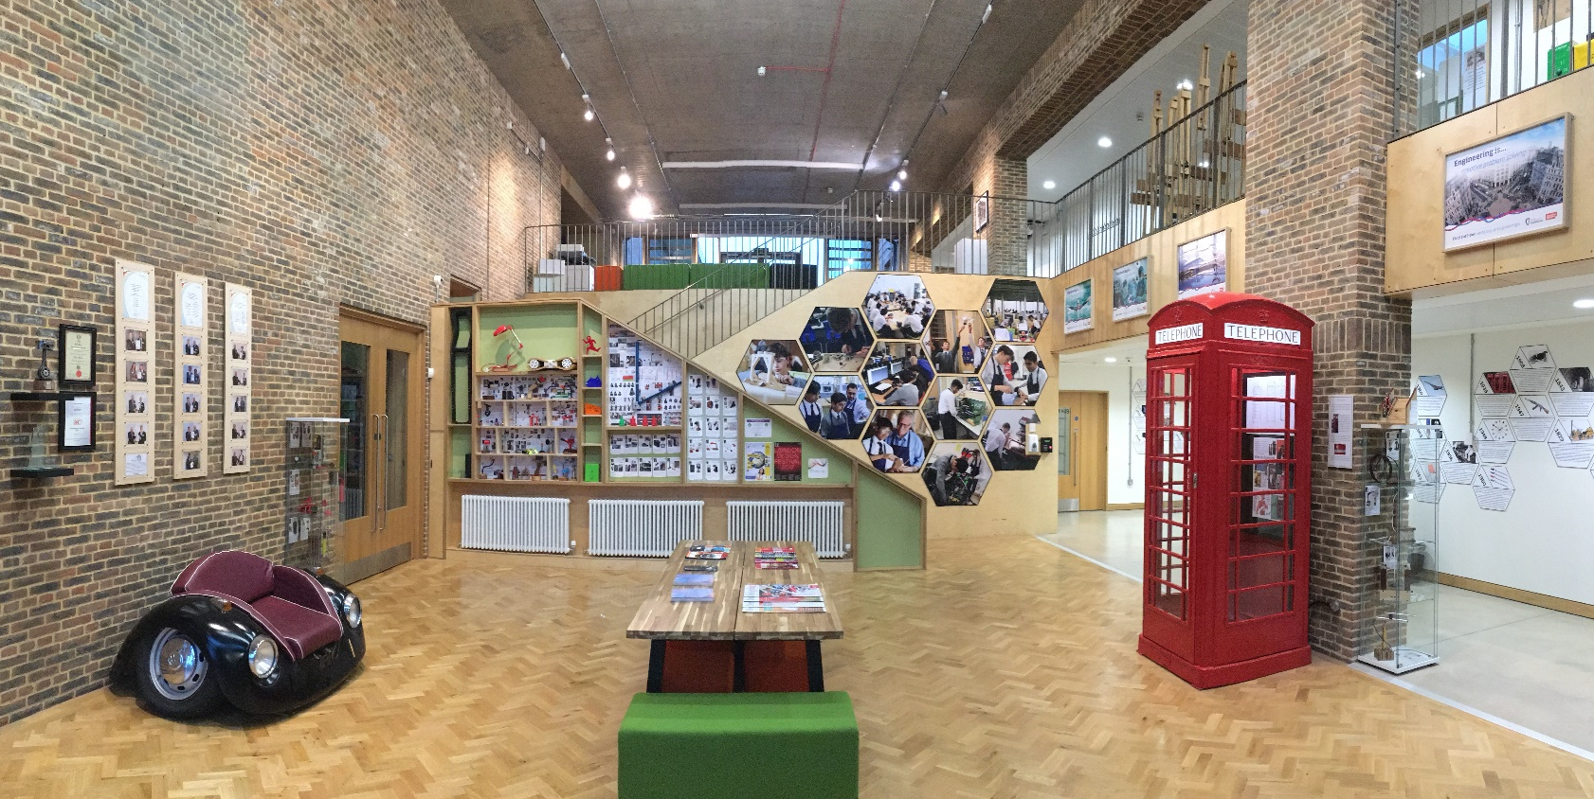
Design Centre entrance

The Department

The department is housed in the purpose built Design Centre opened in September 2015. There are four extremely well equipped workshops, a CAM workshop with laser cutters, a CNC router and a CNC lathe. Adjoined to this is a CAD/CAM hub with full computer suite, nine 3D printers and another laser cutter. Other student workspaces include a dedicated spray room, a hot metal workshop for brazing, forging, welding and CNC plasma cutting, as well as an on-going projects workshop, which is used to enhance our extra-curricular offerings particularly in motorsports. In addition there are three 'clean' teaching classrooms which are equipped with interactive white boards and enough computers for every pupil in the class (running Autodesk Inventor Professional and Fusion 360).

The department is a lively place and extremely popular amongst the boys who see real value in the subject. We are proud to currently have 13 Arkwright Scholars over Y12-13 keeping up the record of having more Arkwright scholarships than any other school. In the last year alone boys have also had success in no less than 3 national competitions and two regional ones. We have a team of 5 full-time teachers and two technicians with a substantial budget to support the high quality teaching and learning within the department. The maximum class size is 12
Curriculum & Results

All boys in KS3 have 1 hour a week of Design & Technology. At KS4 we currently have over 100 boys taking GCSE Resistant Materials Technology (AQA) and 19 taking Electronic Products (AQA). Our Y10 classes have started the new AQA GCSE Design and Technology. There are also 15 boys currently studying A level Product Design (AQA) across years 12-13.

pupils.

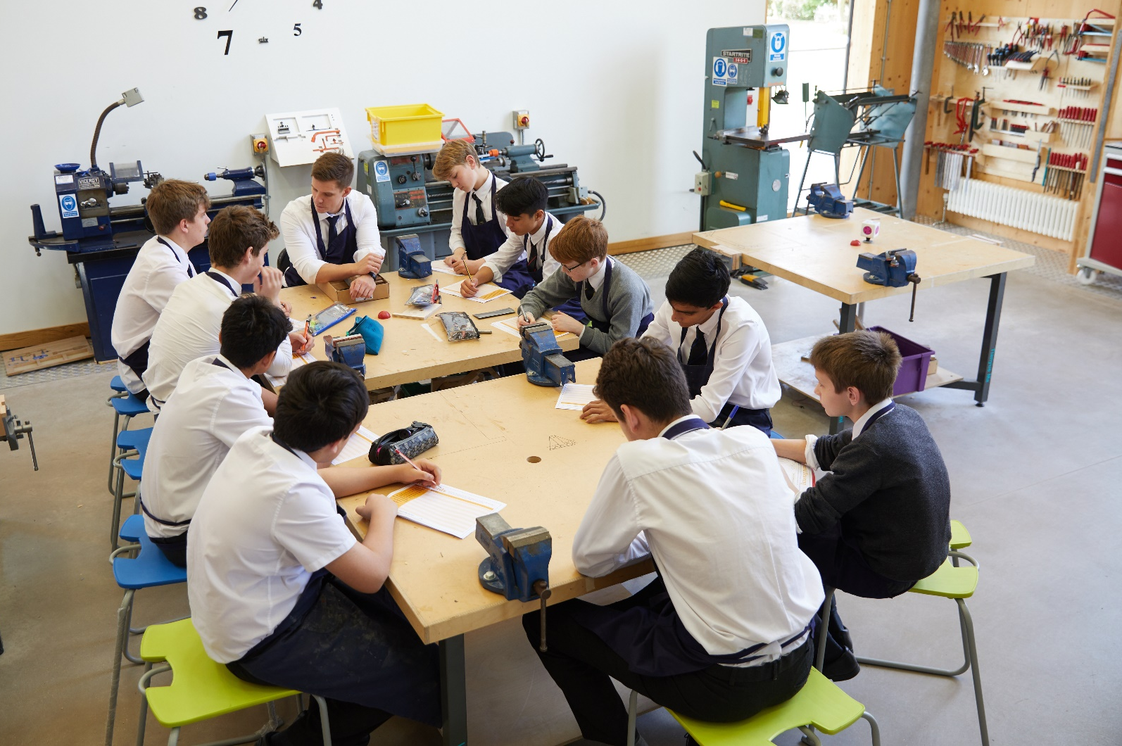

The Position

KS4 Lesson in Workshop 1

The main responsibility of each Assistant Teacher is his/her classroom teaching duty; there are, however, other responsibilities such as being a Tutor, a Form Teacher and taking part in the school’s games and activities programme.

Additional responsibilities

- To discharge all professional duties as outlined in the Contract of Employment and associated Employment Manual
- To set personal professional standards (for example, in matters of dress and punctuality) that are of the highest level and that will enable the individual teacher to act as a role model for pupils
- To support the ethos of the school and to work in accordance with its desired aims and policies
- To share in pastoral responsibility for all pupils (especially those in the individual’s teaching or tutor groups) in liaison with the appropriate Heads of School and senior managers
- To play an active role in the life of the school, including the games and extra-curricular activities programme.

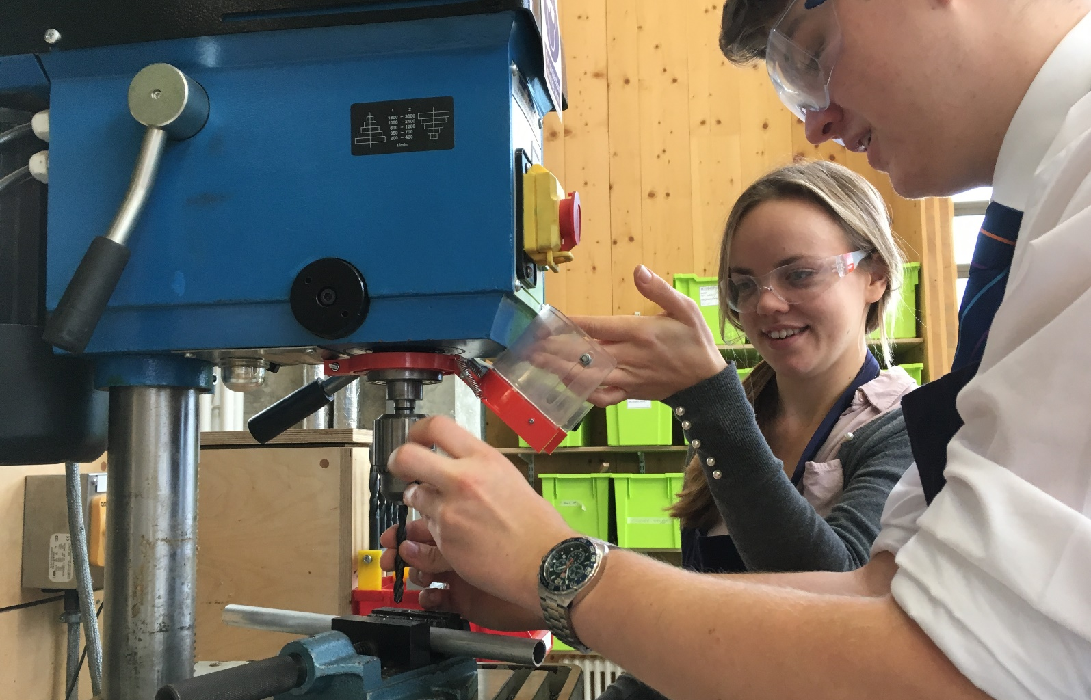
A-level Teaching

More specific Teaching responsibilities

- Planning and preparing schemes of work and lessons
- Assessing, marking, recording and reporting on the development, progress and attainment of pupils in line with school and departmental policy
- Promoting the general progress and well-being of individual pupils and groups of pupils
- Exercising proper care of teaching materials, equipment and rooms to maintain a stimulating teaching environment
- Following the agreed policies in the Departmental Handbook with regard to such matters as programmes of study, teaching methods, homeworks and supporting pupils with learning difficulties.

- Advising and co-operating in the preparation and development of schemes of work, teaching materials,
teaching programmes, and methods of teaching and assessment

Assessment and Reporting

- Providing or contributing to oral and written assessments, reports and references relating to individual pupils and/or groups of pupils
- Communicating and consulting with the parents of pupils, both formally at Parents’ Meetings and informally.
- Participating in arrangements for preparing and assessing pupils’ work for public examinations

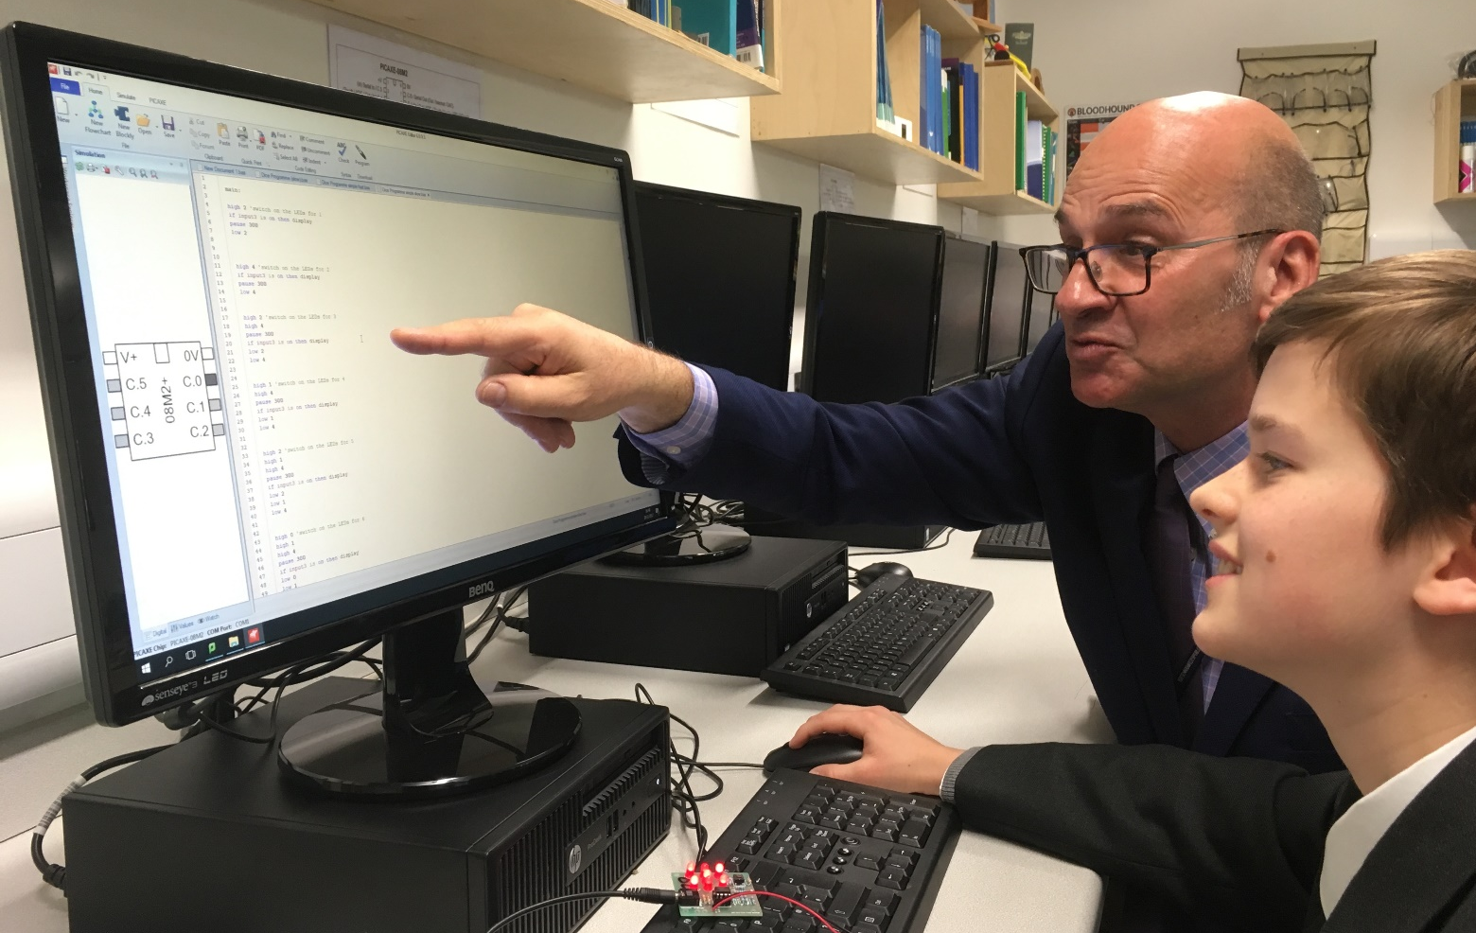
KS3 Electronics Club

Professional Development

- Participating in the school’s arrangements for teacher review, both as a reviewer, and as one under review
- As a teacher new to the school, to take part in the school’s programme of induction and review for new teachers
- Reviewing from time to time teaching methods and programmes of work
- Participating in arrangements for further training and professional development as a teacher

Behaviour Management

- Maintaining good order and discipline amongst the pupils and safeguarding their health and safety, both when they are on the school premises and when they are engaged in authorised school activities elsewhere
- To require from the pupils the high standards of behaviour, dress, punctuality, effort and attendance that

are consistent with the school’s expectations

Meetings

- Participating, as required, in meetings that relate to the curriculum, the organisation of the school or pastoral matters

Cover

- Supervising (and when appropriate teaching) any pupils whose teacher is not available to teach them as required by the Head of Department or the Second Master

Tutor and Form Teacher roles

- When required, to undertake duties as a Tutor and/or Form Teacher as detailed in a separate job description
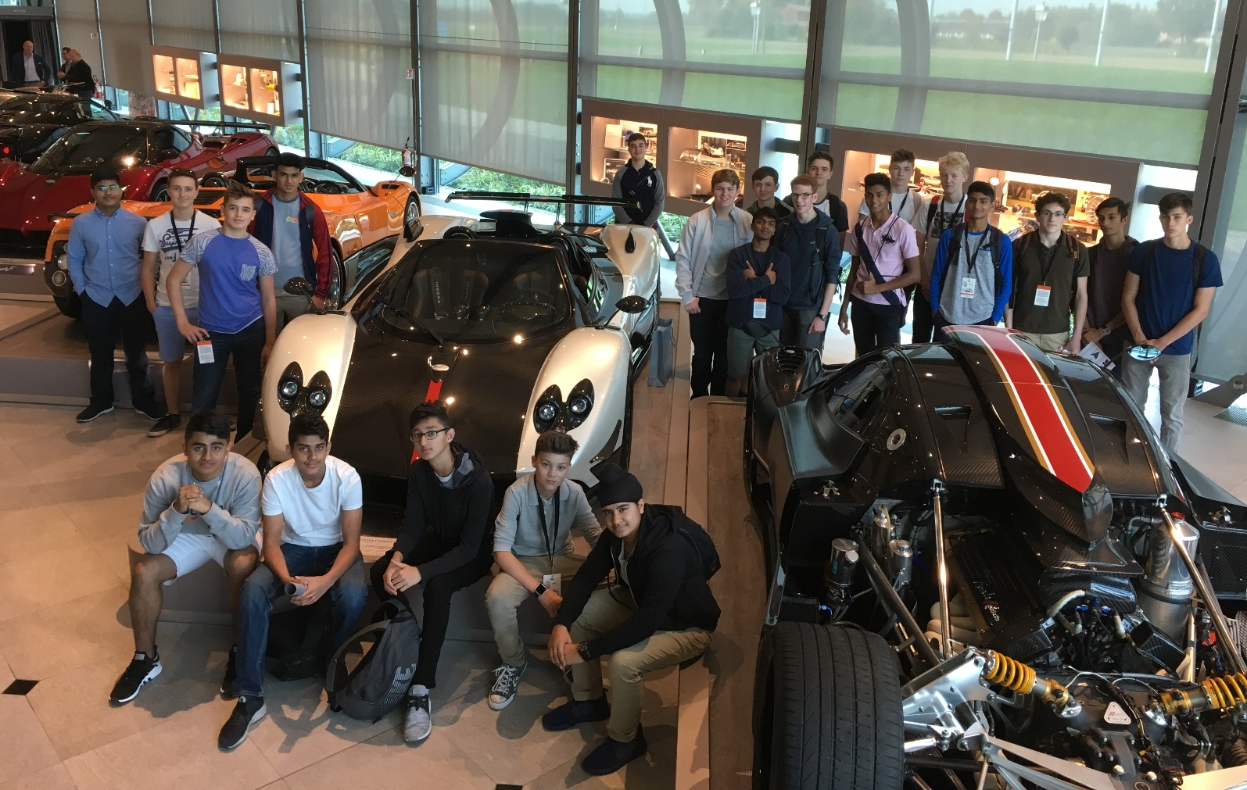
The Benefits
2017 Design & Technology trip to Italy

- The school has high expectations of staff, and therefore rewards them with a generous salary scale and beneficial conditions of service.

- High-quality single and married teacher accommodation is usually available and nearly half the academic faculty lives on campus.

- Interest-free loans are usually available to those staff wishing to leave school accommodation and take out a mortgage.

- The collegiate spirit amongst the academic Faculty is a strong and positive one. The atmosphere in Common Room is exceptionally congenial and supportive, whilst the boys are interesting, talented young men, and the academic environment is conspicuously civilized

- Class sizes are small and the teaching facilities are excellent: most teachers have their own fully-resourced classroom

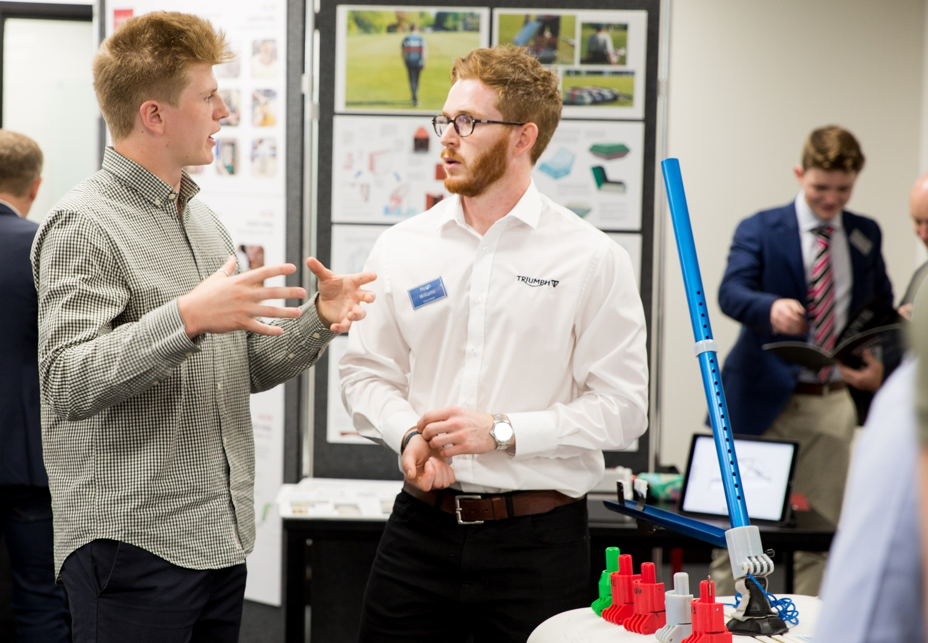
OMT prize winner (left) Lewis Duckworth at Triumph Design Competition 2017
Career

- There is an extensive induction programme for all new colleagues, and we encourage ongoing professional development through generous INSET provision

- Each member of the academic faculty has a voice on professional matters via the General Purposes Committee

Personal

- The school enjoys a superb campus: central London is 25 minutes away, the M1 and M25 are 10 minutes away, Heathrow is less than half an hour

- Fee concessions are available for the sons of any member of the academic faculty who meet the school's entry requirements

- Membership of the Teacher's Superannuation Scheme

- Longer holidays than the maintained sector

- Free on-site parking

- School Nurse on site

- Typically generous sick and maternity/paternity arrangements

For Recreation

- Free use of the school's extensive leisure and sporting facilities: 265 acres of parkland, with more than 65 devoted to sport

- Free lunch and free refreshments are available throughout the working day.

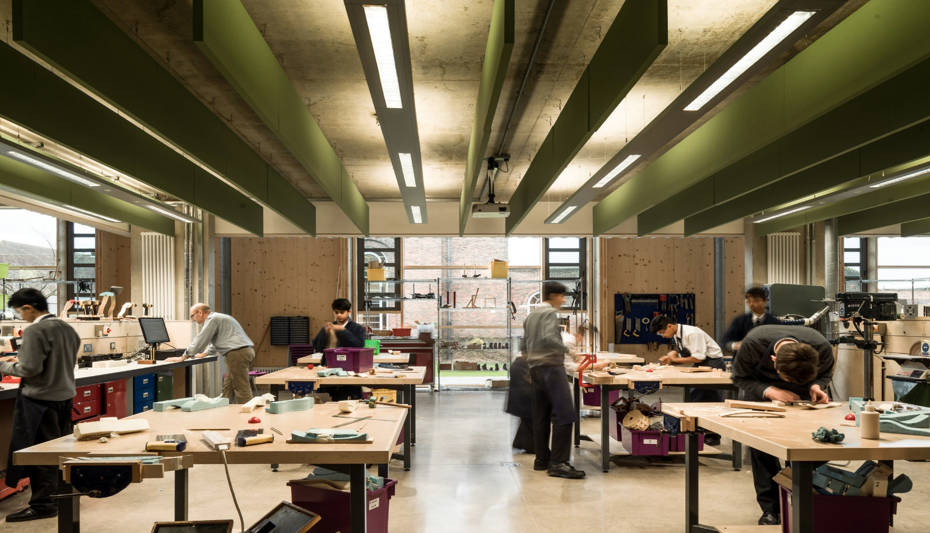
The Process

KS3 Class in Workshop 2

Please complete an application form and an accompanying letter (maximum 500 words) outlining your suitability for the post; you may wish to include a brief CV.

The post will appear in the Times Educational Supplement on Friday 19th January 2018. The closing date is Wednesday 24th January; interviews will be held week commencing 29th January 2018.

Applications to (email, fax, or post):
The Head Master
Merchant Taylors’ School
Sandy Lodge
Northwood
Middlesex HA6 2HT

Fax: +44(0)1923 835110
Email: recruitment@mtsn.org.uk

Head of Design & Technology,
Haydn Hutchings will be happy to answer
any questions; contact him at hhutchings@mtsn.org.uk


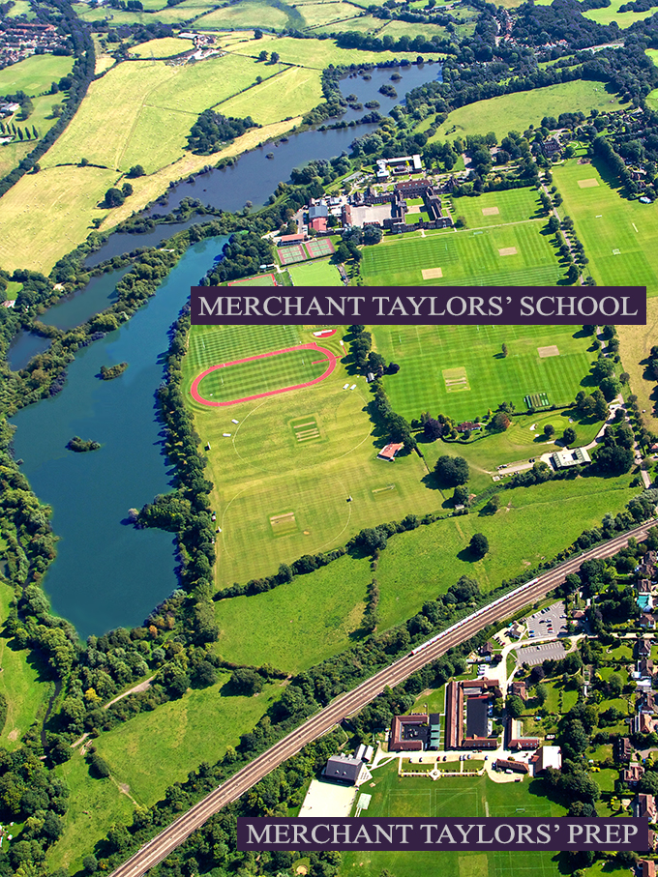

MERCHANT TAYLORS’ PREP
Moor Farm
Sandy Lodge Road
Rickmansworth
Hertfordshire
WD3 1LW
MERCHANT TAYLORS’ SCHOOL
Sandy Lodge
Northwood
HA6 2HT

Tel: +44(0)1923 820644
Fax: +44(0)1923 845522
www.mtsn.org.uk

