
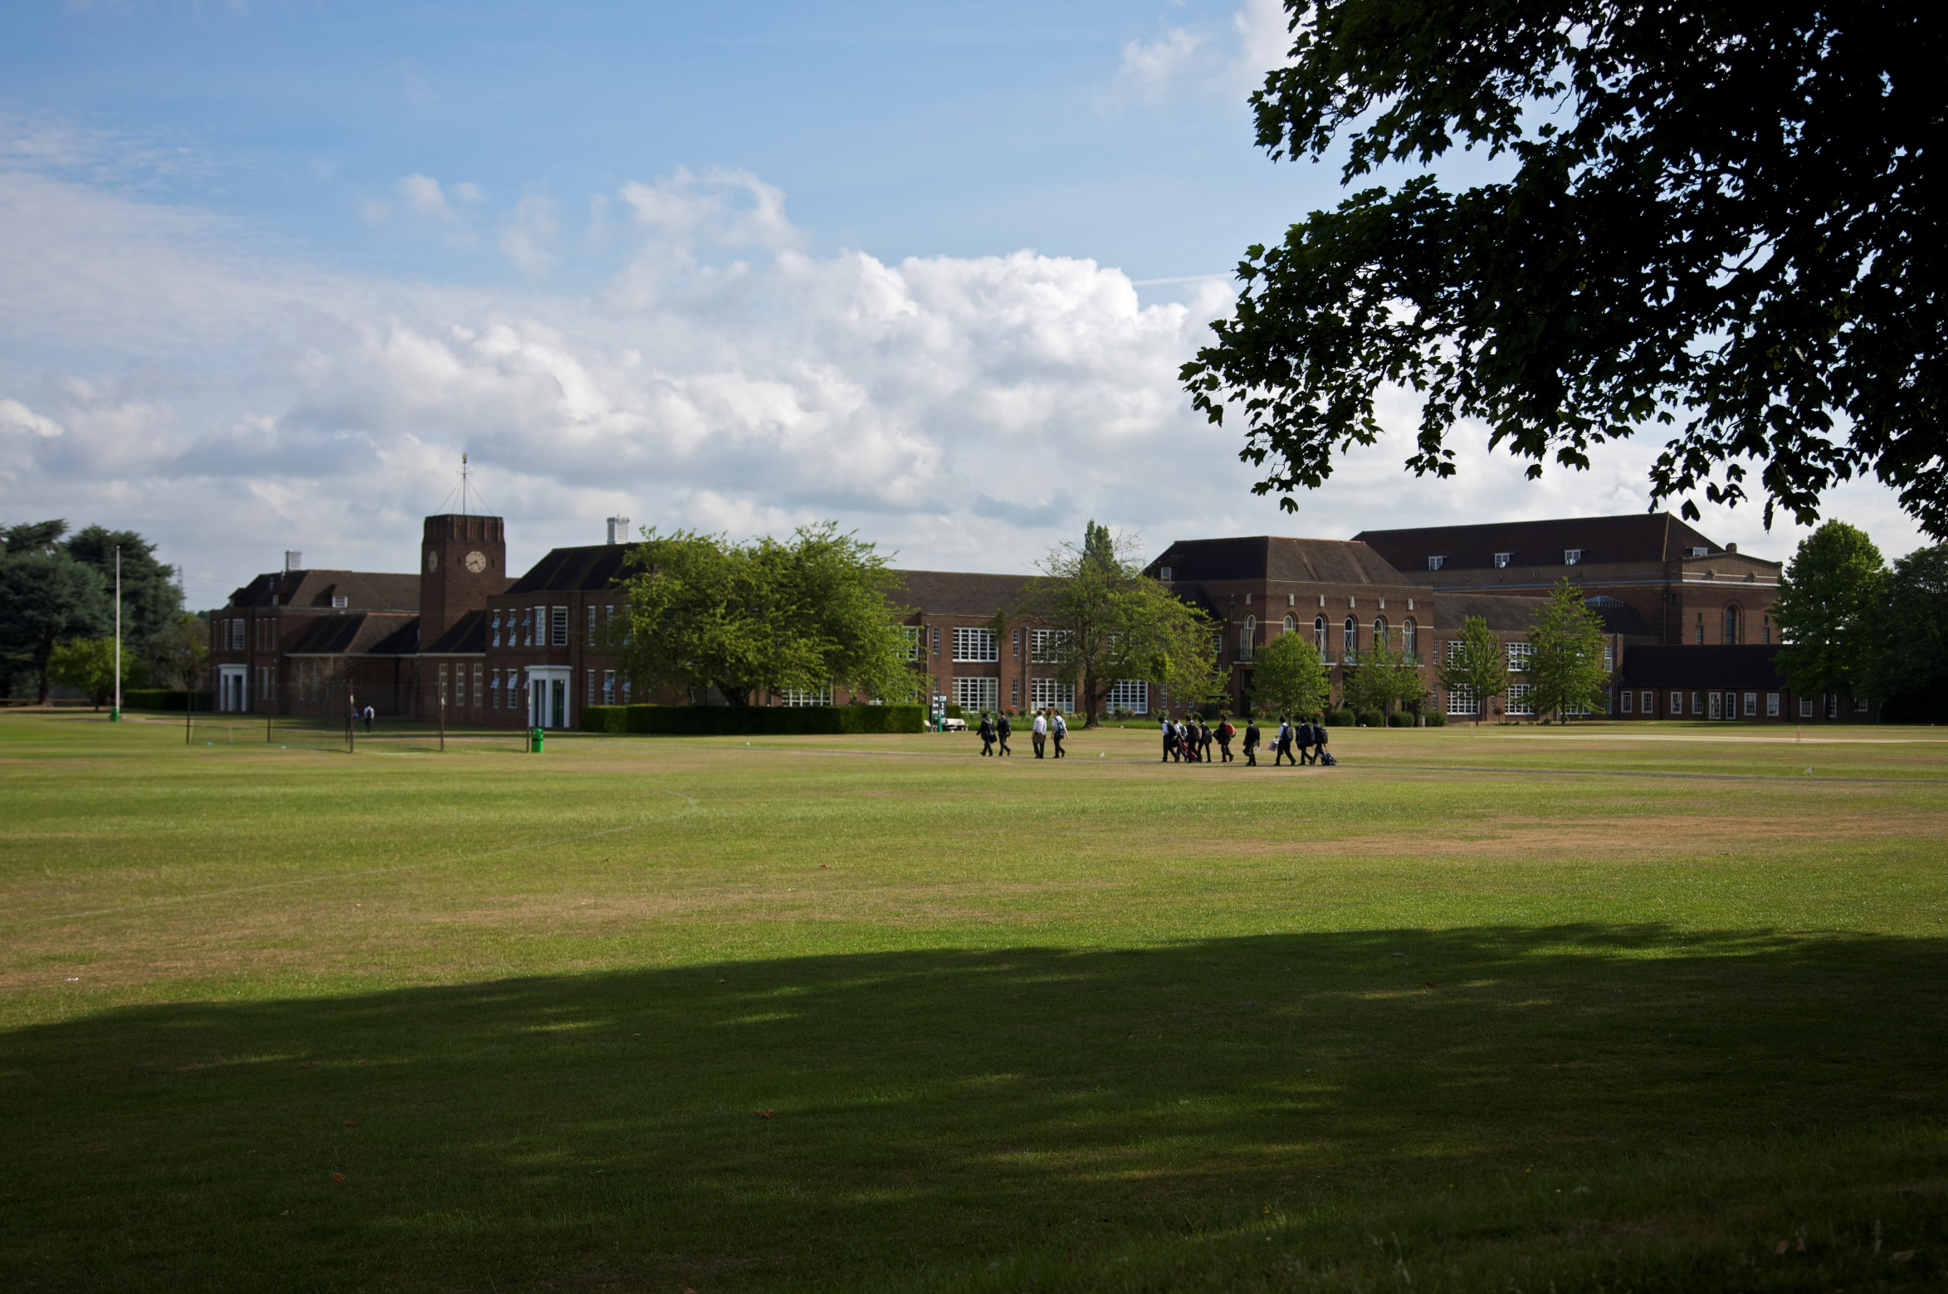
Excellence, integrity, and distinction since 1561
Teacher of Mathematics
For boys 3-18
Information for candidates
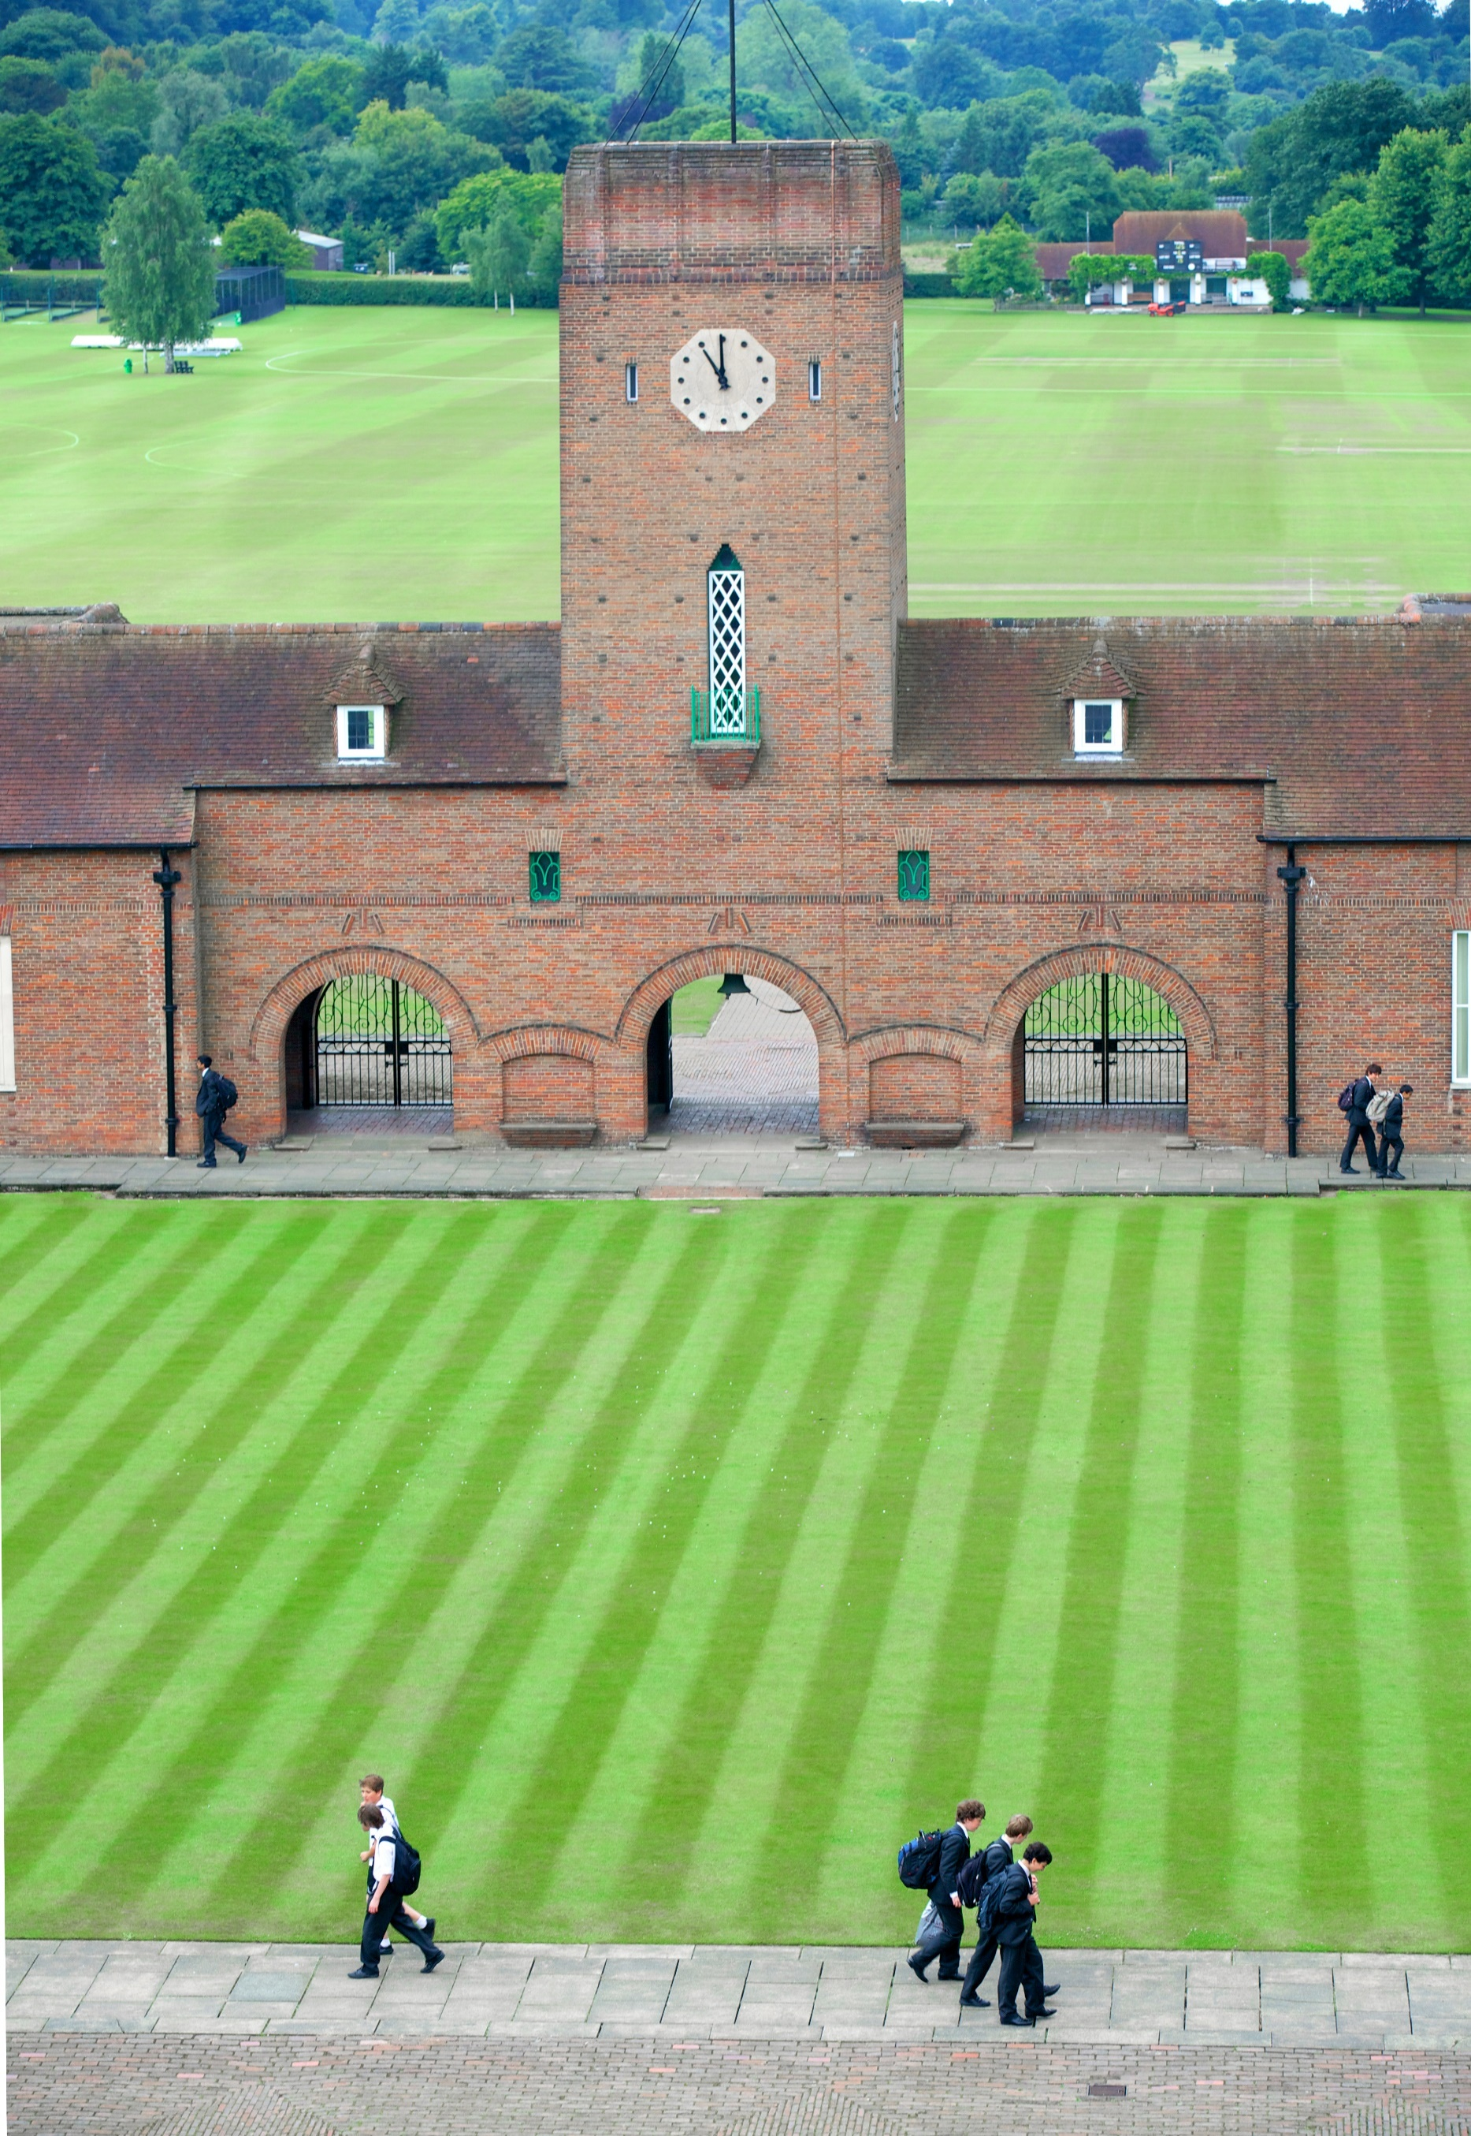

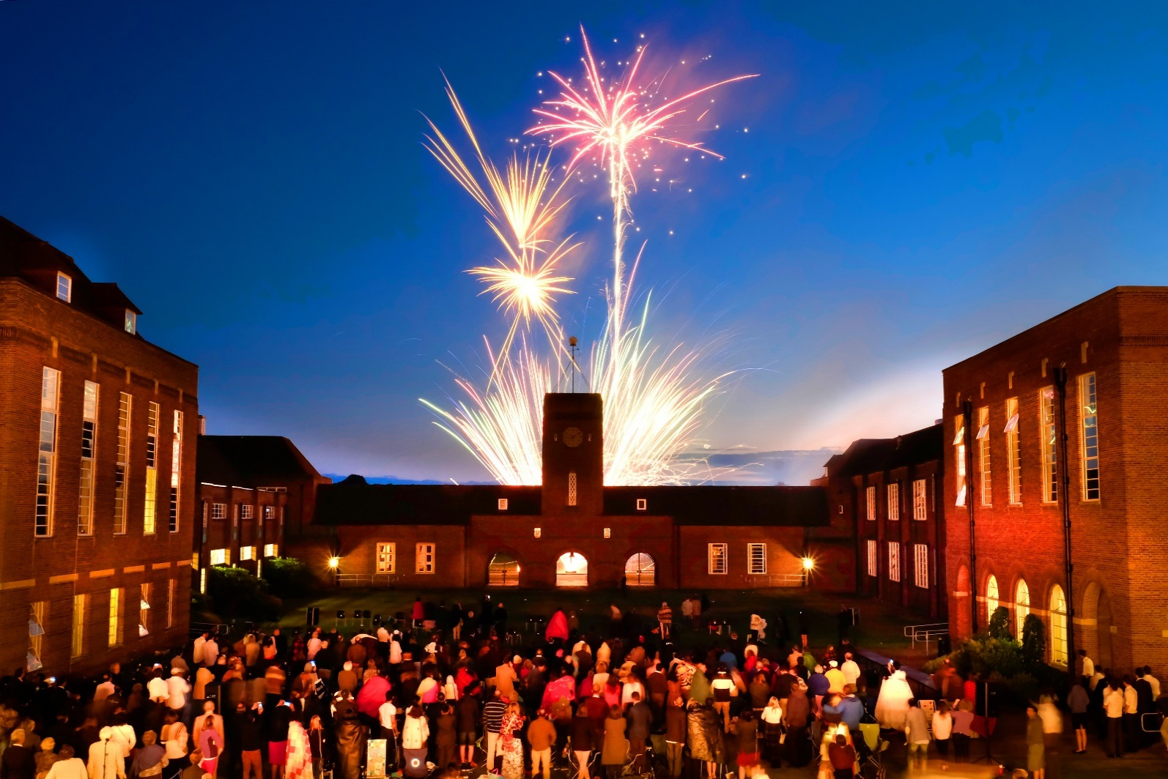
The School
Contents
03 The School
05 The Person
06 The Department
08 The Position
11 The Benefits
13 The Process

Merchant Taylors’ School has been one of the top ten boys’ schools in the UK since its foundation by the Merchant Taylors’ Company, one of the twelve Great Livery Companies of the City of London, in Suffolk Lane in 1561. One of the nine original ‘Clarendon schools’, its alumni have achieved distinction throughout history. However, the school wears its heritage lightly, its strong sense of tradition very much at the service of the future. Through the Merchant Taylors’ Educational Trust, it retains close links with other Merchant Taylors’ schools, and with the Merchant Taylors’ Company itself.

Relocated from the City to Sandy Lodge, Northwood in 1933, the school occupies a superb setting: 286 acres of lakes, playing fields, and woodland, all within easy reach of central London, Middlesex, Buckinghamshire, and Hertfordshire.

There are four distinct boys’ day schools on campus. The Nursery, the Pre-Prep & the Prep cater for 340 boys from 3 to 13

years of age, while the Senior School has
some 890 pupils from 11 – 18, with over 300 in the Sixth Form (The Prep School shares some of its facilities with the Senior School, but is a separate school in its own right).

Competition for places is fierce, and entry is by competitive examination at 11+, 13+, and 16+.

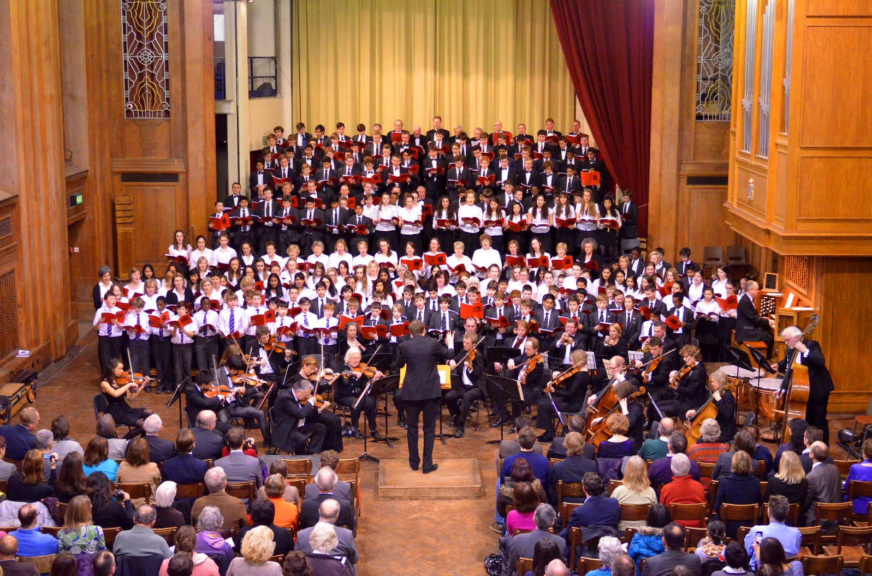
Public examination results are outstanding, the majority of students proceeding either to Oxbridge or other leading universities and medical schools in the UK or abroad.

We pride ourselves on our outstanding pastoral care as well as our excellent academic results, and aspiration in all areas goes well beyond the norm, making Taylors’ a particularly exciting and rewarding place to teach.

The 2014 Inspection Report accorded the school the highest accolade of “exceptional”, finding that pupil achievement and learning are exceptional, and the teaching, curricular and co-curricular provision are all excellent: “Pupils are receptive, alert, highly articulate and well-motivated… friendly, happy and self-reflective… highly articulate… logical and independent thinkers… and show high levels of creativity”.

Merchant Taylors’ is an exciting, rewarding environment in which to teach and work. For those with talent, ambition, and commitment, Merchant Taylors’ provides the means for the development of a successful career in a place with a real sense of community.

Probably the best way to get a taste of life at Taylors’ is to read our weekly magazine Scissorum, which is available on the school’s website www.mtsn.org.uk/scissorum


The Person

We are seeking an outstanding Teacher of Mathematics to join an exceptional department. You will be highly qualified, enthusiastic, innovative, and highly committed: an able communicator, with a positive, encouraging, and collaborative style that can enrich the work of an already very successful department. You will have the ability to inspire both teachers and boys, so that the mathematical culture in the school is a truly exciting one.

You will be involved in the teaching of Mathematics throughout the school as well as contribute to a stimulating, tolerant, and supportive environment that can engender the highest levels of achievement. There is also substantial scope for involvement in related enrichment programmes.

We expect your commitment and ideas to make a significant contribution to enabling the school to maintain its status as one of the top academic boys’ schools in the country. This represents an outstanding opportunity for you to work in a school where teachers have a strong sense of community and enthusiasm and in which involvement, pastorally, and in the extensive broader curriculum, is the norm.


The Department

The Mathematics Department at Merchant Taylors’ is outstandingly successful. There is a very strong mathematics culture within the school, with genuine enthusiasm for the subject beyond the syllabus. The department aims to realise the mathematical potential of each pupil by providing clear, positive, committed, and inspiring teaching tailored to individual needs. Mathematics is the most popular subject choice at A-level, with over 100 candidates in each of the Lower and Upper Sixth Forms. Pupils regularly go on to read Mathematics and Maths related subjects at Oxbridge and other top universities.

Curriculum & Results

Pupils currently follow the OCR linear syllabus at A Level and Further Maths A Level.

Examination results are consistently outstanding (90% A*/A/B at A Level (42% A*) and 84% A*/A at FMA2 (87% A*) in 2017).

We offer IGCSE. Typically, all entrants to IGCSE achieve A*, A or B (95% IGCSE A*/A overall in 2017).


The school structures its teaching through 24 double periods of 60 minutes (together
with games on Wednesday afternoons); typical contact time is 18 periods per week.

These double periods can be broken down into 30-minute single periods and provision takes into account that for subjects such as Mathematics and Modern Languages single periods are often preferable.

Resources & Accommodation

The department has fifteen full-time teachers, most of whom have their own classroom.

Considerable use is made of technology. There is a networked PC in every classroom and all classrooms have permanently installed projectors and interactive whiteboards; there is also a well-equipped departmental resource centre.

Extra-Curricular Activities

Extra-curricular activities include a House Maths competition, an essay competition, a Prep Schools’ Maths Afternoon, and a Primary Schools’ Maths Afternoon.

We take the boys to Mathematics lectures in the Lower Sixth and the Divisions and there is an annual trip to Bletchley Park for the Fourth Form. Substantial time is devoted to preparing Oxbridge candidates.

Pupils enter for the British Mathematical Olympiad and associated competitions, UK Mathematics Trust Team Challenges and the Hans Woyda Competition for schools in the London area.



The Position

Summary of responsibilities

The main responsibility of each Assistant Teacher is his/her classroom teaching duties; there are, however, other responsibilities, such as being a Tutor, a Form Teacher and taking part of the school’s games and activities programme. All these should be carried out to the highest standard to ensure the all-round quality of education for pupils at Merchant Taylors’ School.

- To discharge all professional duties as outlined in the Contract of Employment and associated Employment Manual
- To set personal professional standards (for example, in matters of dress and punctuality) that are of the highest level and that will enable the individual teacher to act as a role model for pupils.
- To support the ethos of the school and to work in accordance with its desired aims and policies
- To share in pastoral responsibility for all pupils (especially those in the individual’s teaching or tutor groups) in liaison with the appropriate Heads of School and senior managers


- To play an active role in the life of the school, including in the games and extra-curricular activities programme

Teaching

- Planning and preparing courses and lessons
- Assessing, marking, recording and reporting on the development, progress and attainment of pupils in line with school and departmental policy
- Promoting the general progress and well-being of individual pupils and groups of pupils
- Exercising proper care of teaching materials, equipment and rooms to maintain a stimulating teaching environment
- Following the agreed policies in the Departmental Handbook with regard to such matters as programmes of study, teaching methods, supporting pupils
with learning support needs and homework
- Advising and co-operating in the preparation and development of courses of study, teaching materials,
teaching programmes, and methods of teaching and assessment

Assessment and Reporting

- Providing or contributing to oral and written assessments, reports and references relating to individual pupils and/or groups of pupils
- Communicating and consulting with the parents of pupils, both formally at Parents’ Meetings and informally
- Participating in arrangements for preparing and assessing pupils’ work for public examinations

Professional Development

- Participating in the school’s arrangements for teacher review, both as a reviewer, and as one under review
- As a teacher new to the school, to take part in the school’s programme of induction and review for new teachers
- Reviewing from time to time teaching methods and programmes of work
- Participating in arrangements for further training and professional development as a teacher

Behaviour Management

- Maintaining good order and discipline amongst the pupils and safeguarding their health and safety, both when they are on the school premises and when they are engaged in authorised school activities elsewhere
- To require from the pupils the high standards of behaviour, dress, punctuality, effort and attendance that are consistent with the school’s expectations

Meetings

- Participating, as required, in meetings that relate to the curriculum, the organisation of the school or pastoral matters

Cover

- Supervising (and when appropriate teaching) any pupils whose teacher is not available to teach them as required by the Head of Department or the Deputy Head (Information Services)

Tutor and Form Teacher roles
- When required to undertake duties as a Tutor and/or Form Teacher as detailed in a separate job description



The Benefits

Benefits

- The school has high expectations of staff, and therefore rewards them with a generous salary scale and beneficial conditions of service

- High-quality single and married teacher accommodation is usually available and nearly half the academic faculty lives on campus

- Interest-free loans are usually available to those staff wishing to leave school accommodation and take out a mortgage

Teaching

- The collegiate spirit amongst the academic faculty is a strong and positive one. The atmosphere in Common Room is exceptionally congenial and supportive, whilst the boys are interesting, talented young men, and the academic environment is conspicuously civilised

- Class sizes are small and the teaching facilities are excellent: most teachers have their own fully-resourced classroom


Career

- There is an extensive induction programme for all new colleagues, and we encourage ongoing professional development through generous INSET provision

- Each member of the academic faculty has a voice on professional matters via the General Purposes Committee

Personal

- The school enjoys a superb campus: central London is 25 minutes away, the M1 and M25 are 10 minutes away, Heathrow is less than half an hour

- Fee concessions are available for the sons of any member of the academic faculty who meet the school's entry requirements

- Membership of the Teacher's Superannuation Scheme

- Longer holidays than the maintained sector

- Free on-site parking

- School Nurse on site

- Typically generous sick and maternity/paternity arrangements

For Recreation

- Free use of the school's extensive leisure and sporting facilities: 265 acres of parkland, with more than 65 devoted to sport

- Free lunch and free refreshments are available throughout the working day

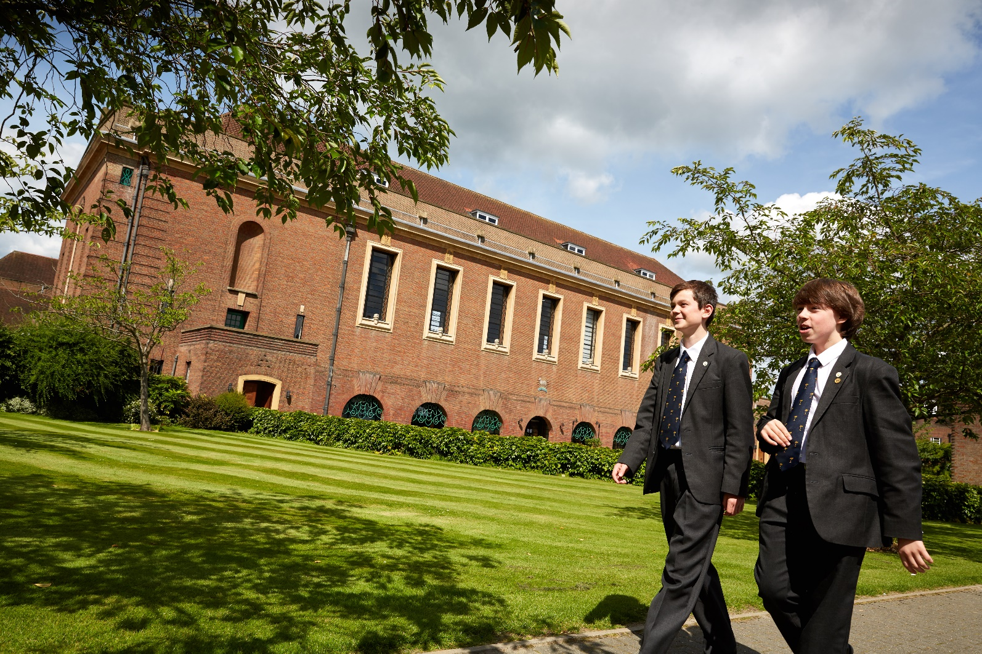

The Process

Please complete an application form and an accompanying letter (maximum 500 words) outlining your suitability for the post; you may wish to include a brief CV.

The post will appear in the Times Educational Supplement on Friday 19th January 2018. The closing date is Wednesday 24th January at 4.00 pm; interviews will be held week commencing 29th January 2018.

Applications to (email, fax, or post):
The Head Master
Merchant Taylors’ School
Sandy Lodge
Northwood
Middlesex HA6 2HT

Fax: +44(0)1923 835110
Email: recruitment@mtsn.org.uk

The Head of Mathematics, Alex Miller,
will be happy to answer any questions; contact him at amiller@mtsn.org.uk


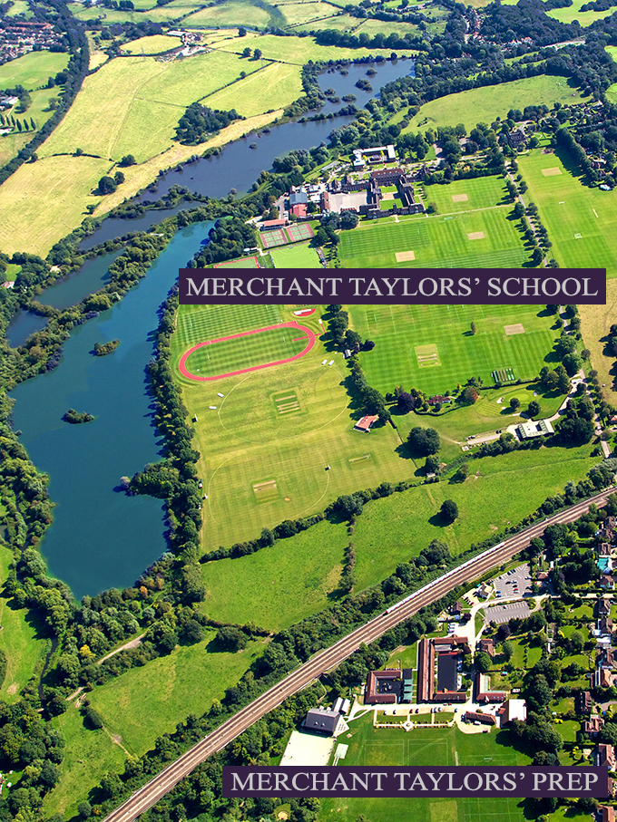

MERCHANT TAYLORS’ PREP
Moor Farm
Sandy Lodge Road
Rickmansworth
Hertfordshire
WD3 1LW
MERCHANT TAYLORS’ SCHOOL
Sandy Lodge
Northwood
HA6 2HT

Tel: +44(0)1923 820644
Fax: +44(0)1923 845522
www.mtsn.org.uk

