
Church of England Schools in the
Newcastle Diocese
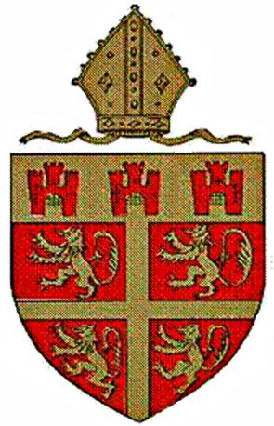

History

The history of the Church’s commitment to the provision of education goes back over centuries. A summary is recorded in “The Church School of the Future Review” published by the National Society in March 2012. The 1944 Education Act provided the framework for the present way in which the church is involved in schools by creating two broad types of church school, the voluntary aided and the voluntary controlled. Information about the differences may be found below. The 1944 Act formalised what has become known as the “dual system” – the partnership between Church and State in the provision of education. There have been many changes in the way in which the education service of this country has been organised but Church of England schools have continued to play a major role in the system. This will continue to be the case as we adapt to make the new forms of structural organisation – e.g. academy schools – meet our needs.

Church of England Schools in the Diocese of Newcastle

The Newcastle Diocese encompasses Northumberland and North Tyneside as well as the City of Newcastle upon Tyne. There are some 45 Church of England schools in the diocese, educating about 7,500 pupils. Church schools have their foundation in the Christian Gospel and are linked to a worshipping community. Day-to-day life in a church school should reflect that foundation, not just in that part of the curriculum labelled Religious Education, or that part of the school day termed “Collective Worship”, but throughout the whole curriculum and ethos of the school.

The Diocesan Education Board

Each Church of England diocese is required by law to set up a Board of Education whose function is to look after the interests of its church schools. Diocesan Boards of Education work with head teachers, governors, Local Authorities and the Department for Education to uphold and enrich the distinctive contribution of church schools to the state education system. The Newcastle Diocesan Education Board employs, jointly with its counterpart Board in the Durham Diocese, a team of experienced officers whose role is to support Church of England schools throughout both Dioceses. The work of this team covers a wide range of areas: representing the dioceses on a variety of committees and statutory bodies; liaising with LA and other officers; supporting schools by providing help and in-service training and by supporting and training governors. The Boards aim to facilitate the working together of governors, teachers, parents, church and other partners to ensure that the quality of education offered to the children in our church schools is of the very highest standard.

In Aided Schools:

- The school is owned by trustees as part of a church educational trust.
- The foundation (church) governors are in the majority on the governing body.
- The staff are employed by the governors.
- The governors are responsible for the external maintenance of the building and for funding improvements to it. For this they receive a grant (currently 90% of the total costs) from the Department for Children Schools and Families for approved projects.
- Religious Education is taught in accordance with the Diocesan syllabus.
- Collective Worship is conducted in accordance with the Anglican foundation of the school.
- The governors are responsible for admissions to the school.

In Controlled Schools:

- The school is owned by trustees as part of a church educational trust
- The foundation (church) governors are in a minority on the governing body.
- The staff are employed by the LA.
- The LA is responsible for the external maintenance of the building and for funding improvements to it, although the authority may delegate most of its responsibilities to the governing body.
- Religious Education is taught in accordance with the LA’s Agreed Syllabus although Religious Education in accordance with the Trust Deed may be provided if parents request it for their children.
- Collective Worship is conducted in accordance with the Anglican foundation of the school.
- The LA is responsible for admissions to the school.

