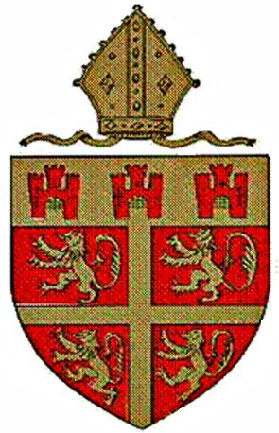

DIOCESES OF DURHAM AND NEWCASTLE

Church School Provision in the two Dioceses

The Durham and Newcastle Diocese Boards of Education provide state-funded education for around 22,000 children in 9 secondary and middle schools and 90 primary and first schools, both phases now including several academies.
Church of England schools are distinctive from their neighbouring schools in terms of their governance and management, their ethos, and their religious education and collective worship, which are distinctively Christian. However, they are inclusive in that they serve their whole community, welcoming children from Anglican families, those of other faiths and those with no faith. As at September, 94% of our schools were judged by OfSTED to be Good or Outstanding.

Details of all our schools, and their recent Ofsted and SIAMS reports can be found on the Joint Education Website: www.jointeducationteam.org .
Through their Joint Officer Team, the Boards of Education carry out statutory functions and provide support for all their schools. These include:

- support for Church schools’ leadership and management, including the recruitment, selection, induction and on-going training of Head Teachers and senior leaders;
- support for schools causing concern, and also those striving to become “Outstanding”;
- appointment, support, training and guidance for governors;
- inspection under the Education Act 2006 (inspection of Anglican schools) as amended
- advice and guidance regarding the RE curriculum and collective worship;
- support for clergy in their relationships with schools;
- regular cluster group meetings for schools;
- review of, and advice regarding school admissions;
- a range of services regarding schools’ buildings and finances;
- Liaison and collaboration with the 10 local education authorities in our region and with neighbouring dioceses.
- Represent the interests of Church schools and academies with partner bodies including Local Authorities, the DfE, the RSC, Ofsted and the National Education Office.
- Promoting at all times the Church of England Christian ethos of the school or academy

Consultation with the Boards of Education

Church school governing bodies must seek the agreement of the Board for their Diocese before:

- publishing proposals for any prescribed alteration to the school;
- publishing proposals for the discontinuance of a school;
- consulting about proposed admission arrangements for any school year;
- publishing proposals for changing the character of a school.
- Applying for academy status
School governing bodies must have consent of the Board in writing which must then go to the Secretary of State before undertaking any alteration or repair which requires a grant.
The trustees of any church endowment held in connection with a church school must gain advice from the Board before agreeing to any alterations being made.

