Bourne Grammar School

Atmosphere

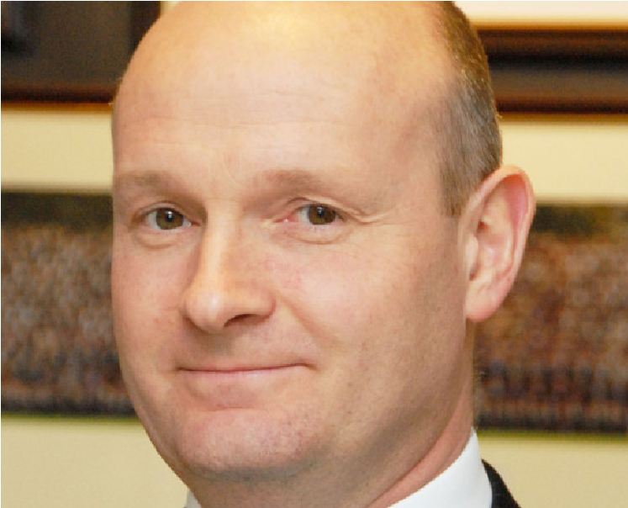
I write as a fellow teacher. It is important to me that I am a teacher for a significant part of my time. I do not run other schools. I am not always out at meetings and conferences.
I am entirely committed to ensuring that Bourne Grammar offers the best experience to its students and, importantly for those who read this, a pleasant and rewarding experience to its teaching staff.

Jonathan Maddox Headteacher
The best schools do everything well - academic, pastoral, sport, music, drama, Duke of Edinburgh’s Award, trips and visits. By virtue of a committed staff working with willing students and an appreciative Leadership Team, we have all these in abundance and to a high standard.

Support
We have no ‘mission statement’ - merely a very short purpose statement: Best Atmosphere, Best Support, Best Results. The order is deliberate; we believe that if we get the first two right then, given our able students and a committed staff, good results will follow. The atmosphere is special and is cherished by us all.

Results
We are a large and busy school, educating the top 25% by academic ability. That means that we do have a range of ability here. Some do very well indeed; practically all achieve at least pass grades in all their GCSE subjects. The students want to be here and their parents/carers want them to be here. Most of the students, most of the time, want to learn and enjoy lessons which are well-planned, well-taught and are engaging.
We have expanded considerably because of demand for our places. A full, expanded school means that our income allows us to run a financial surplus. There have been no redundancies and departments are well funded. We pay salary increments. Our estate and IT systems are in good order. A new, £4m Science Block enhances an estate which is modern and well maintained. We are adding not losing subjects in our large and expanding Sixth Form which will soon have 27 A-level subjects; there is no minimum set-size.

I didn’t go to a grammar school
Neither did I. There are only 164 selective schools in the country so it is not surprising that only a handful of our staff were educated at grammar schools. We recruit teachers who were educated and may now work in comprehensive, selective or independent schools.

I don’t have a degree from a top-class university
We don’t demand that. Colleagues here come from across the entire range of higher education. What matters to me is that you want to teach here.
Behaviour?
Behaviour will be a revelation if you have not worked in a school such as ours. Students want to be here, they want to learn, they do not want to make your life a misery. If you engage well with the students and keep them interested, you can expect calm lessons which leave you feeling positive, fulfilled and worthwhile. You will not drive home feeling shattered.

Please get in touch
We always welcome visits by prospective applicants, although I understand that it isn’t always easy or possible to come here before you apply. In any event, Stella Chamberlain is at the end of the phone, and she responds quickly to email. Please do contact her. She can put you through if you wish to discuss the role.

The best atmosphere, the best support, the best results

The History Department
The Department has a long and consistent track record of achieving good student outcomes at GCSE, AS and A Level. At GCSE level 93% of students achieved grades A*-C. At full A level there was a 100% pass rate with 61% of the cohort achieving A*-B grades. We are very proud of our student’s achievements and there is a real love of the subject shared by many who go on to pursue History at university level. Last year 30%of the A level historians went on to study the subject at highly respected universities
The Department is a cohesive team of able and committed professionals who enjoy their work and take a collaborative and collegiate approach. They are housed in a new (2004) purpose-built suite of four spacious classrooms, with each full-time teacher having their own classroom. For a teacher who is enthusiastic about their subject and wishes to develop their pedagogy with keen, well-disciplined students this is a fantastic opportunity.
History is a very popular subject at A Level, where we offer 2 History sets to the current Year twelve cohort. This year, our Year 12 total 33. At GCSE we follow the new AQA specification and there are currently five sets studying the subject at this level. The Department is very keen to widen the student experience of the past and extra-curricular opportunities are an integral part of studying History at Bourne Grammar School. Over the past decade, we have run very successful annual visits to the battlefields of Flanders and the Somme, the Holocaust memorial centre in Nottinghamshire and we are really excited about a new Year 12 visit to Munich and Krakow in June 2018. The subject has a dedicated team of History Prefects in the current year twelve who help with the subject lower down the School. They have been invaluable in promoting the subject and encouraging students to consider pursuing History at both GCSE and A-level.

The Post
We seek to appoint a dynamic and passionate subject leader to join this highly successful, cohesive and supportive department.

Application process
Arrangements can be made by telephoning Stella Chamberlain on 01778 391648 or emailing recruitment@bourne-grammar.lincs.sch.uk
Go to our website for more information about the School: www.bourne-grammar.lincs.sch.uk
We are happy to accept a CV or an application form.

