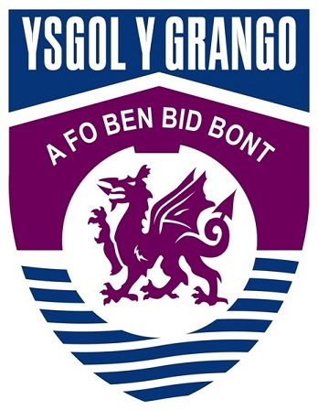

TEACHER OF ENGLISH

PERMANENT CONTRACT

FULL TIME

From 1st September 2018

INFORMATION FOR APPLICANT

Teacher of English
Person Specification

Attributes | Essential | Desirable
Qualifications | - Good honours degree in English  - Teaching Qualification (PGCE)
Knowledge and Skills | - Thorough knowledge of what makes effective teaching and learning  - Excellent skills in literacy and numeracy  - Thorough knowledge of recent education developments (including thinking skills)  - Ability to work as part of a team  - Excellent ICT skills and a willingness to use digital learning | - Knowledge of WJEC English Specifications
Personal qualities and behaviours | - Passionate about learning  - Excellent practitioner in English  - Excellent classroom practitioner  - Problem solving and team work abilities  - Excellent communicator  - Excellent organisational skills  - Self-motivated and committed  - Integrity and honesty  - Enthusiasm, energy and initiative | - Willingness to make a full contribution to the life of the school
Education philosophy | - A commitment to the concept of lifelong learning  - A commitment to integrate fully into the life of the department | - Commitment to developing own learning

Ysgol y Grango English Curriculum Area
The new post holder will work with the Head of English Curriculum area, to plan and deliver outstanding learning opportunities for students in English.
We wish to appoint a very well qualified and passionate teacher who is keen to create and develop innovative and imaginative ways in which to teach this subject. We are looking for a dynamic team player who has energy and vision.
We are a friendly and supportive team consisting of five specialist teachers each with their own teaching base, including an interactive whiteboard. The team has a wealth of experience and skills and teach across both key stages as well as teaching drama.
We currently have four sets in each year group in KS3, with 5 sets in KS4. Reduced class sizes will allow us to really focus on developing every pupil’s skills and understanding in English. All year groups enjoy four 50 minute lessons per week. KS3 classes also have a ‘mini’ option in year 9, where pupils can pick from a range of ‘Literacy’ subjects such as: Drama, Literature, and Digital Literacy.
All year groups are set at the beginning of year 7. Setting is reviewed regularly throughout KS3 and 4; set movements are then actioned, taking account of current data, performance and most likely outcome for pupils.
As a department, we work very closely together producing and sharing resources, and working together to get the best out of every pupil we teach. Our results show that pupils regularly achieve above their predicted FFT D predictions, whether that be A or G.
We are looking for someone to join our close knit team that will help us engage pupils with literacy and take on the challenge of developing the new GCSE specification and KS3 programmes of study.
Facilities
The English department comprises 5 classrooms. The school’s library is a highly valued resource which enriches students’ love of reading.

