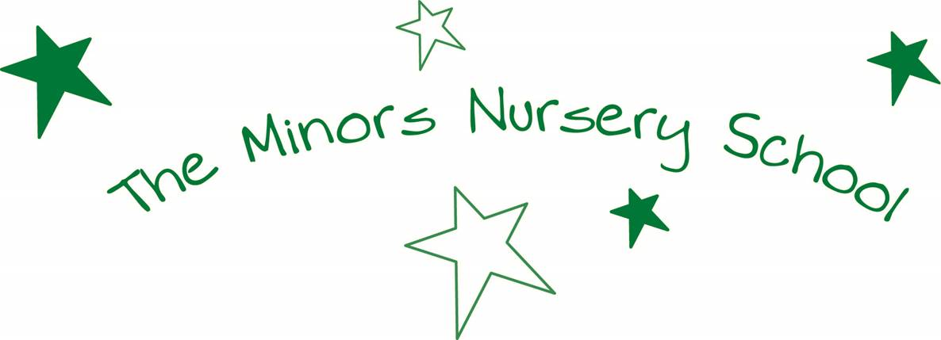

EYFS TEACHER/ CLASS LEADER
PERSON SPECIFICATION

A suitable candidate would :

- be a qualified teacher with either QTS/ EYPS or EYTT.

- be an excellent practitioner who values all children and communicates very well with parents/ carers.

- have high, thorough and realistic expectations of all children whilst promoting the caring ethos of the school.

- have a thorough up-to-date knowledge of the EYFS curriculum.

- have a good awareness of Ofsted requirements for teaching and learning and the well-being of children

- be a committed and enthusiastic teacher who can work individually and as well as part of a team

- be a warm and approachable person with a sense of humour!

- maintain excellent levels of appearance, attendance and punctuality.

- involve themselves fully in the life of the school.

