Haileybury Almaty
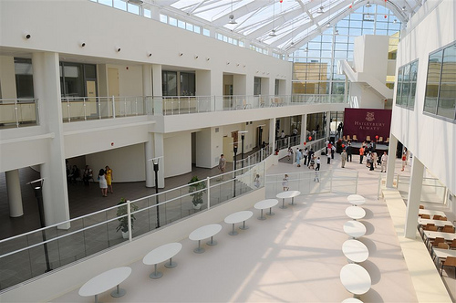
Haileybury Almaty opened in September 2008, followed by its sister school, Haileybury Astana, in 2011. Both schools have strong ties with Haileybury, the famous and highly successful British independent school, which dates back to 1862. Haileybury, Hertford, was originally built to house the East India College but opened as a public school in 1862. It is now a co-educational boarding school. The financial backers of Haileybury Almaty aspire to the standards of the best UK independent schools and they take a keen interest in the school, motivated by the desire to see it fulfil its potential. As a not-for-profit organisation, all operating surpluses are reinvested in the school. The majority of governors are also governors of Haileybury UK and therefore bring with them a wealth of experience. The UK-based governors visit the school twice a year, and there are also opportunities for staff to visit Haileybury UK and Haileybury Astana to share ideas with our colleagues there.
The pupils are approximately 75% local and 25% expatriate and the medium of instruction is English. The quality of English of the local pupils has improved significantly in recent years. All prospective pupils have to pass an admissions test to ensure they will be able to access our courses in English. The children here are pleasant and hard-working and a delight to teach.
As a young school, Haileybury Almaty is still evolving. The school is already established as the leading school in Kazakhstan and pupil numbers have increased every year. Pupil numbers currently stand at about 600, with a growing and thriving Sixth Form. The school already enjoys excellent facilities and an attractive, award-winning building, with plans for further construction projects in the future. Staff who come to work here need to share our vision - to provide a high quality education to prepare our children for tomorrow’s challenges - and ideally be committed to remaining beyond their initial two-year contract period. In return we are committed to the training and development of our staff.

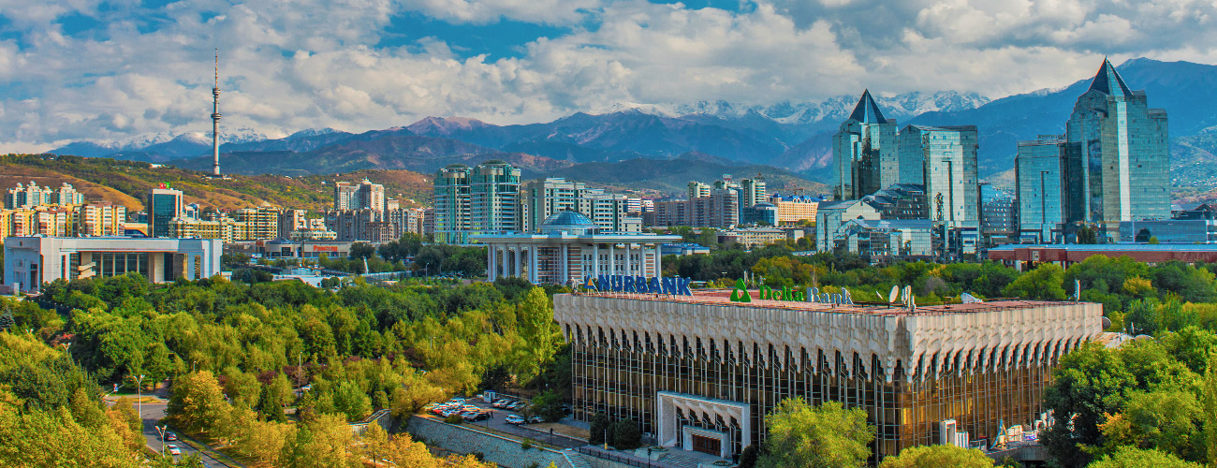

The City of Almaty
Almaty is the cultural and commercial capital of Kazakhstan. Although Astana has been the capital of Kazakhstan since 1997, Almaty remains the largest city in the country by a wide margin, with a population of over 1,500,000 people. Its beautiful location and vibrant city life continue to attract families and ambitious young professionals from across Kazakhstan, as well as a diverse expatriate population from across the world.
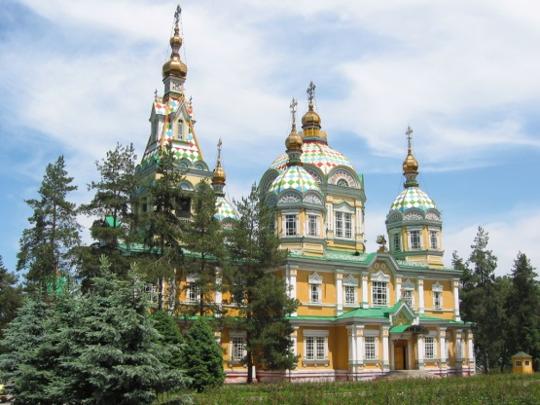
Located among the foothills and rivers of the stunning, snow-capped Tien Shan mountains, with the grassy steppe stretching away to Lake Kapchagai and Lake Balkhash to the north, Almaty enjoys sunny summers and crisp, dry, snowy winters, divided by a gorgeously colourful autumn and a refreshingly green spring. Almaty’s charmingly diverse architecture varies from the wooden nineteenth–century Zenkov Cathedral and colourful Tsarist-era academic buildings, to imposing Soviet concrete blocks, to the present day’s dazzling steel-and-glass towers and glitzy designer shopping malls. Almaty is blessed with an abundance of trees and parks - and like Kazakhstan in general, is a very family-oriented and child-friendly place to live.

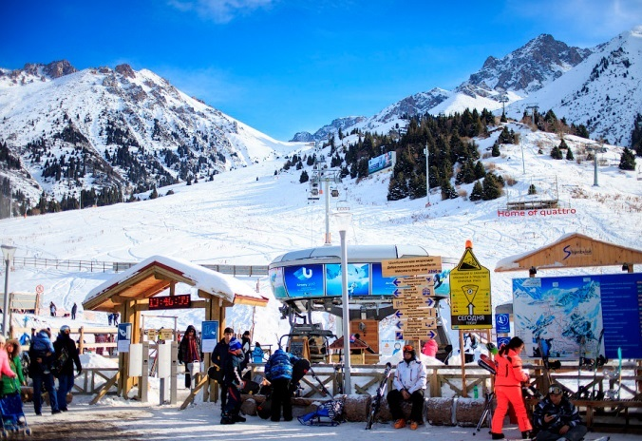
The city and its environs are ideal for outdoor pursuits such as hiking and mountaineering, running, road cycling and mountain biking, and of course winter sports such as ice-skating (on the world’s highest ice rink!), skiing and snowboarding at the Shymbulak ski resort – which can be easily reached within an hour by bus and cable car from the city. Other sights in the region include Great Almaty Lake and Charyn Canyon. Cultural life in the city includes numerous concerts, opera, ballet, English-language cinema, as well as an enormous variety of shopping, dining, bars and nightclubs, and the twin Kazakh obsessions of sushi and karaoke!

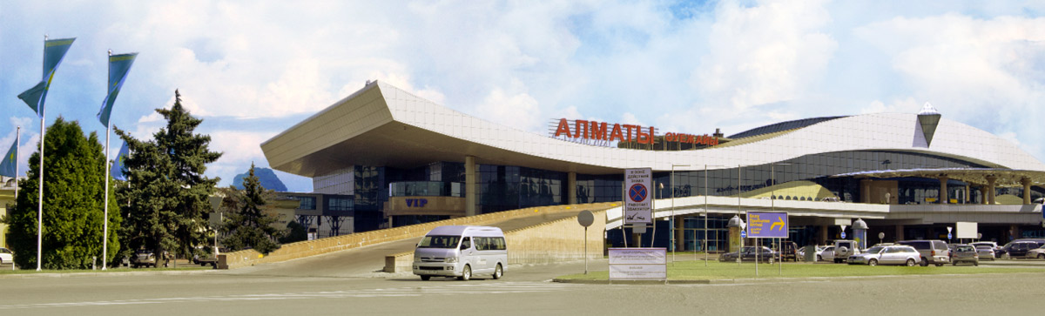
Almaty International Airport in is well served by a range of carriers with excellent links to many global hubs (including London, Amsterdam, Frankfurt, Moscow, Istanbul, Abu Dhabi, New Delhi, and Beijing) with new destinations being added regularly. Popular carriers include Turkish Airlines, Lufthansa and the national carrier Air Astana is rapidly expanding, and offers a high quality service to a wide range of destinations within Kazakhstan as well as internationally.
Living in Almaty
Almaty has all the advantages of a major city with few of the disadvantages. There is plenty to see and do and the city has a youthful, cheerful atmosphere. The range of cafes, bars and restaurants is similar to that of any western European capital and you will instantly recognise many of the products on sale in supermarkets. Some goods you can buy in the UK are hard to get and there may be one or two things you will miss, but on the whole shopping and cooking here are straightforward. The cost of living is similar to that of the UK, with some goods being relatively cheap here and others more expensive, especially imported electrical goods. Kazakhs love children and Almaty is both safe and welcoming for children. There is a good and very cheap network of buses, trams, and metros in the city, though you can get to many places on foot. Taxis are plentiful and inexpensive.

The biggest challenge in Almaty can be the extremes of weather. It is hot in the summer months and can be very cold in the winter, though frequent periods of high pressure give rise to clear, blue skies throughout the winter which allow you to enjoy the dramatic scenery. Although the winter temperatures sound daunting, it is a dry cold with little or no wind, and with the right clothing you will encounter few difficulties. Winter often feels colder in the UK than in Kazakhstan, even if the temperatures in Kazakhstan are lower!

An increasing number of locals in Almaty speak at least some English, but learning basic everyday Russian is worth the effort, as this is the language used in shops and restaurants. Using some Russian and being able to say please and thank you in Kazakh will be appreciated. Kazakhstan is quite bureaucratic, which can be frustrating, but Haileybury staff enjoy the support of an excellent and multilingual administration team. They will, for example, take care of all the paperwork involved in opening a bank account. Teaching assistants are also nearly all trilingual and many have teaching qualifications. There is a growing expat community here and it easy to build up a circle of new friends and acquaintances relatively quickly. Staff turnover is low and many staff are on their second or third contracts – and some who have been at Haileybury Almaty since the day the doors opened!

Terms and Conditions
Contracts are for two years and can be renewed for one, two or three years by mutual agreement. Staff receive their salaries tax paid, so earn significantly more than in the UK. Basic salary is calculated according to the number of years of relevant experience post qualification to a maximum of £35k. There is a generous gratuity payable at the end of each contract subject to satisfactory performance. In addition to the basic salary, staff are paid an extra 10% to contribute to a private pension scheme should they wish to do so. One annual return flight to the country of residence and a generous baggage allowance at the start and end of contract are also included. This includes spouses and dependent children if applicable. There is plenty of excellent accommodation in Almaty and staff are consulted in finding suitable accommodation to meet their needs. The school offers the highest level of healthcare protection through BUPA and staff here have 24/7 access to high level medical care delivered by English-speaking practitioners via the SOS Clinic. Staff have free bus travel to and from work, and free lunches. Staff children can attend the school assuming that they meet the entry criteria and places are available. Fees are not charged for the children of staff.

Application procedure
Applicants should hold a recognised teaching qualification and be either native English speakers or fluent in English to native speaker level. Applicants should send a current CV, including photo, with the names of at least two referees who have knowledge of their work as a teacher, one of whom should be their current or most recent employer.

The school is committed to the safeguarding of children and requires DBS checks or equivalent of potential new employees to ensure that there is no reason why they should not work closely with children.

Initial interviews will be by skype or personal interview where possible, followed by Skype interviews for shortlisted candidates. Applications should be addressed to the Headmistress, Ms Lynne Oldfield and sent by email to Kathryn Walsh at Haileybury UK at Almaty.Recruitment@haileybury.com .

Lynne Oldfield
Headmistress
September 2017

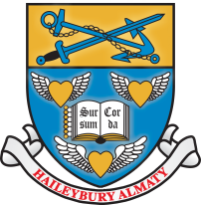
Haileybury Almaty Mission Statement and Aim
“Achievement for All”
Mission Statement
To provide our community with an educational experience which enables our students to fulfil their potential academically, physically, culturally and socially within a global and future context.
Aim
Our aim is to develop pupils who are resilient, resourceful, courageous, inquisitive, organized, and reflective in all that they do. Together, these qualities are known as the ‘Haileybury Habits’.
To achieve this aim, we:
- demand high standards of academic endeavour and personal development through a balanced and challenging curriculum, complemented by a rich extra-curricular programme;
- encourage our students to demonstrate ethical behaviour and to develop a keen understanding of their rights and responsibilities, the need for both teamwork and leadership, and the importance of contributing fully to society;
- reflect in ethos and action the traditions, values, heritage and cultural diversity of the Republic of Kazakhstan and Haileybury School.

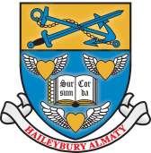
HAILEYBURY HABITS
Pupils of Haileybury Almaty are encouraged and expected to adopt the following habits.
Resilience
Our pupils do not give up at the first hurdle. They learn to set themselves challenging but realistic goals, to celebrate if they achieve them and to reflect on what they could have done differently if they do not. They try to stand on their own two feet, but know they have the support of others if they need it.
Resourcefulness
Our pupils think creatively, consider multiple approaches to problem-solving, and make full use of the resources available. They give due consideration to the ideas of others and are confident in putting forward their own ideas, however unusual they might be. Our pupils do not wait to be told what to do. They work things out for themselves and are not reliant on their teachers for everything they know. They ask the teacher as a last resort, not the first. They want to find out and do things for themselves. They generate solutions both individually and collectively and are able to think imaginatively and devise original responses.

Organisation
Our pupils understand the importance of organisation, planning, and thinking ahead in achieving success, either individually or as a team. They bring the correct materials to their lessons and are prepared to learn.

Courage
Our pupils are not afraid to take risks and make mistakes. They understand that taking on new challenges is important for their personal development, regardless of success. They stand up for what they believe in, challenge injustice and have a strong sense of right and wrong. They take responsibility for their actions. They respect the views of others but are not afraid to question them.

Inquisitiveness
Our pupils enjoy learning for its own sake. They see lessons as part of a learning process and undertake further research and enquiry outside the classroom. They use a wide range of resources intelligently and appropriately to support their learning. They are interested in what others have to say, and in the languages, cultures and beliefs of other communities around the world.

Reflection
Our pupils reflect on their experiences and are aware of their strengths and weaknesses. They know how to accept both praise and criticism and use both to become better learners and better people. They understand the need to develop physically and emotionally as well as intellectually and seek ways to achieve personal well-being.

As global citizens, our pupils are also aware of inequality and actively look for ways to make a difference. They are aware of global issues and have a social conscience. They understand their responsibilities as global citizens and as the future leaders in their fields. They help and support others without prompting. They understand and accept the differences in culture, language, appearance and beliefs of others, actively support the concept of universal human rights and treat all people with equal respect.

