Blue Gate Fields Junior School

Headteacher Pack



http://www.bluegatefields-jun.towerhamlets.sch.uk/

February 2018

King David Lane - London - E1 0EH
Contents

Welcome from Chair of Governors 3
Recruitment Process Details 4
About the School 5
Aims, Values & Ethos 5
School Curriculum 6
English and Literacy 6
Mathematics and Numeracy 6
SEND Policy 12
Pupil Outcomes 14
Ofsted Results 16
Pupil Premium 18
Financial Statement 20
Governors at Blue Gate Fields Junior School 21
Staff at Blue Gate Fields Junior School 22
Headteacher Job Description 24
Person Specification 24

Welcome from Chair of Governors

Dear Colleague,

Thank you for taking an interest in Blue Gate Fields Junior School – a three-form entry ambitious school, situated with the comparative wealth of the Docklands to the south and the City to the west in the area of considerable socio-economic deprivation in King David Lane – between the Highway and Cable Street. The school has a high percentage of pupil-premium children. The vast majority thrive and thoroughly enjoy coming every day to learn. This can be seen in the SAT results and above all, in the attitude of the children, who work hard to meet the high standards set. They strive to become creative, thoughtful individuals and leave ready to take on the challenges of secondary school and Life !
After more than twenty-five year’s service as head teacher, Kathy Halpenny retired in July 2016, and now we seek someone to continue to her outstanding work and lead our incredibly talented staff and pupils.
We look forward to interviewing candidates with a passion for teaching and learning, having confident leadership and communication skills ready to inspire and continue to create opportunities to bring to the juniors of Blue Gate Fields ever more exciting experiences, developing them to succeed as they grow and ever continue education into adulthood.

Best Wishes
Robert Oakley
Chair of the Governors – Blue Gate Fields Junior School

Recruitment Process Details

To start: September 2018

Salary range: L18 to L24 (£67,305 to £76,778)

Closing date for applications: 12 noon on 12th March 2018

Interview date: 26th March 2018

Visit essential, please call Margaret Conteh on 0207 790 3616 to arrange a visit

The Headteacher Job Description and Person Specification can be found at the back of this pack.
To apply for this role please complete the Tower Hamlets Application form.
In addition to the Application Form you are required to respond to the Person Specification requirements for this role with evidence and examples of your experience. You are not at this stage expected to respond to all points as many can only be established at interview. Your response to this should be no longer than 2 A4 sheets in Ariel 11 font.
You are also required to provide a Personal Statement explaining your leadership values with examples of your leadership style together with the reasons why you would like to be the new Headteacher of this school. Your Personal Statement should be no longer than 2 A4 sheets in Ariel 11 font.
If you have any questions about the role or the process of application, please call Andrew Best on 07917 080201.
We are committed to ensuring equality and diversity is central to the operation of our school through the staff we employ and the provision that we make.
We are committed to safeguarding and promoting the welfare of children and young people, and expects all staff to share this commitment. An enhanced DBS check is required for all successful applicants.

About the School
Our three-form entry school is a safe and stimulating environment where children encounter challenging and creative learning experiences.

Aims, Values & Ethos
At Blue Gate Junior School mutual respect underpins all that we do.


School Curriculum

English and Literacy
At Blue Gate Fields Junior School, we recognise how important it is for every child to develop the skills to:
- Read with enjoyment and understanding
- Express ideas clearly in writing, using grammatically correct sentence structures
- Use spoken English to communicate ideas, needs and opinions.
To support us in achieving our aim, we follow the Read Write Inc. Literacy and Language and Phonics programmes. The curriculum is enhanced by resources which use high quality literature and planning suggested by The Centre for Literacy in Primary Education (CLPE).
In addition to literacy lessons, classes enjoy reading stories together from sets of books.
Our library of 20,000 books houses a wide range of high quality fiction, non-fiction and poetry for pupils to borrow and read.
We regularly invite authors to visit our school to share with pupils the literature they publish, as well as their experience of writing and illustration.



Mathematics and Numeracy
The schools aim for mathematics are in line with the National Curriculum 2014 which aims to ensure that all pupils:
- become fluent in the fundamentals of mathematics, including through varied and frequent practice with increasingly complex problems over time, so that pupils have conceptual understanding and are able to recall and apply their knowledge rapidly and accurately to problems.
- reason mathematically by following a line of enquiry, conjecturing relationships and generalisations, and develop an argument, justification or proof using mathematical language
- can solve problems by applying their mathematics to a variety of routine and non-routine problems with increasing sophistication, including breaking down problems into a series of smaller steps and persevering seeking solutions.

Each term in years 3 and 4 pupils study:
• Number, place value and rounding
• The four operations
• Fractions [in year 4 this is extended to include decimal numbers]
• Measures
• Geometry [shape and space]
• Data handling
In years 5 and 6 pupils extend the above to include:
• Approximation and estimation
• Percentages
This is further extended in year 6 to include:
• Ratio and proportion
• Algebra
Pupils study each area of the numeracy programme each term, building on previously taught knowledge so learning becomes progressively more challenging and pupil knowledge is extended.Learning is based on an experiential and investigative approach with pupils understanding of each concept, not rote learning, being central to our philosophy.

Year 3 Curriculum Map

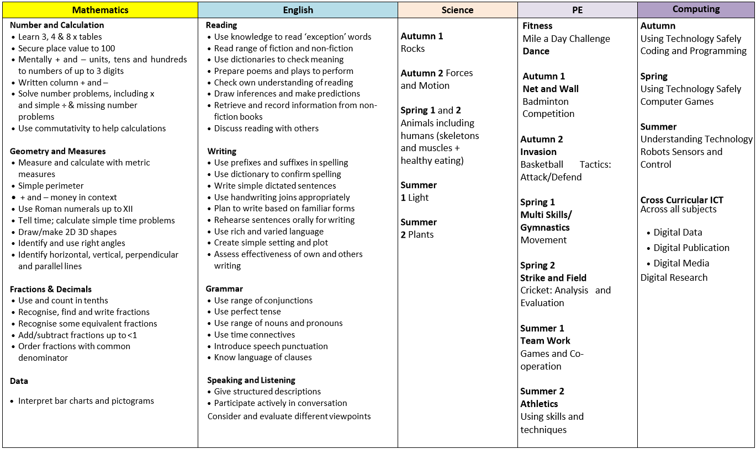
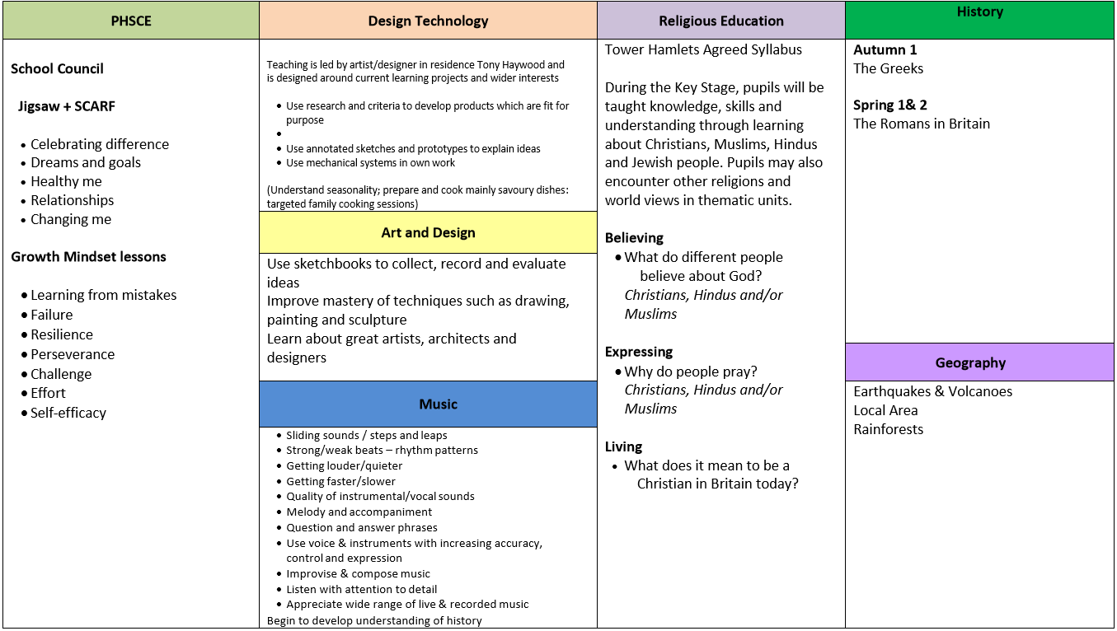
Year 4 Curriculum Map

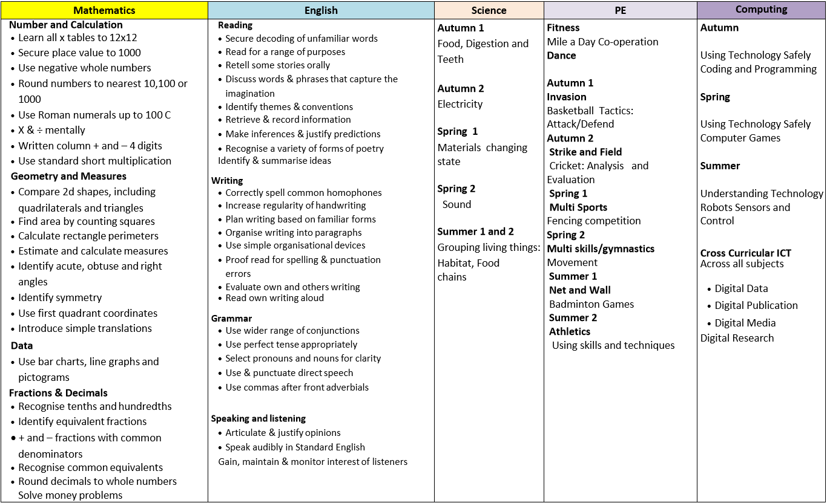
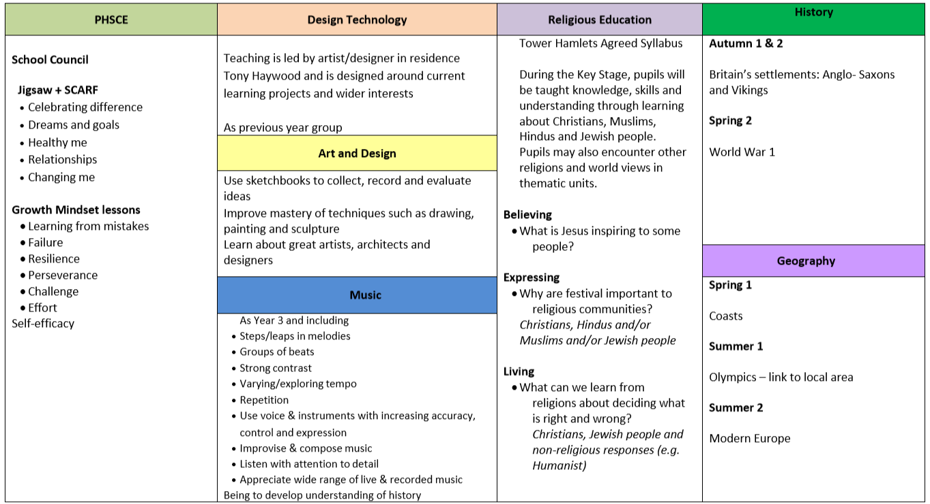

Year 5 Curriculum Map
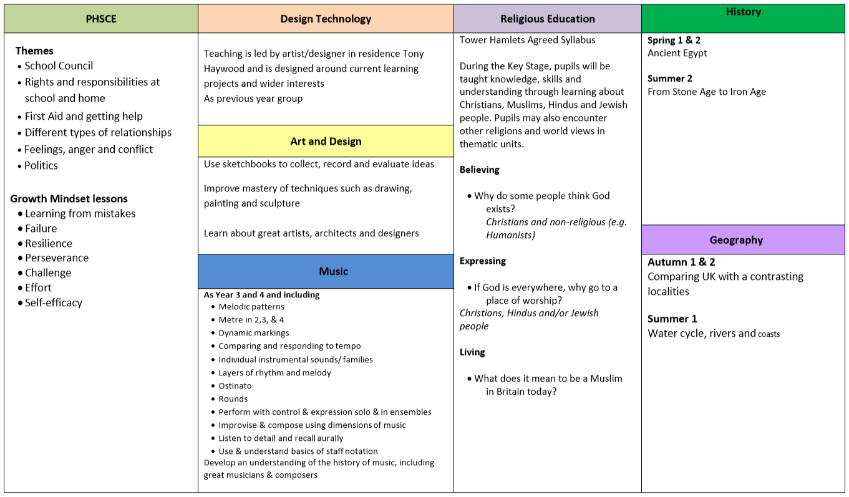
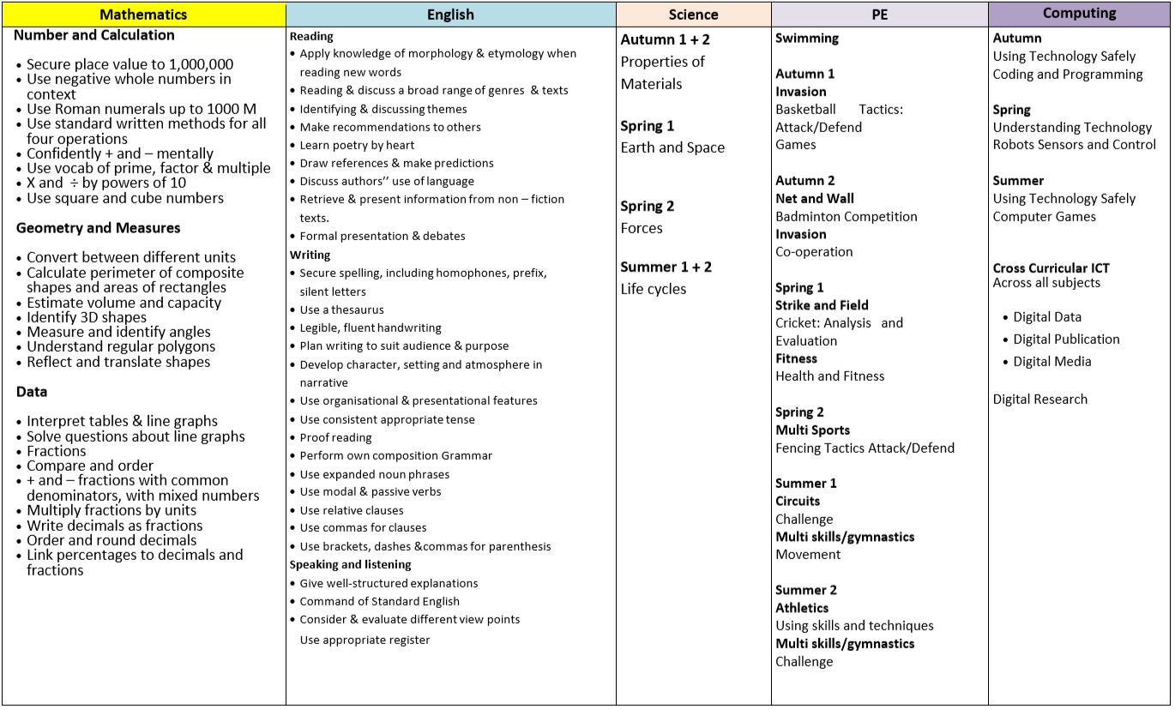

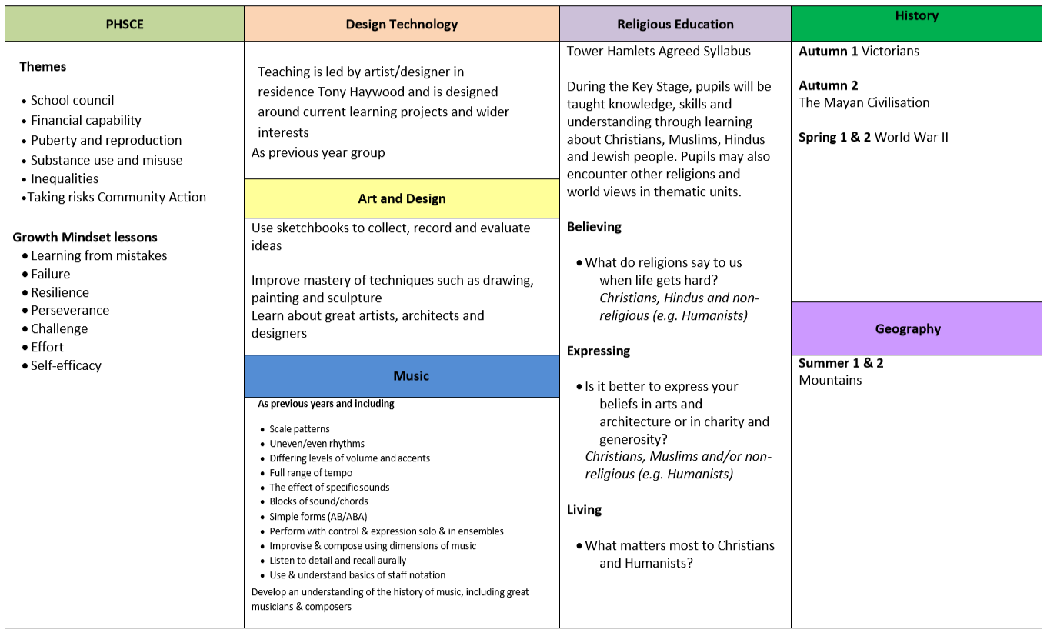
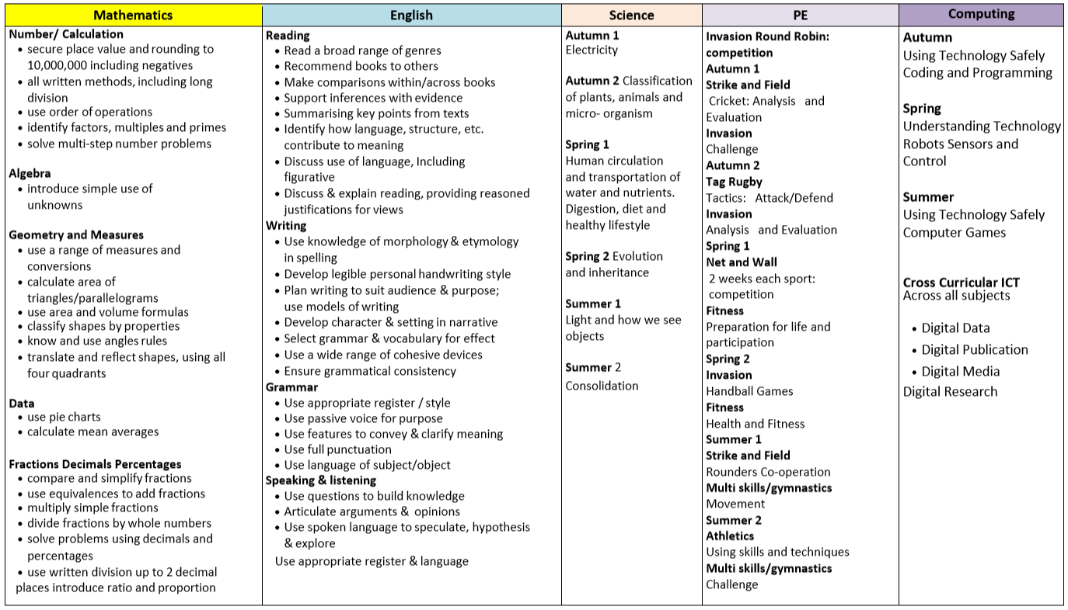
Year 6 Curriculum Map

SEND Policy

Our Ethos/ Vision
At Blue Gate Fields Junior School, we are committed to giving all our children every opportunity to achieve their best. The achievement, attitude and well-being of every child matters and inclusion is the responsibility of everyone within our school. Every teacher is a teacher of every pupil, including those with special educational needs and disabilities. We respect the unique contribution, which every individual can make to our school community.

Key Roles and Responsibilities
The SENCO has day-to-day responsibility for the operation of SEND policy and coordination of specific provision made to support individual pupils with SEND, including those who have EHC plans. The SENCO is a member of the leadership team and is also the designated teacher for Looked After Children (LAC). The SENCO is Parul Begum.
SEN Governor: The SEN governor is Rukeya Khan, who is one of our parent governors. She has responsibility for monitoring policy implementation and liaising between the SENCO and the Governing Body.
DCPO: The interim head teacher, Sian Acreman, has specific responsibility for safeguarding and is the Designated Child Protection Officer (DCPO)

Aims
At BGFJ all pupils, regardless of their particular needs, are provided with inclusive teaching which will enable them to make the best possible progress and feel that they are a valued member of the wider school community. We expect that all pupils with SEND will meet or exceed the high expectations we set for them against national data and based on their age and starting points. We will use our best endeavours to give pupils with SEND the support they need, whilst having access to a broad and balanced curriculum. Working in partnership with families, it is our aim that pupils will become confident individuals able to make a successful transition on to the next phase of their education.

Monitoring and evaluation of SEN
The head teacher regularly monitors and evaluates the quality of provision for all pupils. The school aims to use interventions in school that have proven outcomes and are evidence based. The impact of SEN provision on the progress and outcomes for children on the SEN register is measured through:
• Analysis of pupil tracking data and test results at pupil progress meetings
• Progress against national data and based on their age and starting points.
• Interventions baseline and exit data
• Progress against individual targets
• Pupils’ work and interviews
The SENCO maps provision for each class and uses the TH Provision Management Tool to cost provision. Decisions are made as to whether specific interventions are proving to be effective in terms of impact, time spent on them and the finance used in providing them. Each year we review the needs of the cohort and if necessary make changes to our provision.

Training and development
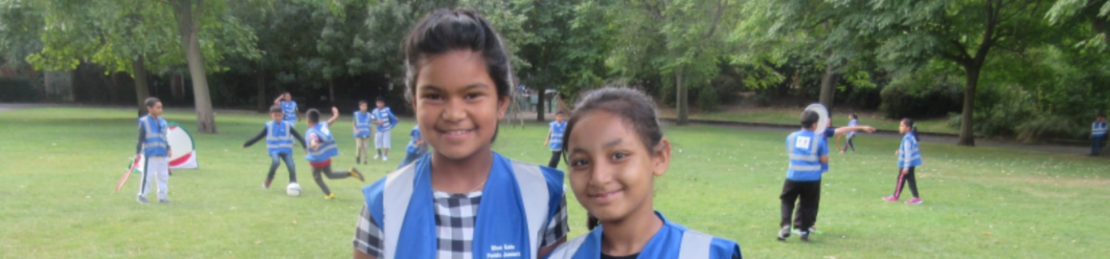
Training needs are identified in response to the needs of pupils currently on the SEN register. School staff have specific training and expertise in speech and language, literacy and numeracy interventions and supporting children with hearing impairment and Dyslexia. The SENCO attends network meetings to share good practice with colleagues and SENCO conferences termly to keep up to date with SEND developments.

Pupil Outcomes
In May 2017, our Yr6 pupils took statutory national curriculum tests in reading, grammar, punctuation and spelling (GPS) and mathematics. Writing assessments were based on teacher assessment from the Yr6 interim framework for assessment from the DfE. In addition to this, the school’s writing teacher assessments were moderated by an external moderator, who agreed with our moderation in all but two cases. Here pupils were assessed to be working at a higher level by the external moderator than by the school’s internal moderation procedures. We have adjusted our assessment procedures and guidelines in light of this.
At the end of KS2 results in each test are reported using a scaled score. A scaled score of 100 represents the expected standard for each test. If a child achieves a scaled score of 100 or more it means they are working at or above the expected standard in the subject. If a child achieves a scaled score of 110 or more it means they are working above the expected standard. The highest scaled score possible is 120, and the lowest 80 in KS2.
This data shows that our pupils performed exceptionally well in the National Tests in 2016 and achieved in excess of the national averages in all subject at almost every measurement.
The school’s primary learning focus during the academic year 20162017 was grammar, punctuation and spelling, and we are pleased that our results in this subject reflect positively the work that was undertaken.

Percentage of pupils working at or above the expected standard:
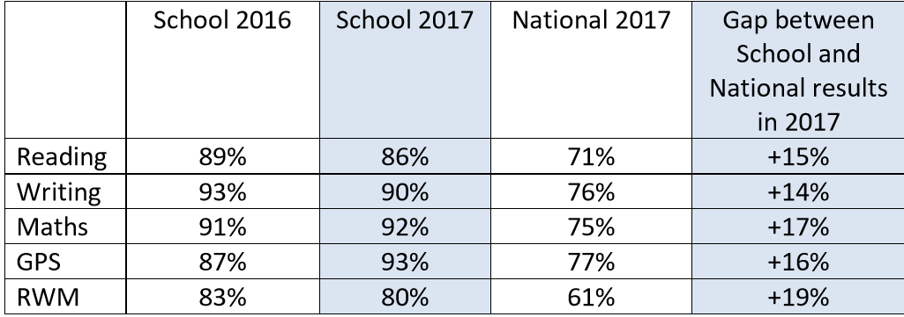

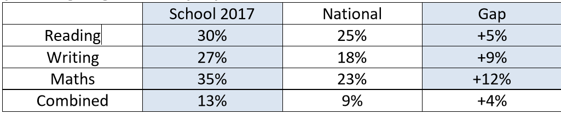
Percentage of pupils working above the expected standard:

Analysis of pupils working at the expected standard, or better, by groups (data obtained from ASP):
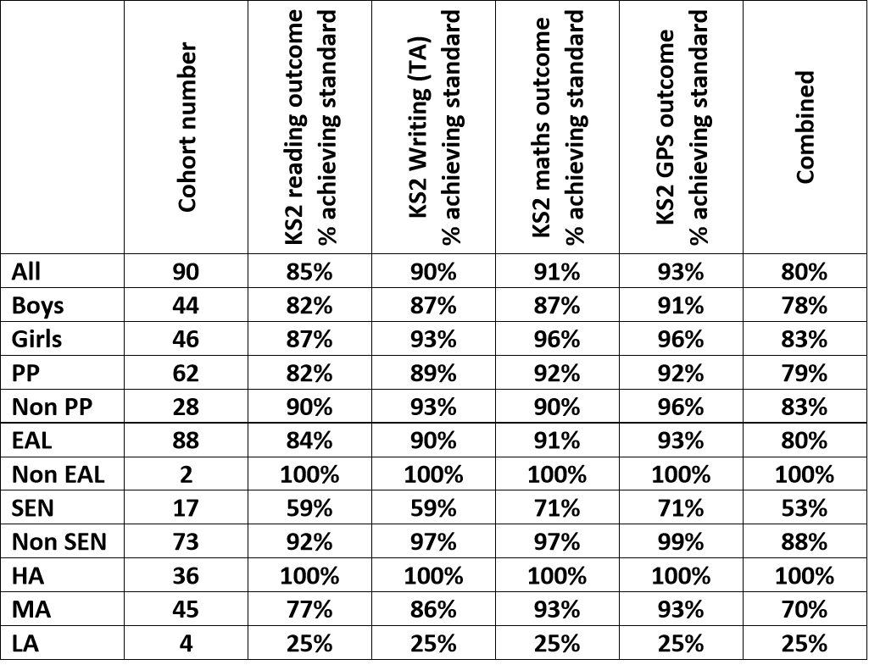

Ofsted Results


Inspection dates 10 Jun 2009

Main findings
Blue Gate Fields is an outstanding school in almost every respect. It has sustained a very high level of performance since the previous inspection and academic progress has been consistently outstanding since the last inspection. A key factor to this is the remarkable leadership of the headteacher. She has an exceptional understanding of the local community and parents and pupils hold her in very high regard. They are right to do so. Parents told inspectors that they were ‘extremely happy’, that they received ‘excellent support’ and that this is a ‘brilliant school’ that ‘goes the extra mile’.
The school has a wonderfully calm atmosphere that allows children to really learn but also have fun both in and outside of lessons. During the inspection a large group of older children returned from a local football academy, clearly having had a great day. Another younger pupil excitedly told an inspector about a trip outside of the city to the local countryside where it ‘was pitch black and you can see the stars’.
A vital element to the school’s continued success is the exceptional work of the home-school liaison team. They work in a highly personalised fashion with families to ensure that any problems affecting them that might create a barrier to the children’s success are overcome. They actively establish long-lasting relationships with families, but also readily respond to requests for assistance. A number of parents told inspectors how appreciative they were of this. Some parents clearly felt that the school had improved their families’ lives immeasurably and that it provided a service that they could always rely on.
A particularly noteworthy feature is the way in which the development of language skills is embedded across the school. Opportunities to develop speaking and listening were consistently seen across all subject areas and teachers never seem to miss a chance to ask a question or to interact with pupils. As a result, pupils can express themselves confidently in a range of situations. Writing is a high priority and even the least able produce work that is not only well presented but demonstrates thought and intellectual engagement. The well-resourced library, run by a full-time, highly committed librarian, is central to the school’s successful promotion of reading. Many children take books home not only for themselves but for siblings.
To continue this high level of performance the school needs to improve in two areas: governance and the monitoring of academic progress. Governance remains satisfactory, as it was at the last inspection, and is the reason why capacity to improve further is graded as good rather than outstanding.
Governors have shown greater commitment to the school over the past three years: they know the school better as they visit more regularly and attendance at governing body meetings have improved. They also have a fuller understanding of financial matters. However, they do not take enough responsibility for holding the school to account for its performance or involve themselves sufficiently in setting priorities for further improvement. To his credit, the chair of governors recognises this. The school can track the progress of pupils accurately because teachers have a very secure knowledge of each pupil and regularly sample and moderate the quality of work in books. However, the system for using this information to formally assess the quality of work on a regular basis is underdeveloped, particularly in Years 3, 4 and 5. Parents have recognised this, as a substantial minority reported to inspectors that they would like more regular information regarding their children’s academic progress. Senior leaders acknowledge this, and it is a key feature of the development plan.

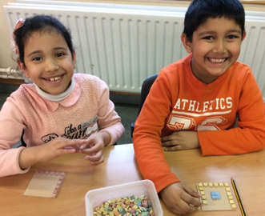
Pupil Premium
At Blue Gate Fields Junior School, staff and governors are committed to ensuring that teaching and learning provision meets the needs of all pupils so that every child makes the maximum progress in learning.
The Government believe that the Pupil Premium, which is additional to main school funding, is the best way to address the current underlying inequalities between children eligible for free school meals (FSM) and their peers. Pupil Premium does this by ensuring that funding to tackle disadvantage reaches the pupils who need it most.
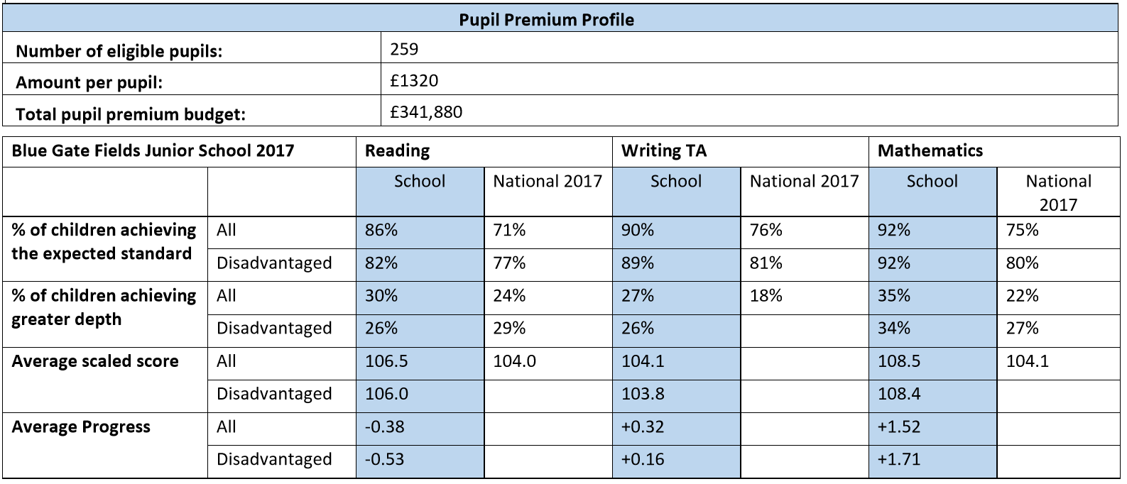
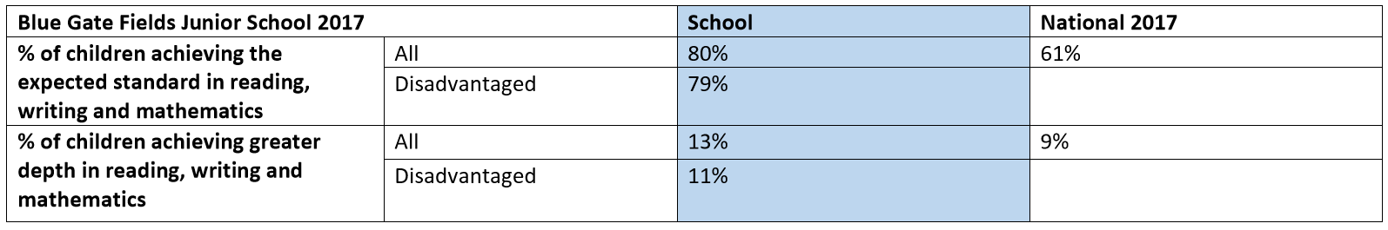
At Blue Gate Fields Junior School, we understand that our pupils experience significant barriers to educational achievement.
- Of 343 enrolled pupils, 98% of pupils are EAL (English as an additional language): September 2017,

- 65% of pupils are disadvantaged and are entitled to support through the Pupil Premium funding: September 2017,

- Parents often find supporting their children’s learning challenging. This is for a range of reasons, including high levels of EAL in the family; limited understanding of the expectations of school and the curriculum and in particular how the broader curriculum impacts positively on academic achievement; strategies and ideas used to support at home are based on the school experiences of the parents and are often very different to today’s teaching methods. Space for studying at home is at a premium with younger children in competition with older siblings for space and resources. Many families on low incomes do not have access to the internet or the financial resources to access cultural activities.

- We know that social and emotional well-being has a direct impact on pupil welfare and learning.

- We recognise that a broad range of cultural experiences adds value through contextualising learning.
We propose to use funding to support these areas of concern for the benefit of all of our children and, in particular, those statistically identified as being disadvantaged. We aim to remove every barrier to learning for our pupils.
We will employ additional teachers to make pupil: teacher ratios supportive of high quality teaching and learning. We will target interventions that focus on reading and basic skills.
Support for parents and families will be provided through clubs for parents and workshops that encourage involvement in school life, good pupil attendance and engagement with the education of their children.
Counselling for pupils experiencing social, emotional and behavioural barriers to learning is a high priority and will be provided by a learning mentor and school counsellors at an individual and whole class level.
We will fund activities that enhance and add value to the curriculum through access to a rich, cultural education that includes music, art and design, theatre and literature.

Financial Statement
The School has a good record of careful budget management and, despite the financial difficulties facing schools in the current economic climate, is anticipating a budget surplus close to 5% at the end of its financial year, March 2018.

Governors at Blue Gate Fields Junior School
Governors make collective decisions as part of the Governing Body. Our main purpose is to help raise the educational standards and performance of Blue Gate Fields Junior School by supporting the work of the Head teacher and school staff. We ensure that the school runs effectively, that quality teaching and learning is happening across the school, that the budget is spent wisely, and that Blue Gate Fields Junior School provides good value for money. We make strategic decisions on how the school is run and are answerable to parents, the wider community and most importantly the children who attend Blue Gate Fields Junior. We govern rather than manage giving direction and focus.

Robert Oakley Kazi Gous-Miah
Chair of Governors Co-opted Vice Chair of Governors Co-opted

Sian Acreman Shabbir Kawsar
Acting Headteacher Parent Governor

Md Sundoor Miah Nasima Khanom
Parent Governor Staff Governor

Shaheen Shahbady Rukeya Khan
Co-opted Governor Co-opted Governor

Patricia Lowe Alta Miah
Co-opted Governor Co-opted Governor

Alta Miah Azizur Rahman
Co-opted Governor LA Governor

Bashir Uddin Ahmed
Associate Governor

Staff at Blue Gate Fields Junior School

Leadership Team  Acting Head teacher:  Sian Acreman  Acting Deputy Head:  Joanna Bates  Assistant Head:  Parul Begum  School Support  Child Welfare Officer:  Patricia Lowe  Senco:  Parul Begum  Child Counsellors:  Julianne Mullen  ​Karen Jones  Speech & Language Therapists:  Jackie Brown  Zoe Carter  Home School Liaison:  Neila Momen  Caroline Diprose  ​Lydia Brenchley  School Bursars:  John Somerfield  David Waller  Premises Manager:  Terry McCarthy  Tom Mountain  Ground Maintenance:  Andy Willoughby  Louise Papachristoforou  School Kitchen  Kitchen Head Cook:  Lisa Ellis  Assistant Cook:  Edith Grech  Playground Support  Christine Wright  Afia Begum  Maria Delgado  IT Support  Dan Chalaye | Librarian  Sue Dearie  School Office  Office Manager:  Margaret Conteh  Admin Officers:  Afruza Hussain & Shahana Chowdhury  Receptionist:  Carole Walker  Teaching Staff  Mark Cooke  Sian Acreman  Joanna Bates  Parul Begum  Charlotte Cubitt  Kate Hennesy  Hanna Filfilan  Jackie Lythe  Salma Ali  Nasima Khanom  Parul Begum  Katherine Davis  Lucy Maciejowska  Linda Frances  Liz Miranda  Jashminara Khanom  Tatiana Goodchild  Louise Sloan  Hayley Doensen  Alice Peacock  Liz Miranda  ​Marina Rodes Prada  Artists In Residence:  Tony Hayward  China Chowdhury  Micheal Goody  ​Jerome Silsby  Julia Miranda  Liz Miranda  Lydia Brenchley  Higher Level Teaching Assistants:  Jenny Shelton  Madeline Pittaway  Shaheen Shahbady  Jackie Walsh  Teaching Assistants:  Habiba Ali  Linda Jackson  Ruth Bonnici  Aniqa Tahsin  Momtaz Syed  Saleha Hussain  Sharifun Nessa  Christine Wright  Emma Went  Tracy Walker  ​Jennifer Marfo

Headteacher Job Description
Reports to | The Governing Body/The Local Education Authority
The Headteacher is required to carry out the professional duties identified below, subject to the conditions of employment as set out in School Teachers’ Pay and Conditions Document. This job description should be read in conjunction with the National Standard for Headteachers (2015) which defines the high standards for all Headteachers within a self-improving school system.
Main Purpose | The Head Teacher will have overall responsibility for the organization, management and conduct of the school, providing professional leadership, vision and strategic direction in order to build upon its successes and ensure achievement of the highest possible standards in all areas of the school’s work, placing its pupils at the centre of all decisions.  The Head teacher will actively involve the community in the life and development of the school, developing a partnership with parents and the wider community, drawing from its richness and diversity to develop a vibrant school life.
Key Responsibilities
Leadership | The Headteacher will:  - Communicate compellingly a shared vision and ethos which inspires all members of the school community to excel.  - Provide professional and inspirational leadership to motivate, manage and develop staff, including appraising and managing performance.  - Maintain an enabled culture, with distributed leadership and responsibility, which recognizes and celebrates success.
Strategic Direction | The Headteacher will:  - Work with the Governing Body and staff to clearly articulate and implement a shared vision and strategic plan which is understood and acted upon effectively by all.  - Work within the school community to translate the vision into agreed objectives and operational plans, underpinned by sound financial planning, which will drive and sustain school improvement.  - Work with staff and the Governing Body to maintain the school improvement plan and identify priorities and targets based on robust school self –evaluation that ensures that pupils achieve high standards and make progress.  - Demonstrate vision and values in everyday work and practice.  - Motivate and work with others to maintain a shared culture and a positive climate.  - Ensure creativity, innovation and the use of appropriate new technologies to achieve excellence.  - Ensure that strategic planning and the school culture and curriculum take account of the diversity, values, experience and aspirations of the school and wider community.
Leading and Managing Staff | The Headteacher will:  - Develop, motivate and lead all staff to achieve the highest professional standards.  - Maintain an organizational structure which reflects the school’s values, and enables the management systems, structures and processes to work effectively in line with legal requirements.  - Delegate the responsibilities of the Senior Leadership Team to ensure the effective running of the school.  - Produce and implement clear policies and ensure that policies and practices take account of national and local circumstances, policies and initiatives.  - Manage the school’s financial and human resources effectively and efficiently to achieve the school’s educational goals and priorities.  - Recruit, retain and deploy staff appropriately and manage their workload to achieve the vision and goals of the school.  - Ensure job descriptions and performance management for all staff are based on clear roles and responsibilities, reviewed at least annually and consistent with current conditions of employment.  - Produce effective induction, CPD and robust performance management systems for all staff.  - Manage change effectively, drawing on expertise from both internal and external sources where needed.
Teaching and Learning | The Headteacher will:  - Ensure that children’s learning is at the heart of every decision; learning and teaching is central to all we do.  - Be actively involved in learning and teaching.  - Maintain an environment in which pupils are given the opportunity to expand their horizons beyond their previous experience, ensuring the highest standards of enjoyment and achievement for all pupils.  - Promote and maintain a successful learning culture that will enable pupils to become effective, enthusiastic, independent learners committed to lifelong learning.  - Promote a learning community which provides and values continuous professional development for all staff.  - Ensure the regular review of a broad, balanced, flexible, creative, engaging, relevant and differentiated curriculum for every child, designed to involve, challenge, stimulate and enthuse.  - Ensure that children are well-informed about their targets and progress.  - Promote and celebrate the positive benefits of living within a culturally and ethnically diverse society.  - Promote and maintain a culture of continuous improvement using comparative data and benchmarks to evaluate and improve performance based upon a sound process of effective planning and assessment for every child.  - Maintain creative, responsive and effective approaches to teaching and learning, promoting high expectations of teaching and monitor and evaluate its effectiveness on learning outcomes.  - Maintain strategies which are seen as consistent, firm and fair and that secure high standards of good behaviour, punctuality and attendance.  - Monitor, evaluate and review classroom practice and promote continuous improvement strategies, providing constructive feedback and relevant support.  - Challenge under-performance at all levels and ensure action is taken to secure improvement.  - Provide a curriculum and ethos in which children feel safe, recognise risks and know how to keep themselves safe.  - Take a strategic role in the development of emerging technologies to enhance and extend the learning experience of pupils.
Managing Resources | The Headteacher will:  - Manage and organise the school environment efficiently and effectively to ensure that it meets the needs of the curriculum and health and safety regulations.  - Ensure that the range, quality and use of all available resources are monitored, evaluated and reviewed to improve the quality of education for all pupils and provide value for money.  - Use and integrate a range of technologies effectively and efficiently to manage the school.  - Agree, set and monitor budgets and ensure systems are in place for effective administration and control of the budget.  - Ensure that the school meets its financial obligations and is in a sound financial position to achieve its objectives, working closely with Governors and proactively seek further funding opportunities as required.
Premises | The Headteacher will:  - Ensure the school premises are fit for purpose for current and future needs.  - Maintain sound procedures for the security, supervision and maintenance of the School environment ensuring that all health and safety regulations are met.
Partnerships | The Headteacher will:  - Maintain and encourage an ‘open door’ policy.  - Maintain the school ethos, which takes account of the richness and diversity of the school community.  - Listen to, reflect and act on community feedback.  - Maintain effective relationships with parents, carers, partners and the community to support and improve pupils’ achievement and personal development.  - Contribute to the development of the education system by, for example, sharing effective practice, working in partnership with other schools and promoting innovative initiatives.  - Seek opportunities to invite parents and carers, community figures, businesses or other organizations into the school to enhance and enrich the school and its value to the wider community.  - Collaborate with other agencies when providing for the academic, moral, social, emotional, spiritual and cultural well-being of children and their families.  - Work effectively with local schools and the local authority to deliver excellent outcomes for children.
Communication and Consultation | The Headteacher will:  - Build effective relationships with all stakeholders through excellent communication and interpersonal skills, taking and providing appropriate advice.  - Consistently use and develop information systems to ensure exemplary communication links with all stakeholders.  - Co-ordinate the school’s work with the next door infants school, as well as with secondary schools to ensure smooth transitions and continuity of learning.  - Regularly and effectively communicate the progress of every child’s learning to the relevant stakeholder.  Work with the Governing Body providing information, objective advice and support to enable it to meet its responsibilities.
Accountability and Governance | The Headteacher will  Have overall responsibility for safeguarding including safer recruitment and vetting and barring of staff, ensuring robust arrangements are in place for safeguarding and promoting the welfare of children.  Enable the Governing Body to continue to be as effective and knowledgeable about the school and to be able to fulfil its role of both challenging and supporting leadership.  - Advise and assist the Governing Body and attend all its meetings.  - Ensure individual staff and team accountabilities are clearly defined, understood and agreed and are subject to rigorous review and evaluation.  - Present a coherent and accurate record of the school’s performance in a form suitable to a range of audiences including pupils, parents, governors and others.  - Promote the positive and mutually supportive relationship linking home and school in a working partnership, ensuring parents and carers are fully informed about all matters relating to the education of their children and are well-informed about their targets and progress.  - Maintain a culture in which all staff recognise that they are accountable for the success of the school and its reputation.  - Engage the school community in the systematic and rigorous self-evaluation of the work of the school and work closely with the Governing Body to ensure that effective school self-evaluation informs school improvement priorities.  - Be an excellent communicator and listener, considering the views of others.
Professional Development | The Headteacher will  - Promote and maintain a learning community which provides and values continuous professional development for all staff.  - Build on and further develop the collaborative learning culture which positively embraces change and progression through staff empowerment and team work, as well as through the development of research based approaches.  - Lead by example and create a shared commitment and responsibility for the school through team work, distributed leadership and professional reflection.  - Develop leadership at all levels through leading and inspiring a team of staff and to promote the development of teamwork and collective responsibility to enable pupils to achieve their full potential.  - Continually improve and maintain effective strategies and procedures for staff induction, professional development and performance review.  - Identify emerging talents, coaching current and aspiring leaders in a climate where excellence is the standard, leading to clear succession planning.  - Treat people fairly, equitably and with dignity and respect.  - Regularly review own practice, set personal targets and take responsibility for own personal development.  - Manage own workload and that of others to encourage an appropriate work/life balance.

This school is committed to safeguarding and promoting the welfare of children and young people, and expects all staff to share this commitment. An enhanced DBS check is required for all successful applicants.
Review
This job description will be reviewed annually and may be amended to ensure that the needs of the pupils in school are being met or to reflect any changes in the role.

Person Specification
Category | Essential | Desirable
Skills, Personal Qualities and Behaviours | - Effective personal management style, balancing clear leadership with good humour and warmth.  - Emotional intelligence  - Intellectual rigour  - Confidence and resilience, energy and commitment  - High expectations of themselves and of others around them  - Commitment to children’s wellbeing and learning being at the centre of all key decision-making.  - Strong presentation, public speaking and writing skills, effective listening and negotiation skills  - The ability to tackle difficult issues, take hard decisions and convey outcomes clearly and sensitively  - Be able to be calm and organised under pressure, to prioritise, and demonstrate and share values by example  - Demonstrate and inspire loyalty: high standards and high care for the whole school community  - The ability to prioritise tasks, make informed decisions and implement them in a flexible manner. Evidence of the ability to delegate work where appropriate, building effective teams and monitoring implementation and impact.  - Excellent ICT skills and an understanding of the role of ICT in effective administration, management and teaching and learning.  - Proven suitability to work with children and commitment to safeguarding and promoting the welfare of children and young people
Qualifications | - Degree  - Qualified Teacher Status (QTS)  - Evidence of relevant continuing professional development which has an impact on school improvement | - NPQH  - Masters Degree  - Other professional/management qualification
Experience | - Proven successful leadership at senior level in a primary school  - An excellent practitioner, experienced across the primary phase, with a clear understanding of what being an outstanding practitioner entails.  - Experience of analysing pupil performance information and data to identify trends to inform teaching and learning outcomes.  - Experience of developing, implementing and evaluating strategies for raising standards and improving outcomes for all children.  - Experience of developing a consistently high quality of teaching and learning through rigorous assessment, monitoring, evaluation and feedback.  - Experience of developing a differentiated and creative curriculum for pupils with a diverse range of social, emotional, cultural, intellectual and physical needs.  - Experience of successful staff recruitment and selection and in conducting all aspects of staff performance management.  - Experience of successful financial planning and budget and resource management. | - Experience of having worked in a range of educational settings with children from diverse backgrounds.  - Proven experience of building mutually beneficial and supportive relationships with other schools, agencies and groups to enhance opportunities and outcomes for children and staff.  - Responsibility for transition of pupils e.g. KS1 to KS2.  - Experience and understanding of managing finance efficiently in accordance with benchmarking, financial management and best value principles.
Leadership / Strategic Direction | - Ability to innovate and find creative solutions and communicate and implement clear and strategic educational vision and direction, in consultation with all stakeholders, leading by example.  - Ability to accurately evaluate the performance of the school and plan effectively for school improvement.  - Ability to formulate objectives, policies and plans and monitor, evaluate and review the impact of these.  - Ability to create and develop a stimulating environment which promotes good behaviour and independent learning, and celebrates success.  - Excellent knowledge of the current major curriculum issues and recent educational developments and legislative changes, together with their significance for the leadership of a primary school.
Leadership and Management | - A track record of success in team work, distributed leadership, staff development, coaching, recruitment and retention.  - The ability to use performance management and line management to secure accountability and improve performance.  - Ability and willingness to challenge underperformance thereby improving outcomes for pupils.  - Success in improving attendance and punctuality.  - Ability to set and achieve challenging targets. | - Success in implementing change to staffing structures.  - Providing a culture of leadership opportunities for children, taking account of the pupil voice.
Teaching and Learning | - Knowledge and understanding of how to raise standards of learning across the school and a proven track record in doing so.  - Successful experience of promoting the personal, social, cultural and spiritual development of pupils.  - A commitment to providing an enriched curriculum throughout the school, over and above the day to day running of the school. | - A commitment to research based approaches and the development of practitioner research in school.
Relationships with Parents, Carers and the Wider Community | - Successful experience of creating and maintaining productive partnerships with pupils, parents, governors and other organisations in the wider community.

Appointment to this post is subject to a satisfactory enhanced DBS check. This post is exempt from section 4(2) of the Rehabilitation of Offenders Act, 1974, as the duties give you access to persons who are under the age of 18. Applicants are not entitled to withhold information about convictions, which would be regarded as spent for other purposes.

