

APPLICATION PACK
TEACHER OF SCIENCE

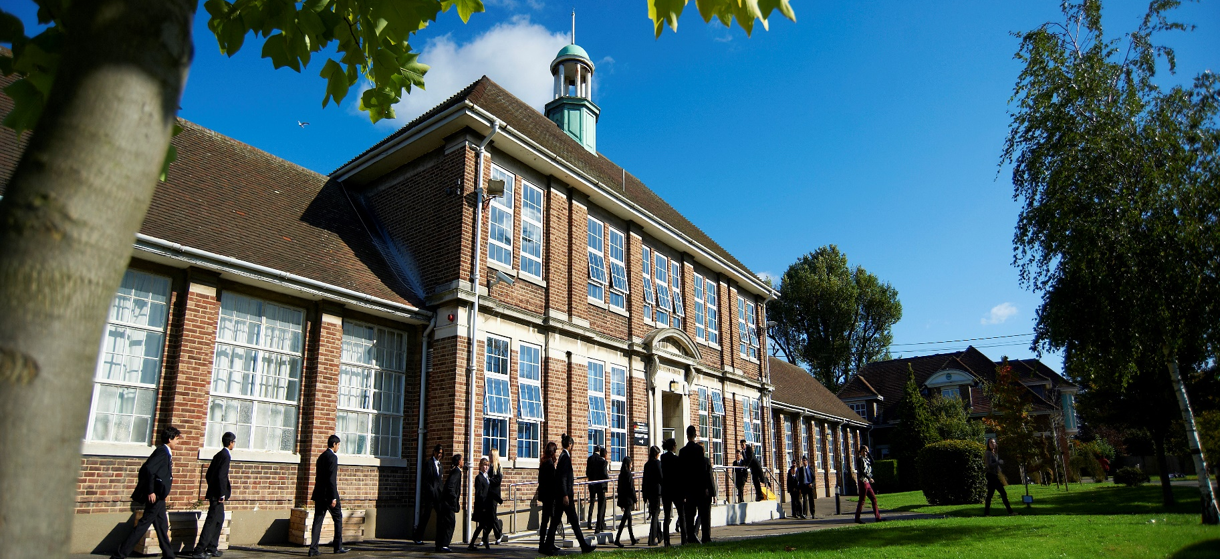

Dear Applicant
Thank you for your interest in the post of Teacher of Science at our School. The School has secured a top 10% progress score, as measured by value added, for the past four years and the successful applicant will play a key role in sustaining this success.
Heston is a high performing, fully inclusive and comprehensive Community School, with approximately 1250 students including 270 in our Sixth Form. Occupying approximately ten acres, adjacent to Osterley Park, the School boasts its own leisure centre and fantastic sports facilities, including several multi-surface pitches and a specialist Centre for the Hearing Impaired, serving Hounslow and the surrounding Boroughs.
I trust that the advert and person specification make clear that, first and foremost, we are looking for an exceptional Teacher of Science who can demonstrate a strong track record of delivering excellent academic outcomes - a colleague who will add value to the Science Team.
As with every application pack, it is near impossible to capture definitively the nature and character of the School or the full extent of the role for which you are applying. However, the key qualities that we are looking for in every appointment are intelligence, integrity and a capacity for sustained hard work - professionals that never shy away from rolling up their sleeves to ensure that no member of the School community ever feels that they must work in isolation.
Though I appreciate it is not always possible, I would encourage you to visit the School prior to making an application, to see for yourself the community of staff and students you would join. I am confident that you will experience what many of our visitors comment on: ‘Students enjoy coming to school, work hard and have excellent relationships with their teachers.’ [Ofsted 2016]

Yours sincerely

Mr Ranjit Berdesha
Headteacher


Heston is a high performing School that consistently achieves a Value Added score that places it in the top 10%, or better, of schools nationally. The tables below provide a summary of our Key Stage 4 and 5 examination results

KEY STAGE 4
Progress 8 Score | 2015 | 2016 | 2017
Whole School | 0.74 | 0.47 | 0.90
English Element | 0.49 | 0.23 | 0.78
Maths Element | 0.22 | 0.09 | 0.73
EBACC Element | 0.85 | 0.7 | 0.88
Open Element | 1.13 | 0.67 | 1.10
Attainment
9 – 4 EM | 55% | 64 | 76%
9 – 5 EM |  |  | 50%
5+ Standard Passes Incl. EM | 55% | 68% | 75%
5+ Good Passes Incl. EM |  |  | 50%
Ebacc | 19% | 42% | 27%

KEY STAGE 5
A* - B | 47% | 47% | 36%
A* - C | 77% | 73% | 67%
A* - E | 98% | 98% | 97%
Vocational Average Grade per entry | Distinction* | Distinction* | Distinction*


THE SCIENCE CURRICULUM AREA

TEAM OVERVIEW

Heston Community School’s Science Team aims to broaden students’ horizons and help them develop an understanding of the world and its citizens. Our emphasis is on asking and answering questions, big and small, to develop our students’ resilience and thinking skills. The Science Team expects its students to compete with students from any state or independent school to enter onto the best possible degree courses at the most respected universities. Destinations in 2017 included:

London School of Economics | Actuarial Science
University of Kent | Actuarial Science
University of the Arts London | Advertising
University of Reading | Ancient History and Archaeology
University of Warwick | Biomedical Science
Royal Holloway, University of London | Economics
Royal Holloway, University of London | English
University of Southampton | English
University of the Arts London | Graphic Design
University College London | Information Management for Business
University of Cambridge | Law
University of Southampton | Mechanical Engineering
University of Leicester | Medical Biochemistry
Royal Holloway, University of London | Modern and Contemporary History
Royal Holloway, University of London | Physical Geography
King's College London | Physics
King's College London | Physics
King's College London | Physics
University of Nottingham | Physics
University of St Andrews | Physics
University of York | Politics with International Relations
University of Reading | Psychology

CURRICULUM OVERVIEW

Heston Community School’s philosophy that every child matters is reflected in the work of the Science Team. Science is taught across the age and ability range at KS3, KS4 and KS5. Biology, Chemistry and Physics pathways remain popular at Post-16.

STAFFING

The Team is led by a Director who is supported in this role by two Assistant Curriculum Leaders. The Science Team comprises 11 full-time teachers. New staff are offered an Induction Programme to facilitate their entry into the life of the School and the community and there is a specific, one year NQT Induction Programme.

CURRICULUM ACCOMMODATION

The Science Team has a suite of designated teaching rooms in the Osterley building, equipped with interactive whiteboards.


Heston Road
Heston
Hounslow
TW5 0QR

www.hestoncommunityschool.co.uk
Email: info@hestoncs.org
Telephone: 020 8572 1931

