Social Sciences Faculty
Recruitment Information Pack

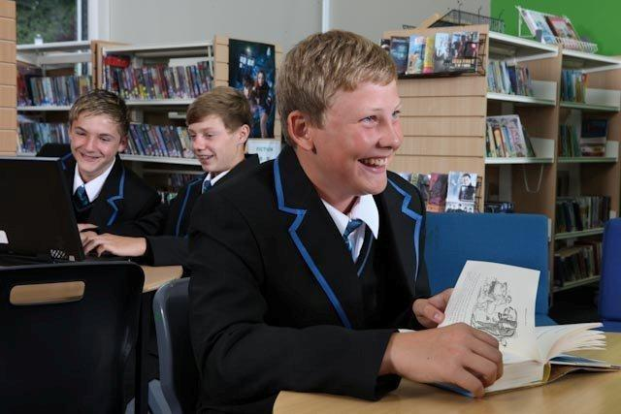

Hall Lane, Dovercourt, Harwich, Essex, CO12 3TG

“Working and learning together”

Social Sciences Faculty
Social Sciences is a key part of The Harwich and Dovercourt High School. History and Geography are taught as foundation subjects twice a week throughout KS3 and are both very popular option subjects at KS4 and KS5. In Geography we deliver the AQA Geography specification with units on Earth Hazards, The Living World, Changing Economic World and Urban Challenges. The UK landscapes we explore are coastal and river landscapes. In History we study Medicine Through Time, Weimar and Nazi Germany, The American West and the Norman Conquest following the Edexcel exam specification.
RE, Child Development, Health and Social Care, Sociology and Psychology are also taught at KS4. The faculty consists of seven specialist teachers (including a Lead Practitioner) who are innovative, forward thinking and mutually supportive. The faculty itself is housed in eight teaching rooms which are light and airy and have good display space. All rooms have interactive whiteboards and projectors. We also have a specialist suite for Sixth Form lessons.
GCSE performance in History and Geography shows a record of strong improvement. We also have a strong record of success in the Sixth Form.
We feel that educational experiences outside the classroom are vitally important. We encourage activities around the school grounds and within the town. We also run a range of field trips, both one day and residential, which always have a high take up. In the past year we have visited: Colchester Zoo, Imperial War Museum, London Olympic Site, Natural History Museum, Brighton and Berlin.
Assessment is an integral part of our teaching. We regularly assess and monitor performance in the light of targets set. We use assessment for learning strategies through summative, formative, peer and self - assessment to show students what they need to do to raise their attainment and to encourage them to take a more active role in the assessment of their work.
The faculty employs teaching strategies which take account of different learning styles. An experiential approach to learning has been both rewarding and educational to students throughout the key-stages and is used whenever possible. Faculty staff have also played a key role in the development of teaching and learning across the school, with Social Sciences identified as a beacon department for good practice.
ICT in the classroom is an invaluable resource. Each classroom has its own chromebook and projector for interactive learning and other stimulating IT resources. Student chromebooks and dedicated ICT rooms are also available for students.
These are exciting times for Social Sciences. We have worked hard to raise the profile of the Faculty and increase student achievement and enjoyment. The Faculty has enjoyed great success in these areas and has expanded rapidly as a result. It is now seen as an area of strength by school leaders, staff, parents and, most importantly, students.

