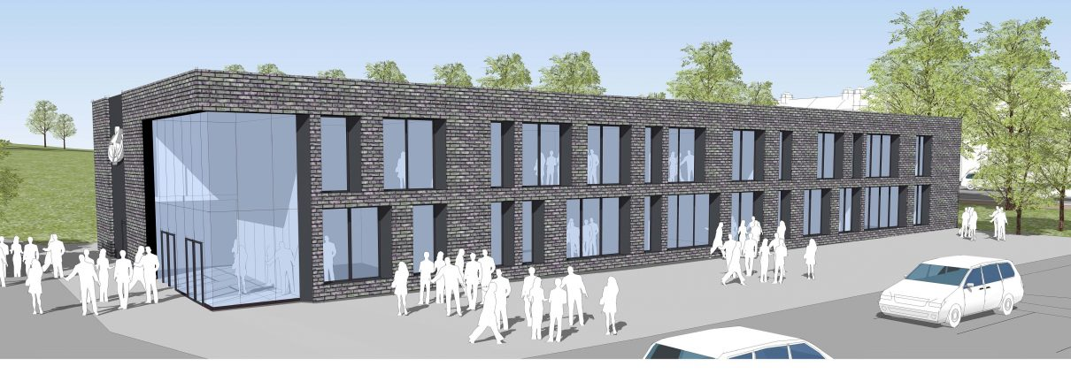

Todmorden High School
Site Team Member
Part time 16 hours +
LG Scale, SCP14-17
Closing Date: 22 January 2020 (9.00am)

Todmorden High School is an aware employer is committed to safeguarding and protecting the welfare of children and vulnerable adults as its number one priority. This commitment to robust recruitment, selection and induction procedures extends to organisations and services linked to the School on its behalf. This post is subject to an enhanced DBS check. We value variety and individual differences, and aim to create a culture, environment and practices at all levels which encompass acceptance, respect and inclusion.

Job Description

Site Team Member
Todmorden High School is an aware employer is committed to safeguarding and protecting the welfare of children and vulnerable adults as its number one priority. This commitment to robust recruitment, selection and induction procedures extends to organisations and services linked to the School on its behalf. This post is subject to an enhanced DBS check. We value variety and individual differences, and aim to create a culture, environment and practices at all levels which encompass acceptance, respect and inclusion.

Purpose and objectives of the role
Working as a Site Team Member you’ll provide support to pupils, teachers and team members with site and maintenance responsibilities. You will work across the school in different departments using a wide range of skills all aspects of building development and maintenance.

Responsibilities
You’ll need excellent communication skills as you will regularly answer the site telephone and liaise with members for the public and staff regarding school-related enquiries. You’ll need good attention to detail to ensure your work is accurate, and have resilience to manage conflicting demands and priorities, as well as personalities.

Below is a summary of your key roles and responsibilities:

Role Specific
- Answer the site telephone professionally and politely
- Liaise with members of the public, students and staff regarding site-related enquiries
- Contribute to the values and vision of the school
- Appreciate and support the work of other professionals
- Attend and participate in relevant meetings
- Participate in training and other learning activities and performance development
- Compliance with all necessary policies and procedures relating to child protection, equality and diversity, health, safety and security, confidentiality and data protection, reporting all concerns to an appropriate person
General
- To deputise for other team members when absent.
- To participate in whole-school initiatives and events as relevant
- To carry out any other reasonable task commensurate with the role and its level.

Person Specification Site Team
A = Application form C = Certificates I = Interview R = References
Qualifications
 | Essential | Desirable | Source
Excellent level of education | E |  | A,C
Previous work experience |  | D | A,C
Willingness to engage in further study, inc First Aid | E |  | A, C
Skills and Knowledge
Professional and confident manner | E |  | A, I
Strong customer care skills | E |  | A, I
Able to resolve problems and think creatively | E |  | A, C
Able to meet strict deadlines | E |  | A
Ability
Able to work within a team and alone and with initiative | E |  | A, I

Professional attributes
To be able to demonstrate an understanding, awareness and empathy for the needs of the pupils at this school. | E |  | I
To be able to support our behaviour management strategies | E |  | A, I
To have excellent written and oral communication skills (which will be assessed at all stages of the process) | E |  | A, I
Show a good commitment to sustained attendance at work. | E |  | R
Personal qualities
Continue to promote the school’s strong educational philosophy and values | E |  | A, I
Inspire, challenge, motivate and empower teams and individuals to achieve high goals |  | D | A, I
Inspire trust in the school community |  | D | I
Demonstrate personal enthusiasm and commitment aimed at making a positive difference to children and young people | E |  | A, I
Build and maintain quality relationships through interpersonal skills and effective communication | E |  | A, I
Demonstrate personal and professional integrity, including values and vision | E |  | A, I, R
Prioritise, plan and organise yourself | E |  | A, I
Think analytically and creatively and demonstrate initiative in solving problems | E |  | A, I
Be aware of own strengths and areas for development and listen to, and reflect constructively and act upon as appropriate feedback from others | E |  | A, I
Demonstrate a capacity for sustained hard work with energy and vigour | E |  | I
Confidential references and reports
A positive recommendation from all referees, including current employer | E |  | R
Application form and supporting statement
The form must be fully completed and legible. The supporting statement should be clear, concise and related to the specific post.

