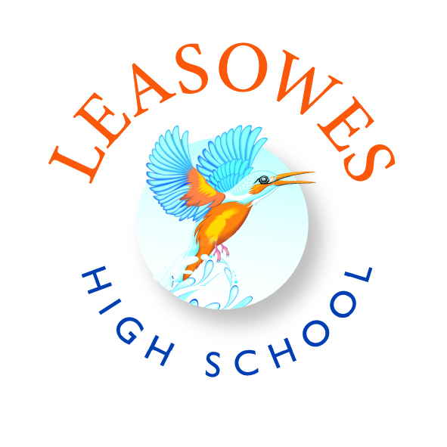
Welcome to the English Department

Thank you for the interest you have shown in applying for a post here at Leasowes High School part of the Invictus Education Multi Academy Trust. We are an 11-18 school and opened our Sixth Form in September 2017. We currently have 751 students on roll.

The Trust consists of 6 schools as follows:
Leasowes High School and Sixth Form
Ellowes Hall Sports College
The Crestwood School
Kinver School
Ounsdale School
Pedmore Technology College

The English Department consist of:
Mr Michael Steven – Head of English
Mrs Wendy Turner – Deputy Head of English
Ms Upkar Kaur – Assistant Head of English
Mr Matthew Abley – Teacher of English
Mr Bradley Hodnette – Teacher of English
Mrs Jo Atherton – Teacher of English

Department information/Facilities:

KS3 - English
Time Allocation:
In Years 7 and 8, pupils will have 4 x 55min lessons a week.
Curriculum Content:
Year 7 | Year 8
- Introduction to Shakespeare  - Messages and Morals  - The Boy in the Striped Pyjamas | - The Hunger Games  - Our Day Out  - Characterisation

Within each scheme of work students also study a range of non-fiction texts, such as newspaper articles, letters and speeches, as well as analysing poetry examples linked to each topic. Furthermore, each unit of work includes, presentation tasks, debating activities and creative writing tasks too.
Assessment:
Each half term students will complete either a reading or writing based assessment task, which focuses on the skills required at GCSE. These include: inference, language analysis, comparison, descriptive writing and writing to argue a viewpoint.

SMSC links:
spiritual, moral, social and cultural
Students explore the importance of religion in society when studying texts from a historical time period, such as Shakespeare and Dickens.
Many texts studied include their own morals, which are discussed as part of the schemes of work. As well as a full unit focused on texts with a moral or message in year 7, students consider the ethics of The Holocaust and the dystopian society presented in The Hunger Games.
Students use a range of social skills within the classroom when working in pairs and in groups to prepare presentations. In addition to this students consider social trends within the texts and how society has changed over the course of time.
They will learn a lot about the culture of different social groups during different time periods, especially through the non-fiction texts that are also studied alongside the schemes of work.

KS4 – English Literature
Time Allocation:
In Years 9, 10 and 11, pupils will have 4x55minute lessons per week.
Curriculum Content:
The English Literature qualification is comprised of two papers: Paper 1, Shakespeare and the 19th Century Novel and Paper 2, Modern texts and Poetry. Paper 1 has 2 sections, each worth 20% of the GCSE qualification whilst Paper 2 has 3 sections, each worth 20% of the GCSE qualification. The specification is fully co-teachable with GCSE English Language. Students will greatly benefit from the transferable skills learnt across the two subjects.
Year 9 | Year 10 | Year 11
- Romeo and Juliet.  - Of Mice and Men.  - Poetry. | - Modern Text. Either  - An Inspector Calls  - Blood Brothers  - Power and conflict Poetry from the GCSE Anthology. | - 19th Century Novel. Either  - Frankenstein  - A Christmas Carol  - Shakespeare. Either  - Romeo and Juliet  - Macbeth  - Unseen Poetry.

Assessment:
Each half term students will complete either a reading or writing based assessment task, which focuses on the skills required at GCSE. These include: inference, language analysis, comparison, descriptive writing and writing to argue a viewpoint.
Additionally, students complete the following Mock examinations: 19th Century Novel and An Inspector Calls in November Yr 11, Shakespeare, Poetry Anthology and Unseen Poetry in March of Yr 11.
SMSC Links:
Students explore the importance of religion in society when studying texts from a historical time period, such as Shakespeare, Shelley and Dickens.
Many texts studied include their own morals, which are discussed as part of the schemes of work, such as attitudes towards, and treatment of, the working classes in Edwardian society.
Students use a range of social skills within the classroom when working in pairs and in groups to prepare presentations. In addition to this students consider social trends within the texts and how society has changed over the course of time.
They will learn a lot about the culture of different social groups during different time periods, especially through the poetry examples studied.

KS4 – English Literature
Time Allocation:
In Years 9, 10 and 11, pupils will have 4 x 55minute lessons per week.
Curriculum Content:
The English Literature qualification is comprised of two papers: Paper 1, Shakespeare and the 19th Century Novel and Paper 2, Modern texts and Poetry. Paper 1 has 2 sections, each worth 20% of the GCSE qualification whilst Paper 2 has 3 sections, each worth 20% of the GCSE qualification. The specification is fully co-teachable with GCSE English Language. Students will greatly benefit from the transferable skills learnt across the two subjects.
Year 9 | Year 10 | Year 11
- Romeo and Juliet.  - Of Mice and Men.  - Poetry. | - Modern Text. Either  - An Inspector Calls  - Blood Brothers  - Power and conflict Poetry from the GCSE Anthology. | - 19th Century Novel. Either  - Frankenstein  - A Christmas Carol  - Shakespeare. Either  - Romeo and Juliet  - Macbeth  - Unseen Poetry.

Assessment:
Each half term students will complete either a reading or writing based assessment task, which focuses on the skills required at GCSE. These include: inference, language analysis, comparison, descriptive writing and writing to argue a viewpoint.
Additionally, students complete the following Mock examinations: 19th Century Novel and An Inspector Calls in November Yr 11, Shakespeare, Poetry Anthology and Unseen Poetry in March of Yr 11.
SMSC Links:
Students explore the importance of religion in society when studying texts from a historical time period, such as Shakespeare, Shelley and Dickens.
Many texts studied include their own morals, which are discussed as part of the schemes of work, such as attitudes towards, and treatment of, the working classes in Edwardian society.
Students use a range of social skills within the classroom when working in pairs and in groups to prepare presentations. In addition to this students consider social trends within the texts and how society has changed over the course of time.
They will learn a lot about the culture of different social groups during different time periods, especially through the poetry examples studied.

Exam Boards
GCSE English (AQA)

