TEACHER OF ENGLISH
Full time (maternity cover)

Teacher of English

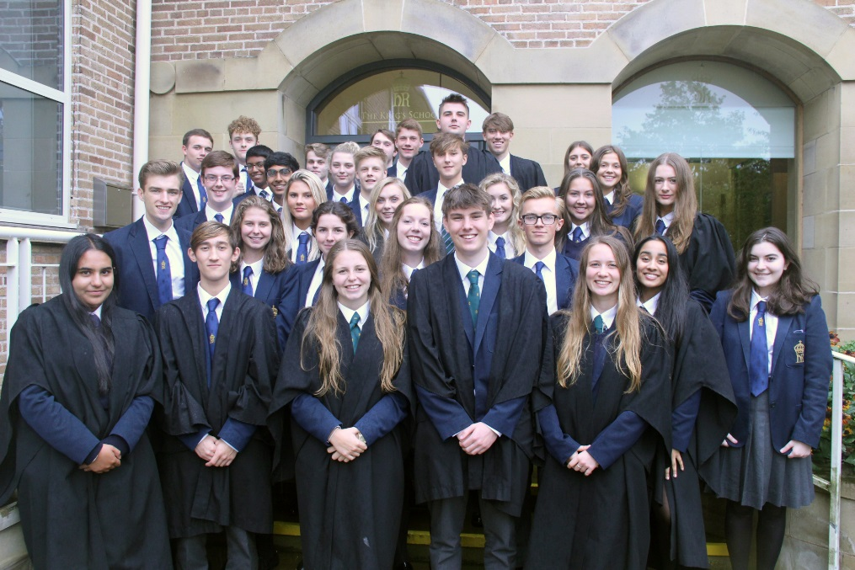
THE KING’S SCHOOL
King’s is an academically selective, co-educational independent school originally founded in 1541 for the ‘poor and friendless’ children of Chester. Almost 500 years later, King’s is a thriving, dynamic and forward-thinking school of 1100 pupils that is considered to be one of the very best of its kind in the country.

At King’s we aim to make the very most of every individual student in the school, both academically as a selective school with a great tradition of scholarship, but also in terms of character development, confidence and wellbeing. This is achieved by a broad curriculum, extensive co-curricular programme, excellent pastoral care and highly committed and professional staff. We want our pupils to remember their time at school with real fondness whilst relishing the prospect of successfully making their mark on the world and leaving it a better place.

The school enjoys a spacious and well-resourced site on the southern outskirts of Chester, having moved from a city centre location in 1960. Our new, state-of-the-art infant school, Willow Lodge, was built 4 years ago with the Junior School being impressively extended a year beforehand. A major site development plan is in progress for the Senior School, with a new £5million Sports Centre due to open this year. The school retains close links with Chester Cathedral where it holds regular services, including a traditional Service of Nine Lessons and Carols at Christmas.

King's comprises the Senior School (ages 11-18), the Junior School (ages 7-11) and the Infant School (Willow Lodge, ages 3-11). There are currently 730 pupils in the Senior School (200 in the Sixth Form), 250 pupils in the Junior School and 120 in the Infants, supported by almost 250 staff (teaching and support). In 2018 the students achieved 72% A*- A at GCSE and 87% A*- B at A level. There are over 100 activities and clubs in the Senior School for students to choose from on a weekly basis. The major sports are football, hockey, cricket and rowing for boys and netball, hockey and rowing for girls. Drama, music and the CCF are also all particularly strong.

Further information about the school can be found on our website: www.kingschester.co.uk
Teacher of English

THE OPPORTUNITY
We seek to appoint a well-qualified graduate teacher of English for January 2019 for a period of maternity cover. This is a full time appointment, preferably for two terms. The successful applicant will ideally have the ability to teach English Language to A level and will have the following attributes:
- a real passion for their subject and excellent subject knowledge,
- the ability to inspire and encourage students’ in their learning and treat them as individuals,
- an enthusiastic willingness to work collaboratively and productively as part of a team,
- a strong commitment to the co-curricular life of the school and an appreciation of its importance in the development of young people.

The person appointed will be expected to contribute to all other duties normally shared by members of the department, such as marking, writing reports, setting work in case of absence, attending departmental meetings and appropriate administrative tasks. All members of the teaching staff are expected to take on duties as a Form Tutor.
THE LANGUAGES AND HUMANITIES FACULTY
All departments at King’s are part of a faculty structure, with Heads of Departments responsible directly to the four Heads of Faculty, who in turn will report to the Deputy Head Academic. The Languages & Humanities Faculty comprises, Classics, English, History and Modern Languages and is led by Seb Neal.
Teacher of English
THE ENGLISH DEPARTMENT
The department consists of 6 teachers and is central to the school’s academic development. Regular departmental meetings are held and the department’s development plan will be available on request.
Staff are encouraged to take on responsibilities within the department. Like most English departments in the country, we are on a rolling programme of change and development and our focus this year has been reflecting on the curriculum and assessment at KS4. Members of the department regularly go on INSET and then lead department meetings upon their return.
The department teaches the AQA spec B specification for A level Literature and OCR for English Language A level. In the upper sixth there are currently two sets taking Literature and two taking Language, and in the lower sixth there are two Language sets and one Literature set. Students follow English Language and Literature AQA GCSEs.
Exam Results (%) 2018
A level | A* | A | B | C | D | E
Language | 0 | 31 | 54 | 15 | 0 | 0
Literature | 40 | 50 | 10 | 0 | 0 | 0
GCSE | Grade  9-8 | Grade 9-7 | Grade 9-6 | Grade 9-4 | Grade 9-3
Language | 27 | 57 | 87 | 98 | 100
Literature | 33 | 59 | 82 | 100 | 0
We are very well resourced in books, having an excellent and ever-increasing stock. At KS3 texts range from Two Weeks with the Queen and Refugee Boy for Year 7 (known as the Removes) to Animal Farm and Martyn Pig for Year 9 (known as the Thirds). There is a fiction library in one of the main English teaching rooms and the department has an office where staff have their desks/PCs and tablets. All the English teaching rooms have a projector linked to a PC and are equipped with visualisers and in some cases interactive whiteboards. Mobile ICT facilities are fully established with most year groups having access to their own tablets. The school library is an excellent resource and is well used by the department.
Drama is taught in distinct Drama lessons at KS3 and is growing in popularity at GCSE and A level. Lessons are delivered by the Director of Drama, who also manages the Vanbrugh Theatre.

Teacher of English
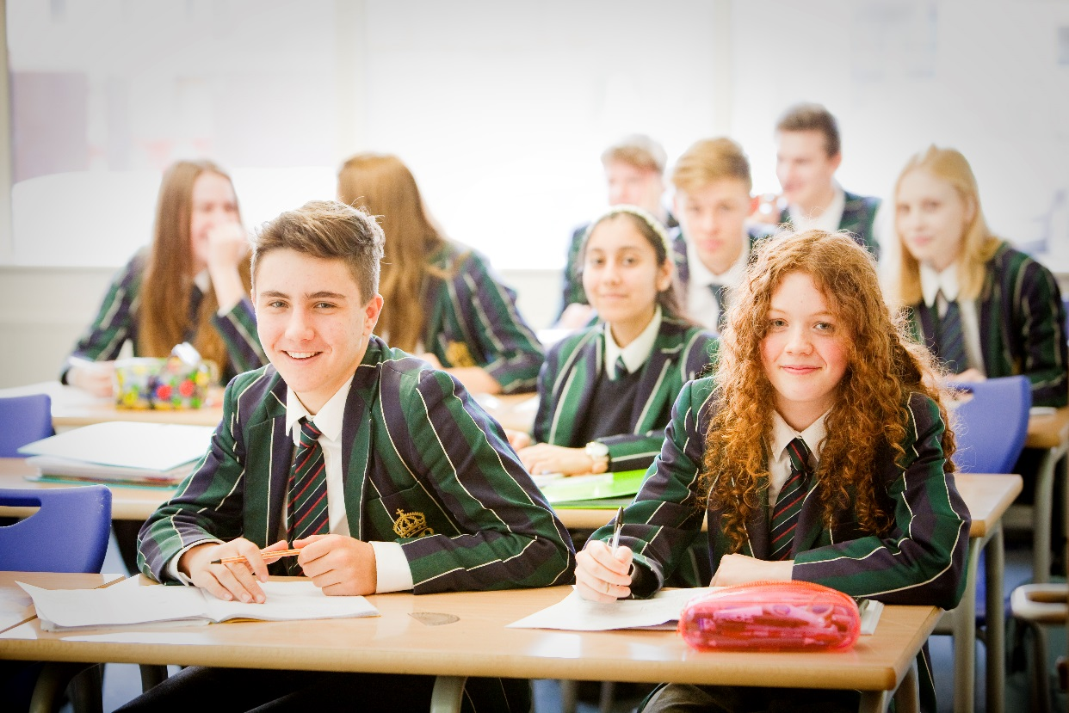
TERMS OF APPOINTMENT
The School will offer a highly competitive salary on our own salary scale which is pensionable under the TPS. A school iPad will be provided, along with a relocation allowance where appropriate. Staff children may be educated at King’s at reduced fees.

PROCESS
Candidates for this post should complete the application form which should be posted or e-mailed to The Headmaster, The King’s School, Chester, CH4 7QL to arrive not later than 12 noon on Wednesday 14th November 2018.
(hm@kingschester.co.uk) Fax: 01244 689501 Tel: 01244 689523
A curriculum vitae will not be accepted in place of the completed application form.
Interviews will be held during the week beginning Monday 19th November.
The Head of Department, Rob Aldridge, is available to discuss the school informally with prospective candidates. He can be contacted via rja@kingschester.co.uk .

The school is committed to safeguarding and promoting the welfare of children and young people and expects all staff and volunteers to share this commitment. The successful applicant will be required to undertake an enhanced DBS check. All our appointments follow the procedures laid out in our Equal Opportunities and Child Protection policies.

