Allendale Road  Ormesby  Middlesbrough, TS7 9LF | Phone: 01642 315538  Email: phelps.l@stgabriels.npcat.org.uk  Web: www.stgabriels.npcat.org.uk

Deputy Head Application Pack
Closing Date: 23 November 2018, 12 noon

Part of
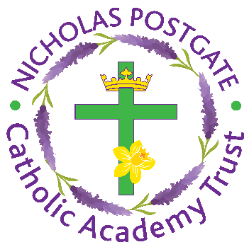
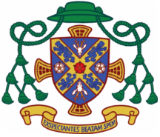

Catholic Diocese of Middlesbrough
Welcome to St. Gabriel’s ict’s

Dear Applicant,
Thank you for taking the time read this applicant pack for our school. It contains lots of information to help with your decision to apply together with a special message from our children.
Within this pack you will find:
- The Job Description and Person Specification
- Applications should be submitted on the Catholic Education Application form for Leadership. Link to the CES website for the application and related documents.
http://www.catholiceducation.org.uk/recruitment-process/item/1000042-application-forms (these can be completed electronically and emailed)
Further information about our school including the most recent OFSTED inspection report (2017), our Section 48 Inspection report and our Child Protection Policy can be found on our website: http://stgabriels.npcat.org.uk
Applying for the Deputy Head role in our school will be start of a journey into the hearts of our amazing children who will welcome you in with the great pride and passion they feel for their school.
Applicants should complete their application with a supporting statement highlighting in particular, their successes to date and their personal strengths. Any gaps in previous employment must be explained. Please submit applications to Karen Clarke, Head of Human Resources via email to: Clarke.k@npcat.org.uk by the closing date, Friday 23rd November 2018 at 12 noon.
Shortlisting is planned to take place 28th November with interviews 6th December 2018.
I invite you to visit the school and/or arrange an informal telephone discussion with Headteacher, Mrs Phelps. These can be arranged by contacting our School Admin Assistant, Mrs Vicky Cook, between 9am – 3.30pm on 01642 315538.
The successful applicant will have the 100% support of our Governors and the Parish of St Gabriel’s to become the best you can be.
Good luck with your application
Lesley Wilson MBE
Chair of St Gabriel’s Governors
Our Mission Statement
‘Learning and loving, on our journey with Jesus’
Our Vision Statement
Our vision is to educate children in the spirit of the Gospel values and the traditions of the Catholic Church, nurturing the talents and potential of each individual. We embrace our core Catholic values, we are gentle, we are forgiving, we tell the truth, we treat each other with dignity and we serve each other. Our core values are rooted in the Beatitudes, taken from the Sermon on the Mount. It allows us to raise our children within our Catholic faith and raise the citizens of the future who respect and love the world we live in.

To fulfil the Church’s mission to evangelise and make Christ known to all, St. Gabriel’s Catholic Primary School is committed to:
- Providing an education with Christ at the centre and a strong sense of Catholic identity meeting the spiritual needs of all
- Being a welcoming, compassionate community, where all are equally loved and valued for who they are
- Being an affirming, challenging educational community committed to the search for excellence for all
- Working together as a family community, and with the Diocese of Middlesbrough, to ensure the best possible Catholic education for our young people
- Working in partnership with other local schools, education providers and stakeholders in order to enhance the quality of provision for all
- Living out the social teaching of the Church, and thereby promote community cohesion;
- Contributing in joyful hope to the creation of a society which is highly educated, skilled, fundamentally loving and generous

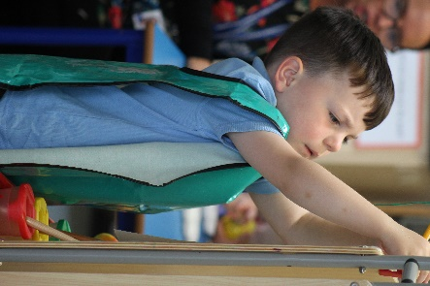

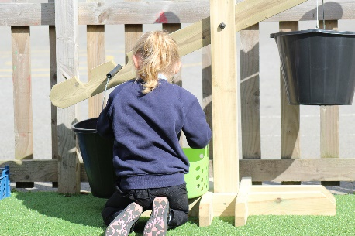
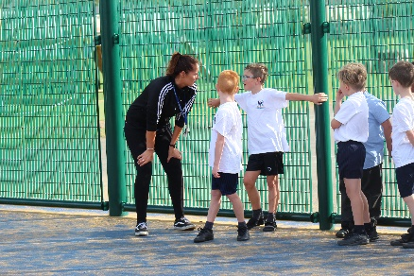
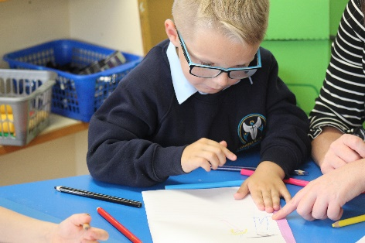

We asked our pupils from Nursery to Year 6 what they would like our new Deputy Head to be like. They agreed that it needs to be someone who fits the Person specification they have created:
‘We are looking for someone who is calm, good at making decisions, is dignified, fair but assertive, is energetic, is patient, is welcoming, will participate in lots of things, is confident, is witty, is attentive and will listen to us, has common sense, uses their initiative and who will look out for us. We need someone who is loyal and will love us just like Mrs Phelps does. We need someone to help Mrs Phelps and join in with her singing.’

They would like our new Deputy Head to help us improve our school:
‘A Deputy Head Teacher, would help to make our school even better and become part of #teamstgabriels. They will let us go to more clubs and make our day even more fun. They will join in with our lessons like Mrs Phelps and be proud of us when we do good work. They would like us to work outdoors more and help us to understand lots of things. They will like treat Friday and always help us to try new exciting activities as we love coming to school.’
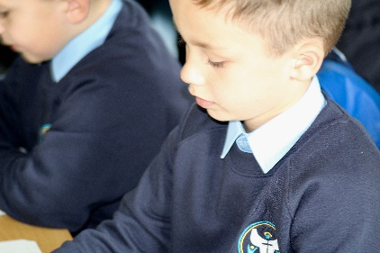

Nicholas Postgate Catholic Academy Trust

Academuy Trust Information

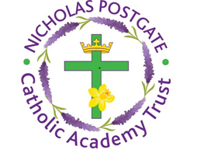
We are proud to be part of Nicholas Postgate Catholic Academy Trust. The Trust is made up of 21 Primary Schools, of which 2 are Teaching schools, four Secondary Schools and a Sixth Form college.

We have worked in close partnership for a number of years and now are formalising our work to ensure a strong Catholic education for children aged 3-18. Working in partnership, as part of the Trust, has a number of key benefits including:
- Rapid dissemination of best-practice across the group – sharing of policies, procedures etc.
- Excellent professional development opportunities, which support the recruitment and retention of staff.
- Training days in common, facilitating high quality CPD.
- Sharing of teachers, expertise and best practice.
- Economies of scale – our Academy Trust can procure “value for money” services for all its Academies.

Our Schools include:

- Corpus Christi Primary School
- Sacred Heart Primary School
- St. Alphonsus’ Primary School
- St. Augustine’s Primary School
- St. Bernadette’s Primary School
- St Clare’s Primary School
- St. Edward’s Primary School
- St Gerard’s Primary School
- St. Joseph’s Primary School
- St. Thomas More Primary School
- Trinity Catholic College and Sixth Form
- St Margaret Clitherow’s Primary School
- St Mary’s Primary School
- St Gabriel’s Primary School
- St Paulinus Primary School
- St Bede’s Primary School
- St Pius X Primary School
- St Therese of Lisieux Primary School
- St Benedict’s Primary School
- St Joseph’s Primary School
- St Patrick’s Primary School
- Christ the King Primary School
- St Patrick’s Catholic College
- St Peter’s Catholic College
- Sacred Heart Secondary

Diocese of Middlesbrough

Bishop of Middlesbrough, Terence Drainey, oversees a large and varied Diocese stretching from Redcar and Cleveland to Kingston Upon Hull.
Formed in 1878, the Diocese comprises the local authority areas which historically formed the North Riding of Yorkshire namely Redcar and Cleveland, parts of Stockton on Tees, Middlesbrough, York, parts of North Yorkshire, parts of East Riding and Kingston upon Hull.
Across the Diocese there are 46 Primary and 8 Secondary Schools and Academies. The smallest of our schools has 88 pupils and the largest 1500.
28 of our 54 schools have converted to Academy status operating within a Catholic Multi-Academy Trust with their local family of Catholic schools.
The Diocesan Schools Service comprises of the Director of Schools, Kevin Duffy; the Primary RE Adviser, Theresa Laverick; the secondary RE Adviser, Anthony Finnegan. The Diocese provides regular Professional Development opportunities and works closely with its Schools and Academies to provide a world class education for all the children in our care.
Primary Schools and Academies in the Diocese use the ‘Come and See’ programme for Religious Education and are subject to a Denominational Inspection by the Diocese.

Diocese of Middlesbrough

DIOCESAN STATEMENT ON EQUAL OPPORTUNITIES IN EMPLOYMENT

The Diocesan Education Service for the Roman Catholic Diocese of Middlesbrough has agreed the following model statement on equal opportunities in employment, for recommendation to governing bodies

The Board of Directors of the Nicholas Postgate Catholic Academy Trust and the Local Governing Body of St Gabriels Primary are committed to ensuring that matters concerning appointments, including promotions, are dealt with in a fair and just manner. Directors and Governors believe that the principle of equal opportunity in selection is consistent with social justice and good personnel practice. This is in keeping with our Catholic aim to recognise the dignity and worth of all who work or apply to work in our organisations.

Our selection processes aim to select the best applicant assessed against the criteria for the post. We are subject to the law of the land and acknowledge our commitment to conducting our affairs in accordance with the law. The governors do not discriminate on grounds of age, sex, race, colour, nationality, ethnic origin or disability.

The Roman Catholic community maintains schools which have, as part of their character, a duty to provide Religious Education and a requirement that those schools be conducted in accordance with the rites, practices and traditions of the Roman Catholic faith. It would therefore be clear that where applicants are equal in qualifications and experience in the context of selection criteria for a post that a Catholic applicant would have an advantage over an applicant not of the Catholic faith in being able to contribute to the mission of the Church in Catholic education. The posts of Head Teacher, Deputy Head and certain other senior posts are reserved for practising Catholics.

In fulfilling the objectives of Catholic schools, Directors and Governors have regard to matters which are particularly significant in the light of the sacramental teachings of the Church. Catholic teachers by their example and practice are witnesses to the Gospels and to the Church’s teachings. The Trust Board would therefore, in line with its responsibilities, reserve the right to take account of circumstances which were genuinely within a person’s control and which might include marital status, avowed personal conviction, belief or conduct.

Job Description

Job Title: Deputy Headteacher
L5 - L9

DEPUTY HEAD JOB DESCRIPTION

INTRODUCTION

The term school is used throughout this document to mean all Catholic schools including maintained schools and academies.

The school has been designated by the Secretary of State as a school with a religious character. Its Articles of Association states that it is part of the Catholic Church and is to be conducted as a Catholic school in accordance with Canon Law, the teachings of the Roman Catholic Church and the Trust Deed of the Diocese of Middlesbrough. At all times the school is to serve as a witness to the Catholic Faith in Our Lord Jesus Christ. The post therefore requires a practising Catholic who can show by example and from experience that he or she will ensure that the school is distinctively Catholic in all its aspects.

This appointment is with the Board of Directors of the Nicholas Postgate Catholic Academy Trust under the terms of the Catholic Education Service contract signed with the Directors as employers. It is subject to the current conditions of service for Deputy Head Teachers contained in the School Teachers’ Pay and Conditions document and other current education and employment legislation.

In carrying out his/her duties the Deputy Head shall work in support of the Headteacher to consult, when appropriate: the Board of Directors, Local Governing Body, the Diocese, the Local Education Authority, the staff of the school, the parents of its pupils, the parish/es served by the school and other local Catholic schools, particularly where collaboration or federation is being developed.

This job description is based on the key areas identified in the National Standards of Excellence for Headteachers published by the Department for Education (January 2015).

The Board of Directors and the Diocese acknowledge the importance of the role of the Catholic Deputy Head and will actively offer long term support, encouragement, affirmation and realistic challenge to the successful candidate.

The Trust Board, Governing Body and the Diocese are committed to safeguarding and promoting the welfare of children and young persons and the Headteacher must ensure that the highest priority is given to following the guidance and regulations to safeguard children and young people. The successful candidate will be required to undertake an Enhanced Disclosure and Barring Service check (DBS).
National Standards of Excellence for Headteachers (2015)

Purpose

The National Standards of Excellence for Headteachers (2015) define high standards within a self-improving school system. These standards are designed to inspire public confidence, raise aspirations, secure high academic standards in the nation’s schools, and empower the teaching profession.

The strategic direction and development of the school stem from the educational mission of the Church. The Deputy Head, in support of the Headteacher, will ensure that his/her leadership demonstrates commitment to promoting and developing the school’s distinctive Catholic identity through the search for excellence in all areas of its work.

These standards are intended as guidance to underpin best practice, whatever the particular job description. They are to be interpreted in the context of each individual Deputy Head and each school, and designed to be relevant to all Deputy Heads, irrespective of length of service in post.

The role of the Catholic Deputy Head

The Deputy Head, working in support of the Headteacher, occupies an influential position in society and shape the teaching profession. They are lead professionals and significant role models within the communities they serve. Their values and ambitions determine the achievements of schools. Working in support of the Headteacher, they are accountable for the education of current and future generations of children. The strategic direction and development of the school stem from the educational mission of the Church. The Deputy Head, working in support of the Headteacher, will ensure that his / her leadership demonstrates commitment to promoting and developing the school’s distinctive Catholic identity through the search for excellence in all areas of its work.

Their leadership has a decisive impact on the quality of teaching and pupils’ achievements in the nation’s classrooms. In a Catholic school the Deputy Head supports the Headteacher in leading a learning community rooted in Christian belief and principles. The search for excellence is given expression in learning and teaching which recognise pupils’ individual worth as made in the image and likeness of God. The Deputy Head supports the Headteacher, leading the school community in promoting positive attitudes to learning amongst pupils and staff which stem from Christ’s vision for humanity.

Deputy Heads lead by example the professional conduct and practice of teachers in a way that minimises unnecessary teacher workload and leaves room for high quality continuous professional development for staff. In support of the Headteacher, they secure a climate for the exemplary behaviour of pupils. In a Catholic school the Deputy Head’s leadership should take Christ as its inspiration. His/her relationships with pupils, parents/carers, governors and staff should demonstrate a belief in their unique contribution as individuals, valued and loved by God. He/she will recognise and act upon his/her own potential for growth and that of others.

The management of a Catholic school should be clearly influenced by the Gospel message and Church teaching. In particular, it should be a place where Christian principles such as justice, truth, respect and reconciliation are at the heart of its life and work. The Deputy Head supports the Headteacher in the responsibility for ensuring that such principles are priorities for the school and are evident in its organisation and management.

The Deputy Head supports the Headteacher in setting standards and expectations for high academic standards within and beyond their own schools, recognising differences and respecting cultural diversity within contemporary Britain. In a Catholic school the Deputy Head supports the Headteacher to deliver their responsibility for the mission of the school to the local and wider Catholic community and beyond. He/she will collaborate with the parish and other Catholic organisations, as well as with the wider educational system, for the benefit of his/her own community and others. He/she will demonstrate a belief that community and school are interdependent and that engagement with the community promotes school development.

Headteachers and Deputy Heads, together with those responsible for governance, are guardians of the nation’s schools. In a Catholic school the Deputy Head fulfils his or her responsibilities in accordance with the Instrument of Government/ Articles of Association. He/she supports the Headteacher, Board of Directors and Local Governing Body in fulfilling its responsibilities to the Diocese under Canon Law as well as in accordance with national legislation. The Deputy Head is accountable to the Headteacher, Board of Directors, Local Governing Body, parents/carers and the school community for the fulfilment of the school’s Catholic mission and its educational success.

The Four Domains

The National Standards of Excellence for Headteachers are set out in four domains,

There are four ‘Excellence as Standard’ domains:

• Qualities and knowledge
• Pupils and staff
• Systems and process
• The self-improving school system

Within each domain there are six key characteristics expected of the nation’s Headteachers.

Domain One

Excellent Deputy Heads in Catholic schools: qualities and knowledge

Deputy Heads, in support of Headteachers:

1. Work within the school and with the parish to hold and articulate clear values and moral purpose, which takes account of the school’s Catholic mission focused on providing a world-class education for the pupils they serve.
2. Demonstrate optimistic personal behaviour which stems from Christ’s vision for humanity. Promotes positive relationships and attitudes towards their pupils, staff, parents, governors and members of the local community recognising their individual worth as made in the image and likeness of God.
3. Inspired by Christ, lead by example - with integrity, creativity, resilience, and clarity - drawing on their own scholarship, expertise and skills, and that of those around them.
4. Sustain wide, current knowledge and understanding of education and school systems locally, nationally and globally, and pursue continuous professional development.
5. Work with political and financial astuteness, within a clear set of principles influenced by the Gospel message and Church teaching, centred on the school’s vision, ably translating local and national policy into the school’s context.
6. Communicate compellingly the school’s vision and drive the strategic leadership, empowering all pupils and staff to excel.

Domain Two

Excellent Deputy Heads in Catholic schools: pupils and staff

Deputy Heads, in support of Headteachers:

1. Demand ambitious standards for all pupils, overcoming disadvantage and advancing equality, instilling a strong sense of accountability in staff for the impact of their work on pupils’ outcomes that reflect the distinctive characteristics of Catholic education.
2. Secure excellent teaching through an analytical understanding of how pupils learn and of the core features of successful classroom practice and curriculum design, leading to rich curriculum opportunities and pupils’ well-being. Ensure high quality provision for the academic, spiritual, moral, social, emotional and cultural well-being of all pupils and families.
3. Establish an educational culture of ‘open classrooms’ as a basis for sharing best practice within and between schools, drawing on and conducting relevant research and robust data analysis.
4. Create an ethos within which all staff are required to treat all people fairly, equitably, and with dignity and respect. Inspire, encourage and support staff to develop their own skills and subject knowledge, and to support each other.
5. Identify emerging talents, coaching current and aspiring leaders in a climate where excellence is the standard, leading to clear succession planning.
6. Hold all staff to account for their professional conduct and practice, emphasising the distinctive nature of Catholic Education.

Domain Three

Excellent Deputy Heads in Catholic schools: systems and process

Deputy Heads, in support of Headteachers:

1. Ensure that the school’s systems, organisation and processes are well considered, efficient and fit for purpose, upholding the principles of transparency, integrity and probity reflecting the school’s Gospel values.
2. Provide a safe, calm and well-ordered environment for all pupils and staff, focused on safeguarding pupils and developing their exemplary behaviour in school and in the wider community to promote Gospel values which unite society in a commitment to social justice and the common good.
3. Establish rigorous, fair and transparent systems and measures for managing the performance of all staff, addressing any under-performance, supporting staff to improve and valuing excellent practice.
4. Welcome strong governance, rooted in faithful stewardship of Gospel values, actively supporting the Governing Body to understand its role and deliver its functions effectively – in particular its functions to set school strategy and hold the Headteacher to account for pupil, staff and financial performance.

5. Exercise strategic, curriculum-led financial planning to ensure the equitable deployment of budgets and resources, in the best interests of pupils’ achievements and the school’s sustainability.
6. Distribute leadership throughout the organisation, forging teams of colleagues who have distinct roles and responsibilities and hold each other to account for their decision making.

Domain Four
Excellent Deputy Heads: the self-improving school system

Deputy Heads, in support of Head teachers:

1. Lead outward-facing schools which work with other schools and organisations - in a climate of mutual challenge – where each pupil is championed to ensure they secure their unique potential and achieve excellence
2. Develop effective relationships with fellow professionals and colleagues in other public services to improve academic, spiritual, moral, social, emotional and cultural outcomes for all pupils.
3. Challenge educational orthodoxies in the best interests of achieving excellence, harnessing the findings of well evidenced research to frame self-regulating and self-improving schools.
4. Shape the current and future quality of the teaching profession through high quality training and sustained professional development for all staff.
5. Model entrepreneurial and innovative approaches to school improvement, leadership and governance, confident of the vital contribution of internal and external accountability.
6. Inspire and influence others - within and beyond schools - to believe in the fundamental importance of Catholic education in young people’s lives and to promote the value of education.

Person Specification

TEACHER CRITERIA FOR APPOINTMENT
(A framework for determining the criteria)
Please note source of evidence of fulfilled criteria: Application Form - A Letter – L References – R Interview - I

TRAINING AND QUALIFICATIONS

 | Essential or Desirable | Evidence
Practising Catholic | E | R
Qualified teacher status | E | A
Degree | E | A
Meets the requirements re: the National Professional Qualification for Headship | D | A
CCRS/CTC or commitment to obtain the certificate | D | A
Professional development undertaken in preparation for leadership | E | A/L/R
Professional development undertaken in preparation for leadership in a Catholic Primary School | D | A/L/R

EXPERIENCE OF TEACHING AND EDUCATIONAL LEADERSHIP

 | Essential or Desirable | Evidence
Leadership and management experience  (Contribution to leadership /management of the school: e.g., assistant head, deputy head, head of department, head of year, key stage leader, subject leader, SENCo or experience as a consultant or teacher adviser. Timetabling, Monitoring & Evaluation, data analysis and target setting etc. Consider number of years’ experience required) | E | A/L

PROFESSIONAL KNOWLEDGE AND UNDERSTANDING
[Compiled with reference to the National Standards 2015]

The successful candidate will be able to demonstrate skill, knowledge and understanding in the areas listed below:

 | Essential or Desirable | Evidence
A distinctive personal vision for a Catholic school
- A clear vision for an effective Catholic primary school | E | A/I
- The role of the Deputy Head in leading the spiritual development of pupils and staff | E | I
- The central place of Religious Education as a core subject in the school’s curriculum; | E | I
- The implications for a Catholic school in a diverse community; | E | I
- Current educational issues, including national policies, priorities and legislation and any implications of these for Catholic schools; | E | I
- The role of the Trust Board and Local Governing Body in Catholic Academies ; | E | I
- Strategies and procedures to ensure the safeguarding of children and young people; | E | A/I
- Strategies for strengthening a school’s link with the wider community including parents, carers and parish; | E | A/I
- The partnership between the school and the parish community; | E | I
- Leading Collective Worship;  - Demanding ambitious standards for all pupils overcoming disadvantage and advancing equality;  - Instilling a strong sense of accountability in staff for the impact of their work on pupils’ outcomes;  - Secure excellent teaching based on an analytical understanding of how pupils learn leading to rich curriculum opportunities;  - Establishing an educational culture of open classrooms sharing best practice within and between schools;  - Effective use of relevant educational research and robust data analysis; | E  E  E  E  E  E | I  I  I  I  I  I
The process of strategic planning for school improvement | E
- The principles and practice of effective school self-evaluation including data analysis; |  | A/I
- The principles and practice of effective teaching, learning and assessment; | E | I
- Strategies to promote and sustain individual and team professional development;  - Commitment to creating outward facing schools which work with other schools and organisations to challenge and champion best practice;  - Build effective relationships with colleagues in other public services to improve academic, spiritual, moral, social, emotional and cultural outcomes for all pupils;  - Challenge educational orthodoxies in the best interests of achieving excellence;  - Harnessing the findings of well evidenced research to move the school forward;  - Shape the current and future quality of teachers through high quality training and sustained professional development leading to clear succession planning;  - Model entrepreneurial and innovative approaches to school improvement, leadership and governance. | E  E  E  E  E  E  E | I  I  I  I/A  I  I/A  I/A

PERSONAL AND PROFESSIONAL QUALITIES AND ATTRIBUTES

The successful candidate will be able to provide evidence of personal capacity to:-

 | Essential or Desirable | Evidence
- Communicate effectively to a range of audiences and in a range of media | E | I
Build and maintain effective relationships  - Prioritise, plan and organise themselves and others  - Seek and take account of the views of others  - Develop effective teamwork | E  E  E | A/I  A/I  A/I
- Maintain a healthy work/life balance | E | A/I
- Convey personal enthusiasm and commitment | E | I

APPLICATION FORM AND LETTER

 | Essential or Desirable | Evidence
Application form to be completed in full and legibly | E | A
Supporting statement to be clear, concise and related to the specific post and appointment criteria | E | L

CONFIDENTIAL REFERENCES AND REPORTS

A positive and supportive written faith reference from a priest where the applicant regularly worships. | E | R
A positive recommendation from current employer or Headteacher | E | R
A second professional reference | E | R

Key Information

Key contacts

To arrange a school visit please contact Mrs V Cook (School Administrator): 01642 315538

Please return completed CES application with the recruitment monitoring form and rehabilitation of offenders form to or by post marked for the attention of:

Key dates for applicants:
Closing date: Friday 23rd November 2018- 12 noon
Interview date: Thursday 6th December 2018
Thank you for your interest in the post of Deputy Head Teacher at St.Gabriel’s. We look forward to receiving your application.
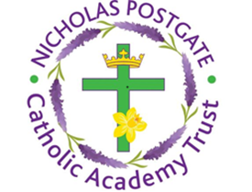
Allendale Road  Ormesby  Middlesbrough, TS7 9LF | Phone: 01642 315538  E mail: phelps.a@npcat.org.uk  Website: www.gabriels.npcat.org.uk

