

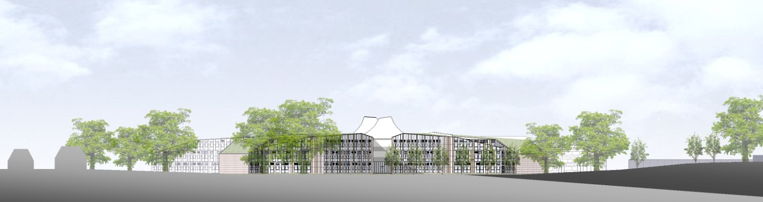

**ST BARTHOLOMEW’S SCHOOL**

**TECHNICIAN: EXPRESSIVE ARTS**

**PART-TIME, PERMANENT**



**Andover Road**

**Newbury**

**Berkshire**

**RG14 6JP**

**Tel: 01635 521255**

**Email:** [**recruitment@stbarts.co.uk**](mailto:recruitment@stbarts.co.uk)

**Website:** [**www.stbarts.co.uk**](http://www.stbarts.co.uk)

**The Faculty**

The Expressive Arts Faculty (also known as Bart’s Arts) is a busy and thriving aspect of the school. We have an extensive extra-curricular programme and offer GCSE and A-level courses in all disciplines. The Faculty is composed of Art, Dance, Drama, Graphic Design, Music, Product Design, Textiles and Photography. In particular, Dance, Drama and Music will require support at different intervals throughout the year from a specialist Technician.

In addition to Concerts, School Productions, Dance Shows and Art Exhibitions, the Expressive Arts subjects also host an annual House event for different subject areas, which feeds into the whole school House structure. Students regularly lead such initiatives themselves, with teacher support offered as appropriate. This also extends to the technical teams who will work under the supervision and training of an appropriate Technician.

St Bart’s new facilities offer staff the opportunity to work in exciting ways, and enable students to learn in state of the art environments. The annual school production has become a showcase for our talented youngsters and staff always take the opportunity to strive for professional outcomes.   Where possible we regularly seek new methods of technology to keep presentations fresh and we offer training where appropriate to ensure that any new technological developments can be fully explored.

In addition to assisting with large scale events, technical assistance is also given to Dance, Drama and Music with regard to GCSE and A-level performance work during class hours, in order to continue to support students in achieving excellent results within these coursework areas.  We are an enthusiastic team, dedicated to our subjects, and welcome a fresh outlook to our Faculty.

**The Post**

* We are seeking to appoint a Technician to join the Expressive Arts faculty as soon as possible on a permanent basis.
* The position is part-time, term time only plus 5 training days pro rata.
* The days and hours of work will be:

18 hours per week including 5 hours worked flexibly to support School performances, term-time only. Hours to be worked over 3 or 4 days to be agreed on appointment. When you work 5 hours or more in a day you are entitled to a 30 minute break which is unpaid).

**The Salary**

* The successful candidate will be paid in accordance with the national APT&C scale, point 3 – 4 (currently £18065 to £18426 per annum full-time equivalent). This equates to a starting salary of £7500.20 gross per annum or £9.36 per hour. Staff will be appointed to the start point of the advertised scale unless there is a specific experience reason for the Headteacher to agree an alternative point within the range.
* All leave must be taken during school holidays. Your annual salary will be calculated to include payment for your leave entitlement. Your annual salary will therefore be 44.5 weeks pay, to be paid in 12 equal monthly amounts.

**How to Apply**

Full post details, an application form and instructions on how to upload your completed application are available via the Jobs & Training / Job Opportunities section on the School’s website:

[**www.stbarts.co.uk**](http://www.stbarts.co.uk)

(Please note that curriculum vitae and covering letters cannot be accepted)

Successful candidates will be subject to a DBS enhanced check along with other relevant employment checks.

## Closing date: Sunday 19 January 2020

Thank you for considering St Bartholomew’s School, we look forward to hearing from you.