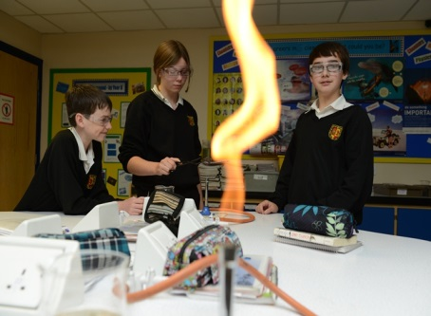
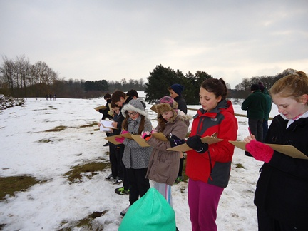

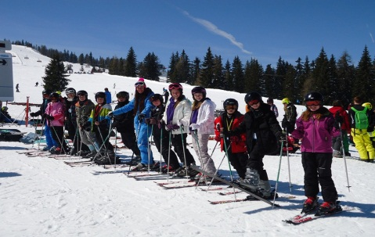
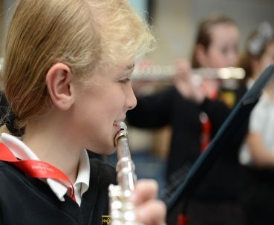

English Teacher
Application Pack
Start date January 2018

November 2017

Dear Applicant

Thank you for your interest in the post. I hope that the information you receive will help and inform your application. We are looking for a motivated and ambitious person to join our teaching team and contribute to raising standards across the school. This is an exciting post and you can make a real difference.
You are very welcome to come and visit the school. Since I joined Alameda in January 2014, I have been impressed with the pupils’ positive approach to learning and the school’s ethos. I am sure you will be too. I will be available for an informal chat about the school and the post.
We seek an enthusiastic teacher with superb communication skills who is committed to excellence. Governors are supportive and want the school to progress to “Outstanding”. In terms of teaching responsibilities, while you will be required to teach English in all four year groups.
The school achieves well due to the fantastic pupils, drive and ambition of its senior leaders and a strong staff team. It is a purposeful and vibrant learning environment.
Within Alameda, overall standards of achievement are excellent, our children are always eager to learn and are very capable but there are areas which need further development. Alameda is a pleasant learning environment, with excellent resources.
We have an ongoing CPD programme and work closely with other schools to develop outstanding practice. We welcome applications from NQTs and offer an excellent programme of support.
I know that you will find this role rewarding and the children will respond well.
Along with this letter, please find:

- Background Information about the school
- Job Advertisement
- Personnel Specification and Job Description

(These are all available on the web-site)
I hope this information will encourage you to submit an application. Application forms are available from the school website for download. Applications can be submitted either via the post or email. I would be willing to discuss the post with any potential candidates. You can contact me at the school or by email.

Yours sincerely
Miss M. Warner
Headteacher

Contextual Information
History
Alameda is a large and oversubscribed Middle School Academy. Pupils are aged between 9 and 13 (years 5-8). The school is set relatively close to the center of Ampthill, a pleasant market town in Central Bedfordshire. Pupils who attend come from the immediate local area of Ampthill and Maulden, although some come from further away in Bedfordshire. We have three main feeder lower schools and most pupils go on to Redborne Upper School.
Alameda is part of the Redborne Schools Partnership, with Redborne Upper, Woodland Middle, The Firs, Russel, Maulden, Flitwick, Kingsmoor and Templefield Lower Schools. We are lucky to have strong relationships with the schools in our area. We also have strong links with the Central Bedfordshire Teaching School.
Pupils and Admissions
At present, the school roll is just over 700. Admissions have increased over the past two years and over time will reach 180 pupils (6 form groups) in each year group.
The school has a much smaller than average proportion of pupils entitled to free school meals. Pupil attendance is outstanding, above the national average.
Site Issues
Alameda is set on a large site in picturesque surroundings. The site is bordered by a Site of Special Scientific Interest and the Alameda walkway. We are close to Ampthill park. Classrooms are spread around the main block, with a new block of six classrooms. There is planning permission for a further four classrooms and a new hall.
There are two well equipped ICT rooms and all classrooms have internet access and interactive whiteboards linked to a PC. There is a well-stocked library, a sports hall and a large music suite.
Staffing
The school has a leadership team consisting of a Headteacher, two Deputy Heads and a Business Manager. As Middle leaders we have Heads of Year and Subject Leaders. There are 41 teaching staff, 16 learning support assistants, 2 learning mentors, 2 cover supervisors, a librarian, an IT technician, 13 assistants in finance/admin/science/tech, a site agent and assistant site agent and a catering manager and 5 kitchen assistants. We are firmly committed to developing the skills of all our staff.
General
We have achieved the Healthy Schools accreditation and the Sportsmark award. We regularly support the training of student teachers from the University of Bedfordshire. We have recently been accredited as a ‘Values Based Education’ school. We strive to reinforce the values of our school that in all that we do.

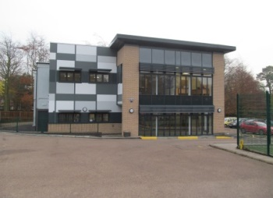
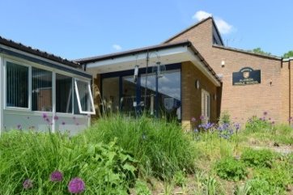
Email: office@alamedamiddleschool.org.uk
Website: alamedamiddleschool.org.uk
Email: office@alamedamiddleschool.org.uk
Website: alamedamiddleschool.org.uk
E
Email: office@alamedamiddleschool.org.uk
Website: alamedamiddleschool.org.uk
Email: office@alamedamiddleschool.org.uk
Website: alamedamiddleschool.org.uk
Email: office@alamedamiddleschool.org.uk
Website: alamedamiddleschool.org.uk
Email: office@alamedamiddleschool.org.uk
Website: alamedamiddleschool.org.uk
Email: office@alamedamiddleschool.org.uk
Website: alamedamiddleschool.org.uk
Email: office@alamedamiddleschool.org.uk
Website: alamedamiddleschool.org.uk

Alameda Middle School

Inspire – Achieve – Excel

The Vision;
‘Alameda is an inspiring and dynamic learning environment where all individuals are valued and everyone has the opportunity to achieve their best’

Our Aims;
Engaging with and supporting the school’s values
Achieving our best in everything we do
Collaboration and Community, Preparing for change

Development of our Aims

Engaging with and supporting the school’s 22 values;
· All members of the school community treat each other with mutual respect
· The 22 values are evident throughout the school community
· Providing strong pastoral care and a nurturing environment
· A courteous, caring and self-disciplined school community

Achieving our best in everything we do;
· Motivate and inspire our children through an excellent educational experience
· To set high expectations and high standards in all areas
· To encourage all pupils to do their best in all areas
· For pupils to achieve high standards in all assessments and tests and to make excellent progress across their 4 years at middle school
· Staff to have high aspirations and to set challenging targets in academic areas
· The whole school community aim for the highest standards they can achieve
· To work with all pupils to build their self-esteem and confidence
· To develop and use the reward system effectively
· To encourage pupils to share and appreciate the achievements of others

Collaboration and Community;
· To communicate with and treat all members of the school community with respect
· To involve parents in their child’s learning
· To keep parents and carers well informed about their child’s progress
· To welcome members of the community into school
· Pupils are involved in decision making in school. They are encouraged to make a positive contribution to the school and wider community

Preparing for Change
· To ensure that excellent ICT facilities across the school enhance teaching and learning
· To continually look to the future and be aware of technical developments which will enhance learning
· To ensure that resources are well use to improve the learning experience

English Teacher
Full Time – Fixed Term or Permanent
Start date January 2018
MPS

English Teacher

We are looking for an enthusiastic, dedicated teacher with the ability to teach KS2 & KS3 English.

If you are interested in the above post, please download a pack from our website. (CV’s will not be accepted) You may also contact Mrs Tilley for more information or to arrange a visit to the school: ctilley@alamedamiddleschool.org.uk

Full details are on our website. www.alamedamiddleschool.org.uk

The successful candidate will be subject to an enhanced DBS check. Alameda is committed to safeguarding and promoting the welfare of the children and young people and expects all staff and volunteers to share this commitment.

Closing date: 9am Monday 20th November 2017
Interview date TBC

Alameda Middle School

Job Description and Person Specification – Full time Class teacher

 | Essential | Desirable
Qualifications | Teaching qualification  KS2 and or KS3 | Degree
Experience | Teaching experience ( either with QTS or as a trainee) | Experience as a form teacher
Skills knowledge and aptitude. | Excellent classroom practitioner with good classroom management and personal organisational skills.  Good understanding of how assessment for learning, monitoring and tracking and other strategies can improve pupil outcomes.  Ability to teach English at Key Stage 2&3  Ability to develop positive relationships with children and work in partnership with parents  Be aware of the need to plan an appropriate curriculum that meets the needs of all pupils  Good interpersonal skills  Ability to work successfully as part of various school teams  Ability to meet specified agreed deadlines for documentation etc. | Confident user of ICT
Philosophy | High expectations of teaching and learning and commitment to achieving them.  To be flexible, adaptable, accept change, take on board new ideas and have a commitment to professional development.  A strong commitment to school improvement
Other | Well-presented application form that addresses the person specification.  To be enthusiastic and energetic  Good Health | To take a full part in the life of the school.  Willingness to run/develop an after - school club.  Driving license with access to a vehicle or the ability to arrange own transport to locations within the county to attend courses etc.

