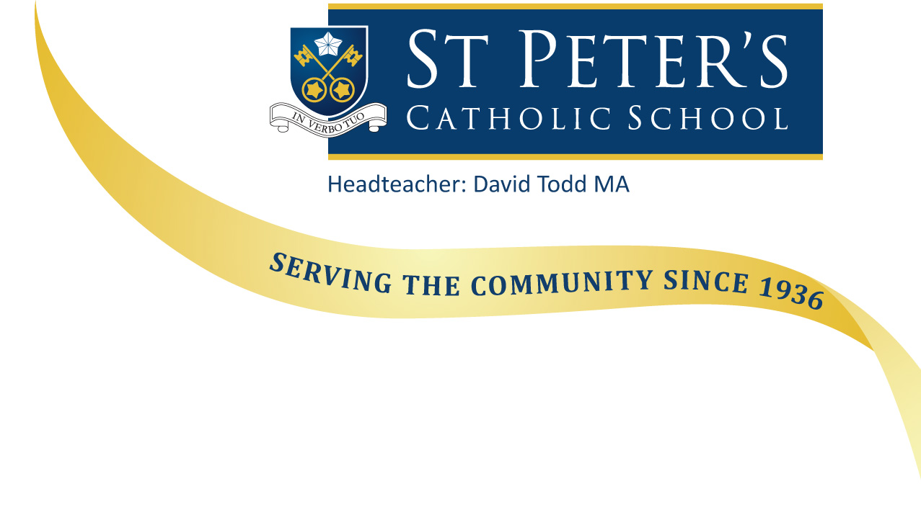

July 2018

Dear Applicant

Re: Sixth Form Office Manager

Contractual hours 37 hours per week

Contractual Weeks Term Time plus two additional weeks

Grade BG4 Scale Point 25 - £11.98 per hour

Thank you for your interest in working with us at St Peter’s School. I hope you find the following information useful. If you have any queries, please do not hesitate to contact Mrs Joy on 01202 421141 or email
supportstaff@st-peters.bournemouth.sch.uk .

St Peters is a Catholic school with a strong Christian ethos which underpins all we do. We are also an Academy, jointly sponsored by the Catholic Diocese of Portsmouth and the De La Salle Order – an international organisation which has been running schools for over 300 years.
The School consists of two sites, Year 7 to Year 13 are based at Southbourne, and our Primary phase at Iford, (currently Year R to Year 3) as St Peter's becomes an All Through school. It is a school with a tradition of success, oversubscribed every year and benefitting from a deservedly positive reputation in the local community. Relationships with families are affirming and constructive, with parents and carers keen to support the school and the child’s learning. We are not a complacent community; all staff are keen to learn and improve, developing pedagogy through research, shared practice and innovation.

We therefore seek individuals who are committed to comprehensive and inclusive education, to developing their practice through collaboration with colleagues and to delivering high standards and success through high expectations. We seek to appoint staff who are comfortable with the Catholic ethos of the school and able to support our core values.
If this describes you, please read through the documentation on our website and should you wish to apply, please complete the Associate Staff application form and return it with the Recruitment Monitoring form, Rehabilitation of Offenders Act 1974 Disclosure form and a hand written letter of application. The closing date for applications is: 9.00am on Wednesday 1st August 2018.
Interviews will be held on Friday 17th August 2018. If, you do not receive a telephone call from us inviting you for an interview by Thursday 16th August 2018, please assume that on this occasion your application was not successful. However, I would like to thank you for your interest in St Peter’s School.

Previous applicants need not apply.

I look forward to receiving your application.

Yours sincerely
Mr D J Todd
Headteacher

