Norwich School – Application Form

IMPORTANT INFORMATION:

We are carrying out “blind” shortlisting for all of our vacancies as part of our commitment to equality, diversity and inclusion and to ensure a fair and consistent approach to recruitment. If you would prefer this application form in an alternative format, please contact recruitment@norwich-school.org.uk.

Candidates will be assigned an application reference number and recruiting managers are sent only sections B and C to assess for shortlisting.

Please do not include any personal information in the application form other than what is requested.

Norwich School appointment procedures conform to guidelines to ensure compliance with safer recruitment guidelines.

We look forward to receiving your application.

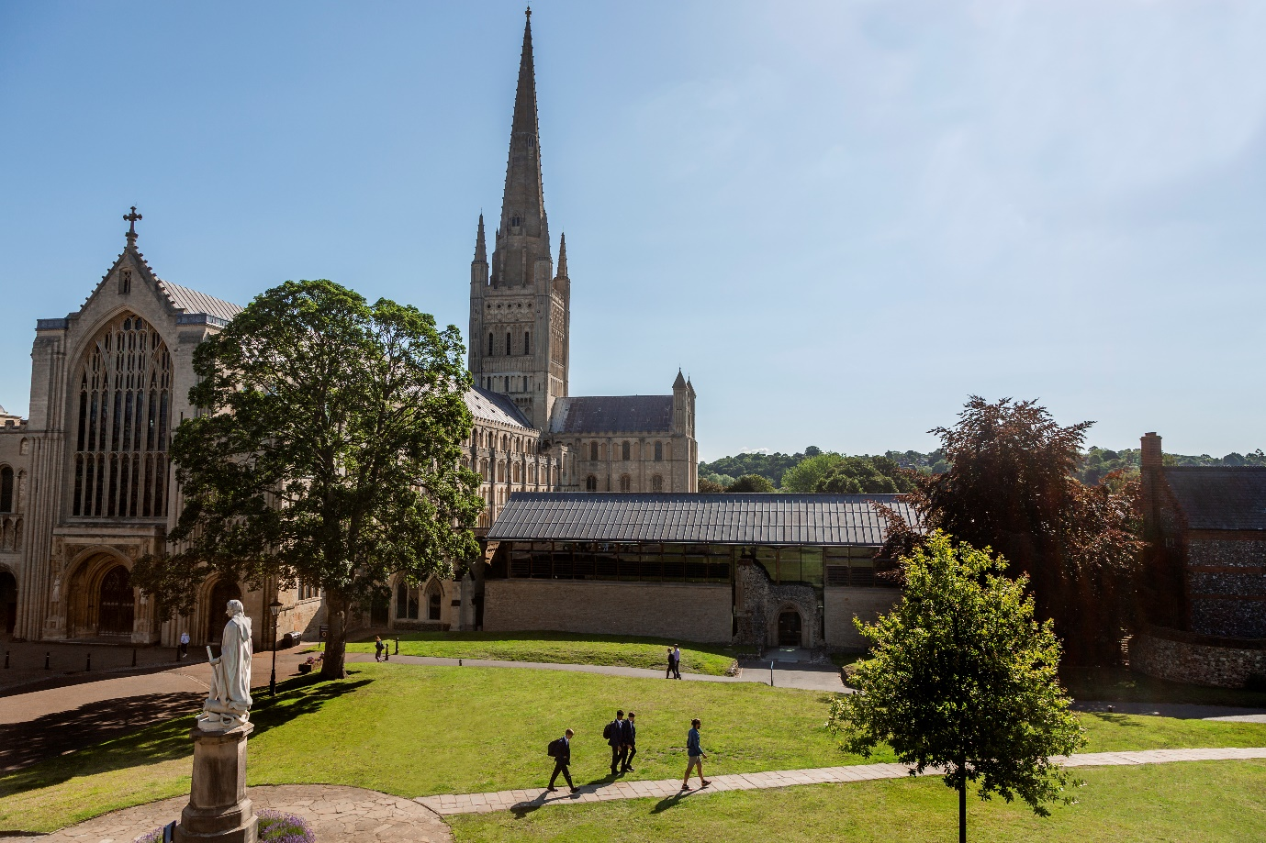

Section A - Personal Details & Right to Work

Personal Information

Surname: |  | Forename:
Title: | Preferred name: | Former name/s (including maiden name):
Address: |  | Contact number:  Mobile number:  Work number:  E-mail address:
Postcode:
National Insurance number: |  | Teacher registration number (if applicable):

General

Are there any special arrangements/reasonable adjustments that you may require in order to attend an interview?  If so, please could you describe what would be helpful: | Yes ☐ No ☐
Where did you see our advert?

Are you related to or do you maintain a close relationship with an existing employee, volunteer or Governor of the School? If so, please give name: | Yes ☐ No ☐
Do you have children that attend the Norwich School? | Yes ☐ No ☐

Right to work in the UK

Do you have the right to live and work in the UK? | Yes ☐ No ☐
Are there any restrictions to your right to live and work in the UK which might affect your right to take up employment with us?  If YES please provide details: | Yes ☐ No ☐

Section B – Education, Qualifications & Employment

This section is designed to give a full history of education in chronological order.

Secondary education – please insert more rows if applicable

Universities/Colleges/Schools attended: |  | Subjects and qualification/s achieved or qualifications pending:
Name | Months/years attended: | Subject: | Result: | Date:  Awarding body:
 |  | GCSE (or equivalent)
Start date:

End date:

 |  | A Level (or equivalent)
Start date:

End date:

Any other achievements/interests at school that you would particularly like to mention:

Tertiary education – please insert more rows if applicable

Universities/Colleges/ attended: |  | Subjects and qualification/s achieved or qualifications pending:
Name | Months/years attended: | Subject: | Result: | Date:  Awarding body:
Start date:

End date:

Start date:

End date:

Any other achievements/interests at university/college that you would particularly like to mention:

Other Awards, qualifications and courses – please insert more rows if applicable

College, Education Centre or Institution |  | Subjects and qualification/s achieved or qualifications pending:
Name | Months/years attended: | Subject: | Result: | Date:  Awarding body:
Start date:

End date:

Start date:

End date:

Employment

Current / most recent employer

Job title:

Brief summary of main responsibilities:

Reason for leaving to find new employment:

Salary and notice period:

Date started (month & year) |  |  | Date employment ended (month & year)
Previous employment – please insert more rows if applicable
Dates of employment (month and year): | Employer name | Job title and brief summary of main responsibilities |  | Reason for leaving
Start date:

End date:

Start date:

End date:

Start date:

End date:

Start date:

End date:

Gaps – please provide an explanation for any periods not in education or employment

Section C – Personal Statement

We recommend that this should be no more than two pages long and should cover:
- what attracts you to the position;
- how you feel your experience, skills and personal qualities qualify you to take on the role;
- how any personal interests might help you to make a positive contribution to our community (e.g. involvement in co-curriculum).

Personal Statement

Section D – Declaration & Data Protection

Declaration

I am aware that Norwich School applies for an enhanced certificate from the Disclosure and Barring Service (DBS) as well as requesting other statutory pre-employment checks on its employees. My signature below indicates that I give my permission for the school to proceed accordingly. I also commit to providing sight of my DBS certificate to Norwich School within 14 days of receiving the documentation and prior to starting employment with Norwich School. | Yes ☐
I declare the information I give in this application is accurate, complete and true. I understand that providing misleading, inaccurate or incomplete information will disqualify me from the appointment or, if appointed, may result in my immediate dismissal without notice. | Yes ☐
I understand the information may be seen by the Governors, Senior Leadership Team, HR Department and the Bursar’s PA, at Norwich School for the purposes of processing and ensuring compliance with safe recruitment best practice. | Yes ☐
I understand that it is a requirement of the post to register with the DBS Updating Service. I do this at my own cost and give permission for Norwich School to check my status at any time. | Yes ☐
Date Protection Statement

By signing the application form you are agreeing to the use and processing of personal data in accordance with the School’s registration with the office of the Information Commissioner under the Data Protection Act. | Yes ☐

Signature & Date

Signature:

Date:

NORWICH SCHOOL | 70 THE CLOSE | NORWICH NR1 4DD
Tel: 01603 72843

