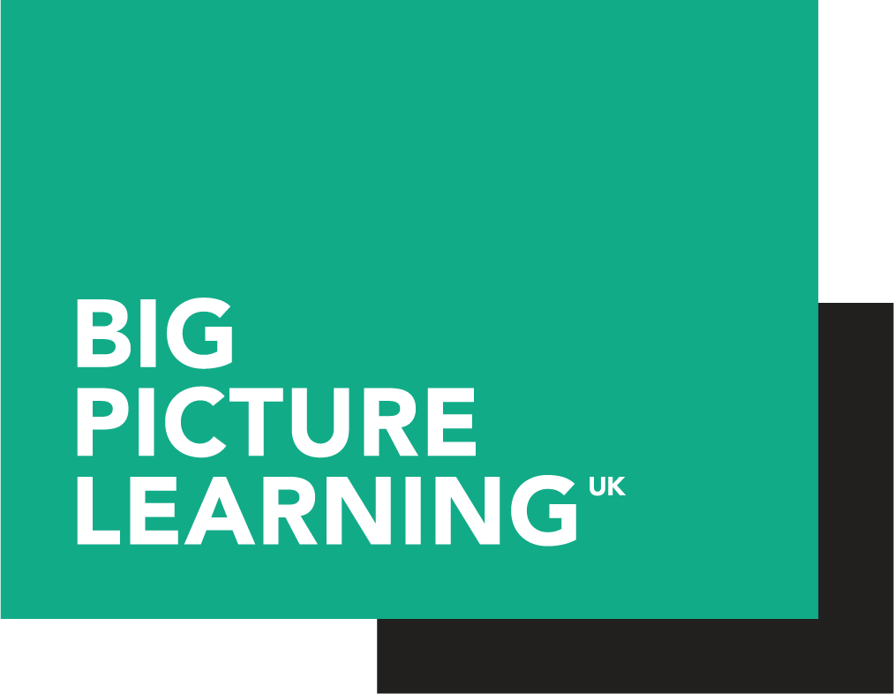

Big Picture Learning CEO - Application Form

Please complete this application form, and return with a CV and letter stating why you would like the role, to Claire Adsley at Claire@bigpictureuk.org by 12:00pm noon on Monday 14th January 2019.

Full name
Address
Phone number
Email address

Education and qualifications | Dates from:to | Grade or Level
Please add extra rows as required

Employment history | Job title | Dates from:to
Please add extra rows as required

Person specification | Please state why you feel you have the necessary and desirable skills, experience and personal attributes for this role
Education, knowledge & experience - Essential
- You have extensive knowledge and understanding of working with education commissioners and other accountable organisations, including schools
- You have experience of working at executive level in start up organisations or small charities, and are well versed in the legal, financial, HR and safeguarding implications and requirements of charities and schools
- You are self sufficient and flexible and can work without the support of a big or established team
- You have experience of problem solving complex implementation challenges involving multiple stakeholders
- You are experienced at fundraising, working with funders, and/or generating new revenue streams
- You have the capacity and willingness to lead and oversee management of Payment By Results mechanisms
- You have a deep knowledge and understanding of the challenges faced by young people from disadvantaged backgrounds in mainstream education. You see the system as the problem and the solution, not the young people.

Education, knowledge & experience - Desirable
- Knowledge of alternative, post 16 and work-based learning provision
- Educational leadership experience, whether in schools or elsewhere
- You have demonstrated your ability to implement radical new approaches into resilient systems that are resistant to change. You understand the associated technical and cultural challenges and have developed strategies to address these in previous work
- You have extensive experience of working with employers and understand how to engage them in creating extraordinary learning experiences for the young people in their community.
- Awareness of Social Impact Bonds and/or Payment by Results contracts
- You are confident and flexible and are able to inspire confidence and flexibility in others.
Personal skills and attributes - essential
- Utter commitment to the mission of Big Picture Learning and to the ethos of Big Picture Doncaster.
- Self aware, a learner, as committed to your own growth as those of your team and the students we benefit
- Superb relationship builder, able to model the empathy and values espoused by Big Picture UK
- A clear, effective and compelling communicator.
- A genuine passion for and belief in the potential of all young people.
- You are passionate and driven, motivated by improving the experiences and outcomes of disadvantaged young people
- Excellent time management, planning and prioritisation skills.

