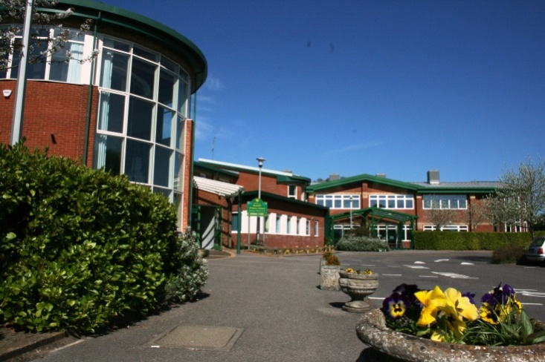

Headteacher Information Pack
Muscliff Primary School
November 2018

‘We place achievement within the reach of all children but, sometimes, we ask them to stand on tiptoe to get there’

Contents

Page 3 Welcome

Page 5 Vacancy details

Page 7 Job Description

Page 9 Person Specification

Page 11 School Information

Application form is in a word document format and available separately

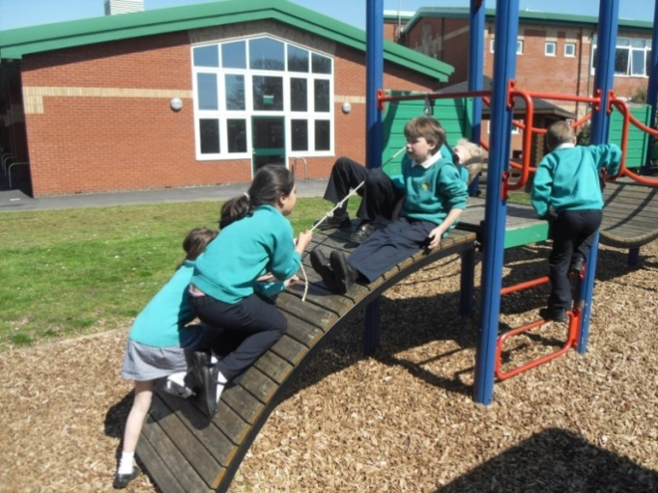

muscliff@muscliffprimary.co.uk

Dear Applicant,
I am delighted that you are considering applying for the post of Head Teacher at Muscliff Primary School. This vacancy has arisen due to the retirement of our very valued current Head Teacher. Within this pack we hope to give you a flavour of the school and an indication of the qualities the Governing Body is looking for.
The community of Muscliff is a diverse and growing one. Muscliff is a popular place to live and we are an oversubscribed school serving this community. We are a three-form entry school at full capacity. We offer a Breakfast and After School Club as well as Holiday Clubs to provide “wrap around” care for our children.
We have a modern school building and grounds which provide many opportunities for children, staff and the community. Outdoor learning is a very important part of our ethos and staff work hard to ensure outdoor opportunities are provided for our children. We have a multi use general area (MUGA), a secret garden with a ‘mud kitchen’ to enhance learning and we are fortunate enough to have a large playing field and playground for outdoor sports activities. Muscliff Primary is situated in the beautiful valley of the River Stour so provides exciting outings for the children to The Kingfisher Barn Visitor Centre and Throop Mill.
Our curriculum and wider opportunities are at the core of what makes our school such a great place to be. Muscliff is very much about the ‘whole child’, and we ensure children achieve well and have a full breadth of learning with opportunities in the Arts, Music, DT and PSHE – all subject areas are vitally important. In PE, children of all abilities are given a wide range of opportunities to take part in sports in-house as well as proudly representing the school in football, netball, tag rugby and athletics.
Our dedicated team of staff has a range of people at various stages of their careers. We have a proven track record of ‘growing our own’ as well as contributing to the wider development of the profession throughout close working with other local schools in the area.
We are a good and improving school, our last Ofsted was in October this year.
Highlights from that report were:
- Leadership team has maintained the good quality of education in the school
- Leadership has created a school that serves the needs of all children in the community, whatever their ability or background
- Senior staff are skilled and experienced
- Strong safeguarding culture across the school
Governors, parents and children are justifiably proud of our school and our ambition is to be an outstanding school for all. We want our children to:
- love to learn
- gain a lifelong thirst for knowledge
- be continually challenged
- grow as individuals
- play a productive role in the local and global community
- achieve their full potential and gain the vital skills and confidence to ‘spread their wings and fly’.

To lead us in the next stage of our journey, we are looking to appoint an experienced and exceptional leader who will build on our existing achievements. You will need to be able to:
- deliver the highest quality of education for our children and families
- invest in the development of our staff, including evidence-based practice
- build on the caring and inclusive school ethos

This is an exciting time to be coming to Muscliff, and I know you will enjoy the strong support and commitment from staff, governors and the wider community.
We are pleased to offer an opportunity for informal visits by candidates (please see page ?) of this pack). During these visits candidates will have the opportunity to meet with a governor and some of our wonderful children and staff as well as see our buildings and grounds and get a real sense of ‘life at Muscliff’.

I encourage you to visit the school to get a feel for what we can offer. We look forward to meeting you and to receiving your application.

Tracey Farwell
Chair of Governors

Vacancy details
School: Muscliff Primary School, Broadway Lane, Bournemouth BH8 0AB. ​Group 4; NOR: 621
Post: HEADTEACHER
Start date: September 2019
Contract term: Permanent
Contract Type: Full Time
Salary: Leadership (L21-27 £65,384-£75,735) per annum FTE
Are you our next Headteacher? Do you have the vision to lead our school and deliver the highest quality education for our children and families? Can you lead us from good to outstanding?
Due to the retirement of our highly valued Headteacher, the Governors, staff and pupils are looking for an aspirational and astute leader for our large, friendly and over-subscribed primary school.
Our mission is to be an outstanding school for all, where children love to learn and gain a lifelong thirst for knowledge. We place achievement within the reach of all children but, sometimes, we ask them to stand on tiptoe to get there. We are committed to providing a happy, safe, fun and secure environment in which every member of the school community feels valued and can flourish.
Our new Head Teacher will be:
- an inspirational and exceptional leader with the ambition, energy and skills to lead our School from good to outstanding
- an experienced Primary School leader who is knowledgeable, creative and able to build on Muscliff’s current success and achievements
- able to support, motivate and inspire staff with a clear vision for the future direction of the school
- passionate about developing teaching and learning to meet the needs of all pupils, with an
imaginative, effective approach to ensuring high standards and good progress
- a skilled communicator able to engage effectively and successfully at all levels

In return, we will offer you
- a thriving school, ambitious for the next phase of development
- well rounded, confident, successful and engaged children
- dedicated, hardworking, talented and committed staff
- a positive learning environment
- supportive parents and community
- a school with an excellent reputation within the local area
- the full support of the Governing Body in your work to lead Muscliff Primary School from good to outstanding

If you believe you are the person who can lead us to further success, we welcome your application.
Please arrange to visit and meet us here at Muscliff Primary School by contacting Paula Harvey on 01202 549654 or by email at:paula.harvey@muscliffprimary.co.uk
If you have any questions about the role, please contact Tracey Farwell, Chair of Governors at:tracey.farwell@muscliffprimary.co.uk

Important dates to be aware of:
Closing date: Tuesday 29th January 2019, 12 noon
Short listing: Wednesday 30thJanuary 2019
Interviews: Thursday 28thFebruary & Friday 1st March 2019

Our School is committed to safeguarding and promoting the welfare of children and young people and expects all staff, volunteers and visitors to share this commitment. This post will require an Enhanced Disclosure and Barring Service check (DBS)

For more information about Muscliff Primary School please visit our website atmuscliffprimary.co.uk

Job Description

Post Title: Headteacher
Responsible to: Governing Body
Salary Range: (L21-27 (£65,384-£75,735) per annum FTE
Contract: Full time, Permanent

Purpose of the Job:
The Headteacher of Muscliff Primary School will ensure that the school’s aims are implemented in accordance with the School Development Plan along with other strategic plans and the policies of the Governing Body.
The Headteacher is required to monitor, evaluate and review the impact of policies, priorities and objectives for improvement and take timely and effective action that results in sustained development.
The Headteacher must provide strong leadership and management of the school and promote a secure foundation from which to achieve the highest possible standards in all areas of the work of the school.
The Headteacher will carry out his/her professional duties in accordance with and subject to the National Conditions of Employment for Headteachers and relevant education and employment legislation.
The Headteacher will always endeavour to meet the Department for Education’s National Standards of Excellence for Headteachers, 2015

Core responsibilities of the post
Specifically, the Headteacher will:
- Lead on safeguarding and child protection; ensure safeguarding systems are highly effective and create a productive and safe learning environment for children
- Articulate a strategic and compelling vision and ambition for the school
- Deliver effective, professional leadership and management of the school ensuring all staff have clear roles and responsibilities and are held to account
- Deliver high quality education by managing and improving teaching and learning to realise the full potential of all pupils.
- Inspiring and influencing an exciting, rich and broad curriculum that is delivered in ways that engages and supports all pupils in their learning and well being
- Identify the needs, experience, interests, aptitudes and stages of development of the children through listening and responding to them; and those caring for them allowing them to have fun whilst helping them learn important life skills.
- Motivate pupils and staff to achieve excellence and value and celebrate their contributions to school life
- Evaluate accurately the school’s performance and identify strengths and priorities for improvement
- Deploy resources efficiently and ensure that effective financial management, monitoring, planning and reporting is in place to achieve the school’s aims and deliver success for children
- Be responsible for day to day management, organisation and administration of the school to ensure a safe, organised and purposeful learning environment for children and staff
- Secure the commitment and engagement of parents, carers and the school’s wider community in supporting the school’s development
- Promote equality of opportunity, respect diversity, eliminate unlawful discrimination and sustain an ethos that supports an inclusive approach for all members of the school community
- Ensure effective people management and Human Resources practices are in place and fully utilised
- Ensure the health, safety and wellbeing of all those who use the school
- Deliver effective performance management for all staff and agree own annual objectives with governors linked to school improvements priorities.
- Ensure there are appropriate continuing professional development opportunities for staff that feed into both personal and career development and school improvement
- Undertake personal professional development to enhance own performance and to keep up to date with latest developments and thinking.
- Work effectively with the school’s Governing Body including the provision of timely and accurate reports
- Builds collaborative relationships with other schools and organisations through positive mutual challenge
- Promoting and sharing best practice linked to well evidenced research to ensure a self-improving school

Safeguarding and Child Protection
The Governing Body are committed to safeguarding and promoting the welfare of children and young persons and headteachers must ensure that the highest priority is given to following guidance and regulations to safeguard children and young people. The successful candidate will be required to undergo an enhanced check by the Disclosure and Barring Service (DBS).

Person Specification for Headteacher at Muscliff Primary School, Bournemouth
Criteria | Essential | Desirable
- Qualifications and Experience
Qualified Teacher Status with degree or equivalent | *
Post Graduate qualification / Continuing Professional Development | *
National Professional Qualification for Headship (NPQH) |  | *
Significant recent experience as an effective Headteacher, Deputy Headteacher, Head of School or Assistant Headteacher in a Primary School | *
Training in Child Protection relevant for Designated Safeguarding Lead |  | *
Safer Recruitment approved training |  | *
Senior leadership experience in a large primary school |  | *
- Qualities and Knowledge
Leads by example with clearly articulated vision, integrity, creativity, energy and resilience | *
Successful implementation of strategies for ensuring high standards across the whole school, including attendance and behaviour for learning | *
Effective leadership of strategic planning and change across the whole school, identifying priorities, monitoring implementation and evaluating impact | *
Analytical and problem solving skills. Uses comparative data and performance indicators to make informed judgements and set targets for improvements | *
Understanding of strategic financial planning and budgetary management and their contribution to school development and pupil achievement | *
The ability to understand and appreciate the school’s current strengths and the ways in which these might be further developed | *
Identifies and deals effectively with priority issues whilst being adaptive and responsive to circumstances | *
Strong organisational skills and an ability to work under pressure, to delegate, plan, monitor and manage time effectively | *
Commitment to ensuring inclusion, addressing diversity and access | *
Excellent inter-personal and communication skills to engage the involvement of staff, parents, governors and the wider school community | *
Sustains wide, current knowledge and understanding of education and school systems and pursues continuous professional development | *
- Pupils and Staff
Motivates all staff and supports them to develop their skills and knowledge through effective performance management | *
Secures excellent teaching with understanding of how pupils learn, successful classroom practice and accurate assessment for learning that informs planning | *
Demands ambitious standards for all pupils, including more vulnerable learners. | *
Desire and passion for capturing children’s interests and allowing them to have fun whilst helping them to learn important life skills | *
Experience of innovative curriculum delivery | *
- Systems and Process
Ensures school’s systems, organisation and processes are well considered, efficient and fit for purpose, upholding the principles of transparency, integrity and probity | *
Responsibility for whole school policy development and implementation | *
Welcomes strong governance and actively supports roles, responsibilities and accountability of governing body to set school strategy and hold head-teacher to account | *
Exercises strategic financial planning to ensure the equitable deployment of budgets and resources in the best interest of pupils’ achievements and the schools sustainability and growth | *
Distributes leadership throughout the school, ensuring all staff have clear roles and responsibilities and are held to account for their decision making | *
Commitment to the welfare and safeguarding of children and young people | *
Commitment to equality and ensuring equal opportunities | *
- Self-Improving school system
Builds and maintains collaborative relationships with other schools and organisations through positive, mutual challenge | *
Effective relationships with other professionals in education and related services | *
Active involvement in school self-evaluation to inform improvement | *
Inspire and influence others to believe in the importance of education | *
Muscliff Primary School promotes equality. The school is committed to eliminating unlawful discrimination and to promoting good relationships with all members of the community.
The governing body is committed to safeguarding and promoting the welfare of children and young people and expects all staff and volunteers to share this commitment. Headteachers must ensure that the highest priority is given to following guidance and regulations to safeguard children and young people.
The successful candidate will be required to undergo an enhanced check by the Disclosure and Barring Service.
All appointments are conditional, subject to references and an enhanced DBS disclosure.

School Information

Website
www.muscliffprimary.co.uk

Ofsted information and visit report
http://www.muscliffprimary.co.uk/ofsted-report/

Newsletters
http://www.muscliffprimary.co.uk/stream/noticeboard/headline/1/

Safeguarding and child protection policy
http://www.muscliffprimary.co.uk/policies/

