Our Ref: SWC/MJN

14th January 2019

Dear Candidate

Bredon Hill Academy is a unique place of learning. Our 10 – 13, Year 6 to Year 8 Academy is one of only a handful of schools in the country where entry is in year 6 and exit in Year 8.

It is in an idyllic rural setting on the outskirts of the village of Ashton under Hill and within the Cotswolds A.O.N.B. This adds to the distinct ethos and culture which will not fail to impress any visitor or potential candidate.

A small number of our pupils leave at the end of Year 6 after sitting tests for Grammar schools within Worcestershire, Gloucestershire and Warwickshire. However, at the end of Year 8, 98% of pupils transfer to Prince Henry’s High School, a high performing Academy in the town of Evesham.

Pupils follow a broad and balanced curriculum throughout Year 6 – 8. Whilst we are accountable for KS2 results, we continue to insist upon joint responsibility with our feeder First Schools for progress through KS2, 75% of which is controlled by them.

We do not overload the curriculum at KS2 with English and Maths lessons, indeed pupils in Year 6 have, where possible subject specialists for a full range of core and foundation subjects. We believe we prepare them for high school a year earlier than a two tier system, with a secondary curriculum scheduled on a two week timetable.

The Academy is 6 form entry (162 per year group) with a PAN of 486. It is always oversubscribed with waiting lists and is held in high regard within the community.

There is a ‘house’ structure and participation rates in extra-curricular activities are very high. The Academy has full International School status, is part of the Erasmus programme and is strongly committed to an Eco-Schools philosophy.

The school day runs from 8.15am – 3.00pm with three one hour lessons in the morning and two 55 minute lessons in the afternoon. Assembly and tutor time are scheduled at the end of the day.

All staff at the school are committed and hard working to ensure that Bredon Hill continues to be the middle school of choice within the area.

The Board of Directors of the Trust and the LGB of Bredon Hill are dedicated and supportive in their roles whilst ensuring that Senior Leaders are held to account for pupil outcomes. There is an active PTA, known as FOBHA (Friends of Bredon Hill Academy).

A full time Headteacher for Bredon Hill and interim CEO for The Hill Trust is required from 1st September 2019. Currently a standalone Trust, The Hill Trust seeks to grow to a MAT, during which the roles and responsibilities of the CEO will evolve.

Candidates can apply by completing the Academy’s application form (no C.V.s please) and writing an accompanying letter of no more than two sides of A4, addressing what experience they have that makes them suitable for this role. The application form and accompanying documentation can be accessed on the Academy website.

All applications should be signed and addressed to:

Mr P Sagar MBE, Chair of Directors c/o Bredon Hill Academy, Elmley Road, Ashton under Hill, Evesham, Worcs WR11 7SW

They may be sent electronically to recruitment@bredon.worcs.sch.uk or posted to the above address.

The closing date for receiving applications is 3.00pm on Friday 1st March.

There will be an opportunity for candidates to visit the school on either 7th or 8th February 2019. Please book appointments via Mrs M Norman in the school office.

The interview process may take up to two days and will take place between 4th and 11th April. Those candidates who are short-listed will be informed the week before the interview date and provided with information regarding the schedule for the day.

Yours sincerely

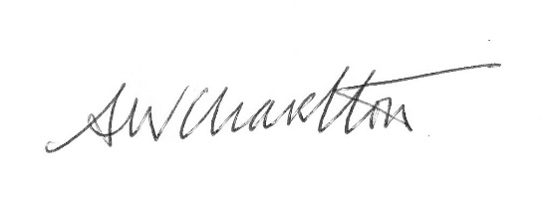

Mr S W Charlton
Headteacher/CEO

