

Headteacher, Culcheth, Warrington

Closing date:18 March 2019NEW THIS WEEK

[Newchurch Primary School, Culcheth](https://www.tes.com/jobs/employer/kearsley-west-primary-and-nursery-school-1027525)

Date posted: 15 Feb 2019  
Start date: September 2019  
Contract type: Full Time

Salary: L13-19  
Contract term: Permanent

The Governors of Newchurch Primary school are seeking an inspirational and dynamic leader with vision, passion and drive. We want a Head Teacher who is ambitious for our school, pupils and our staff, a strong motivational leader who can continue to lead us from good to outstanding. Our current head teacher is moving on to another headship position following the highly effective leadership of our school for 10 years. We are offering an exciting opportunity to lead a successful school.

**We are proud to have and can offer:**

* A successful and nurturing school with an engaging, rich and balanced curriculum which puts our children’s learning and wellbeing at the heart of everything that we do, achieving high standards whilst developing confident and happy citizens for the future.
* Enthusiastic children who love to learn in a warm school with a strong family ethos in a school which has a sense of community and belonging; pupils, staff, families and a supportive governing body all working collaboratively together to make our school the best it can be.
* A strong professional team of highly dedicated teaching staff who are committed to the highest standards and create a caring, happy and positive environment through excellent relationships with parents and the wider community.

**We welcome applications from those who have:**

* Proven strong leadership skills to develop, communicate and deliver upon a shared vision and strategic plan which inspires and motivates the whole school community and builds upon current strengths and initiatives to ensure a smooth transition that delivers outstanding teaching and continuous improvement.
* Talent, vision and passion to provide inspiring motivational leadership for staff and pupils through drive, support, nurture and a clear strategy for developing high standards of teaching and learning to achieve the best possible outcomes for all our pupils whilst leading by example and modelling best practice regarding professional conduct, workload and continued personal development.
* Excellent communication skills and the energy to maintain an outward facing school which works in partnership with other schools, organisations, parents and governors to secure excellent outcomes for our pupils, school and staff.

**Our children tell us that they want a Head Teacher who is:**

A leader, happy, respectful, creative, fun, protective, strong, joyful, kind, helpful, smart, friendly, safe, caring, cheerful, excellent and an explainer.

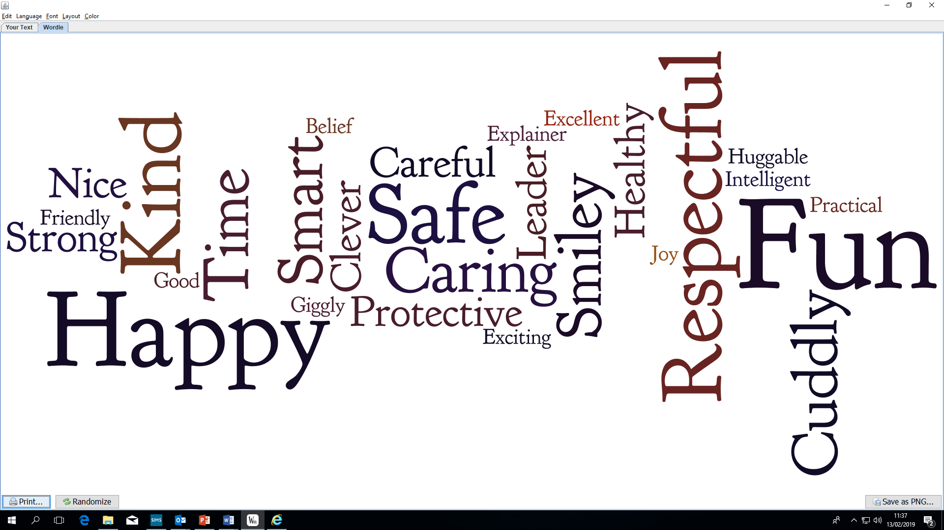

Newchurch is a one form LA maintained school within the thriving popular village of Culcheth in rural north Cheshire, situated mid-way between Manchester and Liverpool. The school is set in extensive grounds which are used to provide our children with lots of opportunities to learn outdoors, engage in a wide variety of sporting activities and in realising our vision of becoming a forest school.

Visits to school are encouraged and warmly welcomed – times are available on 27 February (PM), 7March (AM), 12March (PM) and 13March (AM). If you think you have the experience and knowledge to fulfil this role and would like to visit us, please contact our School Business Manager at [Newchurch_Primary_BusinessManager@warrington.gov.uk](mailto:Newchurch_Primary_BusinessManager@warrington.gov.uk)

The Head Teacher Candidate information pack is attached to download, the professional competencies assessment and completed application forms should be emailed to [Newchurch_Primary_BusinessManager@warrington.gov.uk](mailto:Newchurch_Primary_BusinessManager@warrington.gov.uk) and we will acknowledge your application. Closing date for applications is 18 March 2019 at noon. Shortlisting will be on 25 March 2019. An initial assessment Centre will be held on 4 April 2019. Successful candidates will be invited to a final assessment centre on 5 April 2019.

*The school is committed to safer recruitment, safeguarding and promoting the welfare of young people and expects all staff and volunteers to share this commitment. The post is subject to safer recruitment checks and enhanced disclosure from the Disclosure Barring Service. Our Data Protection Officer is Sara Lawrenson.*