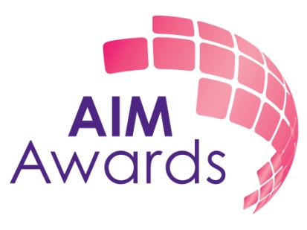

Information Pack

General information about AIM Awards

How to apply

Information about the role: Assessment developer (marketing, PR and communications)

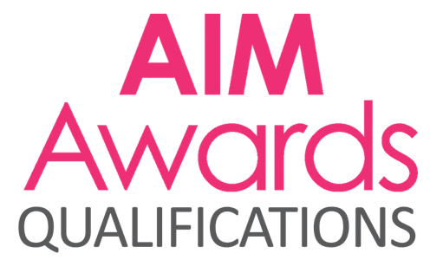 | 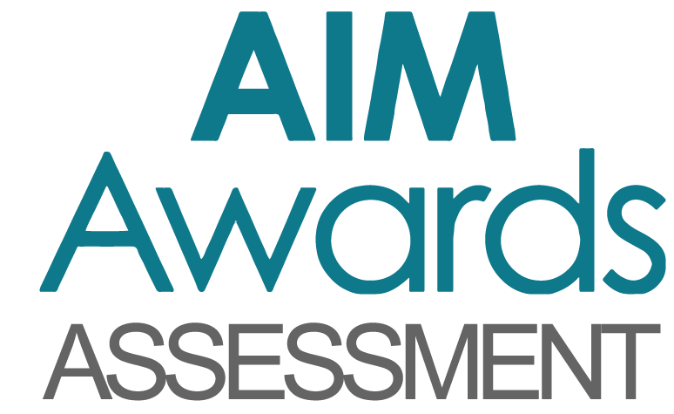 | 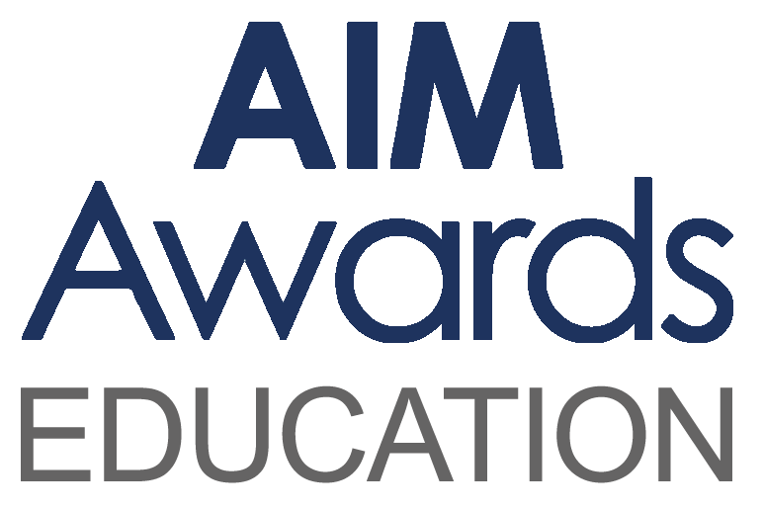

It’s what we do together that sets us apart

Aspirational, Inspirational, Motivational

AIM Awards is a company Limited by Guarantee
Registered No. 5038056 Registered Charity No. 1103300

Dear enquirer

Thank you very much for your interest in working at AIM Awards. We are a registered charity operating as an awarding organisation, Access to HE validating agency and end point assessment organisation. We have a head office based in Derby and are dedicated to offering a high-quality, efficient and effective service whilst remaining supportive and accessible.

We want to continue to grow AIM Awards. We know that great businesses are powered by happy colleagues who feel invested in the company they work for. Our people are curious and creative colleagues that anchor us to our foundations and help achieve our charitable objectives for learning – all kinds of learning for all kinds of people. Whether it’s at home, in the classroom or in the workplace, learning is the key to improving our chances in life.

As well as providing a fun and inspiring workplace, over the years we have defined clear values that inform everything we do, ensuring all our teams are striving to be world-class, constantly innovating and inspiring positivity in their colleagues.

Not just co-workers, we're proud AIM Awards colleagues who help our company thrive. Our friendly and professional teams work together in a diverse range of roles to support the future of work and learning around the world. If you share our commercial focus and passion for helping people to realise their potential – discover more about the exciting careers and great benefits we can offer you.

Key information:
- We have a portfolio of over 500 regulated qualifications in a range of subject areas
- We work in over 40 countries through our partnership with Anglia Examinations
- We validate the Access to HE Diploma for a wide range of FE colleges and training providers
- We are building a series of online training courses to support delivery of our qualifications
- We are developing our footprint as the end point assessment organisation of choice for the creative industries
- We have 30 full and part-time staff in addition to a large number of subcontracted verifiers, assessors and examiners

I place tremendous personal importance on getting the right person to maintain the excellent levels of customer service in which we pride ourselves.

I look forward to your application.

Linda Wyatt
Chief Executive

We welcome applications from all sectors and communities and are able to make specific arrangements and adjustments for candidates whose circumstances require this.
Background

AIM Awards is an Awarding Organisation regulated by Ofqual, CCEA and Qualifications Wales to develop, deliver and award qualifications. We are also recognised by the Quality Assurance Agency for Higher Education (QAA) as an Access Validating Agency (AVA) to develop and approve courses leading to entry to Higher Education. We are currently approved by the ESFA to develop end point assessment for four apprenticeship standards in the creative industries and have an ambitious development plan for significant growth in this new market.
We are a registered charity and originated as an organisation in the 1980s, becoming AIM Awards in 2011. In the past few years we have expanded internationally with our ESOL provision and are now working in partnership with Anglia Examinations in over 43 countries.

We work closely with employers, further education colleges, higher education institutions, schools, offender learning centres, voluntary and community sector organisations and private training providers to ensure our products are as good as they can be. Our qualifications are used by over 400 recognised centres and a growing number of employers and training providers are turning to us for end point assessment.

Our strategic aims are to:
- be established as a significant high-quality end point assessment organisation
- be a leading high-quality AVA
- grow our international market
- be a major provider of offender learning
- maintain and grow all our brands and markets
- maintain compliance with all regulators

AIM Awards Services

There are many benefits for centres working with AIM Awards:

- Value for money, including reasonable charges and a not-for-profit ethos
- Dedicated support through regional account teams
- Access to a network of education and training organisations
- An efficient administrative and certification service, with clear service standards
- A commitment to promoting wider access to learning, equality of opportunity and recognition of achievement

About the role

The post holder will co-ordinate the lifecycle for a portfolio of assessments, provide specialist assessment knowledge and specialist occupational knowledge from their previous experience. The ideal candidate will have previous experience as an FE Lecturer, or comparable experience of teaching in the field of marketing, PR and communications.
The assessment developer will take responsibility for the design and development of assessments and will manage the review process of assessments.
Being an assessment developer for AIM Awards you will having extensive knowledge of assessment practices and experience in writing, delivering and evaluating assessments and/or examinations. The role requires an in depth understanding of vocational education, assessment and delivery and a knowledge of the current market place for assessments. The ideal candidate must have strong project management skills, with the ability to work to deadlines.

Drawing on your previous experience within education, you will work closely with the in full (EPAO) team to deliver and effectively contribute to continually improve the delivery of the apprenticeship end point assessments and ensure that you are providing the best possible service for our in full EPA apprentices and customers.
This role is fixed term for one year in the first instance with the potential for it to be extended. The role can be office or home based and may involve some travel, for which reasonable expenses will be paid.

The benefits

We are committed to making AIM Awards an excellent place to work. The post holder will have access to the following benefits:

- Salary: up to £27,000 (pro-rata)
- 26 days leave per annum plus Bank Holidays (pro-rata)
- Membership of AIM Awards pension scheme
- Flexible working
- Access to training – AIM Awards has been accredited as an Investor’s In People employer

This job is available on a 0.5 contract (18.5 hours per week)
AIM Awards staff teams

AIM Awards has five main teams with specific functions across the organisation.

- The business team is responsible for working with their allocated centres to establish which of our products best meets the need of their learners. The business development managers have responsibility for liaising with the staff in our centres to offer full support on our products and promoting our qualifications to organisations across the country. The Director of Business and Brand Development leads this team.

- The product team is responsible for the development and review of qualifications, assessments and resources throughout their life cycle, ensuring validity and fitness for purpose. The Director of Assessment and Qualifications leads this team.

- The quality team is responsible for standards and regulation across centres and products. Each centre has a named external quality assurance manager or centre lead moderator for annual and periodic review visits, monitoring all aspects of quality assurance and supporting quality improvement. The team monitors standards over time and provides the evidence required for our regulators. External verifiers/moderators within the team have responsibility for checking internal assessment decisions and processes at centres. The Director of Quality and Operations leads this team.

- The customer support team is responsible for ensuring the highest service standards to our centres. They manage the end to end process from centre approval, registration, award and certification of products. They also handle examination and assessment booking and invigilation. The Customer Support Manager leads this team.

- The corporate service team is responsible for delivering an administration service to all areas of the organisation. The Manager of Corporate Services leads this team.

How to Apply

Candidates should submit the application form provided and a letter of application outlining how they meet the criteria for the post (max two sides of A4).

If you have any questions about the role then please contact the AIM Awards Office and ask to speak to Rachael Tweddle, People Manager on the following number: 01332 341822

Completed forms should be returned to:
Rachael Tweddle
People Manager
AIM Awards
3 Pride Point Drive
Pride Park
Derby
DE24 8BX

Email application to: - Rachael.Tweddle@aimawards.org.uk

Closing date Friday 19th April 2019

