SOUTH DARTMOOR COMMUNITY COLLEGE

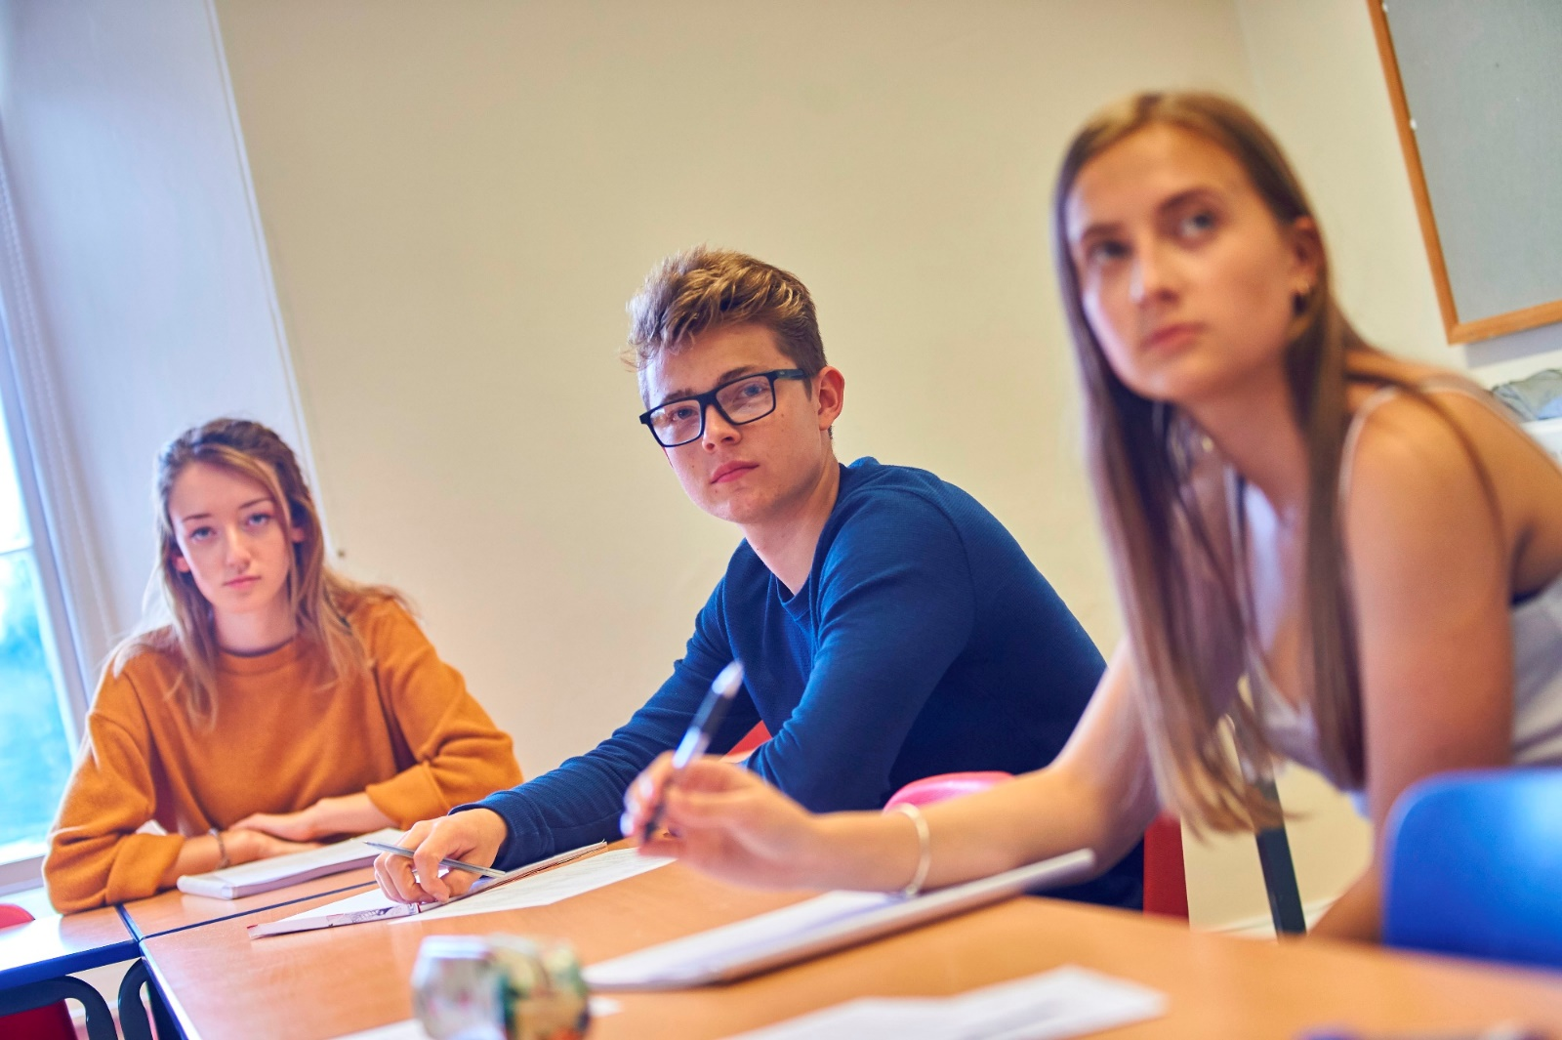

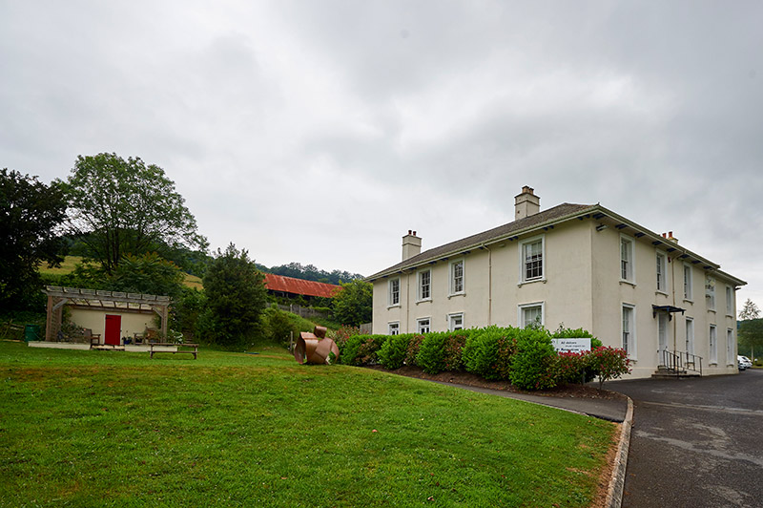
Head of Department - ENGLISH

Dear Applicant,

Thank you very much for your enquiry regarding the post of Head of English at South Dartmoor Community College and Atrium School.

This is an exciting opportunity for someone to develop their own team and vision for the department. Most of our current English team will be leaving in September for promotion and relocation reasons and we would be keen for our new Head of English to join us in recruiting new members of staff over the Summer Term. Whilst attainment has been broadly in line with average, progress 8 scores have been in the bottom 20% nationally for the last 3 years at SDCC and so we are looking for someone who will be able to lead a department to rapidly improve our outcomes. Within your department you will also have an assistant head of English with leadership responsibility across KS3. We have a very successful sixth form with strong outcomes at KS5 and English is a popular choice for our students.

The role would also entail supporting English at Atrium Studio School. This school sits within the grounds of South Dartmoor and draws students from years 9-13 with approximated 34 students per year at KS4. The schools will be sharing classes and therefore the English teacher at Atrium will need to be included as part of the overall English department in order to benefit from moderation and CPD opportunities.

South Dartmoor Community College sits within the historic town of Ashburton and we have one of the largest catchment areas in the country as many of our students live within the stunning Dartmoor National Park. We have supportive parents and the pastoral provision at the school is extremely strong as well as our creative arts and sporting departments. This an exciting time in the life of the school as we will be embarking on a collaborative school improvement journey across departments supported by our strong links with Education South West (a neighbouring Trust) and their teaching and research school.

Informal visits are welcomed. Please contact cedworthy@southdartmoor.devon.sch.uk to arrange a time.

The closing date for completed application forms is 9am on Monday 23rd April.

Thank you for your interest in the post and we look forward to receiving your completed application form.

Yours faithfully,

Rachel Shaw
CEO/Executive Principal.

About South Dartmoor Community College

OUR VISION

The core guiding principle that lies at the heart of everything we do at South Dartmoor Community College is to encourage and develop personal responsibility among all members of our community. We believe in empowering students to take control of their own learning and their own lives so they know how to make good choices and also have the ability to thrive in a fast moving, ever changing world. By creating a learning environment that has high expectations of everyone - and by modelling the behaviour that we expect from our students - we can provide the stepping-stones that bring dreams closer to reality.

OUR SCHOOL

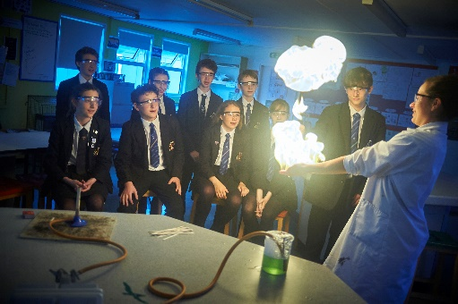
South Dartmoor Community College has approximately 1250 students on roll, including the 6th Form College. The school is split into 5 houses named after local Tors on Dartmoor and the pastoral care of students is very strong. The school also has a CAIRB (communication and interaction resource base) that supports 12 students with communication and interaction needs in accessing mainstream education. The school has a strong reputation for the quality of its arts and sports provision. We also run the school sports partnership which engages with over 50 primary schools and their local secondary schools to provide both competitive and non-competitive sporting opportunities for primary pupils.
About Atrium Studio School

Vision
Our vision is for a forward thinking, inspiring and enriching school, where students are respected as individuals (no "conveyor belt" approach at Atrium!) and have personally-tailored learning plans delivered by enthusiastic and knowledgeable teaching staff. We work hard to create a climate where success is celebrated, students feel valued, and love their learning.

We want our students to grow into confident and skilled professionals, inspired by our mantra, "it's cool to succeed." Alongside this, we recognise that while they're with us, we have a responsibility to develop their approach to fundamental British Values - including tolerance, free speech, personal liberty and the rule of law. At the heart of all we do is our desire for students to be able to live and work harmoniously in a range of environments and communities.

OUR SCHOOL

Atrium is a purpose-built studio school with approximately 120 students from years 9-13. The school draws from a wide catchment area with parents and students choosing to travel long distances to access the unique education the school provides. Students join the school because they have a passion to develop a skill or career in the built environment and this is core to the school’s success. The school uses project-based learning to enhance understanding and has strong links with employers and industry. The school day extends to 5pm Mon-Thurs which enables students to complete their home learning and experience more of a traditional length working day.

Ashburton

Ashburton is a small rural town situated within the Dartmoor National Park, and often described as a gateway to the Moor. The town’s history is largely built on the wool and tin trade and it has maintained the role of Portreeve for 1198 years, leading Medieval courts. There are many cultural and sporting opportunities within the town.

Ashburton has easy access to the A38 and is less than half an hour from both Exeter and Plymouth, affording an easy commute. Our unique location makes it ideal for pursuing many leisure activities including moor walking, mountain biking, caving, rock climbing, white water kayaking and sea related sports/activities. In addition to this, the university cities of Exeter and Plymouth both offer cultural experiences with theatres, respected venues and contemporary restaurants.

About South Dartmoor Multi Academy Trust
South Dartmoor Multi-Academy Trust was formed in April 2011 and consists of 7 local schools: Ashburton Primary, Atrium Studio, Buckfastleigh Primary, Ilsington C of E Primary, Moretonhampstead Primary, South Dartmoor Community College and Widecombe Primary. We are currently looking to create a management partnership with Education South West, a neighbouring trust with 6 primaries, 4 secondaries, a teaching school and a research school. In September 2020 we will also be opening a new special school in Newton Abbot, ‘Glendinning House,’ that will cater for KS2-KS5 children who have communication and interaction difficulties.
At SDMAT we want all of our schools to have their own identity and sense of purpose that reflects the needs and ethos of their community. We also recognise that we are stronger when we can work together and share the best practice within our schools to benefit the education of all of our children. All schools within our MAT ensure:
- We put children first - we care deeply about all of the children in our schools and are committed to combatting disadvantage by ensuring children achieve the highest standards;
- Staff are valued and have a common sense of purpose – staff have clear roles, a work/life balance and the opportunities to develop and grow and become experts in their profession​;
- Our communities feel proud of the school their child attends and benefit from our work in helping children enter the adult world as valued members of society who have much to contribute.
These principles underpin all that we do and are often a focus for our next steps of development as a group of schools. We are extremely united and dedicated in wanting to achieve the highest quality of education for all our pupils and all school leaders within the academy are invested in wanting all the schools to succeed. There is a huge amount of transparency within the schools as we can only work effectively together by fully understanding the challenges each school faces.
Academy Governance
Each school has retained a local governing body which is focussed on monitoring the quality of provision within their school and providing challenge and support to school leaders. The directors of the academy set the strategic direction for the Trust and monitor performance and the members are guardians of the vision and ethos of the Trust.

Job Description

HEAD OF DEPARTMENT SDCC AND ATRIUM
RESPONSIBLE TO: PRINCIPAL, LOCAL GOVERNING BODY & DIRECTORS
This job description is not a comprehensive definition of the post. Discussions will take place on a regular basis to clarify individual responsibilities within the general framework and character of the post as identified below. The job description of teacher also applies.
MAIN PURPOSE OF THE JOB
To lead, hold accountable, support and develop a team of staff to ensure high standards of learning and teaching and well-being of staff and students.

Leadership
- Contribute to school self-evaluation throughout the year;
- Contribute to specific whole school improvement priorities with other members of the school’s middle and senior leadership team;
- Work collaboratively with other school leaders to drive rapid school improvement and secure better outcomes;
- Support the school ethos based on high expectations of all members of the school community;
- Lead the development, planning, implementation and review of the curriculum within the department in response to the national agenda;
- Create a climate within the department where good practice is shared internally, across the wider school and, where appropriate, across the trust;
- Work with Local Governors, when necessary, to monitor and evaluate school provision and ensure the vision of the Trust is achieved;
- Represent the department at appropriate meetings in school and with other agencies;
- Be involved with the appointment of teaching and non-teaching staff in the department;
- Ensure the department has consistently high expectations of students and staff;
- Ensure that Newly Qualified Teachers and trainee students are mentored and new staff are supported in their induction to the school;
- Participate in performance management in line with statutory requirements;
- Effectively manage the department budget;
- Ensure that stock and equipment are looked after and used effectively;
- Support the Health and Safety of students and staff within the department area and communicate any issues to the Health and Safety Manager;
- Lead the teaching and learning of English at Atrium Studio School by supporting the English teacher and involving him/her into SDCC department practises.

Teaching and Learning
- Ensure appropriate schemes of work are established and reviewed to ensure there are high expectations of learning resulting in improved progress and student outcomes.
- Ensure the quality of teaching and learning within the department is good or better
- Ensure that homework of appropriate challenge and sufficient amount is set according to school policy;
- Draw up and implement department policies;
- Create a positive climate within the department regarding attitudes to learning, good behaviour and a sense of community;
- Accurately monitor, evaluate and review the quality of educational provision within the department to provide evidence of the impact of actions taken on student progress and standards
- Ensure that student progress is good or better for all groups of students;
- Ensure effective intervention strategies are in place for students to narrow the attainment gap;
- Liaise with colleagues in all other matters concerning timetable, curriculum, pupil groupings, examinations and related matters;
- Ensure good communications with parents to report student progress, resolve issues and encourage strong home/school partnership working;
- Ensure that the department’s learning area provides a supportive, stimulating, ordered environment for learning (including assigned space in corridors);
- Provide input to the planning and development of the school’s CPD programme;
- Ensure English has a high profile within the school and across departments
- Support SDCC in becoming a school with a strong reading culture
- Encourage a positive attitude to learning and desire to improve from the students;
- Ensure that the school policy on rewards and sanctions is fully implemented within the department area and encouraging positive learning behaviours;
- Work with student support staff and Heads of House to address issues relating to students who display
persistently challenging behaviour;

Person Specification

The following outlines the key skills and experience required for this position. The selection panel will assess each candidate against the criteria listed below, expecting candidates to demonstrate knowledge and understanding of each area and show evidence of having applied (or awareness of how to apply) this knowledge and understanding in the school context.
A = Application I = Interview R = Reference
Qualifications and Experience | Essential | Desirable | Source
- Teaching qualification |  |  | A
- Higher level degree |  |  | AIR
- Relevant recent professional development that prepares the applicant for this post (i.e NPQSL) |  |  | AIR

Experience | Essential | Desirable | Source
- Success in leading department/whole school initiatives |  |  | IR
- At least four years teaching experience in a United Kingdom secondary school |  |  | A
- Working collaboratively with other schools and local community |  |  | I
- Experience of teaching English successfully up to and including A level and a good record of public examination success |  |  | AIR
- Experience of working in more than one school |  |  | A

Professional knowledge | Essential | Desirable | Source
- How to plan strategically |  |  | I
- Knowledge of effective models of teaching and learning based on research |  |  | AIR
- Understanding of national developments and how this impacts on the subject |  |  | I
- Knowledge of effective assessment for learning |  |  | AI
- Strategies to ensure inclusivity, diversity and access |  |  | IR
- Commitment to safeguarding and child protection |  |  | AIR
- Understanding of health and safety and GDPR |  |  | IR

Personal skills and attributes | Essential | Desirable | Source
- Excellent subject knowledge and a passion for the subject |  |  | IR
- Create a fair and open working environment that enables the resolution of conflict |  |  | AI
- Drive and energy for continuous improvement within department |  |  | AI
- Excellent communication skills |  |  | AIR
- Excellent resilience and time management skills |  |  | AIR
- Ability to think creatively and be solution focussed |  |  | AIR
- Strong understanding of how to use data effectively |  |  | AIR
- Ability to inspire and motivate a team |  |  | AIR
- Ability to give high quality feedback to staff to improve quality of teaching and learning |  |  | IR
- Ability to challenge and improve poor performance |  |  | IR
- A willingness to be involved in the wider life of the school |  |  | AIR
- Ability to form strong relationships with students and parents |  |  | IR
- Good sense of humour and commitment to the role |  |  | IR

The Local Governing Body and Directors are committed to safeguarding and promoting the welfare of children and young person and Headteachers must ensure that the highest priority is given to following guidance and regulations to safeguard children and young people. The successful candidate will be required to undergo an enhanced DBS.

The Application Process
Application forms:
Application forms and the recruitment pack are available from the school website (News/vacancies) or you can contact the school directly via phone or email.

School Visits:
Visits to the school are welcomed. Please contact the school directly to arrange to be shown around the school.

Closing Date:
Please send completed applications directly to the school (hr@southdartmoor.devon.sch.uk) by 9.00am on Tuesday 23rd April. Applications received after this time will not be considered.

Shortlisted candidates invited for interview:
Shortlisted candidates will be invited for interview and informed of requirements and timings by 24th April. References will be taken up and proof of identity and qualifications will be required.

Interviews:
Interviews will take place over on Monday 29th April and will take place at South Dartmoor Community College.
Contact details
South Dartmoor Community College
Balland Lane, Ashburton, Devon TQ13 7EW
Telephone: 01364 652230
Email: hr@southdartmoor.devon.sch.uk

Web: www.southdartmoor.devon.sch.uk and www.atrium-studio.co.uk
19

