Junior School KS2 Teacher
and Music Coordinator
– Maternity Cover (full time, fixed term)

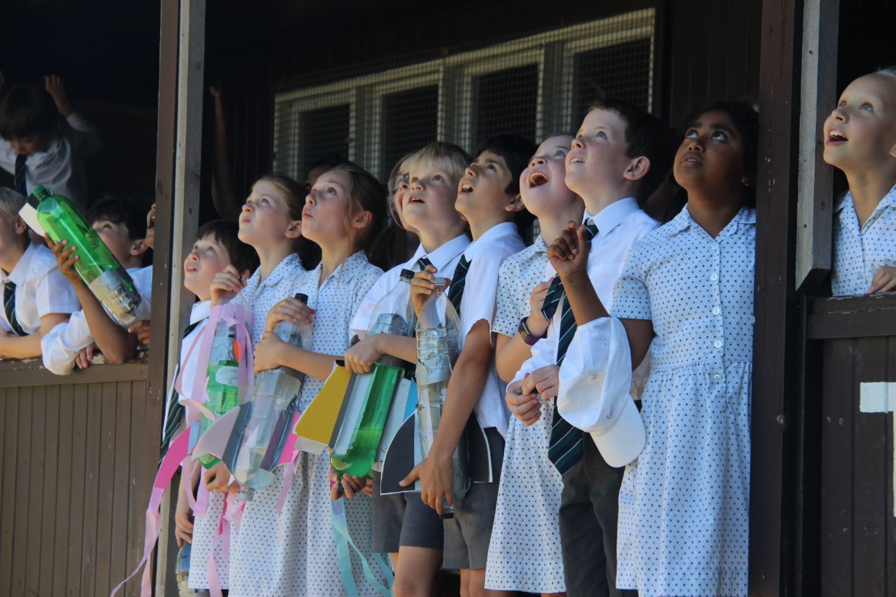
THE KING’S SCHOOL
King’s is an academically selective, co-educational independent school originally founded in 1541 for the ‘poor and friendless’ children of Chester. Almost 500 years later, King’s is a thriving, dynamic and forward-thinking school of 1100 pupils that is considered to be one of the very best of its kind in the country.

At King’s we aim to make the very most of every individual student in the school, both academically as a selective school with a great tradition of scholarship, but also in terms of character development, confidence and wellbeing. This is achieved by a broad curriculum, extensive co-curricular programme, excellent pastoral care and highly committed and professional staff. We want our pupils to remember their time at school with real fondness whilst relishing the prospect of successfully making their mark on the world and leaving it a better place.

The school enjoys a spacious and well-resourced site on the southern outskirts of Chester, having moved from a city centre location in 1960. Our new, state-of-the-art infant school, Willow Lodge, was built 3 years ago with the Junior School being impressively extended a year beforehand. There is a major site development plan in progress for the Senior School that has recently started with the construction of a new £5million Sports Centre. The school retains close links with Chester Cathedral where it holds regular services, including a traditional Service of Nine Lessons and Carols at Christmas.

King's comprises the Senior School (ages 11-18), the Junior School (ages 7-11) and the Infant School (Willow Lodge, ages 4-7). There are currently 730 pupils in the Senior School (200 in the Sixth Form), 250 pupils in the Junior School and 120 in the Infants, supported by almost 250 staff (teaching and support). In 2018 the students achieved 72% A*-A at GCSE and 87% A*-B at A level.

Further information about the school can be found on our website: www.kingschester.co.uk
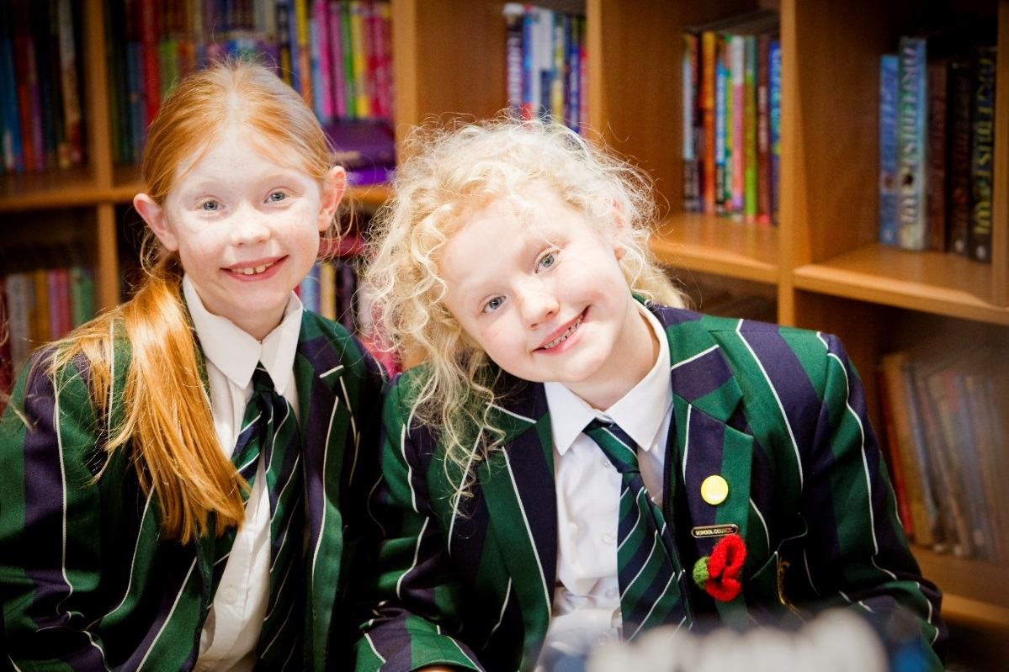
THE JUNIOR SCHOOL
The Junior School accommodation and extensive playing fields are adjacent to the Senior School. In addition to our facilities in the Junior School we also routinely the Vanbrugh Theatre, the swimming pool, the Senior School sports hall, a floodlit AstroTurf surface and eight tennis courts.

A major £1.5 million extension has recently been added to the Junior School. The Learning Centre comprises specialist facilities in Art, DT and Science and a library.
There are currently 250 pupils across the four national curriculum years 3 to 6. Numbers of girls within the school is increasing yearly and currently represent 38% of the Junior School pupil population. There are three forms in each year. Numbers in the lower forms are currently at a maximum of 20 which increases to a maximum of 24 by later age additions. The majority of pupils joining at J1 (year 3) are from Willow Lodge and external pupils are admitted by entrance tests. Appropriate competence is expected in maths and English but above all we look for the potential to do well. Nearly all Junior School pupils join the Senior School when they are 11 following an assessed entry procedure, based upon internal tracking.
There are 16 full-time members of teaching staff, including the Head of Willow Lodge and the Junior School, the Deputy Head and the Director of Studies, and three part-time. Additionally, there are three teaching assistants, visiting staff who teach various activities and four lunchtime supervisors.

The Curriculum
There is a 40-period, five-day week and pupils are taught mainly by their form teachers although they meet other staff. There is more specialist teaching in year 6. A wide range of visits in and out of school enlivens classroom work and brings school work into the context of everyday life.

academic curriculum:
- mathematics, English, science
- history, geography, RS
- art, DT, music, PE, games
- ICT, Spanish
- PSHE
additional short courses:
- Drama, Baking, Zoolab, Forest School, Dance, Yoga, Pilates, Cycling, German, French, Latin, Needlecraft, Newshounds, Gardening and Mindfulness.
extracurricular activities:
- music, drama, sport
- Activity holidays, year group school trips

The School Community
Each pupil is seen as an individual who is a valued member of the school family. We aim to understand their needs and each form teacher gets to know their charges well and cares for their wellbeing and progress. Pupils are encouraged to consider the welfare of others as much as their own needs both within the school and outside. Parents are encouraged to be involved in monitoring their children's progress. Parents’ evenings are held regularly and there are many opportunities for families to be involved in school life.

Fostering Spiritual Awareness
Assembly is held four mornings a week and is one expression of the corporate life of the school community. Through assemblies and cathedral services pupils of all religious persuasions can consider spiritual and moral issues that may confront them in everyday life.

Culture, Leisure and Recreation
There is an extremely lively tradition in music. The orchestra and choir perform regularly and every pupil participates in the annual concerts. Each year there are two drama productions and all pupils above the first year can become involved. Clubs and activities take place during lunch hours when there is also plenty of time for play.

Sporting Opportunities
The school has extensive playing fields and few primary schools can offer the range of games available. Many competitive sports fixtures take place during the week. Selection for teams is on merit and all pupils can be considered. There is a full inter-house sporting programme for all and competitive and recreational opportunities in football, cricket, swimming, tennis, athletics, cross country, biathlon, hockey and netball.

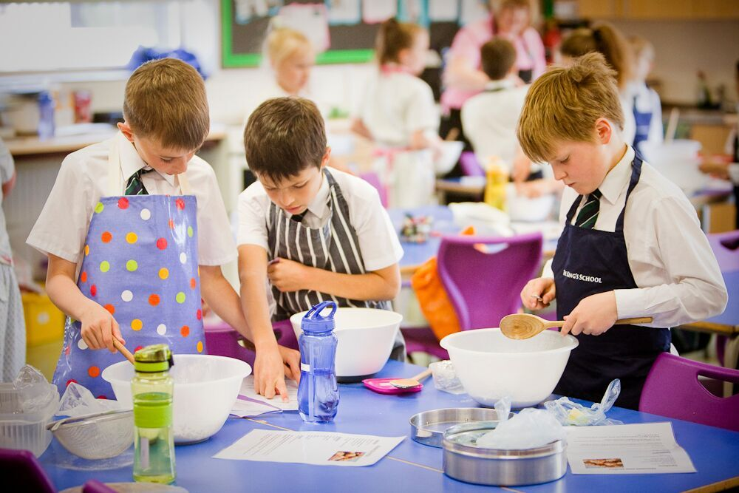
Music in the Junior School
There are currently two members of staff specialising in the teaching of music - the full-time Music coordinator, who teaches Years 5 and 6 music as well as general subjects (History, Geography, RS, Reading & PSHE) to Year 6 and her assistant, who teaches music to Year 3 and Year 4 pupils. The school employs twenty visiting instrumental teachers, some of whom contribute to Junior School music through coaching ensembles.

All pupils receive two periods of class Music per week.

All musical tastes and ability ranges are catered for in our choir, which is open to all and boasts over 60 members. The current post holder also jointly runs the newly formed 6’s & 7’s choir which is open to Year 6 and Year 7 pupils Both our Christmas Concert and Celebration Concert show the full diversity of musical talent of our pupils. In addition to this, there are opportunities for pupils of all abilities to perform as soloists in the very popular series of informal Assembly recitals. More able pupils are stretched by appropriate ensembles. Links with Drama are also very important, as seen in the annual Year 4 and Year 6 productions.

Music lessons are taught within our own Music room, which will be relocated and redeveloped over the summer holidays to include a music and drama suite and peripatetic teaching rooms. Peripatetic lessons currently take place in the Tim Turvey Music School.

Our close links with Chester Cathedral see the Junior School Choir singing at this historic venue two or three times a year.

A term of free ‘taster’ lessons is offered to Junior School pupils who wish to play the violin, cello, bassoon, horn, trombone, euphonium or tuba.

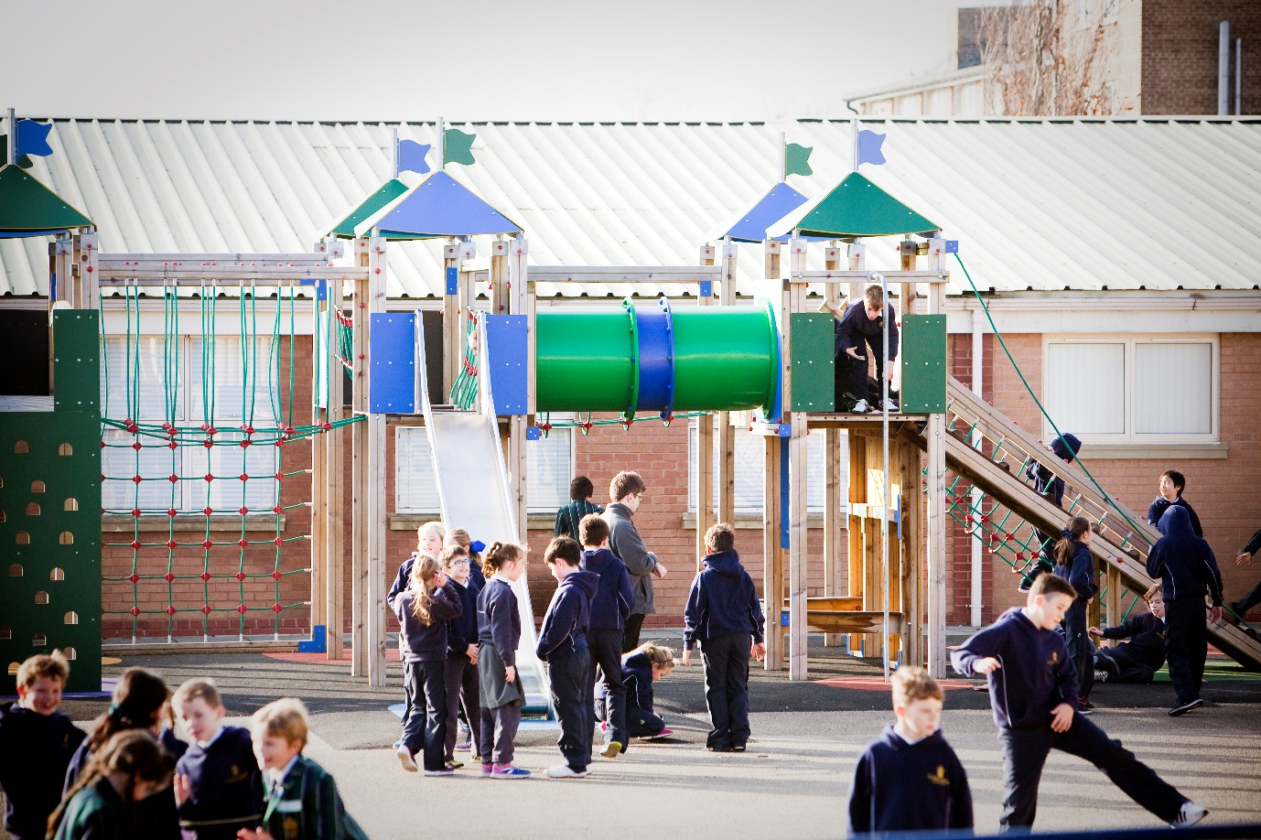

ABOUT THE POST

The King’s School wishes to appoint an outstanding musician as a temporary teacher of music. There is also a requirement to teach History, Geography, RS, Reading & PSHE to Year 6 pupils.

The successful candidate will be a talented and imaginative teacher and performer who is able to accompany whole school productions and performances on the piano. A desire to work as part of a team, promoting the work of the school and contributing to its smooth running and development is essential. So, too, is a strong commitment to the extra-curricular life of the school, both in and out of the classroom.

There will be a pastoral responsibility as a form tutor to a class of Year 6 pupils.

Teaching at King’s is hugely rewarding and great fun.

This is a temporary post, which is likely to last from Monday 2 September 2019 until Friday 27 March 2020, though this may be subject to change due to factors outside of our control.

The salary will be based on the King’s School scale and commensurate with the successful applicant’s experience and expertise.

PROCESS

Candidates for this post should complete the application form which should be posted or e-mailed to the Head of the Junior School to arrive no later than 12pm Friday 26 April 2019.

- infantjuniorhead@kingschester.co.uk
- The Head of the Junior School, The King’s School, Chester, CH4 7QL
A curriculum vitae will not be accepted in place of the completed application form.
Interviews will be held week beginning 20 May 2019.
Short-listed candidates will be asked to teach a group of pupils and meet other key members of staff. The selection procedure will include a formal interview and there will be an opportunity to look round the school.
Candidates, shortlisted for interview, will be asked to complete a confidential health questionnaire. Lunch and reasonable travel expenses will be provided.
For any further information on the post, please contact the Head of the Junior School’s PA by email (kep@kingschester.co.uk) or by phone (01244 689543).

The school is committed to safeguarding and promoting the welfare of children and young people and expects all staff and volunteers to share this commitment. The successful applicant will be required to undertake an enhanced DBS check. All our appointments follow the procedures laid out in our Equal Opportunities and Child Protection policies.

