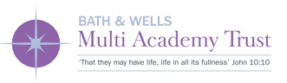

Application Pack

Message from the Board of Directors

Dear Applicant,

Thank you for your interest in the post at Bath & Wells Multi Academy Trust (BWMAT).

The Trust was established in 2012 with four schools, all of which needed sponsored academy conversion following inadequate Ofsted judgements. As of April 2018, the Trust has increased to 30 schools, with in excess of 8,000 pupils; of these only 2, recent joiners, are in Special Measures and 4 Require Improvement, a radical transformation.

The Trust is at a key point in its development, with a clear vision and strategic plan for the future and is continuing to expand in size with 11 new schools, both church and community ones, having joined in the Spring of 2018. Good and Outstanding schools are keen to join us and work within the supportive but aspirational Christian environment that we are developing. This offers enormous opportunities and significant change to oversee.

Our leaders share our vision of the Trust as an outstanding provider of education, but education that is not only excellent academically, but also offers every child the opportunity to develop as an individual in mind, body and spirit. The BWMAT works in partnership with the Diocesan Education Department.

As part of the teaching team, you will be bringing your educational expertise and experience to this role with an approach rooted in excellence, best able to meet the needs of every child within the BWMAT.

The candidate appointed will play a pivotal part in the development of the Trust both as an outstanding educational provider and delivering its Christian mission to ensure that we provide the opportunity for every child and member of staff to experience ‘Life in all its Fullness’. We look forward to receiving your application.

Yours sincerely

Nigel Daniel
Chair of the Board of Directors
Bath & Wells Multi Academy Trust

Message from the Headteacher

Dear Applicant,

Churchfield Church School is a larger than average sized primary school with 450 children in 16 classes located in Highbridge, Somerset. Though being located in the town, the site is large with extensive outside areas, including a well developed forest school. We are located just over a mile from the coast at Burnham on Sea and near to the beautiful Somerset Levels and Polden Hills.

Our school is part of the Bath & Wells Multi Academy Trust. Our latest Ofsted report in November 2017 graded the school as Requires Improvement. As a staff, we are working hard to ensure we make rapid improvement and we work very closely with other schools in the BWMAT.

Our school is known for its strong Christian ethos and nurturing environment and, this is a strength on which we continue to build. We have our own Nursery on site, which caters for children from birth to four years of age. There is also a Children’s Centre on site, and we work collaboratively with local schools to ensure we are part of the wider educational landscape. The quality of the premises and opportunities for the external environment are excellent. We have an extensive extra-curricular programme which takes place after school and in the holidays and over 300 children take part. The activities makes good use of ‘Gus’ our wonderful minibus, giving children the opportunity to travel further afield.

We are committed to developing a creative curriculum that enables every learner to flourish and develop their potential, identifying the needs of every student and ensuring early intervention where appropriate. We are committed to providing relevant and up-to-date CPD for all our staff to ensure good and outstanding teaching throughout the school and we strive to attain high standards across all curriculum subjects.

Yours sincerely,

Justin Philcox

Justin Philcox
Headteacher
Churchfield Church School

The Application Process

We hope you find this pack provides all the information you need in order to consider your application for this post.

If you would like a more detailed discussion about the role please contact the office on tara.jones@churchfield.bwmat.org or by calling the office on 01278 782743.

Applications

Please ensure your application is summited by the deadline for this post as detailed on the advert. Unfortunately, we are unable to accept applications after this time unless the recruitment process is reopened.

Shortlisting

To ensure the fairness of the selection process, shortlisting will be based upon the information which you provide in your application and assumptions will not be made about your experience or skills. We will look for demonstrable evidence that you meet the criteria set out in the person specification.

All applicants will be notified of the outcome of the shortlisting process.

Interview

Further details regarding the selection process will be communicated at the time applicants are invited for interview. If you are offered the position then this appointment will be subject to satisfactory pre-employment checks.

Applicant Privacy Notice
Data controller: Bath and Wells Multi Academy Trust, The Old Deanery, Cathedral Green, Wells, Somerset, BA5 2UG
Data protection officer: I West – Audit West, BaNES, Guildhall, High Street, Bath, BA1 5AW
As part of any recruitment process, the BWMAT collects and processes personal data relating to job applicants. The BWMAT is committed to being transparent about how it collects and uses that data and to meeting its data protection obligations.
What information does the BWMAT collect?
The BWMAT collects a range of information about you. This includes:
- Your name, address and contact details, including email address and telephone number;
- Details of your qualifications, skills, experience and employment history;
- Information about your current level of remuneration, including benefit entitlements;
- Whether or not you have a disability for which the BWMAT needs to make reasonable adjustments during the recruitment process;
- Information about your entitlement to work in the UK; and
- Equal opportunities monitoring information, including information about your ethnic origin, sexual orientation, health, and religion or belief.
- Information obtained during the interview process
The BWMAT collects this information in a variety of ways. For example, data might be contained in application forms, CVs, obtained from your passport or other identity documents, or collected through interviews or other forms of assessment.
The BWMAT will also collect personal data about you from third parties, such as references supplied by former employers, information from employment background check providers and information from criminal records checks. The BWMAT will seek information from third parties as appropriate throughout the recruitment process and will inform you that it is doing so.
Data will be stored in a range of different places, including on your application record, on IT systems (including email).
Why does the BWMAT process personal data?
The BWMAT needs to process data to take steps at your request prior to entering into a contract with you. It also needs to process your data to enter into a contract with you.
In some cases, the BWMAT needs to process data to ensure that it is complying with its legal obligations. For example, it is required to check a successful applicant's eligibility to work in the UK before employment starts.
The BWMAT has a legitimate interest in processing personal data during the recruitment process and for keeping records of the process. Processing data from job applicants allows the BWMAT to manage the recruitment process, assess and confirm a candidate's suitability for employment and decide to whom to offer a job. The BWMAT may also need to process data from job applicants to respond to and defend against legal claims.
Where the BWMAT relies on legitimate interests as a reason for processing data, it has considered whether or not those interests are overridden by the rights and freedoms of employees or workers and has concluded that they are not.
The BWMAT processes health information if it needs to make reasonable adjustments to the recruitment process for candidates who have a disability. This is to carry out its obligations and exercise specific rights in relation to employment.
Where the BWMAT processes other special categories of data, such as information about ethnic origin, sexual orientation, health or religion or belief, this is for equal opportunities monitoring purposes.
For most roles, the BWMAT has a responsibility to seek information about criminal convictions and offences. In addition to these checks information will also be sought in respect to Safeguarding and the suitability to work with children. Where the BWMAT seeks this information, it does so because it is necessary for it to carry out its obligations and exercise specific rights in relation to employment.
If your application is unsuccessful, the BWMAT will keep your personal data on file for six months.
Who has access to data?
Your information will be shared internally for the purposes of the recruitment exercise. This includes members of the HR and recruitment team, interviewers involved in the recruitment process, school office staff and school leadership and IT staff if access to the data is necessary for the performance of their roles.
The BWMAT will share your data with third parties, as appropriate throughout the recruitment process. The BWMAT will then share your data with former employers to obtain references for you, employment background check providers to obtain necessary background checks and the Disclosure and Barring Service to obtain necessary criminal records checks.
Your data may be transferred outside the European Economic Area (EEA) to support right to work checks, where this occurs BWMAT will ensure compliance with data protection law is maintained.
How does the BWMAT protect data?
The BWMAT takes the security of your data seriously. It has internal policies and controls in place to ensure that your data is not lost, accidentally destroyed, misused or disclosed, and is not accessed except by our employees in the proper performance of their duties. The BWMAT has a specific data protection policy and Freedom of information policy

For how long does the BWMAT keep data?
If your application for employment is unsuccessful, the BWMAT will hold your data on file for six months after the end of the relevant recruitment process. At the end of that period, your data is deleted or destroyed.
If your application for employment is successful, personal data gathered during the recruitment process will be transferred to your personnel file and retained during your employment. The periods for which your data will be held are detailed in the BWMAT records retention document.
Your rights
As a data subject, you have a number of rights. You can:
- Access and obtain a copy of your data on request;
- Require the BWMAT to change incorrect or incomplete data;
- Require the BWMAT to delete or stop processing your data, for example where the data is no longer necessary for the purposes of processing;
- Object to the processing of your data where the BWMAT is relying on its legitimate interests as the legal ground for processing; and
- Ask the BWMAT to stop processing data for a period if data is inaccurate or there is a dispute about whether or not your interests override the BWMAT's legitimate grounds for processing data.

If you would like to exercise any of these rights, please contact the Head Teacher of the school or BWMAT HR department. You can make a subject access request in writing including via e-mail.
If you believe that the BWMAT has not complied with your data protection rights, you can complain to the Information Commissioner.
What if you do not provide personal data?
You are under no statutory or contractual obligation to provide data to the BWMAT during the recruitment process. However, if you do not provide the information, the BWMAT may not be able to process your application properly or at all.
You are under no obligation to provide information for equal opportunities monitoring purposes and there are no consequences for your application if you choose not to provide such information.
Automated decision-making
Recruitment processes are not based solely on automated decision-making.

Bath and Wells Multi Academy Trust Mission, Aim and Objectives

Mission Statement: John 10:10
‘That they may have life, life in all its fullness’

The Bath & Wells Multi Academy Trust’s mission is to provide an education which is life-enhancing for every child.

We promise an experience which is lovingly inclusive and inspired.

Aim
To ensure that every school within the Trust provides an outstanding education for every child, enhanced by its distinctively Christian ethos.

Objectives
- That every school in the Trust is able to progress to SIAMS and Ofsted ‘Outstanding’ and to remain outstanding

- To provide outstanding leadership at every level of the Trust

- To ensure high quality teaching and high-quality learning environments for all

- To provide high quality governance at every level

- That the distinctively Christian ethos underpins all the work of the Trust and every aspect of curriculum delivery

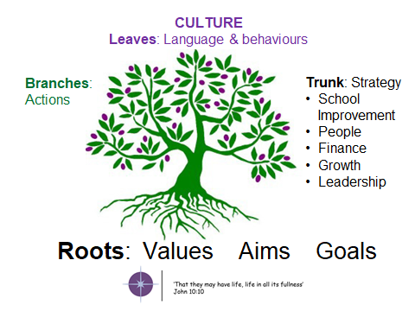

Our Ethos and Values

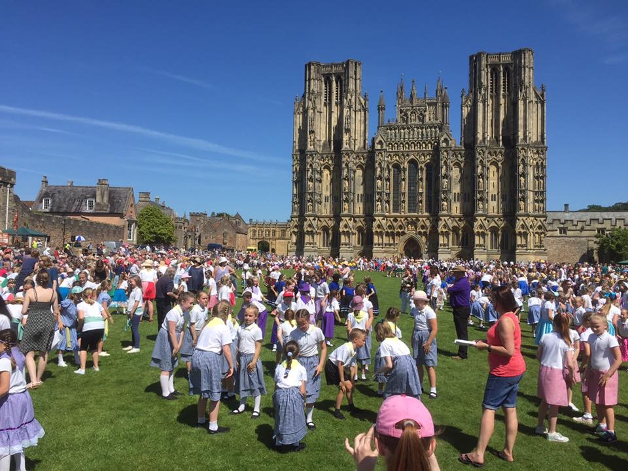
Church schools are integral to the ministry and mission of the Church and can offer a genuine witness to the incarnation and the creative, redemptive and transforming purposes of God. They do this by loving and valuing all humanity equally, and the quality of the community life and concern for individuals. Church schools are called to bring fullness of life to their pupils, whatever the beliefs of the children and young people or their families.

Each school within the Trust is unique and distinctive and we are committed to celebrating the local context and purpose of each school. Our vision is for all of our schools to become highly successful and meet the needs of the community which they serve. Our vision is for all of our schools to be something in which children, parents, staff and the community can take pride.

In May our schools come together at Wells cathedral for a ‘Together in Voice, Together in Faith, Life in All Its Fullness’, where children from all of our schools came together for an evening performance of singing, thoughtful readings and prayers. To listen to one of the children’s songs please click on the below link:
https://drive.google.com/file/d/0B-8x22DIBpBhWVhFSzI4eFBpZ2M/view?usp=sharing
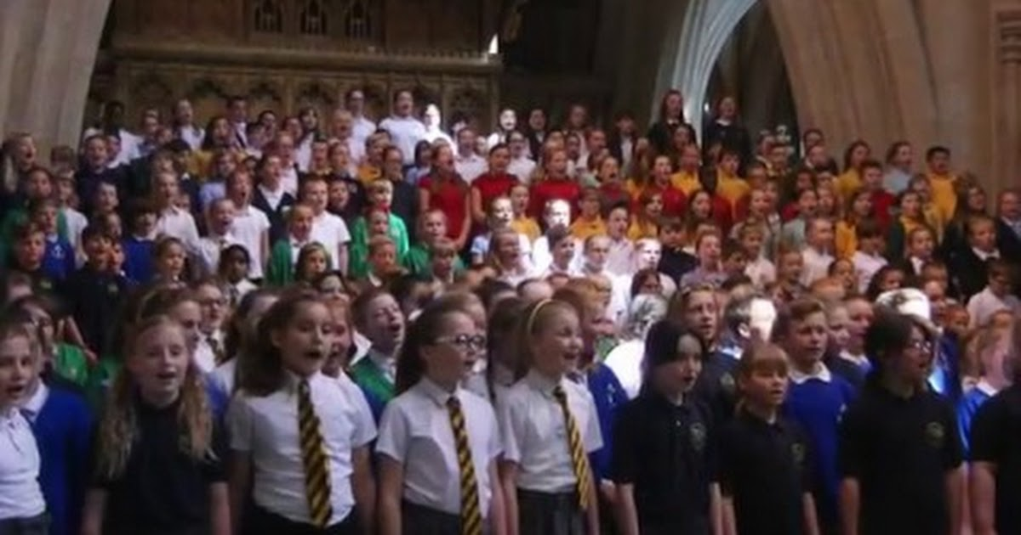

We are bound by a number of guiding principles:

- To promote an educational community based on love and inclusivity, providing a beacon of hope where all can flourish

- To foster, maintain and celebrate Christian distinctiveness in our schools

- To ensure that our academies are centres of excellence with a focus on the nurture of all their members

- To promote mutual support, encouragement and benefit between all our academies

- To develop future and aspirational thinking based on our educational heritage and to make use of the latest research in pedagogy and child development

- To support the nurture and respect of God’s creation with a close focus on the sustainability agenda

- Each child is a unique human being and worth the highest possible standards of education and care and the closest attention to what will enable them to flourish

- We must ensure that ‘every child and young person has a life enhancing encounter with the Christian faith’

- To recognise those who often remain invisible, through ethnic or cultural disadvantage, or through disability or poverty

- Church schools have a particular vocation to the poor, to enable them through education to change their lives

The purpose of the Trust is to secure the rapid and sustained improvement of all its academies. The Trust will enable schools to work together, share expertise and maximise resources. Our vision is for a family of Bath & Wells academies that offers a great learning experience for every child.
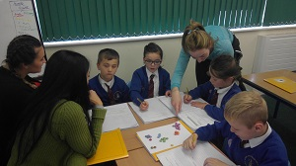
We seek to ensure the best possible educational outcome for every child. The Trust believes that every child has the right to a good education and this will be achieved within a distinctively Christian context, valuing each child as an individual and enabling them to discover and develop their God given gifts.

As academies within the Trust grow and develop, they will be expected and required to share their journey, skills and expertise with other Bath & Wells academies. The Trust will encourage and nurture the dissemination of good practice, fostering a self-sustaining culture of aspiration for educational excellence across all schools.

Working and Living in Bath and Somerset

The Bath & Wells Multi Academy Trust works within the parameters of the Diocese of Bath & Wells, which is nearly coterminous with the traditional county of Somerset. It is a diverse region with:

- an extensive coastline along the Bristol Channel, often referred to as Somerset Coast
- three Areas of Outstanding Natural Beauty – the Blackdown, Quantock and Mendip Hills
- a large part of the Exmoor National Park
- the wetlands of the Somerset Levels

Apart from the M5 from Bristol to Taunton, the county has no significant dual carriageways. The main A roads are radial routes from Bristol (A37, A38), and E-W crossings (A30, A303 in the south and A39, A361 across the centre). The main rail links are the London Paddington main line to the West Country through Taunton, and routes to London from Bath or Castle Cary. There is a significant but slower line that runs to London through the south of the diocese. Bristol Airport lies in the north of the diocese.

Bath has a distinct identity from much of the rest of the diocese, and the proximity of Bristol exerts a powerful influence on commuting and employment patterns.
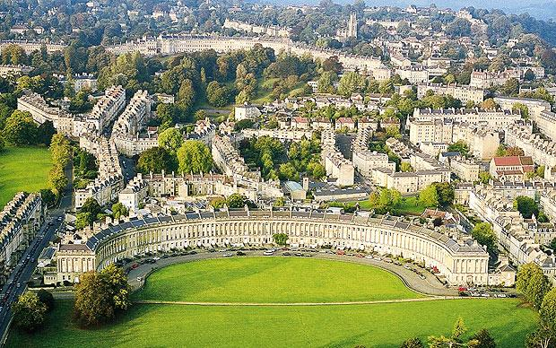
The population of just over 909,000 has grown by 6.7% since 2001, faster than the national average, and is projected to grow to about 1 million by 2021. This is almost entirely through internal migration from other parts of the UK, and nearly all the increase in population in the last 10 years is accounted higher proportion of adults over 40 than the national average, and 20% fewer in their 20s-40s.

The main centres of population fall into three main clusters:

- in the north around Bath and the Bristol commuter belt - Keynsham, Portishead, Nailsea, Clevedon
- the A38/M5 corridor in the west - Weston-Super-Mare, Bridgwater, Taunton and Wellington (now mostly concurrent with the M5)
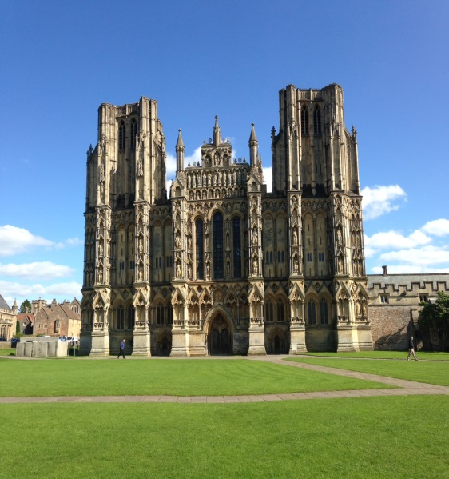
- along the A30 and A303 in the south of the diocese - Yeovil, Chard, Crewkerne and Ilminster.

Other significant towns are Frome in the east; and Wells, Glastonbury and Street in central Somerset.

Between them, Bath, Weston, Taunton and Yeovil account for nearly 1/3 of the population of the diocese.

Church schools are a significant activity of the diocese. 36,000 children attend Church of England schools or academies. 50% of primary aged children attend a Church of England school.

There are six Church of England secondary schools and three middle schools.
State schooling in the diocese is provided by three Local Education Authorities: Bath and North East Somerset (BANES), North Somerset, and the larger Somerset County Council.

Bath and Wells is overwhelmingly ‘White British’ (95%), with significantly lower rates of ethnic diversity and international immigration than England as a whole, even though these are slowly rising. BANES is closer to the national profile (83% ‘White British’, 8% black, Asian or mixed race), but still below average. ‘White other’ is the only other ethnic group to register above 2%, with pockets of European immigration in some urban centres.

In the 2011 census, 64% of Somerset people put their religion as ‘Christian’, significantly higher than the national average, but still a drop of 11% over the decade. Over the last 10 years the number specifying ‘no religion’ has doubled to 250,000. Other religious groupings are small: at 3,500 the Muslim population is the next highest, followed by Buddhists and Pagans.

Local sport and leisure ranges from the all-conquering (Paul Nicholls’ stable in Ditcheat) to the successful (Somerset CCC, Yeovil Town FC and Bath Rugby), with a thriving local club scene in many sports. There are three local racecourses at Wincanton, Bath and Taunton.

The diocese is rich in cultural opportunities - with literature and music festivals in the well-known centres such as Bath and Wells, as well as in the smaller towns and communities.

The Glastonbury Festival draws 180,000 visitors each year and Somerset’s autumn cycle of carnivals is the biggest of its kind in Europe.

Pupil Outcomes and School

2016 : 14 Schools (not organised into Hubs)
2017 ; 18 schools organised into three Hubs

Key Stage 2 100+
 |  | Reading |  | Writing |  | Maths |  | SPAG |  |  | RWM
 |  | 2016 | 2017 | 2016 | 2017 | 2016 | 2017 | 2016 | 2017 | 2016 |  | 2017
National |  | 66% | 71% | 74% | 76% | 70% | 75% | 72% | 77% | 53% |  | 61%
BWMAT |  | 67%  (+1%) | 74%  (+3%) | 76%  (+2%) | 79%  (+3%) | 68%  (-2%) | 72%  (-3%) | 70%(-2%) | 79%  (+2%) | 53%  (0) |  | 61%  (0)
% improved 2016-2017 | % BWMAT | 7.5 % |  | 3.3 % |  | 3.9% |  | 8.8% |  | 7.8%
 | % National | 5 % |  | 1% |  | 5% |  | 5% |  | 8%
N Somerset |  |  | 71% = |  | 77%(+1%) |  | 68%(-7%) |  | 77% = |  |  | 54%(-7%)
S Somerset |  |  | 79%(+8%) |  | 80%(+4%) |  | 72%(-3%) |  | 84%(+7%) |  |  | 68%(+7%)
Taunton |  |  | 77%(+6%) |  | 79%(+3%) |  | 78%(+3%) |  | 78%(+1%) |  |  | 66%(+5%)

Key Stage 2 110+

 | Reading |  | Writing |  | Maths |  | SPAG
 | 2016 | 2017 | 2016 | 2017 | 2016 | 2017 | 2016 | 2017
National (2016) | 19% | 25% | 15% | 18% | 17% | 23% | 23% | 31%
BWMAT | 21%(+2%) | 24%(-1%) | 18%(+3%) | 24%(+6%) | 13%(-4%) | 19%(-4%) | 23% = | 31% =
N Somerset |  | 19% |  | 22% |  | 16% |  | 28%
S Somerset |  | 32% |  | 30% |  | 24% |  | 37%
Taunton |  | 26% |  | 23% |  | 22% |  | 31%
Key Stage 1 ARE

 | Reading |  | Writing |  | Maths
 | 2016 | 2017 | 2016 | 2017 | 2016 | 2017
National | 74% | 76% | 65% | 68% | 73% | 75%
BWMAT | 73% | 80%(+4%) | 74% | 65% (-3%) | 81% | 80% (+5%)
N Somerset |  | 94% |  | 87% |  | 93%
S Somerset |  | 89% |  | 82% |  | 89 %
Taunton |  | 62 % |  | 58% |  | 61 %

Key Stage 1 GD

 | Reading | Writing | Maths
 | 2017 | 2017 | 2017
National | 25% | 16% | 21%
BWMAT | 33% (+8%) | 22% (+6%) | 25%  (+4%)
N Somerset | 38% | 25% | 28%
S Somerset | 44% | 25% | 33%
Taunton | 23% | 17% | 19%

Year 1 Phonics

 | Year 1 Phonic Screener
 | 2016 | 2017
National | 81% | 81%
BWMAT | 81.1% (+0.1) | 81%
N Somerset |  | 85 %
S Somerset |  | 84%
Taunton |  | 76%

EYFS

 | GLD
 | 2016 | 2017
National | 69.3% | 70.7%
BWMAT | 68.7%  (-0.6) | 74%
N Somerset |  | 77
S Somerset |  | 77
Taunton |  | 69

