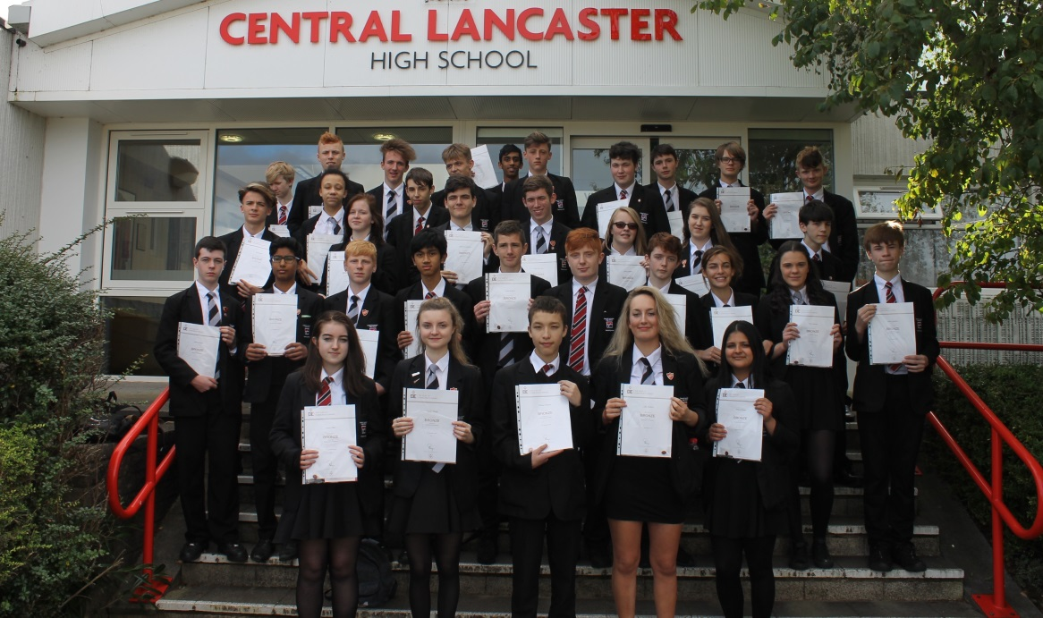 |  | WELCOME TO OUR AMAZING SCHOOL  - Issue Date
About our school |  | what can we offer?

Why work at Central Lancaster?
At Central Lancaster High School our mission is to achieve “success beyond expectations” for every single student who chooses to join us.
Thank you for your interest in Central Lancaster High School. We are delighted that you are considering joining our team, but there really is no better way to find out about our great school than to pay us a visit.
We are ambitious for our school and its students and we are focused on our aim that together at Central we SHINE. Put simply, we are working to ensure we deliver the following:
Set the highest expectations
High quality teaching in every lesson
Individual progress for every student
Nurture respect within our school community
Embrace our wider community; locally and globally
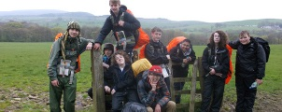
We are incredibly lucky to be based in one of the most beautiful cities in the North West; the gateway to the Lake District is on our doorstep, we are 1 hour from Manchester and 2.5 hours from London on the train and we enjoy a range of wonderful cultural events in our small city every year.
We also enjoy the most incredible views over Morecambe Bay…
Do let us know if you would like to visit Central Lancaster High School. We are very proud of our students and their achievements and would be delighted for you to visit us.
If you have any questions please don’t hesitate to contact us by email at head@lancasterhigh.lancs.sch.uk or call 01524 32636

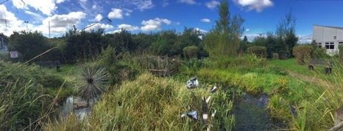
We are a friendly and committed team who share a clear focus on school improvement. We want the best for every member of Team Central and our school offers:
- A dedicated and supportive staff and governing body
- Comprehensive CPD opportunities
- Commitment to leadership development
- Scope to make a significant contribution to a school with vision and ambition
- Amazing young people

Are you ready for the challenge of helping our students achieve “success beyond expectations”?
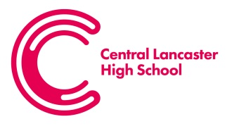

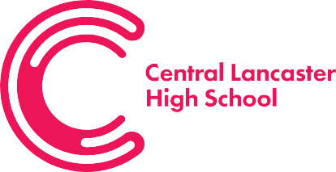
Central Lancaster High School,
Crag Road,
Lancaster,
Lancashire,
LA1 3LS

Tel: 01524 32636
Fax: 01524 849586
Email: clhs@lancasterhigh.lancs.sch.uk
Website: lancasterhigh.uk

April 2019

Dear Applicant,

Thank you for your interest in the position of Teacher of Music at Central Lancaster High School, I hope that you find all the information that you need to prepare your application.

This is an exciting time to join us at Central Lancaster, as we pursue our partnership with The Bay Learning Trust. We are determined in our mission to create opportunities and experiences which empower all our learners to develop commitment, creativity and community. This is an excellent opportunity for someone wanting to shape the future of music at CLHS.

Our core principle will always be that we endeavour to improve the teaching and learning in our school. We are therefore, committed to recruiting only the very best teachers and have the highest expectations in terms of lesson planning, classroom delivery and student assessment. We provide excellent working conditions, a commitment to great CPD and a real sense of community.

You would be joining a team of dedicated teachers who recognise the need for continual improvement. We are focusing upon raising standards of attainment, improving our teaching practice and working collaboratively to share our knowledge and resources. We believe this is the best way to ensure that the students are provided with the very best in teaching and learning. The successful candidate will be a well-qualified graduate, with a passion for music to maximise the best outcomes for our students. Above all, we are looking for a colleague who can inspire our students and contribute to raising their aspirations, enthusiasm and resilience to achieve great things.

If you wish to apply, please complete an application form together with a letter of application that should be no longer than two sides of A4 (Arial, font 11). In your letter you should address: Your vision and values relating to the post, what you can bring to Team Central and why you wish to join our school.

Completed applications should be sent to Heather Low, Headteacher’s PA by noon on Thursday 25th April 2019 heather.low@lancasterhigh.lancs.sch.uk.

Please do not hesitate to contact us if you have further questions in relation to the post, or to arrange a visit to school.

Yours sincerely,

Nicola Hall
Headteacher

Headteacher:
Nicola Hall BSc, MA, NPQH

