SIMON BALLE ALL-THROUGH SCHOOL

SAFER RECRUITMENT POLICY

First Issue: March 2017
Last Issue: May 2018
Next Review: May 2019

Committee Responsible: Personnel

SIMON BALLE SCHOOL

SAFER RECRUITMENT POLICY

Simon Balle School is committed to providing the best possible care and education to its students and to safeguarding and promoting the welfare of the students. We are also committed to providing a supportive environment for all the staff. The school recognises that in order to achieve these aims, it is of fundamental importance to attract, recruit and retain staff (and volunteers) of the highest calibre who share this commitment.

- Introduction

The purpose of this policy and, in accordance with the Keeping Children Safe in Education Guidance, is to set out the minimum requirements of a recruitment process that aims to:
- attract the best possible applicants to vacancies;
- deter prospective applicants who are unsuitable for work with children or young people;
- identify and reject applicants who are unsuitable for work with children and young people.

- Identification of Recruiters

Subject to the availability of training, the school will maintain a position in which at least one recruiter has successfully received accredited training in safe recruitment procedures.

- Inviting Applicants

  - Advertisements for posts, whether in newspapers, journals or on-line, will include the statement:

“The school is committed to safeguarding children and young people. All post holders are subject to a satisfactory Disclosure and Barring Service (DBS) check2 and will bear in mind the school’s Equal Opportunity Policy.

  - Prospective applicants will be supplied, as a minimum, with the following:

- job description and person specification;
- the school’s child protection policy;
- the school’s recruitment policy (this document);
- the selection procedure for the post;
- an application form.

  - All prospective applicants must complete, in full, an application form.

- Short listing and References

  - Short-listing of candidates will be against the person specification for the post
  - Where possible, references will be taken up before the selection stage, so that any discrepancies can be probed during the selection stage.
  - References will be sought directly from the referee. References or testimonials provided by the candidate will never be accepted.
  - Where necessary, referees will be contacted by telephone or email in order to clarify any anomalies or discrepancies. A detailed written note will be kept of such exchanges.
  - Where necessary, previous employers who have not been named as referees will be contacted in order to clarify any anomalies or discrepancies. A detailed written note will be kept of such exchanges.
  - Referees will always be asked specific questions about:
- the candidate’s suitability for working with children and young people;
- any disciplinary warnings, including time-expired warnings, that relate to the safeguarding of children;
- the candidate’s suitability for this post.
  - School employees are entitled to see and receive, if requested, copies of their employment references.

- Secretary of State Prohibition Orders (teaching roles)

  - In all cases where an applicant is to undertake a teaching role of any kind a Prohibition Order check will be made using the Employer Access Online Service. It is anticipated that this will be performed at the shortlisting stage but will in any case be made before any offer of employment is made.

  - Prohibition orders prevent a person from carrying out teaching work in schools, sixth form colleges, 16 to 19 academies, relevant youth accommodation and children's homes in England. A person who is prohibited from teaching must not be appointed to work as a teacher in such a setting.

  - Prohibition orders are made by the Secretary of State following consideration by a professional conduct panel convened by the National College for Teaching and Leadership (NCTL). Pending such consideration, the Secretary of State may issue an interim prohibition order if it is considered to be in the public interest to do so.

  - Secretary of State Prohibition Orders (managerial/leadership/Governors) – a Section 128 check will be carried out

- Digital footprints

  - At Simon Balle All-through School we are committed to ensuring that safeguarding is a top priority.

  - In light of this commitment, where appropriate, potential candidates’ social media or other on line activity will be checked prior to interview and records made of any offensive or inappropriate material

  - This process may include a search for the candidate via:

- Google
- Facebook
- Linkedin
- Other social network sites

- The Selection Process

  - Selection techniques will be determined by the nature and duties of the vacant post, but all vacancies will require an interview of short-listed candidates.

  - Interviews will always be face-to-face. Telephone interviews may be used at the short-listing stage but will not be a substitute for a face-to-face interview (which may be via visual electronic link).

  - Candidates will always be required:

- to explain satisfactorily any gaps in employment;
- to explain satisfactorily any anomalies or discrepancies in the information available to recruiters;
- to declare any information that is likely to appear on a DBS check;
- to demonstrate their capacity to safeguard and protect the welfare of children and young people.

- Employment Checks

  - All successful applicants are required:

- to provide proof of identity
- to complete a DBS application using HertsGuard and receive satisfactory clearance
- have a satisfactory certificate of good conduct relating to time spent living outside of the UK, where applicable
- to pass a prohibition from teaching check
- to provide actual certificates of professional qualifications, as deemed appropriate by the school
- to complete a confidential health questionnaire and be deemed mentally and physically fit to perform the role
- to provide proof of their right to work in the United Kingdom
- to complete a childcare disqualification declaration

  - Proof of identity, Right to Work in the UK & Verification of Qualifications and/or professional status.

All applicants invited to attend an interview at the school will be required to bring their identification documentation such as passport, birth certificate, driving licence etc. with them as proof of identity/eligibility to work in UK in accordance with those set out in the Immigration, Asylum and Nationality Act 2006 and DBS Code of Practice Regulations.

In addition, applicants must be able to demonstrate that they have actually obtained any academic or vocational qualification required for the position and claimed in their application form.

  - Fitness to undertake the role

A confidential pre-employment health questionnaire must be completed to verify the candidate’s mental and physical fitness to carry out their work responsibilities. A job applicant can be asked relevant questions about disability and health in order to establish whether they have the physical and mental capacity for the specific role.

  - Individuals who have lived or worked outside the UK

When appointing a UK citizen who has lived overseas or a non UK citizen, a Certificate of Good Conduct must be obtained (where possible) from the embassy of the country the applicant has specified they have spent a significant period of time in. This must happen where the applicant has lived or worked (including studying) in a foreign country for a period of 6 months within the last 5 years.

There are a number of exemptions to this:
• If the applicant is currently employed by the school and has already provided the certificate, which can be used for future appointments providing that there is no break in service.
• Applicants that have spent time overseas as part of Her Majesty Service i.e. Army, Navy, Airforce.
• Applicants that are seeking asylum will be unable to provide such documentation, as contacting the embassy may jeopardise their safety.
If an applicant is unable to provide a Certificate of Good Conduct, evidence must be presented to show that an attempt to obtain a copy has been made.

Any costs incurred for obtaining a Certificate of Good Conduct must be met by the individual and will not be reimbursed.

If an applicant is unable to obtain a Certificate of Good Conduct then a Risk Assessment Form must be completed and signed off. All other pre-employment checks must be completed.

  - Childcare Disqualification Declaration

Where relevant, all applicants must complete a self-declaration form provided by the school in relation to the Childcare Disqualification Regulations 2009. This is to cover circumstances where the individual has a conviction that may result in them being barred from working with children or someone living at the same residential address is barred from working with children. Where a positive declaration is made a waiver must be applied for from Ofsted, and be satisfactorily granted, before the applicant may commence work.

This applies to:
- Early Years Provision - staff who provide any care for a child up to and including reception age. This includes education in nursery and reception classes and/or any supervised activity (such as breakfast clubs, lunchtime supervision and after school care provided by the school) both during and outside of school hours for children in the early years age range; and

- Later years provision (for children under 8) - staff who are employed to work in childcare provided by the school outside of school hours for children who are above reception age but who have not attained the age of 8. This does not include education or supervised activity for children above reception age during school hours (including extended school hours for co-curricular learning activities, such as the school’s choir or sports teams) but it does include before school settings, such as breakfast clubs, and after school provision.

- Offer of appointment

The appointment of all new employees is subject to the receipt of a satisfactory DBS Certificate, references, medical checks, prohibition checks, childcare disqualification checks and waivers, copies of qualification and proof of identity.

- Volunteers

  - Where a volunteer is recruited to engage in work which is not considered ‘regulated activity’ an enhanced DBS certificate will be obtained

10.2 Volunteers recruited to take part in regulated activity must obtained an enhanced DBS certificate with a barred list check

  - Under no circumstances will a volunteer who has not provided a DBS certificate be left unsupervised or allowed to work in regulated activity.

- Single Central Record

The school must keep a single central record, referred to in the regulations as the register. The single central record must cover all staff (including supply staff, and teacher trainees on salaried routes) who work at the school. Confirmation that these checks have been carried out along with the date the check was undertaken/obtained must be logged on this record for all employees of the school. This record will therefore include all staff (including supply staff) who work at the school and all others who work in regular contact with students in the school including volunteers.

- Induction

  - The school recognises that safer recruitment and selection is not just about the start of employment, but should be part of a larger policy framework for all staff. The school will therefore provide on-going training and support for all staff.

10.2 All staff who are new to the school will receive induction training that will include the school’s safeguarding policies and guidance on safe working practices.

10.3 Regular meetings will be held during the first 3 months of employment between the new employee(s) and the appropriate manager(s).

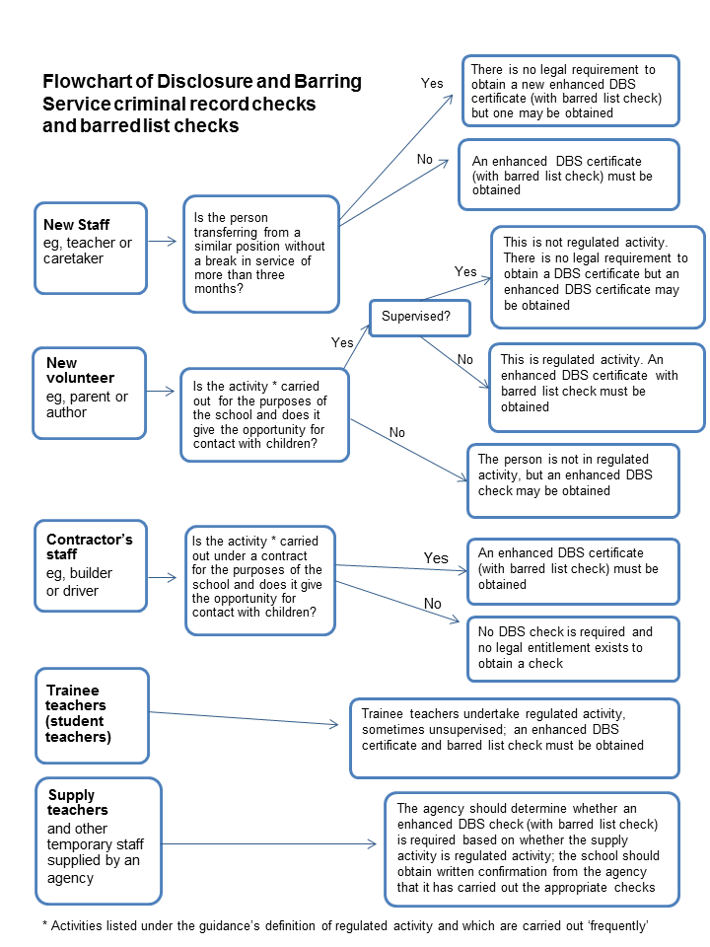
Annex 1: Flowchart of Disclosure and Barring Service criminal record checks and barred list checks.

