
inspiring excellence
Head Teacher: Mrs R Emeny | Deputy Head Teacher: Mr J Easter | Assistant Head Teacher: Ms S Hawkins
Dear Applicant

Thank you for taking an interest in applying for a post at Churchfields Junior School.

I hope that you will find the attached Job Description and Person specification helpful to you. Please look at our school website link (www.churchfieldsjunior.com) for further information about the school.

We are a four-form-entry Junior School, situated in South Woodford in the London Borough of Redbridge. Our school community is diverse and ever-changing. In our last inspection, we were rated ‘Outstanding’ in all categories by Ofsted and have a supportive and positive ethos.

We are committed to a child-centred education and to ensuring that every child in our community has access to the highest possible standard of education. Our school has successfully promoted the creative and performing arts over a long period of time and has been accredited with Arts Mark Gold on five occasions. Our sporting achievements are legion and we have won many national competitions. The teaching team at the school has a wide range of experience and skills, and has worked together over a period of time to achieve consistently high standards in national tests.

We want to appoint a learning support assistant who has high expectations of everyone in our community, who enjoys working as a member of a team and who takes a solution-focused approach. The successful candidate will be well supported by an experienced team and will benefit from being in positive and exceptional learning environment.

We welcome applications from professionals who are keen to further develop their own career. This is an exciting time in the school’s development, with an outstanding Ofsted judgement, enthusiastic staff and governors who are committed to ensuring that we achieve the very best for all our children. I look forward to working with someone who wants to take an important role in ensuring that our school continues on its journey of developing and improving outcomes for all our children.

You are most welcome to visit our school. Please contact Sharon Storey, School Office Manager, on the email above to make an appointment.

We very much look forward to meeting with you.
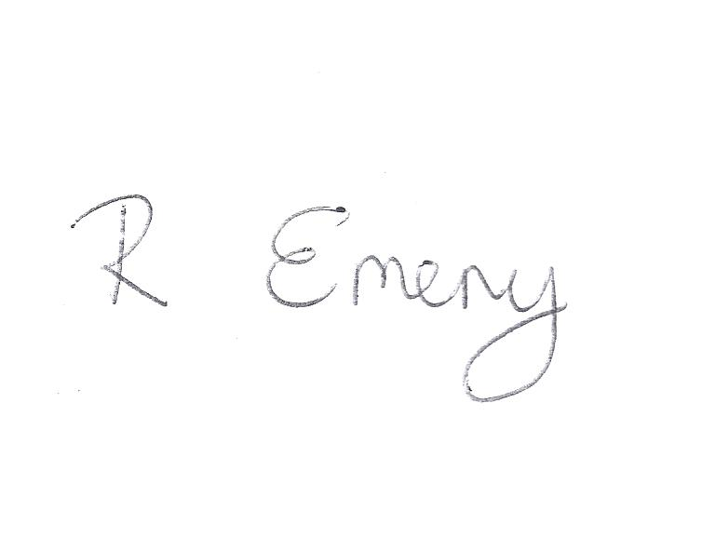
Yours faithfully

Rebecca Emeny
Head Teacher

