Class Teacher

St Peter and St Paul Catholic
Primary School
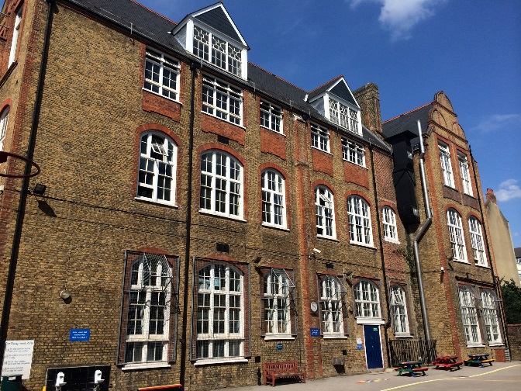
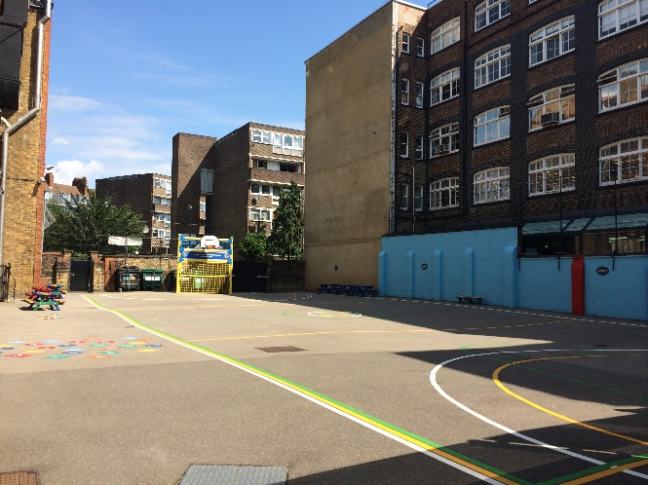
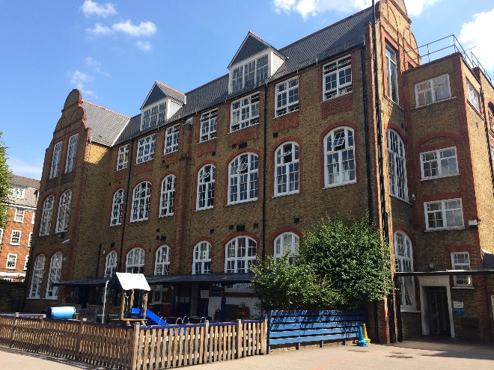

Contents

- Letter from Head Teacher

- Advertisement

- Job Description

- Person Specification

- How to Apply

- Guidance Notes

- Policy on Recruitment and
Employment of Ex-Offenders

7th June 2019

Dear Candidate,

Thank you for your enquiry regarding the teaching vacancy at St. Peter and St Paul Catholic Primary School. Please find attached a teacher application form for your completion, job description and person specification.

Closing date for applications is: Noon Friday 21st June 2019

Interviews will be held week beginning: Week beginning 24th June 2019

In line with current safe recruitment guidelines, references will be taken prior to interview.

If you haven’t already done so, visits to the school are very welcome and can be arranged through the School Administration Officer, Krystal Stack. I look forward to receiving your application form.

Yours sincerely

Miss T Peters
Head teacher
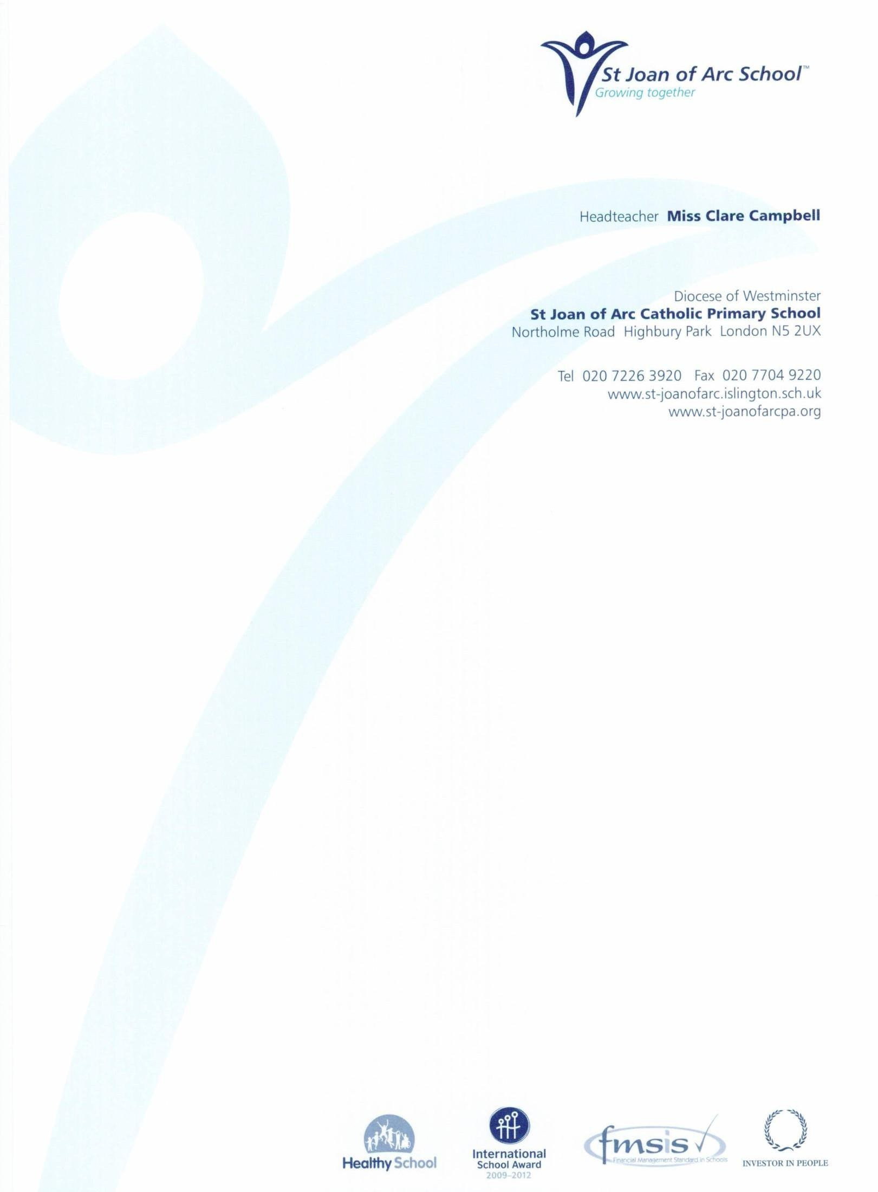
School, 2UX
Class Teachers required for September

Key Stage 1

Salary Grade: Inner London MPS 3-6 + TLR for exceptional candidates
Contract type: Full Time permanent

St Peter and St Paul is a successful and oversubscribed one-form entry Catholic primary school situated in the vibrant and diverse borough of Islington. We strive to bring out the best in all of our pupils; they demonstrate an excellent attitude to learning and attain high academic standards. Knowledge of Inspire Maths (Singapore Method) is desirable. The Governing Body is seeking to appoint a highly motivated and creative teacher to join our team. Both newly qualified and experienced teachers are welcome to apply.

The successful candidates will:
- Support the Catholic ethos of the school
- Have high expectations of pupils and be excellent classroom practitioners
- Be able to communicate effectively with children, parents and staff
- Be able to work as part of a friendly and successful team

We offer:
- Enthusiastic, hardworking pupils who have ‘outstanding’ behaviour
- Excellent teaching and learning resources
- Supportive parents and School Governing Body
- Opportunities for continuing professional development

Visits to the school are strongly encouraged. Please contact Krystal Stack at the school office on 0207253 7226 to make an appointment
Closing Date: Noon Friday 21st June 2019
Interviews: Week beginning 24th June 2019

The Governing Body is committed to safeguarding and promoting the welfare of children and young people and expects all staff and volunteers to share this commitment. All appointments are subject to an enhanced DBS disclosure.
Tel Number: 020 72263920
Fax Number: 020 7 704 9220
www.st-joanofarc.islington.sch.uk
Campbell

St Peter and St Paul Catholic Primary School
JOB DESCRIPTION

POSITION: Classroom Teacher

GRADE: Main Scale 3 – 6 plus TLR for exceptional candidates

RESPONSIBLE TO: Head teacher

PURPOSE OF THE POST

This job description should be read alongside the range of duties of teachers set out in the annual School Teachers’ Pay and Conditions Document.

Members of staff should at all times work within the framework provided by the school’s policy statements to fulfil the general aims and objectives of the School Improvement Plan.

MAIN RESPONSIBILTIES

Relationships with children and young people
- Have high expectations of children and young people including a commitment to ensuring that they can achieve their full educational potential and to establishing fair, respectful, trusting, supportive and constructive relationships with them.
- Hold positive values and attitudes and adopt high standards of behaviour in their professional role.
Frameworks
- Maintain an up-to-date knowledge and understanding of the professional duties of teachers and the statutory framework within which they work, and contribute to the development, implementation and evaluation of the policies and practice of their workplace, including those designed to promote equality of opportunity.
Communicating and working with others

- Communicate effectively with children, young people and colleagues.
- Communicate effectively with parents and carers, conveying timely and relevant information about attainment, objectives, progress and well-being.
- Recognise that communication is a two-way process and encourage parents and carers to participate in discussions about the progress, development and well-being of children and young people.
- Recognise and respect the contributions that colleagues, parents and carers can make to the development and well-being of children and young people, and raising their levels of attainment.
- Have a commitment to collaboration and co-operative working where appropriate.

Personal and professional development

- Willingness to promote and support the Catholic Ethos of the school

- Evaluate their performance and be committed to improving their practice through appropriate professional development.
- Have a creative and constructively critical approach towards innovation; being prepared to adapt their practice where benefits and improvements are identified.
- Act upon advice and feedback and be open to coaching and mentoring.

Teaching and learning
- Have a good, up-to-date working knowledge and understanding of a range of teaching, learning and behaviour management strategies and know how to use and adapt them, including how to personalise learning to provide opportunities for all learners to achieve their potential.

Assessment and monitoring
- Know the assessment requirements and arrangements for the subjects/curriculum areas they teach, including those relating to statutory assessment.
- Know a range of approaches to assessment, including the importance of formative assessment.
- Know how to use local and national statistical information to evaluate the effectiveness of their teaching, to monitor the progress of those they teach and to raise levels of attainment.
- Know how to use reports and other sources of external information related to assessment in order to provide learners with accurate and constructive feedback on their strengths, weaknesses, attainment, progress and areas for development, including action plans for improvement.
Curriculum
- Have a secure knowledge and understanding of their subjects/curriculum areas and related pedagogy including: the contribution that their subjects/curriculum areas can make to cross-curricular learning; and recent relevant developments.
- Know and understand the relevant statutory and non-statutory curricula and frameworks, including those provided through the National Strategies, for their subjects/curriculum areas and other relevant initiatives across the age and ability range they teach.
- Know how to use skills in literacy, numeracy and IT to support their teaching and wider professional activities.

Achievement and Diversity
- Understand how children and young people develop and how the progress, rate of development and well-being of learners are affected by a range of developmental, social, religious, ethnic, cultural and linguistic influences.
- Know how to make effective personalised provision for those they teach, including those for whom English is an additional language or who have special educational needs or disabilities, and how to take practical account of diversity and promote equality and inclusion in their teaching.
- Understand the roles of colleagues such as those having specific responsibilities for learners with special educational needs, disabilities and other individual learning needs, and the contributions they can make to the learning, development and well- being of children and young people.
- Know when to draw on the expertise of colleagues, such as those with responsibility for the safeguarding of children and young people and special educational needs and disabilities, and to refer to sources of information, advice and support from external agencies.

Health and well-being
- Know the current legal requirements, national policies and guidance on the safeguarding and promotion of the well-being of children and young people.
- Know the local arrangements concerning the safeguarding of children and young people.
- Know how to identify potential child abuse or neglect and follow safeguarding procedures.
- Know how to identify and support children and young people whose progress, development or well-being is affected by changes or difficulties in their personal circumstances, and when to refer them to colleagues for specialist support.

Team working and collaboration
- Work as a team member and identify opportunities for working with colleagues, managing their work where appropriate and sharing the development of effective practice with them.
- Ensure that colleagues working with them are appropriately involved in supporting learning and understand the roles they are expected to fulfil.

Planning
- Plan for progression across the age and ability range they teach, designing effective learning sequences within lessons and across series of lessons informed by secure subject/curriculum knowledge.
- Design opportunities for learners to develop their literacy, numeracy, ICT and thinking and learning skills appropriate within their phase and context.
- Plan, set and assess homework, other out-of-class assignments and coursework for examinations, where appropriate, to sustain learners' progress and to extend and consolidate their learning.

Teaching
- teach challenging, well-organised lessons and sequences of lessons across the age and ability range they teach
- use an appropriate range of teaching strategies and resources, including e-learning, which meet learners' needs and take practical account of diversity and promote equality and inclusion
- build on the prior knowledge and attainment of those they teach in order that learners meet learning objectives and make sustained progress
- develop concepts and processes which enable learners to apply new knowledge, understanding and skills
- adapt their language to suit the learners they teach, introducing new ideas and concepts clearly, and using explanations, questions, discussions and plenaries effectively
- manage the learning of individuals, groups and whole classes effectively, modifying their teaching appropriately to suit the stage of the lesson and the needs of the learners.
- Teach engaging and motivating lessons informed by well-grounded expectations of learners and designed to raise levels of attainment.

Assessing, monitoring and giving feedback
- Make effective use of an appropriate range of observation, assessment, monitoring and recording strategies as a basis for setting challenging learning objectives and monitoring learners' progress and levels of attainment.
- Provide learners, colleagues, parents and carers with timely, accurate and constructive feedback on learners' attainment, progress and areas for development.
- Support and guide learners so that they can reflect on their learning, identify the progress they have made, set positive targets for improvement and become successful independent learners.
- Use assessment as part of their teaching to diagnose learners' needs, set realistic and challenging targets for improvement and plan future teaching.

Reviewing teaching and learning
- Review the effectiveness of their teaching and its impact on learners' progress, attainment and well-being, refining their approaches where necessary.
- Review the impact of the feedback provided to learners and guide learners on how to improve their attainment.

Learning environment
- Establish a purposeful and safe learning environment which complies with current legal requirements, national policies and guidance on the safeguarding and well-being of children and young people so that learners feel secure and sufficiently confident to make an active contribution to learning and to the school.
- Make use of the local arrangements concerning the safeguarding of children and young people.
- Identify and use opportunities to personalise and extend learning through out-of- school contexts where possible making links between in-school learning and learning in out-of-school contexts.
- Manage learners' behaviour constructively by establishing and maintaining a clear and positive framework for discipline, in line with the school's behaviour policy.
- Use a range of behaviour management techniques and strategies, adapting them as necessary to promote the self-control and independence of learners.
- Promote learners' self-control, independence and cooperation through developing their social, emotional and behavioural skills.

PERSONAL RESPONSIBILITIES

- To carry out the duties and responsibilities of the post, in accordance with the school’s Health and Safety Policy and relevant Health and Safety Guidance and Legislation.
- To take responsibility for safeguarding and promoting the welfare of children.
- To use information technology systems as required to carry out the duties of the post in the most efficient and effective manner.
- To undertake training and professional development as appropriate.
- To undertake other duties appropriate to the post that may reasonably be required from time to time.

PERFORMANCE STANDARDS

- To ensure that all services within the areas of responsibility are provided in accordance with the school’s Commitment to high quality service provision to the customer.
- At all times to carry out the responsibilities of the post with due regard to the school’s Equal Opportunities policy.

ST PETER AND PAUL CATHOLIC PRIMARY SCHOOL

PERSON SPECIFICATION

Please demonstrate in your supporting statement how you meet the following essential criteria:
Qualifications & Experience | E1: Qualified Teacher Status and proven successful teaching experience across Foundation stage, KS1 or KS2
 | E2: Proven experience of high standards of classroom practice
Professional  Values | E3: Willingness to promote and support the Catholic Ethos of the school
 | E4: Respect for the views of parents and a commitment to the importance of their involvement in the learning process.
 | E5: Evidence of good interpersonal skills and the ability to work as member of a team, developing good relations with all members of the school community, and external agencies when necessary.
 | E6: Evidence of the ability to communicate clearly both orally and in writing with pupils, parents and colleagues.
Knowledge & Expectations | E7: Evidence of a commitment to excellence and the maximising of academic and personal achievement for all pupils.
 | E8: Evidence of good knowledge and understanding of the requirements of the National Curriculum and Primary Strategies.
 | E9: An understanding of the different ways in which children learn, and the appropriateness of a variety of teaching styles to meet the individual learning needs of each child.
Teaching & Class  Management | E10: Evidence of good organisational skills to create and maintain an attractive and purposeful learning environment.
 | E11: Evidence of the ability to successfully organise the curriculum for a class of pupils of mixed abilities, aptitudes and educational needs through planning, preparation, monitoring and assessment.
 | E12: Evidence of knowledge and understanding of effective assessment strategies, and their use in raising pupil attainment and achievement.
 | E13: Evidence of the ability to maintain effective classroom discipline in a positive context, and to promote well-ordered behaviour throughout the school.
Inclusion & Safeguarding | E14: An understanding of the responsibility of the class teacher with regard to the health and safety of pupils in their care, including a commitment to the school’s child protection policy.
E15: A commitment to inclusion and to uphold the principles of the school’s
Equal opportunities policy.

How to Apply

RE: SCH/ Class Teacher

Thank you for your interest in this post.
Please follow below for application documents submission.

1. Email documents to: adminkrystle@stpetersandstpauls.islington.sch.uk
Email your documents by the closing date specified above.

2. Post documents to
Please make sure you allow sufficient time for documents delivery prior to closing date.

3. Hand deliver documents to
Hard copy applications should be handed into reception at the above address during the hours (8.30am-3.30pm). Please note: We cannot be responsible for hard copy applications hand delivered after normal working hours.

In addition, please note the following:

• CVs will not be accepted.

• References will be sought for short listed candidates prior to the interview date.

• This post is subject to a period of 6-month probationary period. This also applies to candidates coming from Local Government.

Should you have any queries please email Krystle at - adminkrystle@stpetersandstpauls.islington.sch.uk

Guidance for candidates applying for a job with Islington Schools

Please read this carefully BEFORE you start to fill in the application form.

General
The application form plays a crucial part in the selection process, both in deciding whether you will be invited to an interview and at the interview itself. It is vital that you complete this form as fully and accurately as possible. We will not make any assumptions about your experience, knowledge, skills and abilities to do the job.

You should complete the form and Personal Statement online or in black ink or use a word processor. The application may be photocopied or scanned and some colours do not photocopy or scan clearly.

Read the Advertisement, Job Description, Person Specification and other accompanying information carefully before you start. All parts of the application form must be completed.

Personal Details
Complete this section fully and clearly. If you do not know your National Insurance number, you can obtain it from your Inland Revenue National Insurance Contributions office or DW P office and they'll tell you what to do. All successful applicants will be required to produce documentary evidence of their eligibility to work in the UK*. Verification of identity is required before confirmation of appointment.

*A copy of the Asylum and Immigration Act 1996 (Section 8) is available from Education HR including a list of the accepted documents.

Present or most recent employment
It is important to give full information, including the organisation or school you work in, or most recent employment if not currently working, full dates, address and other requested details. Do not leave any gaps. If necessary you should include full time or part time education or training and any periods of unemployment and periods for raising a family.

References
All appointments are subject to verification of employment and suitability of the candidate for the post applied for. It is our policy to approach the referees of all shortlisted candidates. We reserve the right to approach any
previous employer for a reference. If your last post did not include working with children, a reference will be sought from the employer by whom you were most recently employed to work with children.

All offers of appointment depend on receiving references satisfactory to the School. You must give two referees that have had managerial/supervisory responsibility for you, one of whom must be your current/most recent employer. If you have not worked before, give the name of someone who can comment on your ability to do the job, e.g. a teacher or tutor. Further advice on who is suitable as a referee is available from HR. The School reserves the right to ask for substitute or additional referees, if the one you have provided is not deemed to be suitable.

You may ask to see these references, however, some of the information may relate to a third party, e.g. authorship. This type of information cannot be disclosed to you unless:
● The third party has consented for it to be released, or
● Your right to know this information and its source outweighs the right of privacy of the third party.

Previous employment for all support staff (non-teaching) posts
Ensure that you put in full dates, names addresses and your job title. Do not leave any gaps. If necessary you should include full time or part time education or training and any periods of unemployment and periods for raising a family. Details of part time and relevant voluntary work should also be entered.

Education, Qualifications and Training
Ensure you give all the information requested, including dates, establishment where you studied and make clear the level of any examinations e.g. GCSE, GCE 'O' Level or 'A' Level or equivalents etc. and the grades you obtained. Also include here any skills training you have had. You will be required to produce original documentary evidence of any qualifications relevant to the job, and these will be detailed on the Person Specification. Proof of qualification is required before the appointment is confirmed.

Relatives and other interests
If this applies to you, please give the name of the employee, the department that they work in and the relationship husband, daughter).

Personal Statement
This statement is an important part of the application form. This is where you should describe your experience, skills and abilities. As a guide, 1-2 sides of A4 are usually sufficient. You must demonstrate competence in all areas listed in the Person Specification by giving short examples. Describe how you match the requirements of the job; include experience gained from previous jobs, community or voluntary work. Ensure that the information you give us is well organised, relevant and brief. You may find it helpful to list each person specification requirement as a separate heading to explain how you meet that requirement.

If you do not send us this statement, you will not be considered for short listing. CVs will not be accepted.

Additional information for people who consider to have a disability under the Equality Act
If this applies to you, please let us know the help you require and we will ensure that reasonable adjustments are made where possible.

Disclosure & Barring Service
Islington Schools operates a Disclosure procedure in line with DBS guidelines. If you are selected for appointment to a post that involves access to children you will be subject to this procedure. All Disclosures are carried out in the strictest confidence and are made only in connection with your application for employment and for no other purpose. The application for an Enhanced Disclosure will be activated before your first day of work.

Posts that involve such access include: all School based posts, Youth Workers, Early Years Service posts, Education Psychologists, Education Welfare Officers as well as all Office based posts where the post holder, on occasion will be required to visit any establishment where there are children.

A copy of our policy on the Employment of Ex-Offenders is enclosed. Please contact Islington Schools HR on
0207 527 5787 if you would like further clarification about the post you are applying for.

If you have been shortlisted and invited for an interview, you will be required to give full details of your criminal record to a HR Advisor, in confidence, prior to completing an application for an Enhanced Disclosure with the Disclosure & Barring Service. This information will remain strictly confidential and will only be seen by those responsible for the recruitment decision. The information will be shredded in line with our policy on the handling and storage of information relating to criminal record disclosures.

Declaration
Under the Data Protection Act 1998, we must ask you to freely give your explicit consent to the processing of information on this application form in accordance with London Borough of Islington's registration under that same Act for personnel and payroll purposes, equal opportunities monitoring and to fulfil statutory requirements.

Equal opportunities monitoring information
All job applicants are expected to complete the monitoring details of the form in order to assist us in complying with statutory requirements. All successful applicants are expected to support the policy actively. Copies are available from Education HR on 0207 527 5787.

Before you send your application, please read it thoroughly and ensure all sections have been completed legibly and fully and you have addressed all the criteria in the person specification.

Policy on the recruitment and employment of ex-offenders

Background

London Borough of Islington uses the Disclosure & Barring Service (DBS) to help assess the suitability of applicants and volunteers for positions of trust. We do this in compliance with the DBS’s Code of Practice (copies are available from Islington Schools HR Services) or on the internet at www.homeoffice.gov.uk or www.direct.gov.uk. This policy on the recruitment of ex-offenders is made available to all applicants and volunteers to jobs that require a Disclosure.

Policy

The Code of Practice requires us to treat all our job applicants and volunteers who have a criminal record fairly and not to discriminate unfairly against staff and applicants on the basis of a criminal record or other information revealed by a disclosure.

London Borough of Islington is committed to equality of opportunity for all staff. A diverse workforce benefits and adds value to the services we provide. We will be proactive in removing barriers that deny equality to people based on race, gender, disability, ethnic origin, religious beliefs, sexual orientation, age or offending background. Having a criminal record will not necessarily bar you from working for Islington Schools. This will depend upon the nature of the position you have applied for and the background of your offences.

During the application process

When you apply for a job with Islington Schools you will be told if the job you are applying for is subject to a criminal record check. If it is, you will be asked about any criminal record you may have. You should include details of all cautions, reprimands, warnings and convictions. This information is kept confidential and is only seen by those who need to see it as part of the recruitment process. We select applicants for interview based upon their skills, experience and qualifications.

A failure to disclose a criminal record (including all cautions, reprimands, warnings and convictions, spent or otherwise) at the application stage will normally lead to the withdrawal of any subsequent job offer.

If you are offered a job at Islington Schools

The job offer will be made subject to satisfactory completion of a criminal record and other checks such as references, medical fitness for the post, proof of relevant qualifications and any other essential requirements for the post.

In the starter pack you will also receive comprehensive guidance notes explaining how to fill in the disclosure form. If, after reading the guidance, you have any questions please contact Islington Schools HR Services as detailed in the covering letter.

All employees/advisors involved in the recruitment process have been suitably trained to identify and assess the relevance and circumstances of offences, or will seek appropriate advice before making a decision. We also ensure that they have received appropriate guidance and training in the relevant legislation relating to the employment of ex-offenders, e.g. the Rehabilitation of Offenders Act 1974.
In the event of the successful candidate having a criminal record, the candidate will have the opportunity of discussing the disclosure with a service manager. As a minimum, the following will be taken into account when deciding whether to confirm the appointment:

✓ Whether the conviction or information was disclosed during the application stage;

✓ Whether the conviction or information revealed is relevant to the job;

✓ How long ago the offence(s) took place;

✓ The candidate’s age at the time of the offence(s);

✓ The number and pattern of offences;

✓ Any other relevant circumstances.

All staff/advisors in a position to make recruitment decisions are trained to identify and assess the relevance and circumstances surrounding a criminal record or will seek appropriate advice before making a decision. No decision will be made until your explanation and the above issues have been considered.

Appeal

You should appeal to the DBS if you believe that the disclosure information is not accurate.

Islington Schools HR Services will decide whether the nature of the inaccuracy is such that a decision on whether to appoint should be postponed until the appeal is completed.

Policy on handling disclosure information

All disclosure information is kept securely and will only be seen by those who need to use it to carry out their duties. After a period of six months, it is securely disposed of. The disclosure forms are never kept on personal files.

Islington Schools HR Services has a policy statement on the secure storage, handling, use, retention and disposal of Disclosures and Disclosure information which is available from Islington Schools HR Services on request.

