PVG Information – Children
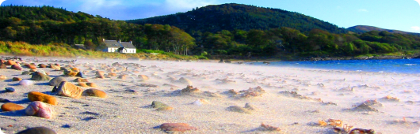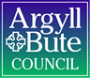

Applicants should note that this position falls within the scope of the Protecting Vulnerable Groups (PVG) Scheme which came into force on Monday 28th February 2011; the scheme replaces enhanced disclosure checking arrangements for “regulated” positions.

Should you be the preferred candidate after interview, you will be required to gain membership of the PVG scheme in relation to working with children, prior to any unconditional offer of appointment.

For those candidates who are not already a member of the PVG in relation to the workforce above, the following will apply:
- The total amount for membership of the PVG Scheme is £59.00. The successful candidate will be asked to pay £41.00 to join the scheme and the Council will contribute £18.00 to your scheme membership.

- If you do not work for Argyll and Bute Council, or are employed on a casual basis, payment is essential before an unconditional offer of appointment will be made.

- If you currently work for Argyll and Bute Council, payment can be made in full or arranged to be deducted from your salary over a period of up to a maximum of 6 months.

- Methods of payment will be confirmed at interview, should you be successful for interview.

