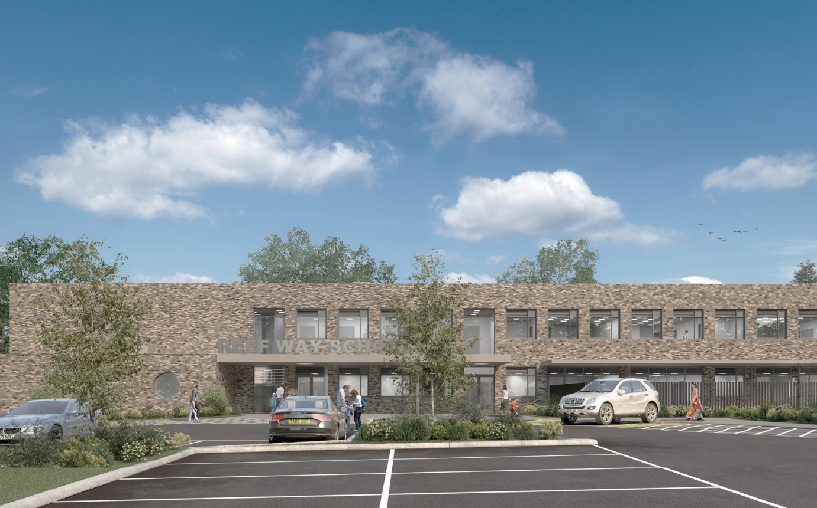
The proposed three-storey school will have spaces for 80 students aged 4-16, and will cater for children with SEMH and ASD (Autistic Spectrum Disorder.) This project forms part of East Sussex County Council’s wider strategy for providing specialist teaching facilities across the county, and will be run as a free school by an independent provider.
Dr Jonty Clark OBE, the CEO of The Beckmead Trust, said:
“In all my years I have never seen a design that takes the needs of the children so seriously, I can clearly see the care and attention that has gone into the design.”
Reef Way school will include an outdoor games court and playgrounds, with internal primary and secondary teaching areas complemented by specialist therapy facilities.
The material and colour pallet has been chosen to provide variety and interest whilst avoiding over-stimulation for pupils. A feature entrance and signage complements the rhythm of the façade, which is offset by the clean walls of the projecting PE hall.

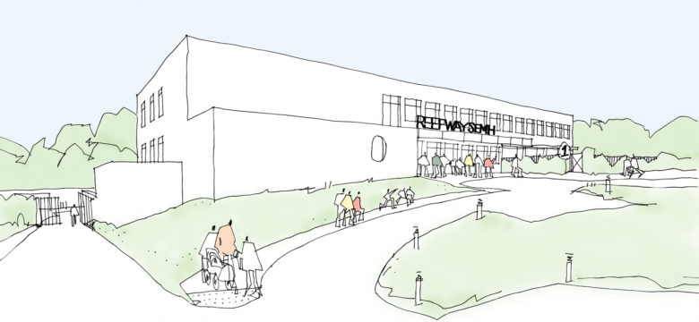
The school will be situated on a 2 hectare sloping field, which will require significant regrading and drainage works due to the geology of the site. Careful consideration has also been taken to minimise any potential impact on the site’s existing ecology, which includes newts, bats and birds.
This project offers an exciting opportunity to provide a welcoming, high-quality environment to support both pupils and staff in a new bespoke setting.

