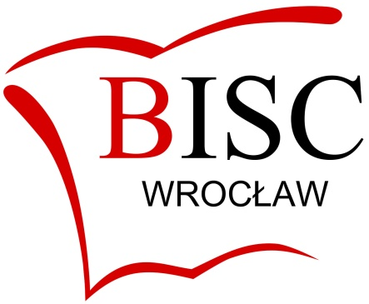

THE BRITISH INTERNATIONAL SCHOOL WROCŁAW

General information for candidates

For the academic year 2019-2020

BISC Wroclaw is a branch of the British International School of Cracow – our sister school which was founded in 1995. The Wroclaw branch was opened upon request of the Wroclaw City Council in order to support the families of the growing international business community. We are registered with CIE and ISA, and we are members of ECIS and COBIS.

We opened our doors on 1st September 2006 with 20 pupils and now have just over 200. We follow the English national curriculum, but adapt it to international needs.

Our pupils hail from all over the globe, although the largest single group is from Korea due to the local LG Electronics plant which was set up in Wroclaw several years ago. Our teachers also come from many different countries, with a predominance from the UK and Poland.

The level of English in most classes varies considerably. In view of the this, it is essential that candidates are prepared to cope with the differentiation required of mixed language levels. The percentage of beginners is higher in the lower primary section. Some students have little English when they arrive, therefore lot of emphasis is placed on additional EAL support (English as an Additional Language).

In the main our classes do not exceed 18 students, which enables our staff to focus on their pupils as individuals rather than just as a whole class. The overall ambience throughout the school is warm, friendly and relaxed, yet at the same time our standards are demanding and our exam results are very good, especially considering the large number of non-native English speakers in the school.

Our school is located in two beautiful nineteenth-century villas within the same plot of land, in a quiet residential area of the city. One villa is for primary, the other for secondary classes and specialist rooms, eg. science lab, computer lab, library and dining room. The grounds incorporate an orchard and basketball pitch. Several rooms and artistic features in the larger building are listed due to being of historic interest. (It is rumoured that an important Nazi general and his lover lived here during the war!)

Candidates must be fully qualified teachers, preferably with experience in the British educational system, and native speakers of English.

Cost of living
The cost of living in Wroclaw is lower than Britain. The currency is the zloty (zl). A single person will find the salaries we offer more than adequate to live on. To give an example, a flat near the centre costs between 1,500 and 2,000 zl per month, plus utilities depending on size. The further away from the centre, the lower the rent.

For people who like a cultural or social life, Wroclaw is the place to be. It is a beautiful, historic city with a fascinating past. In medieval times it used to be belong to Poland, then it passed hands to Germany for the next few hundred years, and after World War II it once again became part of Poland.

There are plenty of concerts (classical music, folk, jazz, opera, ballet, and more), exhibitions, cinemas, various celebrated days throughout the year, as well as a huge variety of cafes, bars, clubs and restaurants in the old centre. There is also a fascinating historic heritage to explore and various castles and medieval monasteries are scattered around the locality. Skiing and hiking addicts will also be happy to know that the beautiful Sudety mountain range is not far away by coach.

For further information about our school, please look us up on our website: bisc.wroclaw.pl

