Overstone Combined School
Wing

Candidate Information Pack
Headteacher
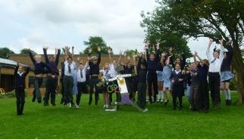
Community, Challenge, Curiosity

Contents
Welcome letter from Mark Watson, Chair of Governors 3
The terms and conditions of the role 4
Job description 5
Person specification 7
Our School Values 9
Application process and timescales 10
School visits: 10
Applications: 10
Shortlisting: 10
Interview: 10
Information about Overstone 11
A Glimpse of Life at Overstone……………………………... 12
Local Information about Wing in Buckinghamshire 13

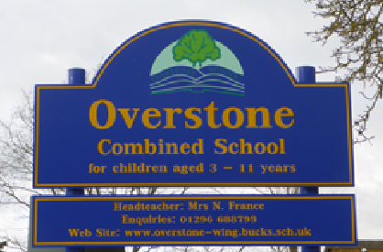
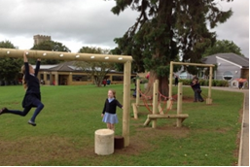
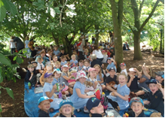

Welcome letter from Mark Watson, Chair of Governors

Dear Applicant,

We are delighted that you are interested in becoming the next Headteacher of Overstone Combined School. Overstone is a lovely village primary school with enthusiastic pupils, fantastic facilities and a supportive Governing Body. We are seeking to make an appointment in April or September 2020, with handover opportunities during the summer term, as the Deputy Headteacher has currently stepped up to the role of Acting Headteacher.

Our school is a village primary school admitting pupils aged between three and eleven years. It is situated in the village of Wing between Leighton Buzzard and Aylesbury. We are a foundation school which means that the governing body is the employer, owns the land and buildings and sets the admission criteria. This means that while the school is not an academy, it has significant autonomy in its day-to-day running which offers great scope for career development for the Headteacher.

We are proud that Overstone provides a caring and safe environment based on mutual respect, where children achieve their full potential and develop creative, enquiring minds to prepare them for future opportunities and challenges.

In November 2019, OFSTED judged Overstone as continuing to be a good school. However, the school has been on a journey since its last inspection in 2016 and we expect to be revisited in 2021. We are looking for an exceptional, empathetic leader who can drive us forward, who will ensure that all staff are valued equally and focus on providing high quality education for all children. Your challenges will include reviewing our Curriculum Design to ensure that it promotes strong achievement in all subjects for all groups as well as developing teacher’s pedagogical and subject knowledge. This will need to be balanced with a holistic approach, ensuring not just good results but the well-being of the whole child.

As our new Headteacher, you will have strong support from:

- a dedicated, professional and motivated team of teaching and support staff
- a supportive team of governors with a variety of skills and experience
- an engaged parental community
- a proactive and hardworking PTA.
- enthusiastic children

We are looking for someone special who can:

- communicate and work with all stakeholders to create a vision for our changing future and set a strategic direction for the school
- continue to raise standards of achievement
- ensure that every child at our school feels confident and valued
- encourage innovation and lead the way in educational best practice
- continue to build, develop and inspire our excellent teaching and support staff
- manage and maximise our resources and finances
- ensure the consistent implementation of the behaviour policy

This is a post that provides real scope for personal and professional development. It will be extremely rewarding for an outstanding leader looking for a new challenge.

I would encourage you to visit the school prior to submitting your application. To make an appointment, please contact our school business manager Andrea Toosey by telephoning 01296 688799 or emailing sbm@overstone-wing.org Please note the school is closed for the Christmas holidays but emails will be monitored.

Yours faithfully

Mark Watson

Email: sbm@overstone-wing.org

Tel: 01296 688799

The terms and conditions of the role
Salary: Group 2

Hours: This is a full-time position.

Start date: As soon as possible, though a September 2020 start date will be acceptable for the right candidate.

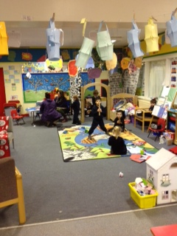
Job description
Overstone Combined School – Headteacher – Job Description

Responsible To: | The Governing Body
Primary Purpose: | To develop and manage the school effectively and efficiently, providing a clear vision with positive, inspirational but reliable and consistent leadership. Setting an educational direction for the school and creating a collaborative working environment that allows staff and pupils to flourish and participate in the shared journey.

MAIN DUTIES AND RESPONSIBILITIES
The duties include those set out for Headteachers in the current Teachers Pay and Conditions Document and Headteachers’ Standards

1. To provide clear leadership, educational direction and professional guidance by working with the Governing Body to develop and implement agreed aims and policies.

2. To work with the Governing Body and the Senior Leadership Team to initiate and lead institutional development planning, target setting, monitoring and self-evaluation.

3. To formulate an annual development plan for the School for presentation to the Governing Body and to secure its implementation with the collective support of staff.

4. To plan, deploy and manage financial and other resources according to best value principles: maintaining appropriate financial and accounting systems in line with financial regulations, and providing financial reports as required and requested.

5. To ensure the effective deployment of school staff and resources.

6. To be responsible for all Child Protection and Safeguarding in the school.

7. To direct the planning, delivery, monitoring and reviewing of an appropriate, balanced and enriching curriculum that meets pupils’ individual needs and interests.

8. To encourage and support a wide range of out of classroom and extra-curricular activities and opportunities

9. To ensure the writing and regular updating of relevant whole-school policies.

10. To maintain suitable staff and pupil records.

11. To line manage and support the Senior Leadership Team.

12. To lead, co-ordinate, motivate and support the full school staff team, ensuring effective staff development and training, with opportunities for each individual’s personal and professional growth within the wider staff team.

13. To create a safe and positive learning environment and establish effective behaviour management policies and procedures.

14. To ensure effective monitoring of teaching and learning and to give regular and detailed reports on this to the Governing Body.

15. To establish and maintain strong, positive communications with parents and the wider community.

16. To establish effective induction and initial assessment procedures for pupils, as well as ongoing progress tracking and monitoring.

17. To ensure regular progress reports are received by parents.

18. To maintain appropriate links with relevant external agencies and services.

19. To complete a range of returns and written reports, in particular in relation to self-evaluation and the Headteacher’s termly report to the Governing Body.

20. To provide day-to-day management of the school site, including all aspects of Health and Safety, plus building and grounds development and maintenance.

21. To be the first point of contact for LA emergency procedures.

22. To undertake any other reasonable duties as may from time to time be requested.

23. To communicate with and oversee the onsite nursery operated by Ashbourne Day Nurseries. The nursery also offer the wraparound care to school pupils in the form of breakfast club, after school club and holiday clubs.

24. To liaise and communicate with the Buckinghamshire County Council who operate the onsite Children’s Centre

Conditions of Employment

The above responsibilities are subject to the general duties and responsibilities contained in the written statement of conditions of employment (the Contract of Employment).

The post holder is required to support and encourage the school’s ethos and its objectives, policies and procedures as agreed by the governing body.

To uphold the school's policy in respect of child protection matters.

The post holder shall be subject to all relevant statutory and institutional requirements.

The post holder must be prepared to undertake training relevant for the post.

The post holder may be required to perform any other reasonable tasks after consultation.
This job description allocates duties and responsibilities but does not direct the particular amount of time to be spent on carrying them out and no part of it may be so constructed.

This job description is not necessarily a comprehensive definition of the post. It will be reviewed at least once a year and it may be subject to modification at any time after consultation with the post holder.
Person specification

Method of Assessment
ED  E Essential criteria to be appointed  D Desirable criteria to be appointed  How assessed  AF Application form  SS Supporting statement  I Interview | E/D | Assessment
Education, Training & Qualifications  1. Qualified Teacher Status  2. Evidence of additional training or professional development, particularly in school management, and the teaching of pupils in Early Years and Primary  3. NPQH unless a current or returning head/ new enhanced non-mandatory qualification | E  E  D | AF  AF  AF/SS
Knowledge & Experience  1. Experience of teaching primary age pupils in at least two schools  2. Experience of headship in a primary setting  3. Experience of educational and institutional management and self-evaluation processes  4. Experience of curriculum planning, development and management  5. Experience of the monitoring and assessment of teaching and learning  6. Experience of resource and budget analysis and management  7. Experience of multi-agency working  8. Knowledge of current practices, developments and trends in the education of young people  9. Knowledge of the OFSTED Inspection Framework and Self Evaluation  10. Knowledge of current Teachers Pay and Conditions and the Performance Management Framework.  11. Knowledge of the SEN Code of Practice  12. Understanding and experience of Safeguarding and Child Protection requirements and procedures.  13. Understanding Equalities law and the public sector equality duty, and how this relates to the school community. | D  D  E  E  E  D  D  E  D  E  E  E  E | AF/I  AF/I  SS/I  SS/I  SS/I  SS/I  SS  SS/I  SS  SS/I  SS/I  I  I
Values, Skills & Abilities  14. A commitment to supporting and maintaining an inclusive ethos in a school, within an equalities framework.  15 A commitment to inclusive practice which values every child equally  16. Ability to establish and direct appropriate systems and procedures for institutional self-evaluation and planning  17. Ability to devise, plan, manage and review an appropriately balanced and inclusive curriculum  18. Ability to establish and implement effective procedures and systems for the monitoring of teaching and learning  19. Ability to foster a feeling of mutual respect in both pupils and adults  20. Proven leadership qualities, and the ability to demand and maintain consistently high standards and expectations  21. A demonstrably positive approach towards young people with learning and behavioural difficulties and a sympathetic understanding of the impact of educational exclusion on them and their families  22. Ability to work productively with other Headteachers and to make a contribution to developing partnership working  23. Ability to win the confidence of and work positively with, parents, LA colleagues and other professionals  24. An ability to act at all times as an ambassador for Overstone Combined School  25. Excellent communication skills for a wide range of contexts and purposes  26. Ability to ensure the school is at the heart of the community | E  E  E  E  E  E  E  E  E  E  E  E  E | SS/I  SS/I  SS/I  SS/I  SS/I  I  SS/I  I  I  I  I  SS/I  SS/I

Our School Values

At the heart of our village community, we are all proud to be part of the Overstone family, creating a happy, inclusive and respectful culture where everyone can flourish.

We are a skilled and passionate learning team, motivated to make a positive impact on every child’s life. We recognise and value each child’s uniqueness and feed their curiosity through a rich variety of stimulating learning experiences. In a safe, nurturing and fun environment, we ignite their joy of learning and challenge each other to achieve more. Everyone is encouraged to push on different doors to discover what they love.

Focusing on each child both academically and personally, we prepare them for the responsibilities of life and to stand up and make a difference in their community. We promise to inspire our children to grasp every opportunity in order to have a life full of choices.

Community, Challenge, Curiosity

Through our teaching we aim to:
- Enable children to become confident, resourceful, enquiring and independent learners
- Foster children’s self-esteem and help them build positive relationships with other children and adults
- Develop children’s self-respect and encourage children to respect the ideas, attitudes, values and feelings of others
- Show respect for all cultures and, in so doing, promote positive attitudes towards other people
- Enable children to understand their community and the role they play within it; to help them feel valued as part of this community
- Help children grow into reliable, independent, self-disciplined and caring citizens
- Plan and prepare children for smooth transition through the school and beyond.

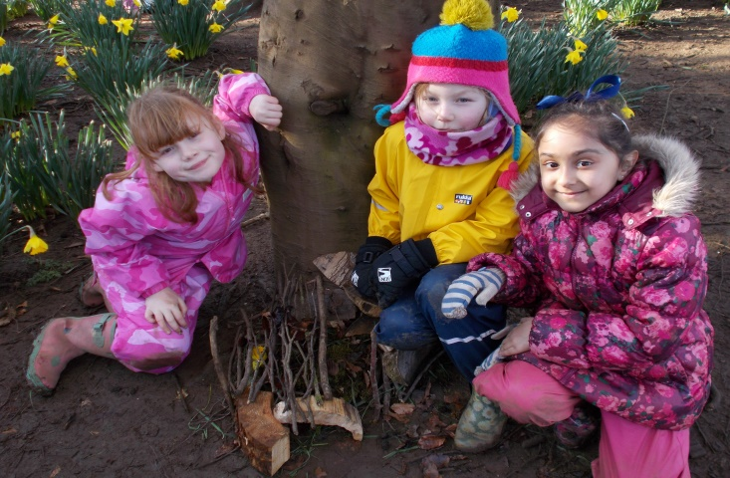

Application process and timescales

School visits:
For an informal conversation about the role, please contact Mark Watson, Chair of Governors via the school using the contact details below. To arrange a visit to the school, please contact Andrea Toosey, school business manager, by email sbm@overstone-wing.org or by phone on 01296 688799. Please note the school is closed from Friday 20th December to 3rd January inclusive.

Applications:
Please submit your completed application form and supporting statement by email to sbm@overstone-wing.org for the attention of Mark Watson by 9am on Monday 20th January.

Shortlisting:
Shortlisting will be carried out by Governors and candidates will be contacted by Friday 24th January to let you know whether you will be invited to interview. References for shortlisted candidates will be taken up at this stage.
Interview:
Interviews will be held at the beginning of February at the school and are expected to take most of the day. Candidates will be asked to undertake a range of activities and we will ensure that you have plenty of opportunities to ask all the questions you may have so that you feel sure Overstone is the right next step for you.
Equal Opportunities Employer:

We are an equal opportunities employer and we are determined to ensure that no applicant or employee receives less favourable treatment on the grounds of gender, age, disability, religion, belief, sexual orientation, marital status, or race.
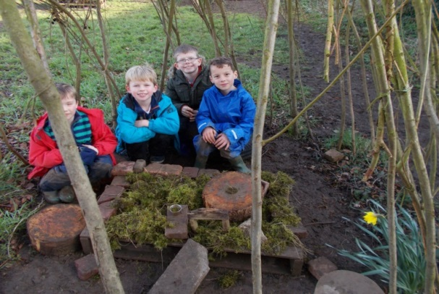

Information about Overstone

Key Information
Age range: | 3 – 11
Gender: | Mixed
Faith: | All
Location: | Wing, between Aylesbury and Leighton Buzzard
Phone Number: | 01296 688799
Email: | admin@overstone-wing.org
Website: | www.overstone-wing.bucks.sch.uk
OFSTED Rating: | Overstone Combined School was inspected on November 19/20th 2019 and is rated as a good school. Go to Ofsted website to read the report. The school URN is 110519
School premises: | The school has four interlinked buildings which are modern, spacious and well maintained. There is a large school hall. The classrooms are large and light and have been recently refurbished. We also have a covered heated swimming pool.  The school is fortunate to have extensive grounds with far reaching views. Within this there is a large playing field, a hard-surface playground and fitness trail equipment. There is a designated forest school area within the school grounds. The school nursery has its own large, well-planned outdoor area with an all-weather play surface and a spacious covered area allowing learning outdoors to be an integral part of every day.  There is a separate building, owned by the school, in which a nursery for children up to the age of four is operated by a separate company, plus a children’s centre operated by the Buckinghamshire County Council.
Number of children | 214 (Dec 19). The number of intended admissions for the year commencing 1 September 2020 is 42. Our existing Year 6 group has just nine pupils so the overall school numbers will increase.
Number of SEN: | 20 SEN, 3 EHCP

A Glimpse of Life at Overstone …………………………...

Good OFSTED

In November 2019 OFSTED judged Overstone to be continuing as a good school. However, the school has been on a journey since its last inspection in 2016 and the school should expect to be revisited by Ofsted in 2021. Overstone is receiving support from the local authority to help it in raising standards.

The latest report states that “Overstone is a welcoming school where the pupils are happy and feel safe. Pupils enjoy a wide range of activities to help them broaden their learning and experiences.

Children in the early years are well looked after. They are happy and calm. They learn to play well together and follow school routines.

Leaders provide pupils with a range of experiences and support pupils’ personal development. Pupils have a well-rounded understanding of life in modern Britain.”
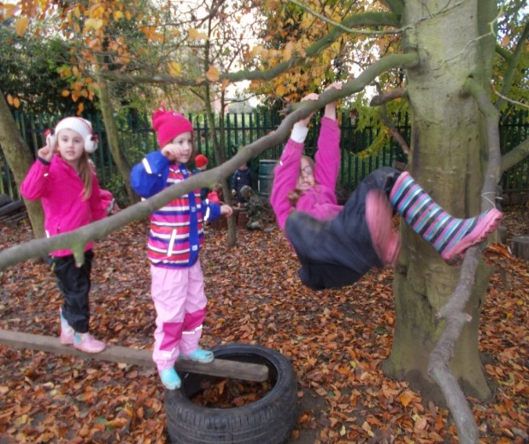
Forest School
Forest School sessions are a tried and tested format which seeks to encourage, motivate, engage and inspire children through positive outdoor experiences. All Reception and Key Stage 1 pupils spend regular sessions in an area of woodland that is natural, safe and accessible, working to their usual curriculum but in an outdoor setting. The forest school approach demands that the outside space is not seen as merely a place where children go to burn off energy. The divide between indoors & outdoors is broken and children learn in and from nature.

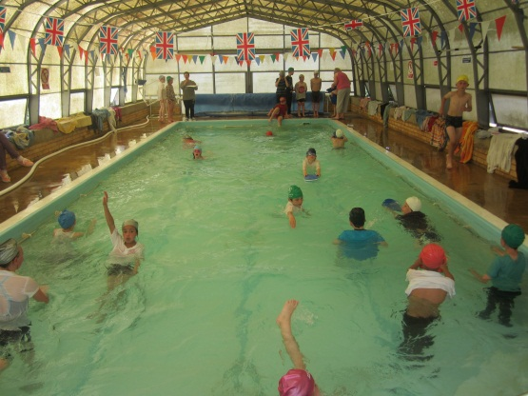

Covered & Heated Swimming Pool

All children swim at least once a week during the summer term. The swimming pool is a huge asset to the school.

Local Information about Wing in Buckinghamshire

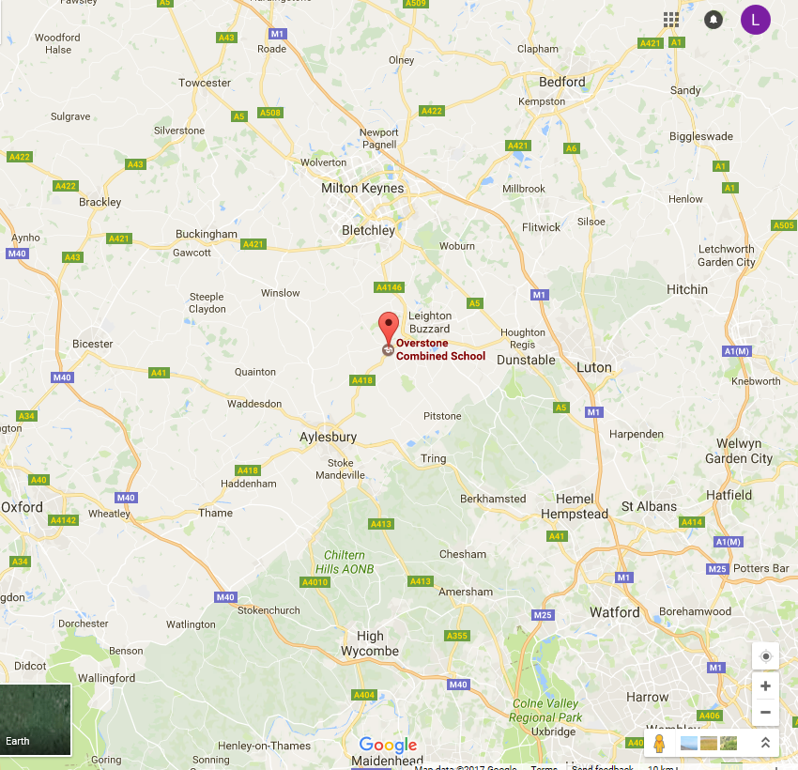

Overstone Combined School is situated on Church Street in Wing, near The Cottesloe School.
Wing is a friendly community which is growing in size with 100 new houses having been built in the last two years. We are close to Ascott House, one of the Rothschild residences which is operated by the National Trust. We have good road and bus links to Aylesbury, Milton Keynes and Leighton Buzzard. We are less than 10 miles from 2 different mainline British Rail stations, serving London and the Midlands.

Buckinghamshire has a selective education system, and children are selected for Grammar School places via the 11+ test taken at the beginning of Year 6.

Accommodation:
There is plentiful housing in the areas around Wing both rental and owner occupied. Within a 15 mile radius of Wing, 3 bedroom semi-detached properties can be sourced from £300K+ in areas such as Dunstable, Luton, Milton Keynes and Buckingham.

Shopping and Recreation:
Wing has an excellent range of local amenities including a post-office and general store, chemist, pubs and restaurants. There are two GP surgeries and other local businesses nearby. Both Aylesbury and Leighton Buzzard have regular markets and a good selection of retail and recreation facilities.

