January 2020

Dear Candidate

On behalf of our Trust and Castlefields Local Governing Body, we would like to thank you for your interest in the post of Headteacher at Castlefields School.

This vacancy has arisen because Jackie Hampson, the current Headteacher, has decided to retire at the end of this school year. Jackie has worked tirelessly to transform Castlefields into a school that we are very proud of. We are looking for candidates who understand the qualities and ethos that have made Castlefields such a special place, and who will have the vision and ability to build on existing good practice and lead the future development of the school.

Castlefields School provides an inclusive, nurturing environment that enables all our pupils to learn and achieve. Our pupils are curious, thoughtful, enthusiastic and eager to do well and be involved in all aspects of school life. They are respectful towards others and sensitive to their interests and needs – a quality that pervades the school and is exemplified by the Headteacher and her staff. Governors and Trustees alike are fully supportive and determined to ensure that Castlefields continues to provide a distinctive learning experience for all our pupils.

We strongly encourage you to visit our school so you can experience our warm and welcoming environment before you prepare your application. We will be glad to meet you and accompany you on your visit. Please contact Frances Sherrington at frances.sherrington@oldburywells.com or on 01746 760509 to arrange a visit. You will also find a wealth of information giving further detail on school policies and performance on the school website www.castlefieldsprimary.co.uk.

We do hope that you will decide to apply and look forward to receiving your application, along with a letter of introduction, which should be sent to Mrs Sherrington at either the above email address or the Trust Office address quoted below. Your letter of introduction should be no more than three sides and include why you believe you are a suitable candidate for the post and how you would develop Castlefields School. The closing date is 9am on Monday 27 January 2020. Interviews are scheduled for the 30 and 31 January 2020.

Thank you once again for your interest in our school.

Yours sincerely
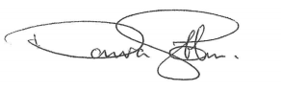
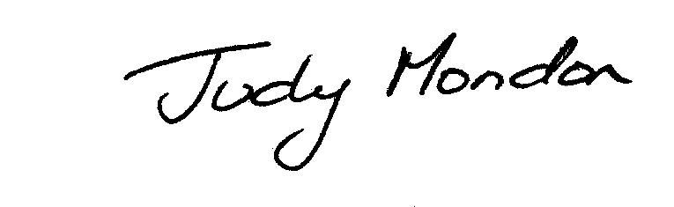

Judy Mondon Donovan Gibbons
Chair of Trustees Chair of Governors

Executive Headteacher Trust Office
Mrs Sarah Godden BA MEd c/o Oldbury Wells School E head@oldburywells.com Bridgnorth, Shropshire WV16 5JD
T 01746 765454 F 01746 762746 E admin@oldburywells.com
Company Number: 9617166

