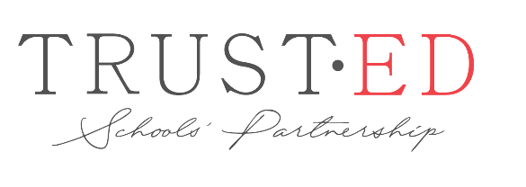
Introducing our Trust
Our Trust is comprised of a small family of six schools. We were originally called the Bridgnorth Area Schools’ Trust but have recently changed our name to TrustEd Schools’ Partnership. All the Trust academies are all based in South Shropshire and all share the same ethos and values. We have four schools around the market town of Bridgnorth and two schools around the market town of Church Stretton.

Oldbury Wells School, which is a secondary school and the founding school in our Trust, is very close to Castlefields Primary School, and in fact the two schools share school fields! Alveley Primary School joined the Trust as a sponsored school in 2016. Since this time the school has gone from strength to strength and it secured one of the very first Ofsted ‘good’ judgments under the new framework. St Leonards CE Primary School joined us in 2016 at which point the Trust changed its status and we became a ‘mixed MAT.’ This means we can have both secular and Church of England schools in our family. We are proud of this inclusivity and we cherish this variety. Castlefields Primary School also joined the family of schools in 2016. Church Stretton Secondary School is in the market town of Church Stretton and Stokesay Primary School is close by in Craven Arms. These two schools joined our Trust in September 2019.

Our Governance has two tiers. The Trust Board (and its committees) has the overarching responsibility for governance of the Trust and each school. Each school also has delegated powers to their Local Governing Body.

As a Trust we support our schools with a helpful suite of central services which has its offices at Oldbury Wells, Bridgnorth. This team, which supports core aspects such as finance, HR and premises, is led by Karen Cook, our Director of Finance and Business. Each Headteacher retains leadership and responsibility for these areas but is supported in these tasks by central services. As a result of this approach, all of our schools continue to develop and improve under their Headteacher’s leadership, and each enjoys healthy finances. HR is run through our Trust, as the employer of staff at all of our schools, including, of course, Headteachers.

Our schools are also supported by a central service for education and governance. This is led by Sarah Godden who is our CEO and Executive Headteacher based at Oldbury Wells School, supported by Frances Sherrington who is Clerk to our Trust Board. We employ a School Improvement Advisor, and two of our Team are Ofsted inspectors which is most helpful. We work in a consistent way on several key education processes, such as Ofsted preparation and improvement planning. Again, each Headteacher retains leadership and responsibility for all aspects of education in their schools, but these processes are supported by the Trust where appropriate. As a result of this approach, each school continues to develop and improve, but each school retains their uniqueness.

As a small Trust in a close geographical area, our school leaders frequently work together on joint projects and support each other. Our CEO is also a regular visitor to schools and governors’ meetings, and she takes a keen interest in all aspects of our schools. We look forward to welcoming a new Headteacher who shares the same vision for working collaboratively in a family of schools and who places the interests of all our pupils at the heart of their work.

For further information, please refer to our Trust website, www.trusted-schools.com

