ERSKINE STEWART'S MELVILLE SCHOOLS’
GOVERNING COUNCIL

The Mary Erskine School

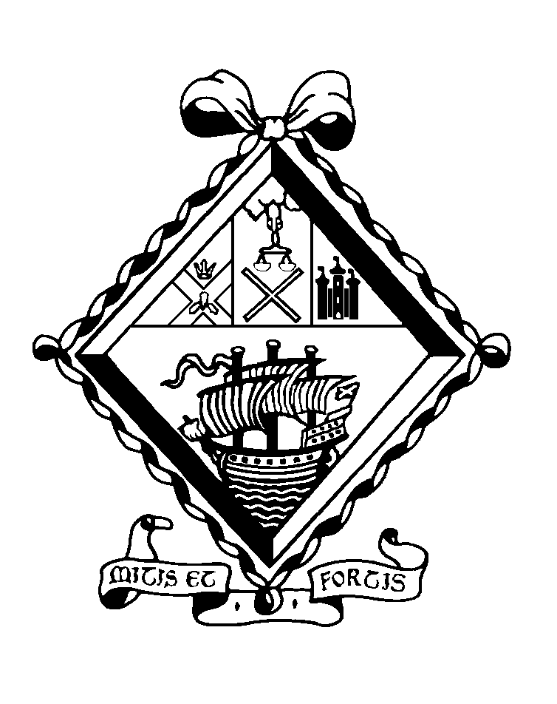

APPOINTMENT OF
TEACHER OF MODERN STUDIES WITH GEOGRAPHY
(maternity cover)

THE MARY ERSKINE SCHOOL

The Mary Erskine School comprises approximately 740 girls aged 12-18. Founded in 1694 by Mary Erskine and the Company of Merchants of the City of Edinburgh to educate and care for the daughters of city burgesses who found themselves in reduced circumstances, it is the oldest girls’ school in Scotland and one of the oldest in the whole of the United Kingdom. Throughout its history, the school has been administered by the Edinburgh Merchant Company.

Since 1978 the school has been twinned with Stewart's Melville College. Through this arrangement, the senior schools are separate and single-sex but are each led by the Principal, while all the girls and boys below the age of 12 are educated together in the ESMS Junior School. Senior school boys and girls come together in orchestras, choirs, drama and musicals, as well as in numerous Outdoor Education projects and in the Combined Cadet Force. Since August 1999, the Sixth Year has become a genuinely 'twinned' experience, with boys and girls jointly comprising a single academic, pastoral and social unit.

The Mary Erskine School was inspected by Her Majesty's Inspectors in 2017 and was highly commended in the subsequent report. It was named The Sunday Times Scottish Independent Secondary School of the Year 2012.

The Erskine Stewart's Melville Schools have a charitable foundation and today provide financial assistance to over 150 bursary holders, who attend Stewart's Melville College or The Mary Erskine School.

BUILDINGS

The school, named The Mary Erskine School in 1944 to mark the 250th anniversary of its foundation, has been housed on various sites in the city - the Cowgate, Bristo, Lauriston and Queen Street - and the buildings are depicted on the engraved glass panels in the entrance hall. In October 1966 the school moved to purpose-built accommodation on the magnificent 38 acre site adjoining Ravelston House. These new facilities have been enhanced by the building of a Sixth Form Centre in 1995 and by the more recent refurbishment of the Science Laboratories, Art Department, Home Economics Department, Careers Department, Library, ICT suite, the provision of two floodlit Astroturf hockey pitches, and the construction of six new tennis courts.

A new Sports Hall was completed in October 2000. It houses the National Cricket Academy and the Scottish Cricket Offices. A community sports facility is in operation seven days a week, outwith school hours and the project, which is linked to the sports facilities at Queensferry Road, are managed by the Community Sports Development Manager.

CURRICULUM

The Erskine Stewart's Melville Schools are committed to the all-round personal development of all children in their care. Their education is underpinned by nine values: appreciation, commitment, confidence, enthusiasm, grace, integrity, kindness, respect and responsibility.

The school follows its own curriculum prior to examination years. The Curriculum for Excellence is not followed. Girls generally sit the public examinations prescribed by the Scottish Qualifications Authority. It is normal for girls to sit a combination of eight subjects at National 5 and to proceed to Higher courses in S5. The majority will return for a final year in Sixth Form, with a high proportion taking Advanced Highers. ‘A’ Levels are offered in Art and in Music.

TEACHERS

There are approximately 80 teachers at the school. They rely on an excellent team of support staff, whose high standards contribute greatly to the quality of the school.

PROFESSIONAL REVIEW AND DEVELOPMENT

All teaching and support staff participate in a three-year cycle of professional review.

EXTRA CURRICULAR ACTIVITIES

Teachers are expected to play a full and active part in the extra-curricular life of the school. The ability to contribute to the Games programme (particularly hockey), the Combined Cadet Force (particularly the RAF Section) and the Duke of Edinburgh Award would be most welcome.

THE DEPARTMENTS

Modern Studies is mainly taken by S5 and S6 pupils at Higher and Advanced Higher, with a small number of S5 pupils studying at National 5. The subject is increasingly popular with senior pupils, with three large ‘crash’ Higher sets. Academic results are excellent. There is one other full-time teacher, who is the Head of Department.

There is a considerable range of trips and events arranged by the Modern Studies Department. Advanced Higher candidates visit a local prison, in part as preparation for their dissertation. Numerous lectures and film screenings organised by the likes of the Howard League are actively promoted and pupil uptake is very strong. A range of events including visiting speakers from the Scottish Parliament, hustings and mock elections are organised in school. A new Politics Club for S1 and S2 pupils is also starting in August 2018 which aims to compliment the S1 Current Affairs course (which is organised, but not taught, by the Department).

Geography is a popular subject within the school with a strong retention of pupils in certificate courses. Academic results are excellent. There are two other full-time teachers, one of whom is the Head of Department, and one part-time teacher working in the Department.

There is a strong focus on fieldwork in the Geography Department. S3 pupils are offered the opportunity to spend a weekend in the Yorkshire Dales and, as part of the Carbisdale Outdoor Education Project, they study ‘Landscapes and Land Use’ in Assynt. S4 and S5 pupils complete fieldwork days in the local area in order to gather data for their Assignments. Combined trips to the French Alps have occurred annually and other destinations, such as Iceland and further afield, are often visited. Through our active GeogSoc, pupils also participate in activities such as the RSGS Illustrated Talks season and lunchtime film screenings.

Teachers within the Departments are allocated a number of subject specific responsibilities which may change by negotiation. This will involve the remediation and development of teaching and learning materials as well as the evaluation and implementation of assessments. In addition, staff are also expected to contribute to the annual review of the teaching and learning programme within the objectives of the development plans. The Departments have high academic standards and a variety of teaching strategies are implemented in order to support effective learning for all levels of ability. Pupils are encouraged to take responsibility for their own learning and to develop good study skills. The Departments are well resourced and share a Staff Base as well as a suite of laptops available for use by pupils at any time. All full-time teachers have their own room, equipped with interactive screens.

THE POST

This is a full-time, maternity cover post from August 2018 until June 2019. The successful candidate will be expected to teach up to and including Higher Modern Studies and, in Geography, all levels up to and including National 5. The ability to teach the geographical elements of National 5 Environmental Science would be an advantage. All staff are expected to promote the ethos of the Department which strives to achieve a stimulating, positive and purposeful learning environment for all pupils.

The generic job description for a teacher at The Mary Erskine School is appended.

REMUNERATION AND OTHER CONSIDERATIONS

Remuneration will be on the school’s own scale, which is above that paid in the State Sector, and is dependent on qualifications and experience. All teachers are entitled in term time to school lunch free of charge in return for supervisory duties.

Please note that the school operates a No Smoking Policy and smoking is not permitted on the school campus at any time.

APPOINTMENT PROCEDURES

Applications should be in the form of a letter, addressed to Mrs L A Moule, Vice Principal and Head of The Mary Erskine School Senior School, and should be supported by a full Curriculum Vitae along with the names, addresses and contact details of two referees. They should be sent by email to recruitment@esms.org.uk or by post to the HR Administrator, Erskine Stewart's Melville Schools, Ravelston, Edinburgh EH4 3NT, from whom further particular may be obtained. This information can also be found on our website.

The closing date is 12 noon on Friday 2 March 2018.

