Robert Smyth Academy
Market Harborough

Teacher of Science
Applicant Information Pack

Dear Applicant,
Thank you for your interest in Robert Smyth Academy. I suspect that if you are anything like me, the first thing you may be interested to learn will be about our climate for learning and the expectations of students. It would be fair to suggest that we are an institution that has a commitment to structure, predictability and routine. These are important foundations for a calm and purposeful learning environment that benefits all students and the staff who work alongside them. Our students are courteous, kind and have high aspirations for their futures and they are the best thing about life at our Academy. These key ingredients are the collective building block for passionate, empathetic and hard working teachers to make a difference and to foster a love of learning. This is a fantastic opportunity to enrich our community with your own gifts, passions and values. Put simply, this would have been the school of my dreams when I was teaching a fuller timetable earlier in my career, particularly with the ability to teach to A-Level and retain that connection with my degree (I still love the opportunity of teaching and teach students in Year 7 today and this remains a privilege).
Students are achieving greater progress in their national examinations and this year we have seen our best results for four years. It may be of interest to you that the Academy saw a dramatic increase to Progress 8 this summer (-0.21 improving to +0.04) with excellent progression and destination information from Year 13 students with many of those pursuing study at their universities of choice including Oxford and Cambridge. We were inspected by Ofsted in 2017 and graded as 'Good' however, there has been continued transformation since this stage and there is no doubt that the quality of education and experiences which students receive are beyond comparison with the school seen two years ago. We also offer students a formidable package of enrichment opportunities and the magic of this offer is that we are not just the sporty, artistic, creative, musical or academic school but we are a truly comprehensive provider and we have strength and high quality provision in each and every one of those specialist areas. It is little wonder that we have seen a significant increase in admissions as we become the provider of choice in Market Harborough.
We have an excellent track record of supporting teachers. If you were to ask experienced colleagues, Recently Qualified Teachers (RQTs), Newly Qualified Teachers (NQTs) and the trainee teachers that we work with, you will find that this is a welcoming, supportive and warm environment. Members of staff work hard together toward a common aim of giving our students an excellent experience and they do this through mutual support and helping each other. Senior leaders are visible around the site at all stages of the day to support teachers, associate staff members and students whenever we can and wherever it is necessary. Much of the time that our leadership team invests in being present comes back to proactive, positive supervision so that students benefit from structure and enjoy their learning. We are all part of the same team and this is truly a place of work where the right team player will thrive and develop very quickly.
The hopes and dreams of students who join our Academy matter to me. I believed so strongly in my vision for a culture of excellence that I moved my life and family to Market Harborough. Every day my experience of working with students, staff and parents reinforces my conviction that this is a very special place to work. My aspirations for students are limitless and this is an exciting time to join us.
I don't expect perfection but I do expect you to be passionate about your subject, our students and your own professional development. I am always happy to speak to prospective teachers and if you would like to find out more then please let me know and I will give you a call. You can follow me on Twitter to see if the 'talk' holds true to the 'walk' (@RSAPrincipal).
Yours sincerely

Dan Cleary
Principal

ADVERTISEMENT

Teacher of Science (Maternity Cover – 1 Year contract)

Closing Date: Monday 6th April 2020 (9am)

Interview Date: Week Commencing 6th April 2020
Start date: | 24th August 2020 | Contract type: | Full Time
Salary: | (M1 to U3) | Contract term: | Permanent
Suitable for NQTs: | Yes

Our staff are our most valued asset. The Academy has access to a wealth of support provided by outstanding practitioners, giving opportunities for staff to flourish and develop.

The Role
An outstanding Teacher of Science is required for August 2019, to join a committed and hard-working department. Applications are welcome from both experienced teachers and NQTs. The department has close links to other schools in the Tudor Grange family. A wide range of teaching and learning strategies are used in the delivery of Science including a focus on developing students’ independence and spontaneity.

Additionally, you will benefit from:
- Joining a department judged as ‘good’ in the school’s recent OfSTED inspection (September 2017).
- Teaching in a forward thinking department with excellent resources and facilities for teachers who are passionate about their subject.
- Working in a Faculty which achieves excellent results:
GCSE:
Science 50% A*-C
Additional science 67% A*-C
Biology 80.3% A*-C
Chemistry 89% A*-C
Physics 84% A*-C
A Level:
Biology 40% A*-A; 88% A* - C,
Chemistry 29.8% A*- A; 74.5% A*- C
Physics 36.4% A*-A; 72.7% A*-C

The Academy
The Robert Smyth Academy developed from Market Harborough’s oldest school and was founded in 1607. It is now a vibrant, fast growing 11 – 19 Academy with nearly a thousand students, including well over 300 students in the sixth form. The area around Market Harborough, which is an attractive and a growing market town, is increasing in its diversity and offering significant potential for the Academy to grow.

In 2016 and 2017 the Academy’s Key Stage 4 and 5 results were very pleasing and underpin the progress that has been made. The OfSTED inspection in September 2017 deemed the Academy as ‘good’. This, with other progress being made, is the foundation of the Academy’s journey to being ‘outstanding’. The Academy also enjoys a very positive reputation in its community and particularly for its considerable extra-curricular offer in many areas, most notably in art, music and sport.
If you join us, you will benefit from:

- Teaching pupils who are well motivated as the school enjoys strong parental support
- Working in a Trust with structured professional development opportunities
- A real chance to develop in a forward thinking, highly successful academy
- Developing yourself in our ‘can do’ culture and positive ‘want to’ climate

Staff Wellbeing

We actively place staff wellbeing at the centre of everything we do. Our staff are our single biggest asset, and the success of our students depends on them. So we take care of and invest in them properly.

A few of the things we offer are:
- A comprehensive CPD programme for all staff whether they are NQT, RQT or aspiring leaders.
- A supportive, open and approachable management team
- Friendly colleagues who are always happy to help each other
We really value our staff and will do whatever we can to meaningfully demonstrate that

Staff Incentives
· Free tea, coffee
Corporate Gym membership
Weekly Yoga classes
Employee Assist Programme
Weekly running group
On-site parking for staff
The Academy participates in the childcare voucher scheme

Informal visits and conversations about the post are most welcome.
The recruitment process is robust in seeking to establish the commitment of candidates to support the school’s measures to safeguard children and to identify, deter or reject people who might pose a risk of harm to children or are otherwise unsuited to work with them. The successful applicant will be required to undertake an Enhanced DBS check. All applications will be considered on their merit and the post will be offered subject to the usual health, criminal record and reference clearance. We are committed to safeguarding and promoting.
SCIENCE AT ROBERT SMYTH ACADEMY

The Faculty is an exciting and dynamic place to work with a strong culture of success and innovation. There are nine teachers and two technicians who work together to, continually, improve teaching and learning; support each other in an environment which is creative and inspiring. All new staff are mentored and it is important to our science faculty, and the Academy, that members of staff feel valued and supported both in their teaching and professional development.

The aim of the science teachers and technicians is to make students excited about science. In addition to this, we want students to find academic success and have the desire to study science further.

We now have a full cohort of students in Key Stage Three and have enjoyed developing, and teaching, the curriculum based on the Collins Activate programme. There has also been much work invested in preparing for and delivering the new GCSE and A Level specifications.

Being part of the Tudor Grange Academies Trust means that we are sharing support and expertise and enjoying working collaboratively with other schools within the Trust.

We offer GCSEs in combined science (trilogy), biology, chemistry and physics and teach the AQA syllabus at GCSE.

The current A Level specifications are:
- Biology OCR A H0420
- Chemistry OCR B (Salters) H435
- Physics OCR B

A levels in Science are proving extremely popular. A level teaching currently comprises more than one third of our curriculum. Our teaching materials support all GCSE lessons and help make planning effective lessons easy whilst freeing teachers up to be innovative and creative. These resources have recently been extended to the A level curriculum.

The Faculty has a suite of laboratories that were recently refurbished, a Space Education Centre, a pond, greenhouses and an arboretum of national significance.

The Robert Smyth Academy is one that is very positive about education and the opportunities that we are able to offer to all of our students. We have strong relationships with our feeder schools and have offered a Science conference to all primary key stage two over a number of years. Whatever the outcome of your application, we hope that you will have found this information useful. Should you require any further information, please do not hesitate to contact us.

General Information
The successful candidate will be expected to play a full and active part in developments in the subject area and a readiness to become involved in the extra-curricular life of the school would also be greatly valued.

HOW TO APPLY
If you would like to join our outstanding team and apply for this post, please complete the application form in full. Please note that incomplete applications may result in possible rejection from the shortlisting process.

Section 1: Letter of Application
Please attach a letter of application and use this opportunity to show your suitability for this post as outlined in the job description and person specification and tell us why you want to join us at Tudor Grange.

Sections 2, 3 and 4: Current/Most Recent Employment and Full Chronological History
Please ensure that this section is completed fully. If you have gaps in your employment please indicate the reasons for this. This may be explored further in an interview.

Section 5, 6 and 7: Education, Training and Qualifications
Please complete this fully and ensure that you have proof available of your qualifications. If you are not in possession of this proof, please be aware that we will require your permission to contact the relevant awarding bodies prior to a firm offer of appointment, should you be successful.

Section 8: Other Relevant Experience, Interests and Skills
Please add anything that is not already covered in your letter of application.

Section 9: References
Please provide two referees and their details. A telephone number or email address often makes this process easier and would be much appreciated. The references MUST include your current or most recent employer and will ask about your suitability to work with children. Open references or testimonials will not be considered. Please be aware that we may approach previous employers to verify particular experience or qualifications.

Section 10: Personal Information
Please ensure that all details are completed including your date of birth. This is to ensure that appropriate identity checks can be made. Ensure your NI number, email address and contact numbers are also included. For Teaching staff please make sure you include your Teacher Reference Number (TRN) number.

Section 15: Declaration
Please be aware that by signing the declaration you are declaring that you are not on List 99, disqualified from work with children or subject to sanctions imposed by a regulatory body e.g. the General Teaching Council (GTC) and that you either have no convictions, cautions or bind-overs or that you have attached details of these in a sealed envelope. You are also aware that you will be subject to a DBS Disclosure appropriate to the level of the post should you be successful.

Please be aware that providing false information is an offence and could result in the application being rejected or summary dismissal if you are appointed on the strength of this, with possible referral to the police.

The Academy
The Robert Smyth Academy developed from Market Harborough’s oldest school and was founded in 1607. It is now a vibrant, fast growing 11 – 19 Academy with nearly a thousand students, including well over 300 students in the sixth form. The area around Market Harborough, which is an attractive and a growing market town, is increasing in its diversity and offering significant potential for the Academy to grow.

In 2016 and 2017 the Academy’s Key Stage 4 and 5 results were very pleasing and underpin the progress that has been made. The OfSTED inspection in September 2017 deemed the Academy as ‘good’. This, with other progress being made, is the foundation of the Academy’s journey to being ‘outstanding’. The Academy also enjoys a very positive reputation in its community and particularly for its considerable extra-curricular offer in many areas, most notably in art, music and sport.
If you join us, you will benefit from:

- Teaching pupils who are well motivated as the school enjoys strong parental support
- Working in a Trust with structured professional development opportunities
- A real chance to develop in a forward thinking, highly successful academy
- Developing yourself in our ‘can do’ culture and positive ‘want to’ climate

Informal visits and conversations about the post are most welcome.
The recruitment process is robust in seeking to establish the commitment of candidates to support the school’s measures to safeguard children and to identify, deter or reject people who might pose a risk of harm to children or are otherwise unsuited to work with them. The successful applicant will be required to undertake an Enhanced DBS check. All applications will be considered on their merit and the post will be offered subject to the usual health, criminal record and reference clearance. We are committed to safeguarding and promoting.
SCIENCE AT ROBERT SMYTH ACADEMY

The Faculty is an exciting and dynamic place to work with a strong culture of success and innovation. There are nine teachers and two technicians who work together to, continually, improve teaching and learning; support each other in an environment which is creative and inspiring. All new staff are mentored and it is important to our science faculty, and the Academy, that members of staff feel valued and supported both in their teaching and professional development.

The aim of the science teachers and technicians is to make students excited about science. In addition to this, we want students to find academic success and have the desire to study science further.

From September 2018 we will have a full cohort of students in Key Stage Three and have enjoyed developing, and teaching, the curriculum based on the Collins Activate programme. There has also been much work invested in preparing for and delivering the new GCSE and A Level specifications.

Being part of the Tudor Grange Academies Trust means that we are sharing support and expertise and enjoying working collaboratively with other schools within the Trust.

We offer GCSEs in combined science (trilogy), biology, chemistry and physics and teach the AQA syllabus at GCSE.

The current A Level specifications are:
- Biology OCR A H0420
- Chemistry OCR B (Salters) H435
- Physics OCR B

A levels in Science are proving extremely popular. A level teaching currently comprises more than one third of our curriculum. Our teaching materials support all GCSE lessons and help make planning effective lessons easy whilst freeing teachers up to be innovative and creative. These resources have recently been extended to the A level curriculum.

The Faculty has a suite of laboratories that were recently refurbished, a Space Education Centre, a pond, greenhouses and an arboretum of national significance.

The Robert Smyth Academy is one that is very positive about education and the opportunities that we are able to offer to all of our students. We have strong relationships with our feeder schools and have offered a Science conference to all primary key stage two over a number of years. Whatever the outcome of your application, we hope that you will have found this information useful. Should you require any further information, please do not hesitate to contact us.

General Information
The successful candidate will be expected to play a full and active part in developments in the subject area and a readiness to become involved in the extra-curricular life of the school would also be greatly valued.

HOW TO APPLY
If you would like to join our outstanding team and apply for this post, please complete the application form in full. Please note that incomplete applications may result in possible rejection from the shortlisting process.

Section 1: Letter of Application
Please attach a letter of application and use this opportunity to show your suitability for this post as outlined in the job description and person specification and tell us why you want to join us at Tudor Grange.

Sections 2, 3 and 4: Current/Most Recent Employment and Full Chronological History
Please ensure that this section is completed fully. If you have gaps in your employment please indicate the reasons for this. This may be explored further in an interview.

Section 5, 6 and 7: Education, Training and Qualifications
Please complete this fully and ensure that you have proof available of your qualifications. If you are not in possession of this proof, please be aware that we will require your permission to contact the relevant awarding bodies prior to a firm offer of appointment, should you be successful.

Section 8: Other Relevant Experience, Interests and Skills
Please add anything that is not already covered in your letter of application.

Section 9: References
Please provide two referees and their details. A telephone number or email address often makes this process easier and would be much appreciated. The references MUST include your current or most recent employer and will ask about your suitability to work with children. Open references or testimonials will not be considered. Please be aware that we may approach previous employers to verify particular experience or qualifications.

Section 10: Personal Information
Please ensure that all details are completed including your date of birth. This is to ensure that appropriate identity checks can be made. Ensure your NI number, email address and contact numbers are also included. For Teaching staff please make sure you include your Teacher Reference Number (TRN) number.

Section 15: Declaration
Please be aware that by signing the declaration you are declaring that you are not on List 99, disqualified from work with children or subject to sanctions imposed by a regulatory body e.g. the General Teaching Council (GTC) and that you either have no convictions, cautions or bind-overs or that you have attached details of these in a sealed envelope. You are also aware that you will be subject to a DBS Disclosure appropriate to the level of the post should you be successful.

Please be aware that providing false information is an offence and could result in the application being rejected or summary dismissal if you are appointed on the strength of this, with possible referral to the police.

ABOUT ROBERT SMYTH ACADEMY

When Robert Smyth founded the original Market Harborough Grammar School in 1607 he would not have known that, over 400 years later, his school would become the Robert Smyth Academy, a thriving and successful school at the heart of the local community. Today, the spirit of Robert Smyth lives on through the ambition, excellence and opportunity which are central to our ethos. We have a reputation for academic success, extensive curricular and extra-curricular provision and the personalised support and care that we offer to our students. We are proud to serve the young people of Market Harborough and look forward to working with you as you join our Academy.

You are joining us at an exciting time of change as we join Tudor Grange Academies Trust and, from September 2018, complete our transition to an 11 - 19 academy. This latter development will enhance continuity of the student experience and ensure maximum progression.

We are looking forward to working with all of our students during their secondary school experience and being able to follow, nurture and support them on their journey to adulthood. We have high expectations and set high standards. We will continue to inspire our students to reach their potential, achieve their goals and make a difference.

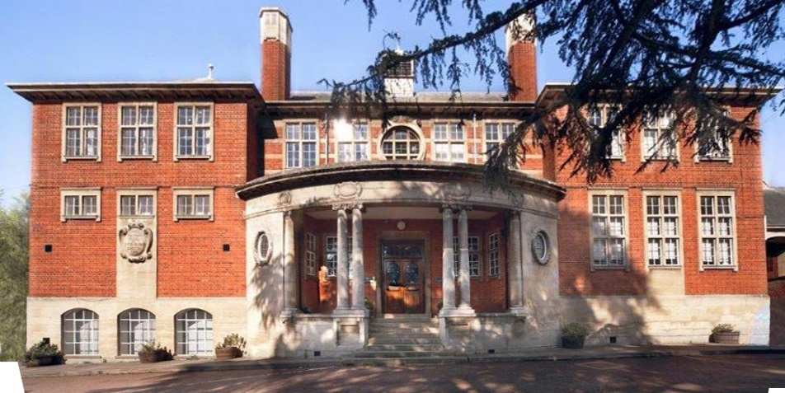

The Trust, as of September 2018, is a Trust of eight schools: five secondary, one all through academy and two primary academies. Restlessness characterises all our academies: we are not afraid to challenge complacency and weaknesses identified are seen as opportunities to improve, the energy and drive for the ceaseless journey comes from our key ambition: ‘Every child deserves an outstanding education.’
This movement as a Trust offers a huge opportunity for up to date training, cross curricular working, bespoke professional development pathways and allows all staff to be at the cutting edge of national and international educational movement. All staff are encouraged to better themselves and we collectively celebrate success in a vibrant and healthy working community.

2017 EXAM RESULTS
A Level Results 2017
A* - A = 24%
A* - B = 50%
A* - E = 98%

GCSE Results 2017
Progress 8 = -0.23
Attainment 8 = 46.6
English and Maths Grade 4 or above = 73%
English and Maths Grade 5 or above = 49%

LEADERSHIP TEAM AND GOVERNORS
Principal
Mr D Cleary

Senior Leadership Team
Mrs V McNair
Mr M Payne
Ms L Kirk
Miss K Nicholson

Associate SLT
Mr G Luhrs
Mr J Davies

Chair of Governors
Mr P Machon

Our Vision

Students who attend Robert Smyth Academy will benefit from an outstanding education which will enable them to live happy and fulfilling lives. We are committed to becoming a centre of excellence in the East Midlands and as we move to the next stage in this journey to outstanding, we are committed to the following principles:

- We put students at the centre of what we do

- We are a true comprehensive school, inclusive in the fullest sense

- We are committed to providing an environment that is academically special. We will maintain a climate where students learn, and teachers enjoy teaching and developing their practice

- We expect all members of our community to enjoy and to be excited by learning

- We are committed to securing student outcomes that consistently exceed national comparison

- We aim to develop a sense of enquiry in all

- We listen to all stakeholders

- We will ensure that all stakeholders are proud of their relationship with the Academy

We believe in success in its most broad and complex form for all students and we are committed to:

- Empowering students with knowledge

- Enabling students to attain excellent qualifications

- Stimulating students to make excellent progress in all areas

- Encouraging students to develop a sense of social responsibility

- Supporting students to become economically literate

- Inspiring students to find their passion for learning

- Equipping students with the confidence to take their next steps

Our Values

It is vitally important that all students understand three basic, daily expectations of their approach to Academy life. We believe that all students, irrespective of background require structure to achieve their best. These values apply in every facet of Academy life and they are as relevant to a new student in Year 12 as they are to a new student joining in Year 7. At the core of these three expectations is a belief that discipline equals freedom.

Be prepared
All students are expected to be immaculately dressed, on time and ready to learn every day. These routines apply like clockwork and allow students to make the most from the curriculum by being in a state of preparation. Every student is expected to demonstrate this mindset so that no time is wasted and they are able to learn and make exceptional progress across the curriculum. The expectation for students to be punctual, organised and well presented is a consistent feature of Academy life and there are no exceptions.

Be kind
All students are expected to be kind and show compassion toward one another. We embrace traditional values and expect students to say “Please” and “Thank you” as well as to hold doors for one another around the Academy site. We encourage students to express gratitude to their peers and other members of the community and to pick each other up when they face times of difficulty. We explicitly reinforce the importance of kindness and ensure that students know that how they treat others really matters.

Work hard
All students are expected to work hard. We encourage students to take responsibility for their performance and reject excuses or quick fixes. We believe that all students will exceed expectations through a commitment to discipline in their concentration, thought and work. We know that learning is a change to long term memory and that for learning to take place there must be focus, repetition, checking and retrieval. We expect all students to demonstrate a strong work ethic that will enable them to be empowered with significant advantages in knowledge acquisition.

OUR FACILITIES
Robert Smyth Academy was opened in 1607 as a single classroom school in the centre of the town. It then moved up to its current site in 1909. It occupies a site just outside the centre of the market town. The Academy is made up of a variety of buildings including specialist buildings for Sport, Music, and Art & Design.

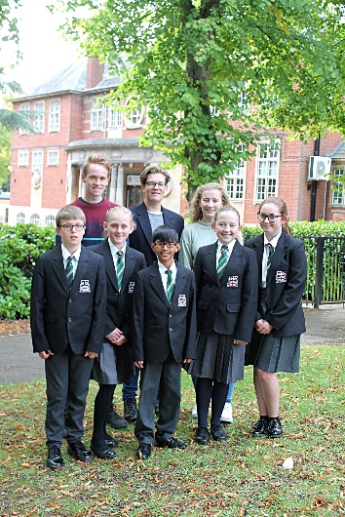
• Eight Science Laboratories
• Specialist building for Design & Technology and Art
• Specialist building for Music with rehearsal rooms
• Five ICT suites on the Windows platform
• Whole school network of over 200 PCs
• Media Studies suite
• Large Sports Centre with two Sports Halls and Changing Rooms
• Extensive sports fields surrounding the site
• Two cafeteria style dining areas with additional Food Bar in playground
• 6th Form Centre with 4 classrooms and study areas
• 6th Form only Café with study area
• 6th Form Quiet Study Area
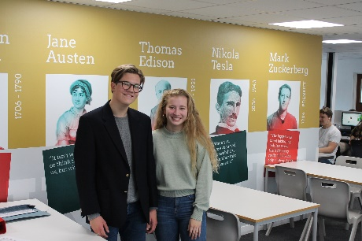
- 6th Form Wi-Fi

ACADEMIC ORGANISATION
At Robert Smyth we will be moving to a two week timetable in September 2018, with 25 one hour lessons in each week.
We have also introduced a split lunch system with Years 7 and 8 having an earlier lunch than the rest of the school.
There are no bells to signify when lessons begin and end which we feel makes for a more pleasant environment and helps prepare students for life after school which, in most cases, will not be controlled by bells.
The philosophy of Robert Smyth is that each student is entitled to a curriculum that prepares him or her for life’s opportunities, responsibilities and experiences. Statutory requirements of the national curriculum are supplemented by the Academy’s broader curricular provision.
At Key Stage Three, students follow a common curriculum. In Years 9, 10 and 11 students are offered greater choice, enabling a more personalised curriculum that meets the needs of each individual learner; for example those needing extra help can do an additional studies course instead of one of the mainstream option choices.
Key Stage Three
All students in their first two years at the Academy study the core curriculum which includes English, mathematics, science, physical education, citizenship and guidance and religious studies. Their curriculum is enriched by studies in humanities, art, three design subjects, performing arts, digital literacy and a modern foreign language.
During Year 8, full consultation takes place between staff, students and parents to support curriculum choices at key stage four.
Key Stage Four
The Key Stage Four curriculum is designed to give students every opportunity to achieve their full potential and to maximise the choices available at Post-16.
All students in Years 9, 10 and 11 study English language, English literature, mathematics, science, physical education and citizenship and guidance. In Year 9 students engage in discrete religious studies lessons while in Years 10 and 11, the subject is taught as part of the citizenship and guidance programme.
Students are encouraged to comply with the EBacc subject list, so most are expected to study geography or history and a modern foreign language. There is a considerable amount of curriculum choice available for their remaining two options.
Key Stage Five
The curriculum in the Sixth Form is designed to prepare students for both university and the world of work. Each Sixth Form student has their own specific goal and ambition and we ensure that each student has a personalised curriculum that meets their individual requirements. Students choose from a diverse range of subjects so that they are able to participate in challenging and enjoyable courses. Extra qualifications such as the Extended Project are also available.
We provide a variety of opportunities within the Academy, and are proud that our students have been able to succeed as peer mentors, sports coaches, volunteer care workers and much, much more.
PASTORAL ORGANISATION
Students are looked after in one of four Colleges; Bragg, Hammond, Logan and Moseley, each led by a College Leader
In addition, we have two College champions whose role is to celebrate any good work with students across their Colleges in any arena of school life or indeed achievements outside of the community. When a student starts at Tudor Grange they are placed in vertical tutor groups; for 2018-19 these will be Years 7-8; 9-11; with Year 12 and Year 13 separate.

EXTRA CURRICULAR ACTIVITIES
As an Academy we feel strongly that the development of team and interpersonal skills is enhanced by the opportunities and experiences students have outside of the classroom. Hence, we provide a diverse breadth of activities that are part of a weekly timetable for students to opt into. These activities run before, during or after school and are delivered by willing and specialist staff who want to relay their knowledge and passion.
The list below shows just a small selection of the programme on offer:
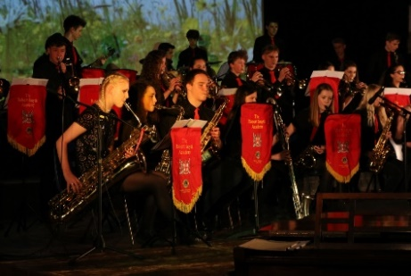
• Sports Teams including Football, Rugby, Netball, Hockey, Cricket, Basketball, Handball and Trampolining for both boys and girls
• Various Choirs
• Various Orchestras
• Drama
• Dance
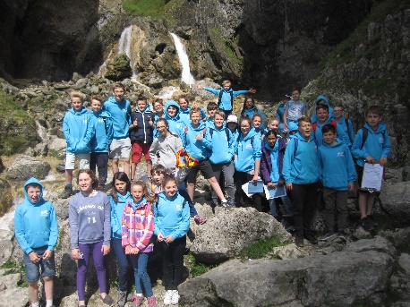
• STEM Club
• Chess Club
• Duke of Edinburgh
- Outlooks Expedition
