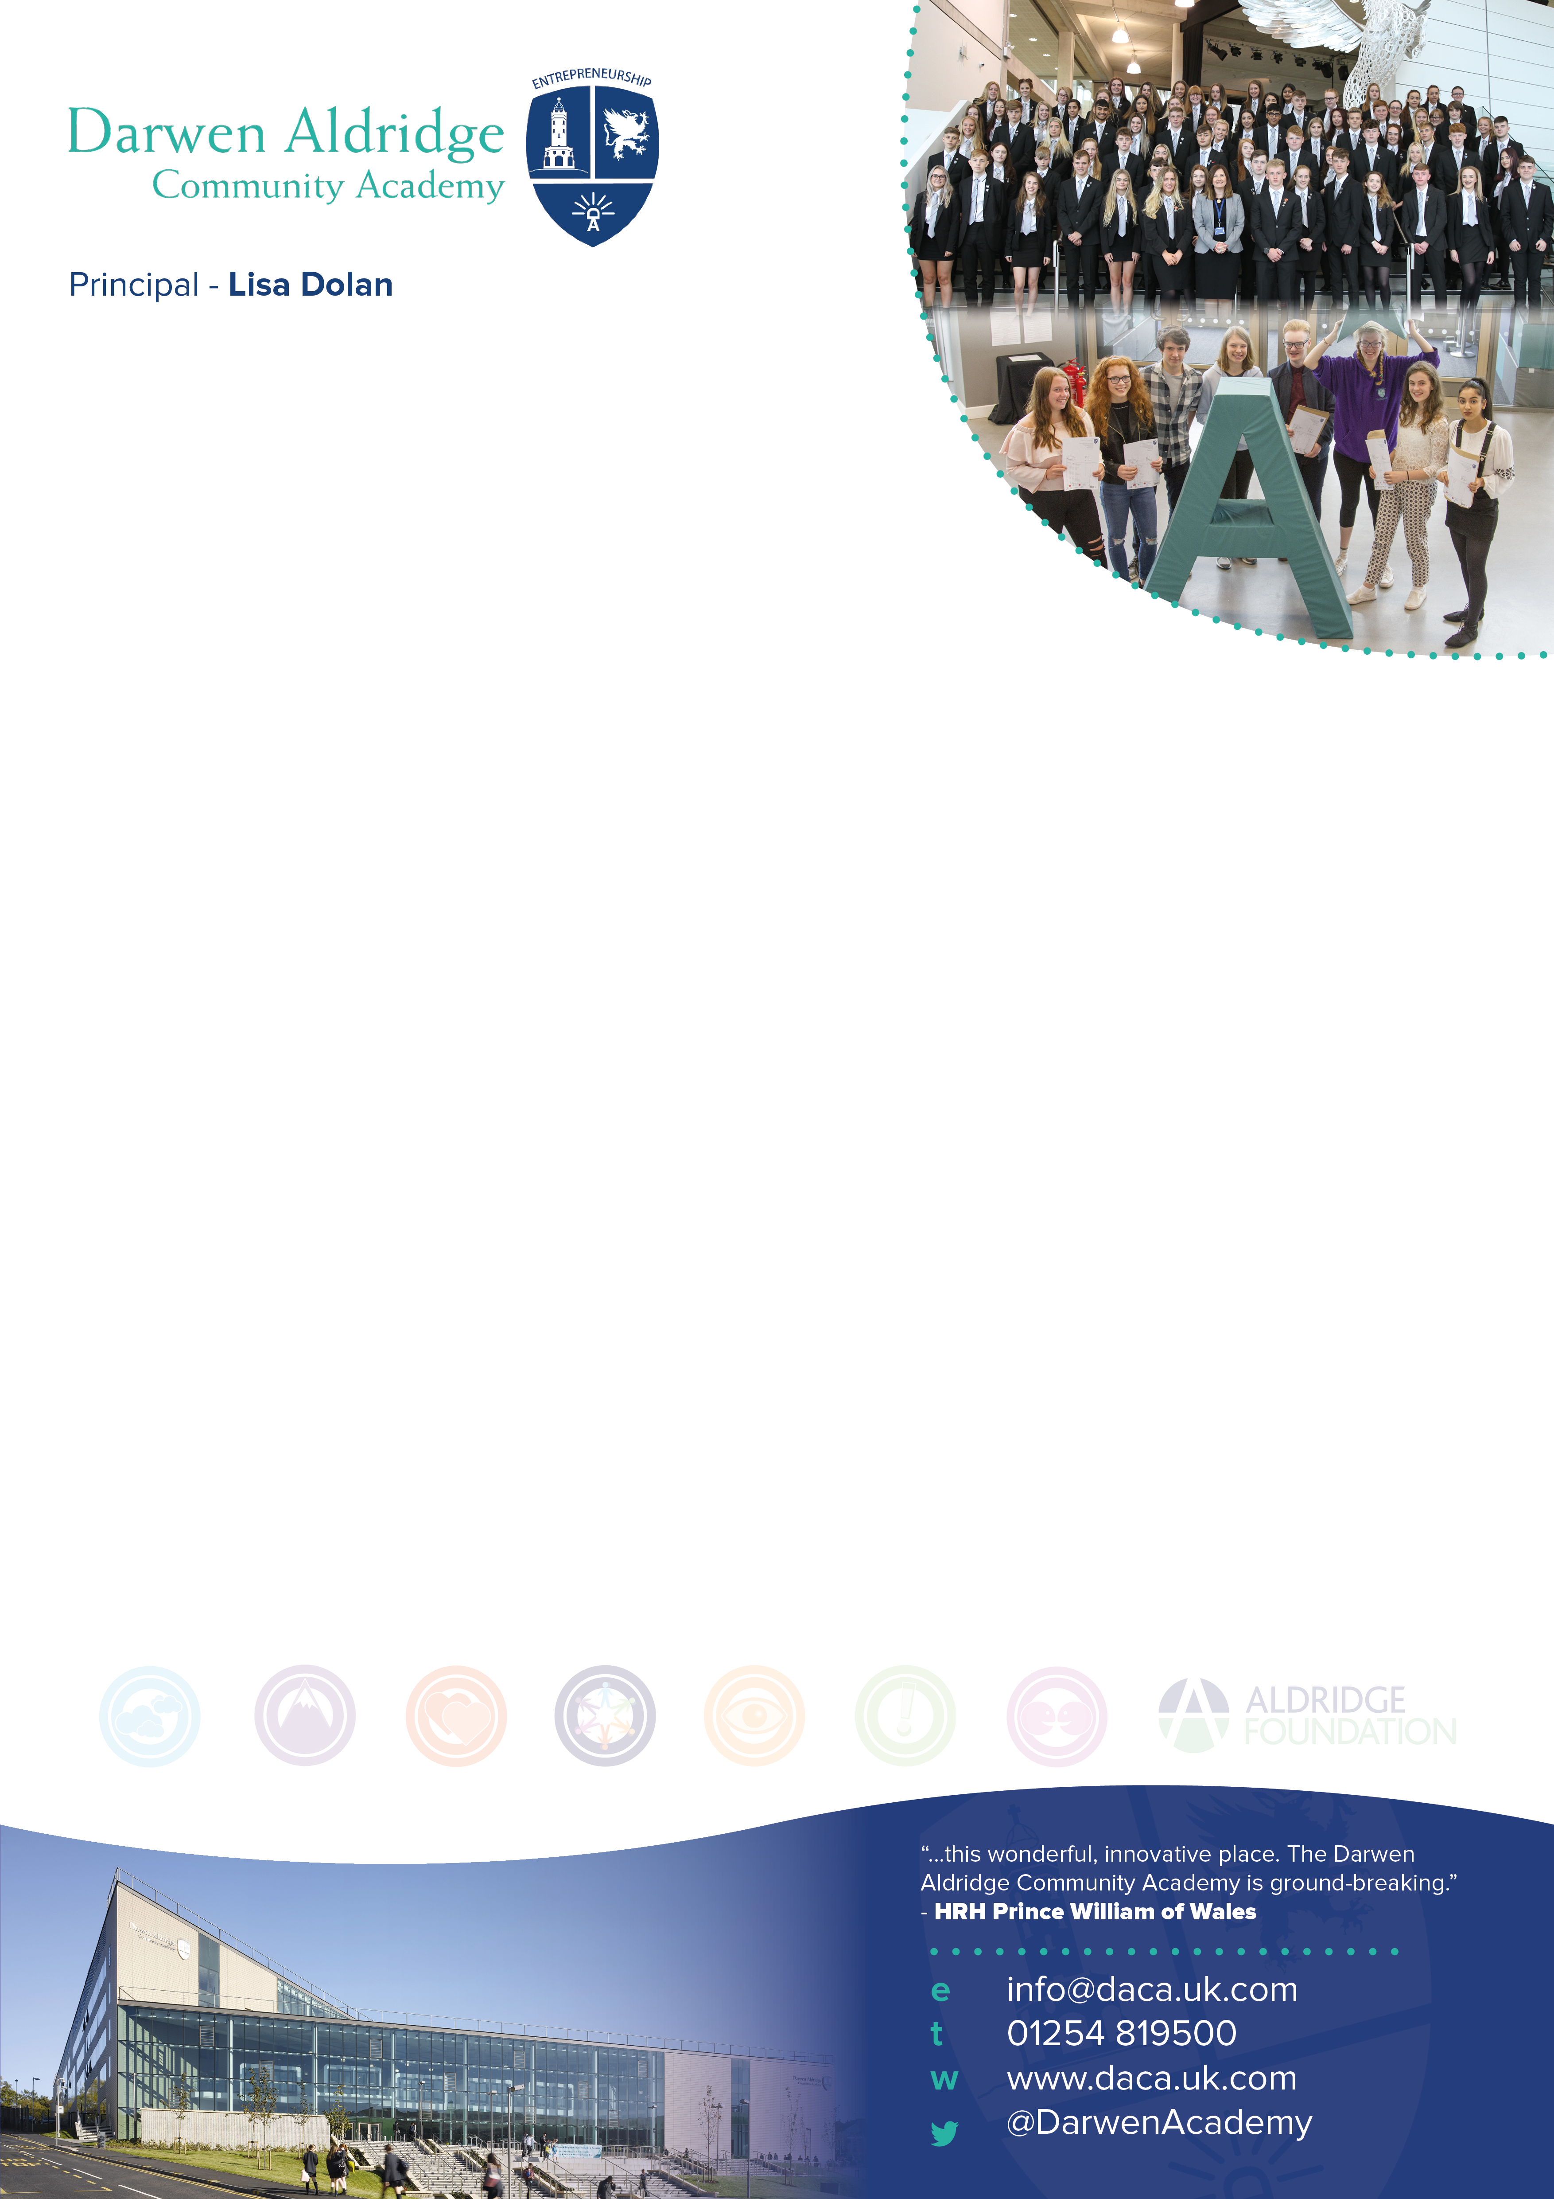

Teacher of Mathematics
MPS/UPS
Darwen Aldridge Community Academy is looking to appoint an excellent and enthusiastic Teacher of Mathematics.

We are looking for a dedicated practitioner who is passionate about their subject, and who recognises the value of collaboration, and believes that any child can achieve the highest grades regardless of background or prior attainment.

You will be joining a vibrant team who strive to produce improved results for all students across Key Stages 3 to 5. This is an opportunity to work within a team of experienced, supportive and enthusiastic colleagues at an exciting stage in our journey towards excellence.

OFSTED recognised the Academy as Good in May 2017 and inspectors noted our ‘highly positive and industrious culture’. We have excellent facilities and our sixth form is in the top 10% of all sixth forms nationally. Our vision and ethos is centred around the Aldridge Attributes of creativity, determination, risk taking, team work, passion and problem solving.

We are part of a cluster of schools in the North West, which includes Darwen Vale High School, Darwen Aldridge Enterprise Studio, Sudell Primary School and UTC Media City in Salford. We are part of the Aldridge Education MAT.

For further details and an application pack or to arrange an informal visit, please contact the Principal’s PA, Sam Grimshaw (sam.grimshaw@daca.uk.com) at the Academy.

Closing date: Friday 24th January 2020 at 12pm. Interviews will take place on Wednesday 29th January 2020.

Teacher of Mathematics
MPS/UPS

Information for applicants
Required 1st September 2020 or earlier

Darwen Aldridge Community Academy
Job description – Teacher of Mathematics

You are to carry out the professional duties of a school teacher as set out in the current School Teachers’ Pay and Conditions Document.

All colleagues are expected to demonstrate a wholehearted commitment to the development of the Faculty and a willingness to assist the Faculty Director of Learning in preparing for, and adapting to, the changing needs of the Faculty.

Your primary role as a Teacher of Mathematics is to assist in raising standards of Mathematics and numeracy.

You will model the entrepreneurial traits of having a determination to succeed and a positive attitude in all aspects of your work. You will endeavour to instil these attitudes in colleagues and students. You will be sincere in the belief that no barrier can prevent a student from achieving.

PURPOSE OF POST:
To teach a timetable of Mathematics at Key Stages 3 and 4, and where available Key Stage 5, across the ability range of the Academy, delivering agreed Schemes of Work, and to carry out the duties of a classroom teacher. You are accountable for the quality of teaching and learning within your classroom. Your understanding of what makes effective teaching in Mathematics and the sharing of that with other colleagues is a core part of this role.

Your role as Teacher of Mathematics is to:
- Plan high quality lessons and lead the delivery of consistently good and outstanding teaching and learning opportunities.
- Carry out day to day duties of a classroom teacher.
- Take responsibility for the teaching groups and form group assigned to you.
- Support the raising and maintaining of standards across the Mathematics Faculty.
- Liaise with partner schools, other stake-holders and the wider community where appropriate.
- Model effective behaviour for learning, and ensure that high standards of discipline and respect are evident throughout the faculty, supporting colleagues in line with Academy policies and practice.
- Play an active role in whole Academy management and monitoring of students behaviour by supporting Academy policies and practice.
- Take a lead in delivering at least one extra-curricular/enrichment session a week and promote staff and student involvement in a range of activities related to the priorities of the faculty and or Academy.
General Duties
- You will work in accordance with current health and safety requirements: Governing Body, DfE, and Government policies.
- You will abide by the Conditions of Employment set out in the relevant paragraphs of the School Teaches’ Pay and Conditions document in operation at the time when you are carrying out your duties.
- You will carry out any other duties relevant to your post designated by Senior Staff and Director of Learning.
- You will participate in induction and / or Teacher Appraisal arrangements.
- You will take an active part in the pastoral care and discipline of students within your classes and set appropriate sanctions as set out in Academy policies.
- You will carry out the role of Form Tutor, according to the Academy policy.
- You will carry out a share of supervisory duties in accordance with the duty rota schedules.

Relationships
You are responsible to the Director of Learning of Mathematics.

Additional Note
The above represents a broad outline of the duties and responsibilities currently attached to the post of Lead Practitioner of Mathematics. Depending on the needs of the Academy, these may be altered from time to time in accordance with the conditions set out in the currently operating School Teachers’ Pay and Conditions Document and the relevant Governors’ Policy Documents.

Darwen Aldridge Community Academy  Person Specification – Teacher of Mathematics | Essential | Desirable | Evidenced by
Experience | Relevant teaching experience 11-16 | Recent, relevant teaching experience either Key Stage 2 and 3, or 11-18  Recent experience of delivering consistently good and outstanding lessons  Recent experience as a form tutor | Application form  Interview
Qualifications | Qualified Teacher Status  Suitable qualification for the subject required | Higher degree or advanced qualification  A commitment to pursuing further qualifications | Application form
Professional Development | Evidence of responsibility for own professional development | Recent, relevant in-service training in current educational practice related to developments in Mathematics | Application form
Skills and abilities | Evidence of successful teaching which is consistently good or better  Excellent ICT and pedagogical skills  Excellent classroom management skills  Knowledge and use of a range of appropriate teaching and learning styles including strategies for differentiation  Enthusiastic and creative approaches to teaching and learning which maximise students’ abilities  Able to develop others’ capabilities and help them realise their full potential  Effective organisational skills and the ability to meet deadlines  Ability and willingness to work effectively in a team, planning co-operatively, sharing information, ideas and expertise  Proven ability to transfer enthusiasm and understanding of maths to students | Proven ability to inspire and motivate young people to achieve high standards  The ability to create and maintain a teaching environment which promotes effective learning and strives for achievement and excellence  Ability and willingness to initiate and participate in both cross curricular and extra-curricular activities, as well as  demonstrating successful involvement in all aspects of  Academy life  Evidence of excellent student achievement  A broad knowledge of relevant curriculum areas and current  national initiatives including a sound understanding of assessment and monitoring | Application form  Interview  References  Lesson  observation
Other | Commitment to the safeguarding and welfare of students  Commitment to the aims and values of the Academy  Commitment to academic excellence and high standards  Presentational skills, confidence and fluency to deal with students, parents and others  Awareness, understanding and commitment to inclusion and equal opportunities  An understanding of the needs of young people  Capacity to work hard with all students  Energetic, positive and cheerful attitude  Is a strong role model for staff and students including having excellent attendance and punctuality | Ability to contribute to the Academy specialism of Entrepreneurship  A good sense of humour, able to work under pressure and the ability to keep things in perspective | Interview  Lesson observation

