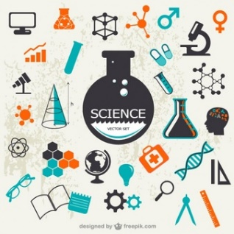
Science Department

Our Community:
The Science department is a large team consisting of 21 Biologists, Chemists and Physicists with 6 Science technicians supporting behind the scenes. The 21 teachers bring a variety of expertise to the Science curriculum and the classroom; BSc Hons Nutrition and Food Science, BSc. (Hons) Chemistry, Physics with Planetary and Space Physics (MPhys), BSc (Hons) Environmental Biology & MSc Environmental Assessment and Forensic Science (MSc) to mention but a few of the degrees that are used to ensure the teaching is relevant and interesting.

The Curriculum:
The Science department delivers a number of courses. Firstly, learners will engage with KS3 (or are we using GCSE Foundation (everyone should use the same)) Science which is designed to build on KS2, engage learners with the breadth and depth that is Biology, Chemistry and Physics and introduce of ‘How Science Works’. At year 9 learners will start their GCSE’s. At GCSE, we follow the AQA syllabus with 2 possible routes; Triple Science, also referred to as Separate Sciences, resulting in three GCSE’s in Biology, Chemistry and Physics or Trilogy Science (sometimes referred to as Double Science (where all three Sciences contribute to a two grade GCSE).

In Sixth form, we offer a further four courses; A Level Biology, A Level Chemistry and A Level Physics, all following the AQA exam board. We also offer BTEC Applied Science, a vocational course that offers an alternative route into Science based careers and University.

Resources and Facilities Available:
Here at Poole High School the Science department are incredibly lucky in that we are very well resourced. We have 15 fully equipped Science laboratories which are managed by our team of qualified Science technicians. We have a wealth of equipment allowing us to prepare a series of engaging and exciting activities which support the learning in class.

We make great use of the school grounds and the stunning Dorset landmarks in our fieldwork investigations; we have increasingly worked with Southampton University and other educational institutions to promote Science education.

Results and Achievements:
In summer 2018, we had some excellent results with Trilogy (Double) Science attaining 0.54 positive progress demonstrating progress above that of similar centres. Separate Sciences also demonstrated positive progress with Physics 0.54, Chemistry 0.35 and Biology 0.08. At A Level, we have seen similar success with Chemistry ALPS 3 Physics ALPS 6 and Biology ALPS 8. We are incredibly proud of all the hard work and effort that went into securing these results by the team.

Team Activities, Teamwork and Planning:
We are a friendly department with a wealth of talent and knowledge. We are working hard to develop an atmosphere with a relentless focus on teaching and learning to ensure the quality of teaching is excellent in the classroom. Within the department, we have teachers actively involved with research, reading research, working to become lead practitioners or attending course with SSAT, Royal Society of Chemistry, Institute of Physics, South Coast Learning centres and PiXL.

Training Support:
Every Wednesday morning, we have a team meeting with the sole focus of sharing good practice and when not working on the curriculum department meetings are built around coaching (a process by which teacher reflect and ask meaningful questions to promote a deeper thinking about lessons that have taught or yet to be taught).
Other exciting things that happen:
Without a doubt, the Science department is the most exciting department to be a part of as either a learner or a teacher. We are constantly working to improve anything and everything and always seeking opportunities to make Science exciting.

