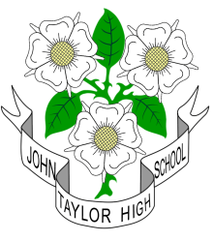
 JOHN TAYLOR HIGH SCHOOL
Dunstall Road, Barton under Needwood,
Burton upon Trent, Staffordshire DE13 8AZ

is a mixed 11-18 comprehensive with over 1500 students on roll
including nearly 400 post 16

“Outstanding”
(OFSTED 2014)

Personal Assistant to the Head of School and Governors and HR Support
to commence in post as soon as possible

You will be required to work 37 hours per week
(term-time only plus one week)

Payable on Grade 8 (SCP 28-33)
Pro-rata salary range: £22,134 – £25,999

For further details and an application form please visit:-
JTHS website: www.jths.co.uk
Please return completed form to recruitment@jths.co.uk

Closing date : 9am Wednesday 29th November 2017
Interviews will be held on : Tuesday 5th December 2017

The school is committed to safeguarding and promoting the welfare of children and young people/vulnerable adults and expect all staff and volunteers to share this commitment.

An enhanced disclosure check will be a requirement of the post.

