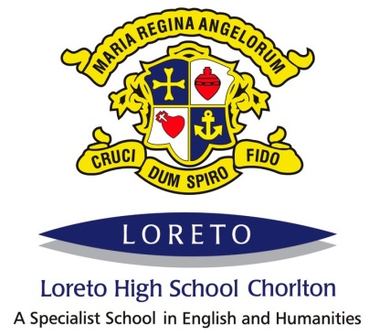
Loreto High School
Job Description
Admininstration Officer – General, Grade 3
The post holder will report to the Office Manager. Apart from other colleagues in the school, the main contacts of the job are the head teacher, teaching and other support staff, pupils parents.
Main Purpose of the job
To provide a comprehensive administrative and financial support to the school
To work collaboratively with all staff and parents in order to support pupil well being and to promote the five outcomes of Every Child Matters
Organisation
- To receive visitors to the school and to communicate with courtesy and clarity to all staff, pupils, parents, carers, visitors, outside agencies and the wider community, including answering general telephone and face to face enquiries.
- To assist with pupil first aid and welfare duties, including looking after sick pupils and liasing with parents and staff etc
- To undertake routine clerical and administrative support duties on behalf of individual members of staff, Sections / Departments or Faculties, in relation to the organisation of school activities.
Administration
- To provide general clerical and administrative support, for example, photocopying, filing, faxing, completing standard forms and returns to the LA and outside agencies and responding to routine correspondence
- To maintain and update all administrative and information systems and processes as required, including retrieving and collating information to ensure deliver of a high level administrative service
- To produce lists, information and data as required, for example, pupils data and to maintain and collate pupil reports
- To assist with school administrative duties relating to examination invigilation where appropriate.
- Arrange meetings and events and take notes at meetings to a high standard
- To collect and distribute incoming mail, despatch outgoing mail as appropriate
- To undertake routine administration of school lettings and other uses of school premises
- To maintain display boards and to ensure these are refreshed regularly
- To administer school registration procedures in line with statutory requirements
Resources
- To operate relevant equipment and ICT packages (for example word, excel, databases, email, internet)
- To maintain records of stationery supplies and stock, cataloguing and distributing and order stock and equipment as required
- To operate uniform, snack and other ‘shops’ within the school
- To provide general advice and guidance to staff, pupils and others
Responsibilities
- Use initiative in time management to organise own workload in order to meet deadlines
- To provide cover for other administrative colleagues when required
- To be aware of and comply with policies and procedures relating to child protection, health and safety, security, confidentiality and data protection, reporting all concerns to an appropriate person as soon as they arise
- To be aware of and support difference and to ensure equal opportunities for all
- To contribute to the overall ethos, work and aims of the school
- To attend and participate in relevant meetings as required
- Help to identify own personal development needs and to participate in training and other learning activities and performance development as required

Where the postholder is disabled, every effort will be made to supply all necessary aids, adaptations or equipment to allow them to carry out all the duties of the job. If, however, a certain task proves unachievable, job redesign will be fully considered.

Loreto High School
Person Specification
Admin Officer - General
Experience
- Experience of general clerical, administrative and financial work
Qualifications/Training
- Possess good numeracy and literacy skills
Knowledge/Skills
- Ability to manage own workload effectively
- Willingness to undergo first aid training
- Ability to produce accurate written minutes /notes of meetings
- Knowledge and experience of information technology and ability to use ICT packages, including spreadsheets, data bases and word processing
- Possess good keyboard skills in order to produce high quality documents
- Accuracy and precision when preparing, maintaining and monitoring financial records and dealing with cash
- Have a knowledge and awareness of the regulatory framework around education and schools
- Ability to relate well to children and adults
- Be able to work constructively as part of a team, understanding school roles and responsibilities and your own position within these
- Ability to identify your own training and development needs and cooperate with the means to address these needs

Personal Style and Behaviour
Tact and diplomacy in all interpersonal relationships with the public, pupils and colleagues at work.
Self motivation and personal drive to complete tasks to the required timescales and quality standards.
The flexibility to adapt to changing workloads demands and new school challenges.
Personal commitment to ensure that services are equally accessible and appropriate to meet the diverse needs of the service users.
Personal commitment to continuous self-development.
Personal commitment to continuous school improvement.
Personal commitment to the school’s professional standards, including dress code as appropriate.
The school is committed to safeguarding and promoting the welfare of young people and expects all staff and volunteers to share this commitment. Successful candidates will be required to undertake an enhanced DBS check and first aid training.

