KENT COLLEGE

______________________________________________________
INDEPENDENT DAY AND BOARDING SCHOOL FOR GIRLS 3-18

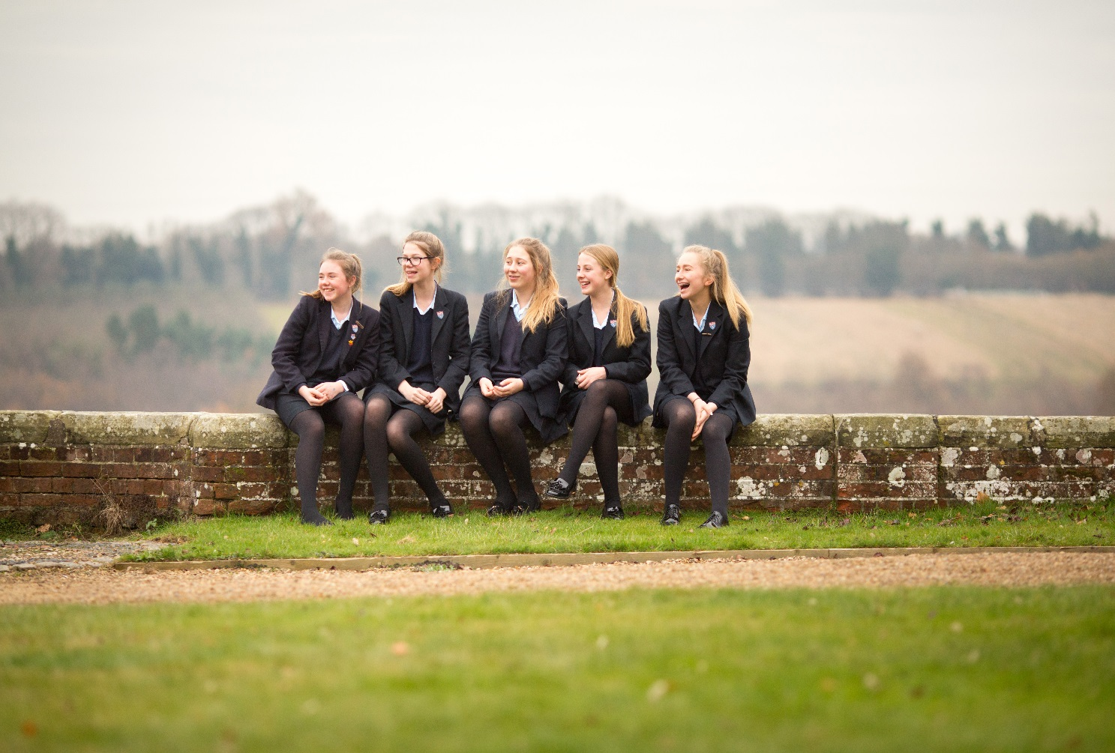

KENT COLLEGE PEMBURY

Biology Teacher
Part time 0.6
January 2018

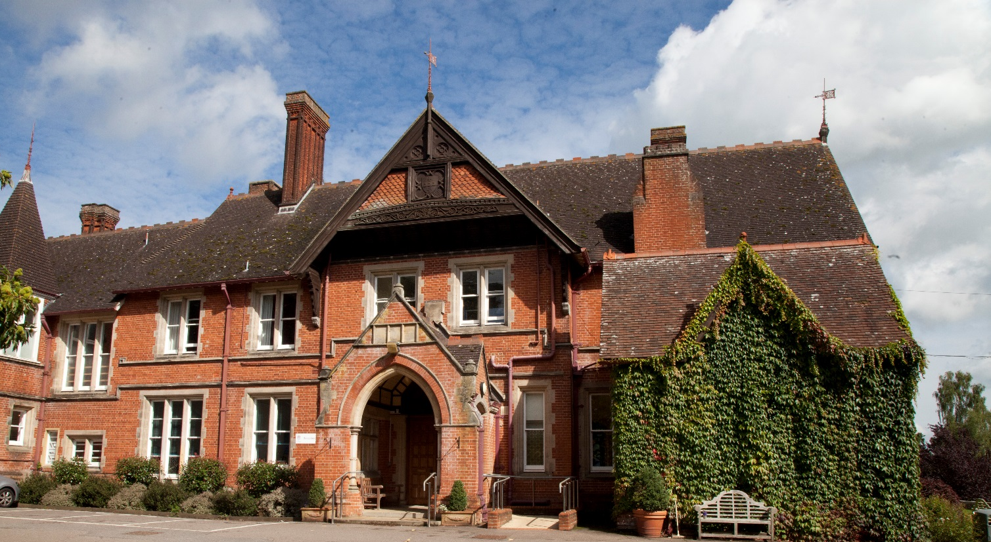

Background
Founded in Folkestone in 1886, Kent College is an independent day and boarding school for girls, with a Senior School (ages 11-18) and Preparatory School (ages 3-11) sharing the same site, facilities and some specialist staff. The school is one of a group of ten schools under the control of the Methodist Independent Schools Trust. The school has a resident Chaplain who leads the Christian worship in the school.

Since 1939, Kent College has been located on 75 acres of beautiful countryside in Pembury, near Tunbridge Wells. The school campus comprises an elegant Victorian manor house and purpose-built modern facilities, including boarding houses, a music centre, science building, sports hall, A level study centre, and an indoor, heated swimming pool. The school is committed to a continuous programme of development and the resources are excellent. IT provision is first-rate, including the number of interactive white boards, laptops and data projectors. In 2008 a new science wing was opened, providing inspirational science laboratories, and recent boarding refurbishment includes an extension of ICT facilities to individual study areas. The Countess of Wessex Theatre reopened in 2012 following extensive refurbishment and an iconic Library and Arts Centre opened in spring 2013. Our additional Sports Hall is now complete and was opened in October 2015.

The Senior School
The current roll in the Senior School is approximately 450 and attracts girls from all over the world. Entry at eleven and thirteen is by the school’s own entrance test and the school accepts quite a wide range of academic ability, with approximately half of our KS3 intake within the top 25% of the national ability range. Kent College offers a choice of 25 GCSE subjects, with group sizes usually between three and eighteen. Top students will be aiming for ten A and A* grades at GCSE, less academic students may take eight GCSE subjects. In summer 2015, 97% of GCSE grades awarded were A*-C and the school’s value added was around 8 grades for each girl’s set of results, based on predictions at KS3 baseline data. Excellence was seen in core subjects such as English, Modern Foreign Languages and Science, with 95% all English grades awarded A* - B. The school is in a highly competitive area with girls’ grammar schools, strong comprehensives and many independent schools locally.

Students are also accepted for entry at 16+ and there are approximately 125 girls studying for A-level courses. At A-level there were 92% A*-C grades and 50% A*-A Grades. The 26 subjects are mostly of the more traditional type with class sizes at 16+ normally ranging between three and 12. Scholarships to the Senior School are offered at 11+, 13+, 16+ and means-tested bursaries are available.

Extra-curricular Activities (ECAs)
Kent College places a strong emphasis on extra-curricular activities and has a flexible and innovative lunchtime and evening programme of prep and activity sessions. Boarders can choose when they do their prep and day girls choose whether to do homework at home or at school. All girls participate in extra-curricular activities and are encouraged to plan the use of their time so that they follow a balanced programme of academic work and extra-curricular activities. The pastoral care in the school is very strong and all staff are highly involved in PSHCE and general pastoral matters. All teaching staff are required to be involved in at least one ECA and most do more than this, as both subject and general ECA are available.

Inspection
The school underwent a full integrated inspection by the Independent Schools Inspectorate in December 2015 and was found to be excellent in all areas. The report together with other information about Kent College can be found on our website at www.kent-college.co.uk

Benefits
Kent College Pembury employs over 200 people in both academic and support staff positions. Highly skilled, dedicated and passionate staff are the driving force behind our ‘Excellent’ school.

We are delighted to welcome applications from candidates who share our core values and who are able to contribute to our continued future success. We recruit staff of the highest calibre who will inspire, support and challenge the girls, and fellow colleagues, to achieve their full potential. Whatever your role, you will benefit from a being part of a large staff community with opportunities for professional development.

We believe in rewarding our staff and offer a complete range of employee benefits including:

- Reduced school fees
- Childcare voucher scheme
- Free meals during working hours
- Free eye tests
- Subsidised Flu Vaccinations
- Free onsite parking
- On-going training and development
- Use swimming pool and fitness suite (at allocated times)

Impressive new science laboratories were opened in September 2008 to provide the facilities science needs and deserves for the 21st century. A modern entrance foyer leads into the new Darbyshire Wing, which comprises three new laboratories (two general purpose and one Sixth Form), upgraded storage and preparation areas, and a new staff work room. The existing laboratories have been upgraded, one as a computer suite with 20 networked pcs and an interactive whiteboard.
Science is a thriving department with a good academic record with well-qualified and dedicated staff who work closely together. Three excellent technicians ably support them.

Students are taught in purpose-built science accommodation, with specialist laboratories for physics, chemistry and biology. The latest apparatus is used and maintained to a high standard, and the department has ICT facilities with internet access via the school network.

Academic standards are very high; GCSE, AS and ‘A’ level results are good and a larger percentage of girls stay on to study Physics and Chemistry ‘A’ levels than do nationally. Normally we have one Physics, two Biology and two Chemistry sets at both AS and A2 level. Most years see one or two science students being offered Oxbridge or medicine places and a number of others follow science related courses.

In Years 7 and 8 girls follow a general science course, based on the National Curriculum. The sciences are taught separately from Year 8. Currently all girls follow the double or triple award Edexcel IGCSE at GCSE. At ‘A’ level students follow the OCR ‘A’ courses.

Many of our international boarders include at least one science in their ‘A’ level choices, and they require sympathetic teaching as English can be a problem at first.

IT provision in the department is strong; in addition to the computer suite all the main labs are equipped with a networked PC connected to a digital projector and the new labs are equipped with interactive white boards. The department makes some use of datalogging.

The Post
We are seeking an enthusiastic and well-qualified teacher to cover maternity leave. Applicants need to be confident in teaching Biology to A-level. The ability to teach a second subject, especially Chemistry, would be an advantage. Inspirational science laboratories providing excellent resources

Salary
Kent College’s salary structure is based on the national Teachers’ Pay Scale according to experience, albeit with enhancement, together with the school’s own management and responsibility points. Kent College also offers the staff the opportunity of moving to the upper pay range of teachers’ pay, including progression from U1 to U2, on KC criteria; existing threshold achievement to U2 will be honoured. The postholder will be eligible to join the Teachers’ Pension Scheme operated by the Teachers' Pensions Agency

Application process
The completed application form, including the names and addresses of two referees, cv and a letter of application should be sent to Headmistress, Ms Julie Lodrick, Kent College, Old Church Road, Pembury, Tunbridge Wells, Kent TN2 4AX by letter, fax (01892 820232) or email (hr@kentcollege.kent.sch.uk)

Closing date: Friday 29 September 2017 by Midday

References will be taken up prior to interview. One of the referees should normally be the applicant’s current or most recent employer. The post requires the highest level of clearance through the Disclosure and Barring Service (DBS).

Kent College is committed to safeguarding and promoting the welfare of children. Appointees must be prepared to undergo child protection screening Child Protection and welfare are taken very seriously at Kent College, with guidelines on confidentiality and staff-pupil relationship procedures well-publicised to staff.

All gaps of employment are to be accounted for and rigorously investigated. Referees are contacted to ensure the validity of the reference. Testimonials are not acceptable in place of confidential references.

