HEADTEACHER – SIR ROGER MANWOOD’S SCHOOL

Sir Roger Manwood’s School offers a dynamic and welcoming environment for both staff and students, fostering a culture where everyone is highly valued. We take pride in our bright, capable students who are eager to learn, enabling our dedicated teachers to deliver exceptional education in their subjects.
Our school vision, encapsulated in the motto "Engage…Explore…Excel…", reflects our commitment to both personal growth and academic excellence. We encourage you to explore our school website to discover the diverse array of activities we offer, ranging from our weekly Combined Cadet Force and adventurous weekend training to our challenging Duke of Edinburgh’s Award programme. Additionally, our vibrant arts scene includes regular drama productions, music concerts and sports fixtures, complemented by numerous extra-curricular clubs and societies led by our staff. Furthermore, Sir Roger Manwood’s School organises numerous overseas trips annually, providing invaluable cultural experiences for our students, from Year 7 going to Boulogne for a day and Year 11 visiting Berlin in December annually, through to Sixth Formers visiting our twinned schools in India and The Gambia each Easter.
Nestled in the picturesque setting of Kent, our school is conveniently located near the delightful medieval centre of Sandwich, close to both coast and rolling countryside. The area boasts world-renowned championship golf courses, providing recreational opportunities amidst stunning landscapes along the idyllic East Kent coast. Convenient access to the channel crossings at Dover and Folkestone, as well as excellent transportation links to London via high-speed rail and major roadways, ensures ease of travel. Local house prices and rents are considerably lower than those in London and the other Home Counties.
We take pride in our inclusive, friendly, and welcoming community, prioritising the holistic development of every individual alongside academic progress. If you are passionate about education and seeking a fulfilling career in a supportive environment, we invite you to join us to shape the future of Sir Roger Manwood’s School.

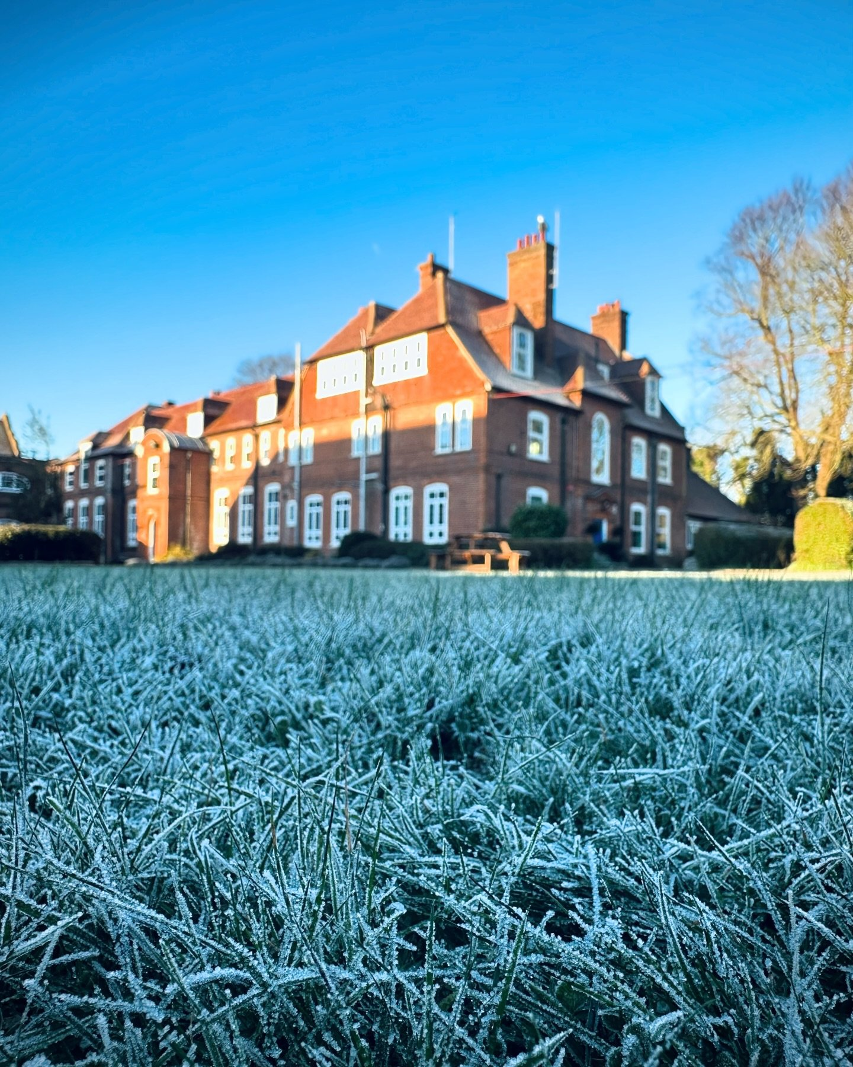

A Message from the Chair of Governors
I am delighted to welcome you to apply to become the next Headteacher at Sir Roger Manwood’s School. As one of the oldest schools in Kent, we are proud of the school and of its long history, and this year sees many exciting developments and projects that will allow our school’s evolution to continue, to keep up with our changing times.
With a focus on academic excellence and a broad extra-curricular offering, we aim to prepare our students for wherever life may take them beyond school.
Our current, exceptional Head is retiring at the end of this calendar year and the Governors wish to appoint a dynamic and inspirational Head to take up the role in January 2025. We are looking for a strong leader, communicator and educationalist who can engage the various members of the school community and provide Manwood’s with visible leadership.
Please look at our website or come for a tour of our extensive grounds and buildings and meet the staff and students; we are sure you will want to join our community - we look forward to meeting you.
Richard Chew, Chair of Governing Body


A Message from the Headteacher

Dear potential applicant
I moved from South West London when I accepted the offer of the Headship here at Sir Roger Manwood’s School back in 2013 and I have not regretted it for a minute. This is one of the friendliest schools I have worked in – due, I think, in great part to the fact that as a mixed school, brothers and sisters attend together; and often with their cousins! We even find that several generations of local families have been educated here at SRMS which is a real testament to the regard that SRMS is held in.
The school is ever-evolving. Computer Science, Economics and Sociology have been added to the Sixth Form curriculum, while subjects like Business and Psychology have exploded in popularity in recent years. Major developments and refurbishment of the fabric of the school have also taken place.
You would be joining the School at a very exciting time – a brand new, full size multi-games area is due to open this Easter, which will give us an exciting new sports resource, as well as a valuable revenue generator. In addition, a major fundraising drive for £500,000 is underway to enable the refurbishment of an ex boarding house into a building that contains a state of the art Sixth Form Centre, staff offices and seven 32-seat classrooms. As well as the fundraising effort, this project has been enabled by a Funding Agreement with Kent County Council for £2.2 million of Section 106 money, of which approximately £1.1 million is yet to be collected and passed on to us, and the sale of ex boarding assets.
If you are someone who loves the idea of leading a school that seeks to give young people opportunities they will remember for a lifetime, whilst at the same time pushing them to achieve their best academically; if you like the idea of working with a very supportive Governing Body; if you are excited by the idea of leading major improvement works; if you enjoy listening and interacting with alumni and members of the local community, and love the idea of living in a rural area close to the coast which is close to France and only an hour from St Pancras… then SRMS is the school for you!
Lee Hunter MA (Cantab)
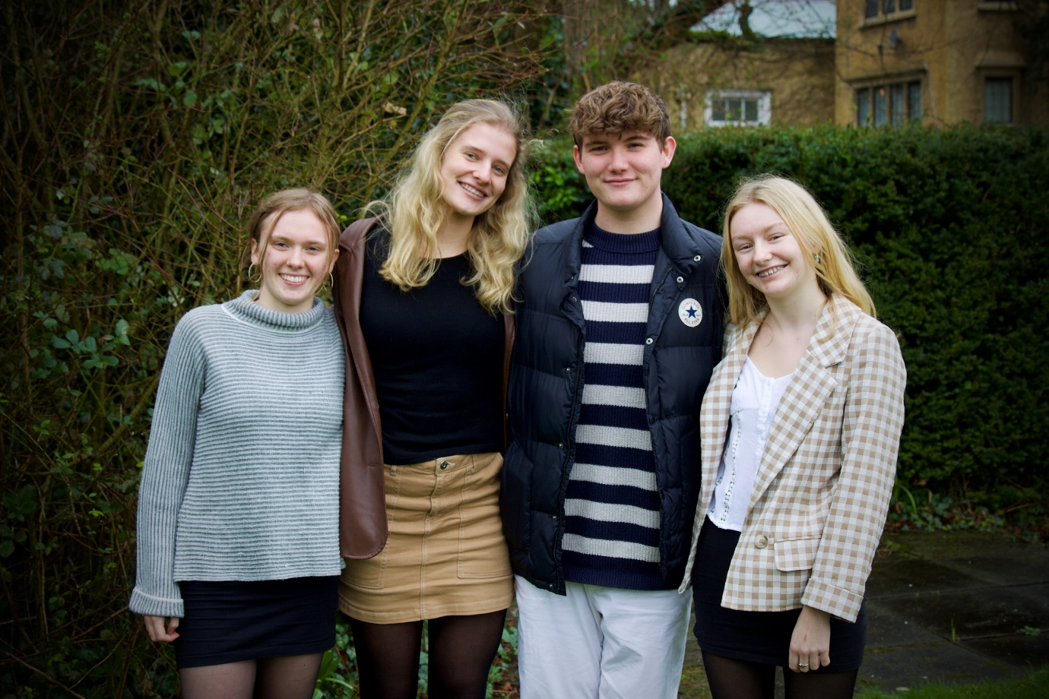

A Message from the School Captains
As School Captains, we have been able to deeply better our understanding of our school. The connections that this school provides between staff and students is outstanding, especially with the captains. The staff at our school can be viewed as a means of support both inside and outside the classroom. This creates the sense of community that we have at Sir Roger Manwood’s.
In our time here, we have enjoyed the extensive range of subjects to which the teachers bring great passion and expertise - from Sports to Science, and Music to Humanities, there is always something to keep us engaged. The beautiful grounds of the school stimulate our learning; the greenery and large fields provide the opportunity to play team sports and be constantly surrounded by a luscious environment. Furthermore, modernisation of the grounds, which is currently in progress – for example, the new astro-turf that is under construction – is a great way of building a contemporary community, whilst remaining true to the values of the school.
We are so excited to see what a new Headteacher has to offer here at Manwood’s.
School Captains 2023-24
(Gracie, Paige, Morgan, and Phoebe)

For further information about our school, please visit Sir Roger Manwood's School website.

How to Apply
- Complete the school application form available on the school website, ensuring that all questions are answered. Please note CVs and other forms are not acceptable.
- Write a letter supporting your application (maximum two sides of A4). In your letter you should:
- State your reasons for applying for this post.
- Outline the experiences that you believe have prepared you for this post.
- Describe the skills and strengths that you will bring to the school, paying particular attention to the Person Specification.
- Your completed application should be returned to Mrs Kellie Robinson, Headteacher’s PA, at Head@srms.kent.sch.uk marked for the attention of Mr Richard Chew, Chair of Governors. The application should be received in school by noon on 25th March 2024. Applications will be acknowledged on receipt.
The schedule is as follows:
- Shortlisting – 26th March
- Interviews – 29th and 30th April
For more information or to arrange a visit or an informal call with the Head or Chair of the Governing Body, please contact Head@srms.kent.sch.uk
The school values diversity and is committed to equality of opportunity. We are happy to discuss any reasonable adjustments that individuals may require during the recruitment process or once in post.

Person Specification:
The successful candidate will demonstrate the following range of qualities as outlined below:
- Educated to degree level with a teaching qualification; additional higher, postgraduate or leadership/business qualifications are an advantage.
- Focussed on academic excellence. Holds teaching staff to account for their performance and identifies areas for academic improvement.
- A proven track record of successful senior leadership with experience of school improvement and raising teaching standards.
- Embraces the school ethos and values and provides strategic direction for the school’s future.
- A thorough understanding of the issues, and commitment to the processes and legislation, regarding child protection and safeguarding in an educational context.
- Maintains knowledge of educational developments. Adheres to education policies at school, local and national level. An understanding of the functioning of academy trusts.
- Leads staff in developing a supportive learning environment and positive behaviour management.
- Astute financial acumen with a strong sense of budgetary prioritisation and allocation of resources. The ability to drive our capital projects to completion.
- Change management: initiate changes for the benefit of the school, carry them through with sensitivity, ensuring support and adoption from all stakeholders.
- Committed to supporting art, music, drama, sport and our other extra-curricular activities.
Personal Qualities:
- An engaging self-motivated individual who will integrate into the Manwood’s community; be a visible leader who will engage with pupils, staff, parents, alumni, and governors.
- Demonstrate proven senior leadership, support of and delegation to staff, ensuring high levels of performance and accountability.
- Have an ability to make difficult decisions and communicate the rationale for them with empathy; be held accountable to the decisions.
- Demonstrate tact, openness, and sensitivity.
- Be able to prioritise tasks under pressure in a busy environment.
- Capacity for effective, timely communication with students, parents and other stakeholders, and the ability to build positive relationships with staff, students, parents, governors, and the wider community.
- Show a clear sense of financial judgement and know when to seek advice from fellow professionals.
- Dedicated to equality and creating a diverse community for all members of the school.
- Act as an ambassador; sustain links with local feeder primary schools and network with local secondary schools.
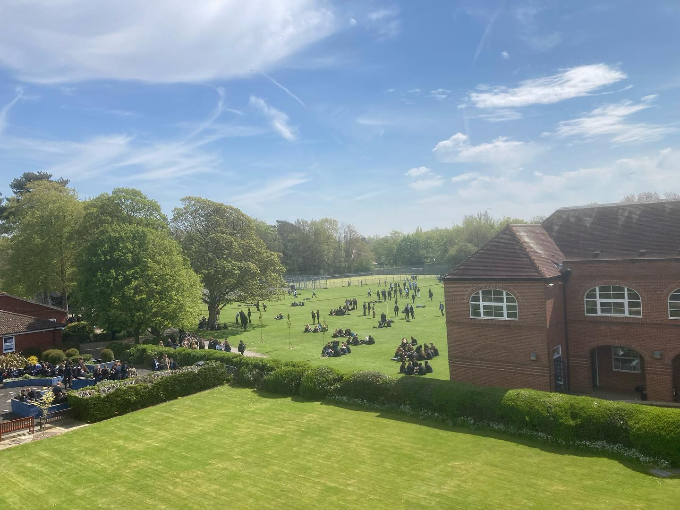
Sir Roger Manwood’s School is committed to safeguarding and promoting the welfare of children and young people and expects all staff to share this commitment. Due to its Safer Recruitment Policy, the School will take up references before interview.

