All Saints Catholic College
Bradley Bar, Huddersfield, HD2 2JT
Website: www.aschc.com
email: office@aschc.com

Principal: Ms K Colligan

LAY CHAPLAIN

DECEMBER 2018

Grade 7 (24 hours per week term time + 1 day only) £11,960 pa

Section 48 Inspection (May 2018) ‘This is an Outstanding School ‘
‘Pupils like and value their school where pupils from different cultures and religions are able to be part of this Catholic community, living daily together as one happy community.’

INTRODUCTION
The school has been designated by the Secretary of State as a school with a religious character. Its Instrument of Government states that it is part of the Catholic Church and is to be conducted as a Catholic school in accordance with Canon Law, the teachings of the Roman Catholic Church and the Trust Deed of the Diocese of Leeds. At all times the school is to serve as a witness to the Catholic Faith in Our Lord Jesus Christ. The post therefore requires a practising Catholic who can show by example and from experience that he or she will ensure that the school is distinctively Catholic in all its aspects.
This appointment is with the governors of the school under the terms of the Catholic Education Service contract signed with the governors as employers and should be endorsed by the Bishop or his representative. It is subject to the current conditions of service for support staff and other current education and employment legislation.
The governing body and the Diocese acknowledge the importance of the role of the chaplain and will actively offer long term support, encouragement, affirmation and realistic challenge to the successful candidate.

LETTER FROM THE PRINCIPAL
Dear Applicant
Thank you for your interest in the post of Lay Chaplain.
This is a perfect time to join our college; we are a “Good” school as identified by Ofsted (June 2017) and “Outstanding” in terms of our recent S48 inspection by the Diocese of Leeds (June 2018).
We are a cohesive community, outward-facing and are keen to continue to develop and deepen our relationship with our families, our partner primaries as well as our local parishes.

All Saints is a popular school, enjoying State of the Art facilities and a population rich in its diversity where everyone is valued as a child of God.
Our staff body is growing in numbers and we wish to recruit a Lay Chaplain to be a key figure in the spiritual life of our College Community.
The successful candidate will work alongside Senior and Middle Leaders in broadening further the pastoral work of our Catholic school and crucially, take the lead in further developing the worship and evangelization our young people experience.
I hope you are encouraged to take a closer look at our College with a view to applying for this post.
Ms K Colligan
Principal

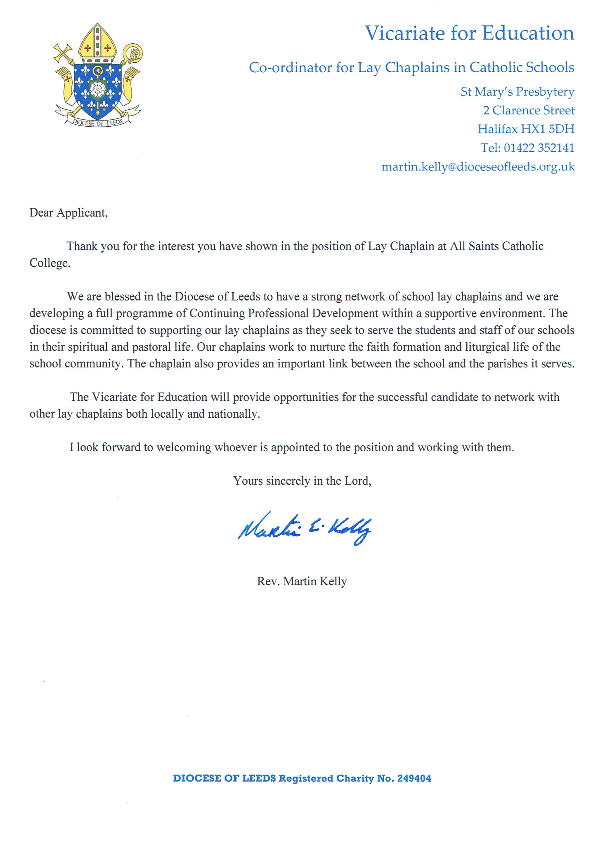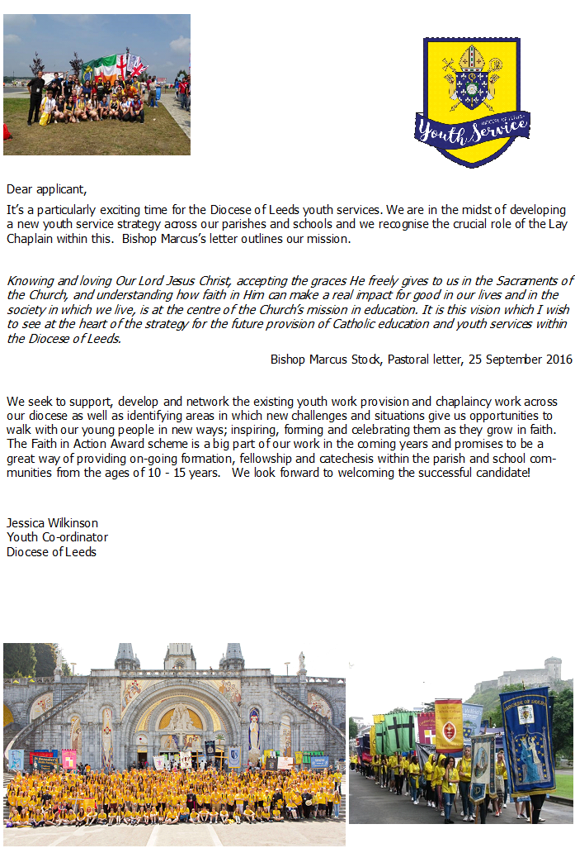

JOB DESCRIPTION : LAY CHAPLAIN
2

CORE RESPONSIBILITIES

The Chaplain as witness
- Help people to recognise God’s love for them and their need of God
- Inspire through example
- To encourage staff and pupils to live the faith by being involved in projects relating to social justice and global citizenship

The Chaplain as pastor
- Be visible and approachable around the school
- Accompany people at particular stages of their journey through life
- Get to know people individually and use every opportunity for contact to the best advantage
- Support the Head Teacher in his/her role as faith leader in school
- To play a central role in the pastoral system

The Chaplain as leader
- Support and further develop the spiritual, religious and liturgical life of the school.
- Use a collaborative style of ministry that encourages a team approach to chaplaincy to develop and lead a chaplaincy team.
- To offer opportunities of prayer for staff and students.
- Plan to celebrate Mass and the sacraments regularly, liaising with local clergy
- Develop suitable activities to mark and celebrate the major feasts and seasons of the Church
- To support staff and pupils in their planning, preparation and leading of liturgies and collective worship
- Help with the provision of suitable resources for the prayer life and worship of the school
- Ensure the school environment and displays reflect the school’s Catholic Christian identity.
- Promote and care for the Chapel as a sacred space
- Develop a school retreat programme for pupils
- Support students to participate in the sacramental life of the Church, where appropriate.
- To celebrate and share the faith life of the school with the wider community
- Develop a programme of transition events with partner primaries
- To include the local parishes in school celebrations, where appropriate
- Help with sensitive issues, advising on the Church’s teaching

The Chaplain as educator
- To support and enhance the RE curriculum, where appropriate

The Chaplain as professional
- Have input into the school development plan, its operation and review
- Advise the Senior Leadership Team, where appropriate
- Challenge and support on standards, morals and the values of the Christian life
- To meet regularly with the line manager
- To engage in a regular process of appraisal
- To report to and work with Governors/Directors to promote the Catholic ethos and distinctive nature of the school.
- Attend where possible staff meetings and any other meetings as appropriate
- To engage with Continual Professional Development (CPD) relevant to the role of chaplain.
- To avail of opportunities for enhancing his/her own spiritual well-being
- To lead school based CPD for staff in relation to the Catholic life of the school.
- To be a member of the Diocesan Chaplaincy Group or its equivalent, attending meetings regularly
- To liaise with Diocesan agencies, groups and individuals, where appropriate

